Construction and application of copper ion and amino acid probe based on functionalized metal–organic framework probe
Xinyi Liu, Dilong Hong, Qian Zhang, Yuliang Jiang*
Jiangsu Collaborative Innovation Center of Biomedical Functional Materials, Jiangsu Key Laboratory of Bio-functional Materials, School of Chemistry and Materials Science, Nanjing Normal University, Nanjing 210023, Jiangsu, Peoples R China
List of contents
- Synthesis route of DHDP
- ¹H NMR spectra of DHDP
- HRMS spectra of DHDP
- SEM and TEM images of UiO-66-(COOH)₂
- UiO-66-(COOH)₂ and DHDP@MOF corresponding particle size distribution histogram
- ICP chart at DHDP@MOF
- The TGA curve of DHDP@MOF
- XPS spectrum of DHDP@MOF
- Fluorescence and ultraviolet spectra of different substance
- UiO-66-(COOH)₂, DHDP and DHDP@MOF color under daylight lamp
- The color change of DHDP@MOF solution
- Photo of test strips containing various substance
- The time response curve and cyclic experiment of DHDP@MOF to Cu²⁺; DHDP@MOF PXRD spectra and fluorescence stability
- UV absorption spectra of Cu²⁺ and fluorescence spectra of DHDP@MOF; The zeta potential and UV-vis absorption spectra
- Determination of Cu²⁺ in water samples
- Linear relationship between fluorescence intensity ratio and Cys/Hcy/GSH
- UV-vis absorption spectra of three amino acids added to DHDP@MOF-Cu
- DHDP@MOF-Cu fluorescence imaging of Cys response in Hela cells
- DHDP@MOF-Cu fluorescence imaging of Hcy response in Hela cells
- DHDP@MOF-Cu fluorescence imaging of GSH response in Hela cells
- Fluorescence imaging of zebrafish DHDP@MOF-Cu in response to Cys
- Fluorescence imaging of zebrafish DHDP@MOF-Cu in response to Hcy
- Fluorescence imaging of zebrafish DHDP@MOF-Cu in response to GSH

1. Synthesis route of DHDP
Scheme S1. Synthesis route of DHDP.

2. ¹H NMR spectra of DHDP
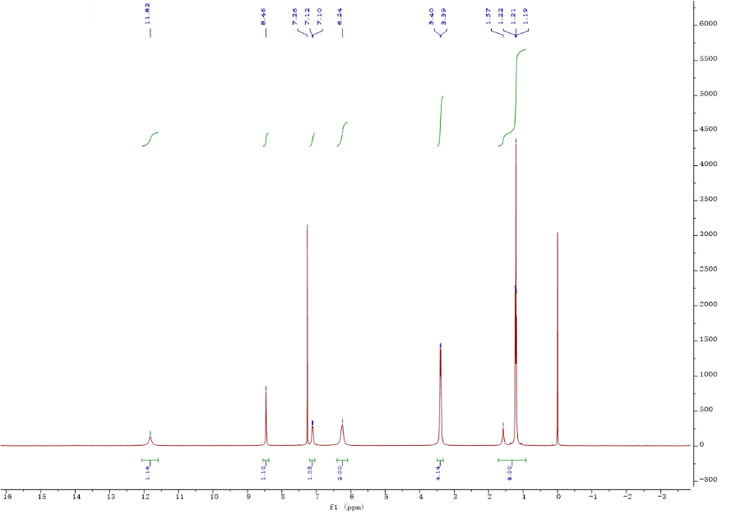
Figure S1. ¹H NMR spectra of DHDP.

3. HRMS spectra of DHDP
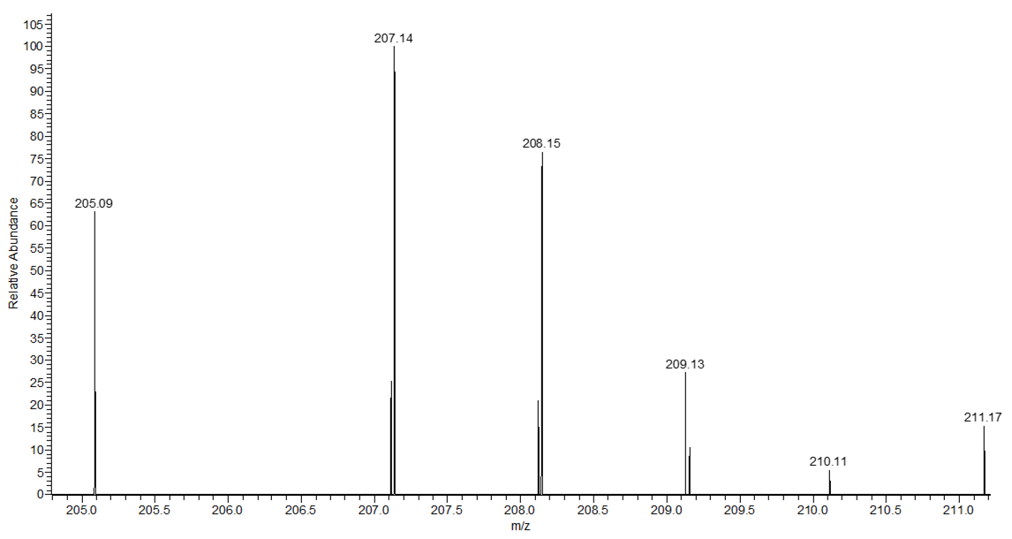
Figure S2. HRMS spectra of DHDP.

4. SEM and TEM images of UiO-66-(COOH)₂
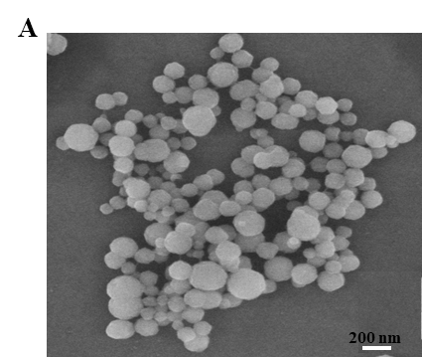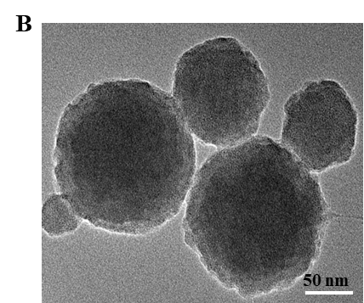
Figure S3. (A) SEM and (B) TEM images of UiO-66-(COOH)₂.

5. The materials corresponding particle size distribution histogram
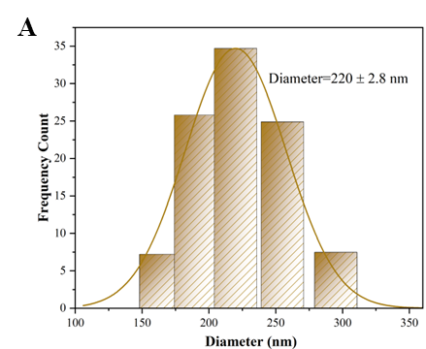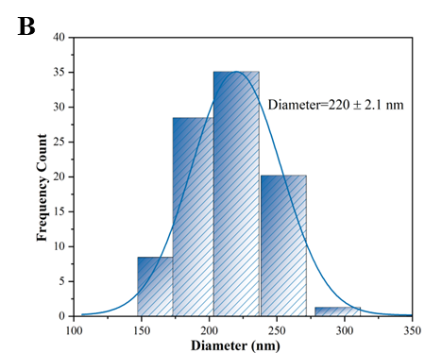
Figure S4. (A) UiO-66-(COOH)₂ and (B) DHDP@MOF corresponding particle size distribution histogram.

6. ICP chart at DHDP@MOF
Table S1. ICP chart at DHDP@MOF
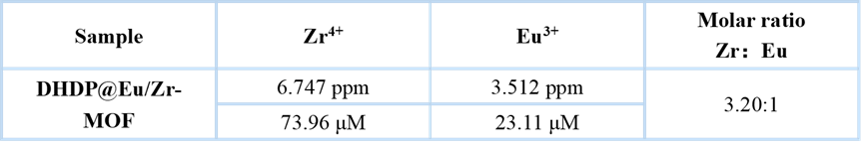

7. The TGA curve of DHDP@MOF
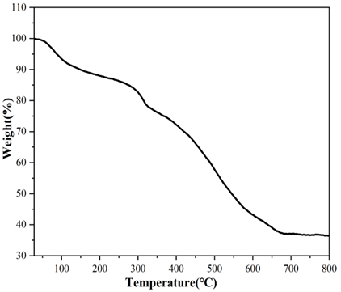
Figure S5. The TGA curve of DHDP@MOF.

8. XPS spectrum of DHDP@MOF
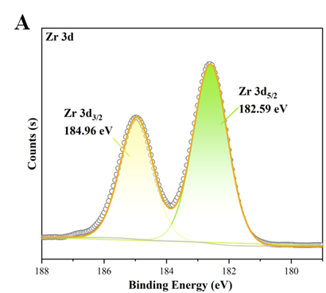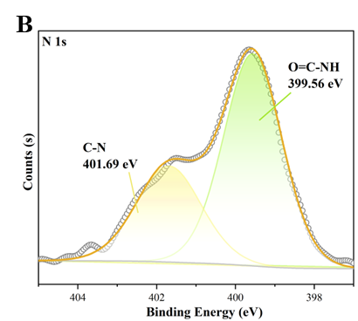
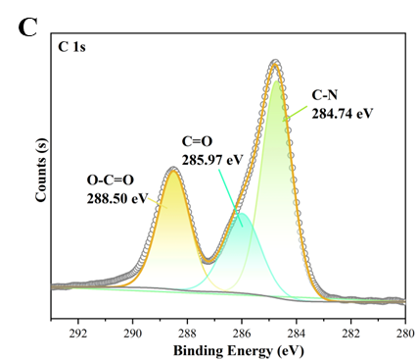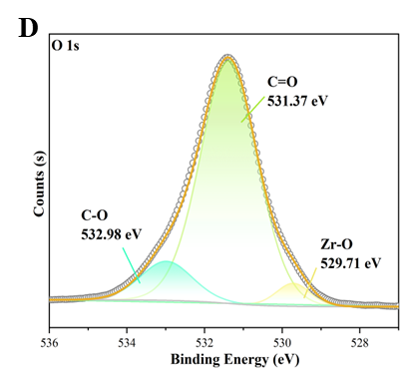
Figure S6. (A) Zr 3d, (B) N 1s, (C) C 1s and (D) O 1s XPS spectrum of DHDP@MOF.

9. Fluorescence and ultraviolet spectra of different substance
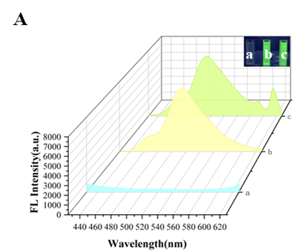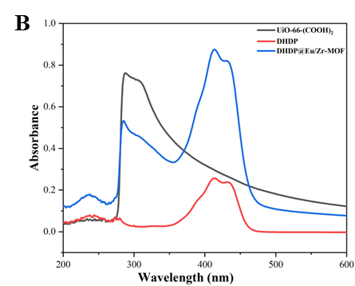
Figure S7. (A) Fluorescence spectra of (a) UiO-66-(COOH)₂, (b) DHDP, (c) DHDP@MOF. The illustration shows the colors of a, b and c solutions under ultraviolet light (365 nm). (B) Ultraviolet spectrogram of UiO-66-(COOH)₂, DHDP and DHDP@MOF.

10. UiO-66-(COOH)₂, DHDP and DHDP@MOF color under daylight lamp
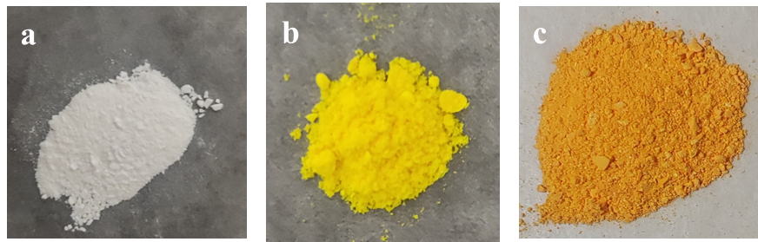
Figure S8. (A) UiO-66-(COOH)₂, (B) DHDP, (C) DHDP@MOF color under daylight lamp.

11. The color change of DHDP@MOF solution
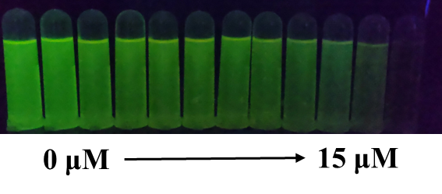
Figure S9. The color change of DHDP@MOF solution with different concentration of Cu²⁺ under UV lamp (365 nm).

12. Photo of test strips containing various substance
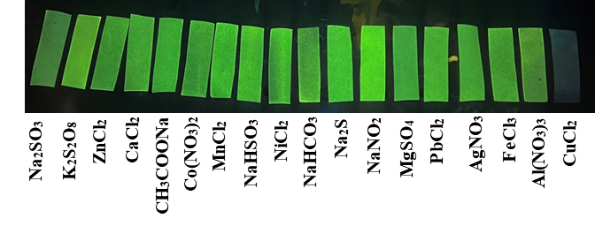
Figure S10. Photo of test strips containing various substances under 365 nm UV lamp.

13. The time response curve and cyclic experiment of DHDP@MOF to Cu²⁺; DHDP@MOF PXRD spectra and fluorescence stability
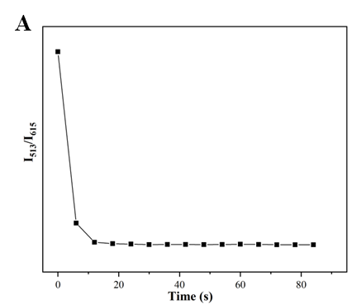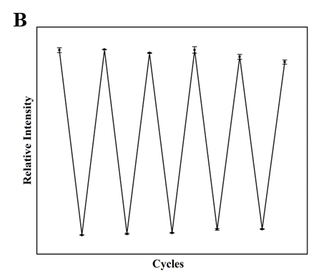
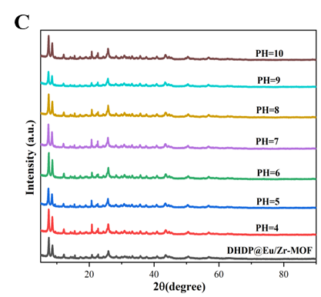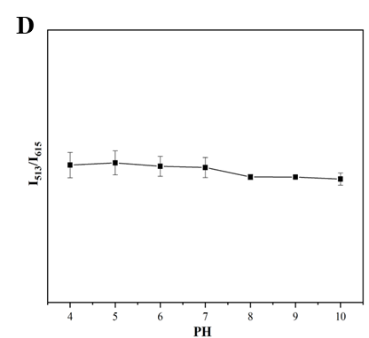
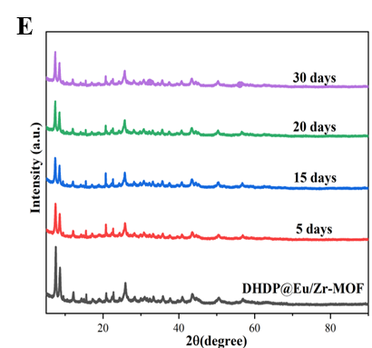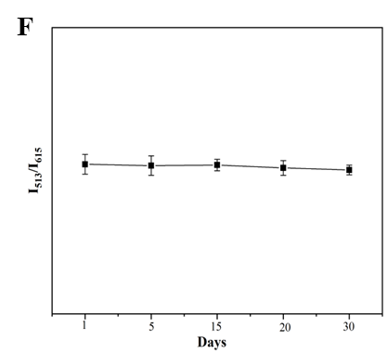
Figure S11. (A) The time response curve of DHDP@MOF to Cu²⁺; (B) DHDP@MOF cyclic experiment of Cu²⁺; DHDP@MOF PXRD spectra after immersion in (C) different PH and (E) ethanol solution; Fluorescence stability under (D) different PH and (F) ethanol solution.

14. UV absorption spectra of Cu²⁺ and fluorescence spectra of DHDP@MOF; The zeta potential and UV-vis absorption spectra
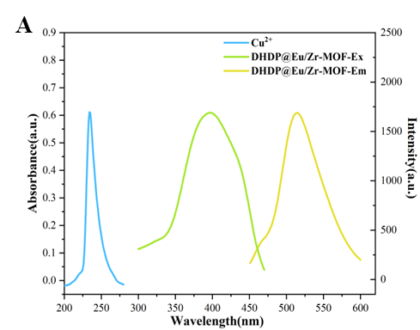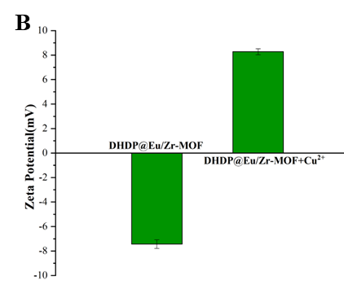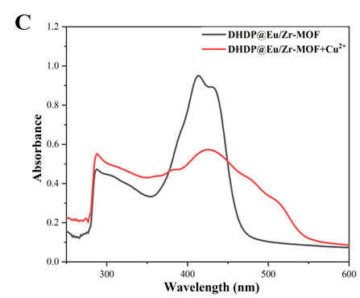
Figure S12. (A) UV absorption spectra of Cu²⁺ and fluorescence excitation and emission spectra of DHDP@MOF; (B) The zeta potential and (C) UV-vis absorption spectra of DHDP@MOF before and after Cu²⁺ detection.

15. Determination of Cu²⁺ in water samples
Table S2. Determination of Cu²⁺ in water samples (n=3).

16. Linear relationship between fluorescence intensity ratio and Cys/Hcy/GSH
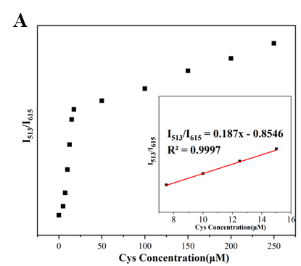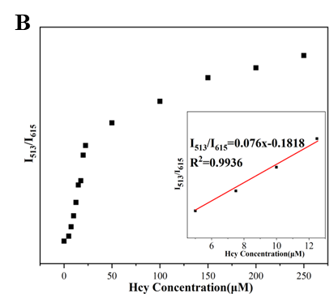
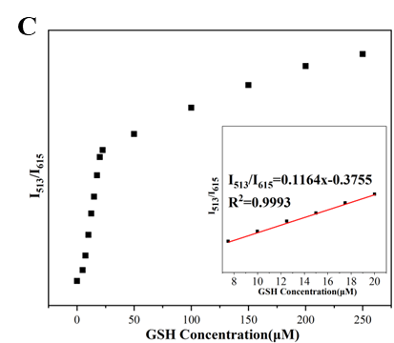
Figure S13. Linear relationship between fluorescence intensity ratio (I₅₁₃/I₆₁₅) and (A) Cys, (B) Hcy, (C) GSH concentrations.

17. UV-vis absorption spectra of three amino acids added to DHDP@MOF-Cu
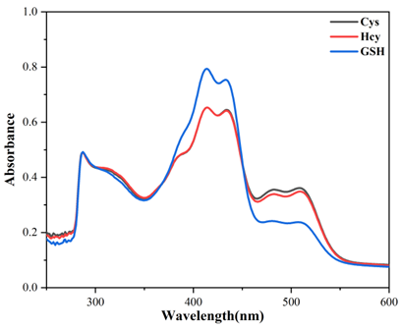
Figure S14. UV-vis absorption spectra of three amino acids added to DHDP@MOF-Cu.

18. DHDP@MOF-Cu fluorescence imaging of Cys response in Hela cells
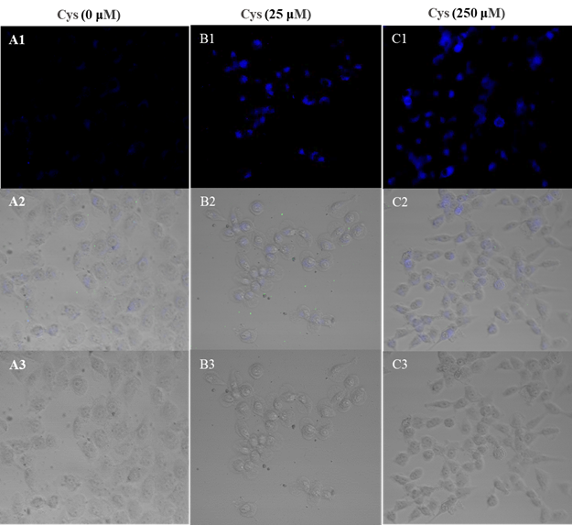
Figure S15. DHDP@MOF-Cu fluorescence imaging of Cys response in Hela cells at different concentrations (0, 25 and 250 uM). Blue channel (A1-C1), merged image of blue channel and bright field image (A2-C2), bright field image (A3-C3).

19. DHDP@MOF-Cu fluorescence imaging of Hcy response in Hela cells
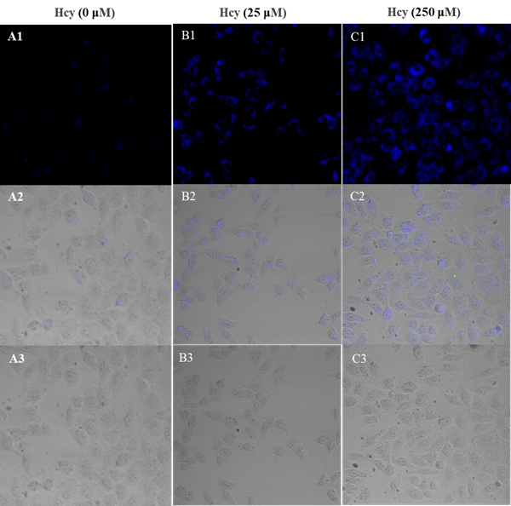
Figure S16. DHDP@MOF-Cu fluorescence imaging of Hcy response in Hela cells at different concentrations (0, 25 and 250 uM). Blue channel (A1-C1), merged image of blue channel and bright field image (A2-C2), bright field image (A3-C3).

20. DHDP@MOF-Cu fluorescence imaging of GSH response in Hela cells
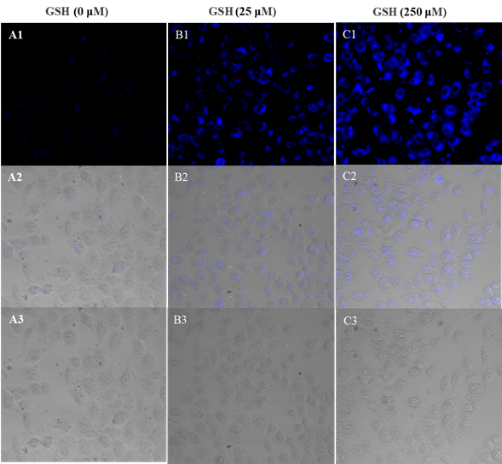
Figure S17. DHDP@MOF-Cu fluorescence imaging of GSH response in Hela cells at different concentrations (0, 25 and 250 uM). Blue channel (A1-C1), merged image of blue channel and bright field image (A2-C2), bright field image (A3-C3).

21. Fluorescence imaging of zebrafish DHDP@MOF-Cu in response to Cys
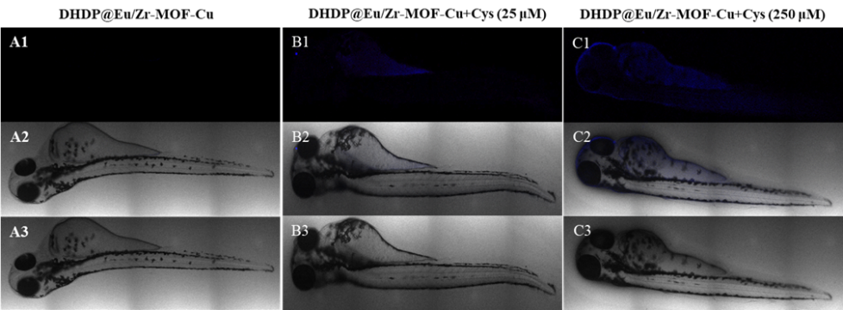
Figure S18. Fluorescence imaging of zebrafish DHDP@MOF-Cu in response to Cys at different concentrations (0, 25 and 250 uM). Blue channel (A1-C1), blue channel combined with bright field image (A2-C2), bright field image (A3-C3).

22. Fluorescence imaging of zebrafish DHDP@MOF-Cu in response to Hcy
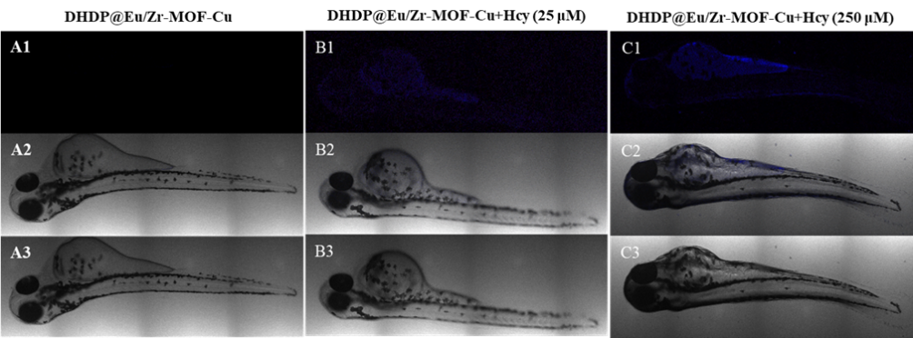
Figure S19. Fluorescence imaging of zebrafish DHDP@MOF-Cu in response to Hcy at different concentrations (0, 25 and 250 uM). Blue channel (A1-C1), blue channel combined with bright field image (A2-C2), bright field image (A3-C3).

23. Fluorescence imaging of zebrafish DHDP@MOF-Cu in response to GSH
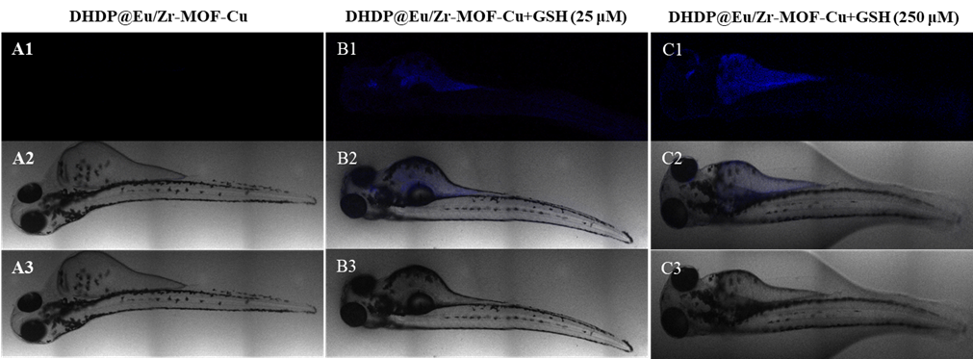
Figure S20. Fluorescence imaging of zebrafish DHDP@MOF-Cu in response to GSH at different concentrations (0, 25 and 250 uM). Blue channel (A1-C1), blue channel combined with bright field image (A2-C2), bright field image (A3-C3).

