Supplementary material to Maintenance of mitogenomic diversity despite recent population decline in a critically endangered Aotearoa New Zealand bird

Table of Contents
1. Supplementary Methods 2
1.1 Modern sample collection 2
1.2 Modern mitogenome library preparation 2
1.2 Modern sample bioinformatics processing 3
1.3 Historical sample mitogenome library preparation 4
1.4 Processing of negative controls 8
1.5 Historical sample bioinformatic processing 9
1.6 Resolving species identification of historical samples 9
1.7 Mitogenome haplotype comparisons with Cytb haplotypes 11
2. Supplementary Tables 12
3. Supplementary Figures 22
4. Evidence of mitochondrial gene duplication in kakī 25
4.1 Introduction 25
4.2 Methods 27
4.2.1 MinION long-read sequencing of the region of potential gene duplication 27
4.2.2 Long-read sequence processing 27
4.2.3 Assembly of long-read sequencing data for kakī 28
4.3 Results 30
4.3.1 MinION long-read sequencing 30
4.3.2 Assembly of kakī mitochondrial gene duplication from MinION reads 31
4.3.4 Sequence mapping to MinION-corrected kakī mitogenome 36
4.3.5 Annotation of the corrected mitogenome 37
4.4 Discussion 41
4.4.1 Robust methods to identify and validate mitochondrial gene duplication in kakī 41
4.4.4 The challenge of identifying and validating mitochondrial gene duplication 43
4.4.5 Future directions 43
5. References 45

1. Supplementary Methods

Modern sample collection
Samples from two Australian pied stilts, DNA IDs B60406 and B60480, were provided by Adelaide Zoo under the Royal Zoological Society of South Australia Specimen Licence Agreement (Import Permit: 2016061954; Figure 3.1, Table 3.1). Samples from two poaka (DNA IDs B40279 and B50004, both plumage node B as per Pierce (1984b)) from Auckland Zoo were supplied under Auckland Zoo Animal Ethics Committee approval. A third poaka sample (DNA ID Poaka1) was received from Hawke’s Bay, North Island. All other modern samples were collected under approval of the Department of Conservation Animal Ethics Committee (AEC #283) as part of routine handling practice at kakī captive breeding facilities in Twizel (DOC) and Christchurch (Isaac Conservation and Wildlife Trust), Aotearoa.

Modern mitogenome library preparation
The amplified mitochondrial products were pooled for each sample and sonicated (Covaris, nine cycles, 15 s on, 45 s off). Successful shearing of products was confirmed via gel visualisation. T4 Polynucleotide Kinase and T4 Polymerase (New England Labs Inc.) were used for blunt end repair, followed by purification using a MinElute kit with products eluted in 30 µL elution buffer. A-tailing was performed with 1.7 µL Klenow (New England BioLabs Inc.) using 25 µL of the purified product, 3 µL NEB#2 Buffer, and 0.3 µL dATP, incubated at 37°C for 30 min, and then purified. Illumina-compatible double-stranded adapters (Adapter_P5 and Adapter_P7) were ligated to purified products via incubation for 1 hour at 22°C, and then purified and eluted. A common P5 adapter and a unique P7 adapter were used for each sample as in Knapp et al. (2012). High-fidelity amplifications used the KAPA HiFi PCR Kit (KAPA Biosystems), with the reaction consisting of 1✕ KAPA HiFi Buffer (with Mg2+), 0.3 mM dNTPs, 0.3 µM each of the P5 and P7 extension primers, 0.6 U KAPA HiFi DNA Polymerase, and 19 µL PCR product. Thermocycling consisted of 94°C for 3 min, twenty cycles of 94°C for 25 s, 60°C for 15 s, and 72°C for 15 s, followed by an extension step at 72°C for 15 min. Amplified products were purified as in the methods in the main manuscript, and quantified via Qubit. Library fragment sizes were visualised using an Agilent 2100 BioAnalyzer. Libraries were pooled equimolarly. An additional clean-up step was performed to improve fragment size distribution, where 2 µL AMPure XP beads (Agencourt) were added to 20 µL pooled library and incubated for 10 min at room temperature. The suspension was placed on a magnetic rack and the supernatant was transferred to a new tube, before adding 1.8✕ the volume of beads, and incubating again for 5–10 min before returning to the magnetic rack. The supernatant was removed and the beads washed with 200 µL 90% EtOH before the pooled DNA was eluted into 20 µL 0.1✕ Tris-EDTA buffer. Final library DNA quantity was confirmed via Qubit.

1.2 Modern sample bioinformatics processing
Briefly, the kakī mitogenome assembly was indexed with BWA v0.7.17 (Li and Durbin 2009). Sequence data was pre-processed with AdapterRemoval v2.1.7 (Schubert et al. 2016) to remove adapters, collapse paired-end reads with a maximum mismatch rate of ⅓, trim low quality bases (Q < 20) and Ns from the end of reads, and remove trimmed reads shorter than 25 bp. Paired-end reads were aligned with BWA-MEM v0.7.17 and sorted with Picard v2.18.0 SortSam (Picard Toolkit 2019). SAMtools v1.7 (Li et al. 2009) merge was used to merge the aligned BAM files produced from the collapsed and uncollapsed reads. The alignment was indexed, and mapping metrics collected with idxstats. Picard CleanSam was used to fix mapping quality scores to 0 for unmapped reads and to soft-clip overhanging reads. Unmapped reads were removed with SAMtools view, and duplicates removed with Picard MarkDuplicates. Mapping depth was collected with SAMtools depth for each sample, and visualised using a custom R script.

1.3 Historical sample mitogenome library preparation
Double-stranded libraries were produced for all historical samples and negative controls following Greig et al. (2015) for in-solution hybridisation capture and paired-end sequencing on an Illumina platform. Between each step, libraries were purified over a MinElute PCR Purification Kit (QIAGEN) according to manufacturer’s specifications, with two PE wash steps. First, blunt-end repair using T4 Polynucleotide Kinase and T4 Polymerase was conducted. Purified products were eluted in 20 µL 0.1✕ TE + 0.05% Tween. Illumina-compatible adapters, Sol_adap_P5 and Sol_adap_P7-BIO (biotinylated at the 5’ end) were ligated to purified products and eluted in 25 µL 1✕ TE. Adapter-ligated libraries were fixed to prepared streptavidin-coated magnetic beads and the beads were thoroughly washed to remove unincorporated adapters. Adapter-ligated libraries were denatured from the beads and eluted in 20 µL 0.1✕ TE.

Libraries were then prepared for quantitative PCR (qPCR) to determine the appropriate number of cycles to minimise the production of chimeras in the subsequent PCR amplification step (Meyerhans et al. 1990; Odelberg et al. 1995; Judo et al. 1998; Thompson et al. 2002). Each qPCR consisted of 1✕ SYBR Green Master Mix (Thermo Fisher Scientific, Inc.), 0.25 µM of each primer (Sol_quant_P5 and Sol_quant_P7), 1µL template DNA, and ultrapure water to make up to a total volume of 25 µL. qPCR amplification was conducted using QuantStudio 3 (Applied Biosystems), with an amplification protocol of 95°C for 10 min, forty cycles of 94°C for 30 s, 58°C for 30 s, 72°C for 60 s, followed by an extension step of 72°C for 10 min. The cycle number at which amplification plateaued for each sample was recorded, and 10 µL each qPCR product was visualised on a 2% agarose gel run at 100 V for 1 hour.

Libraries were double-indexed with one of two distinct P5 barcoding primers (Sol_prim_ext_P5) and a unique P7 (Sol_prim_ext_p7) barcoding primer for each sample. Indexing reactions consisted of 1✕ Taq Buffer, 0.5 mM MgCl2, 1 mM dNTPs, 0.2 µM each P5 and P7 primer, 3.75 U AmpliTaq Gold polymerase (Thermo Fisher Scientific, Inc.), with 19 µL prepared library and ultrapure water added to a total reaction volume of 50 µL. All PCR amplifications were conducted in a modern lab facility. The thermocycling protocol consisted of 95°C for 12 min, 15–20 cycles (determined by qPCR results) of 94°C for 30 s, 58°C for 30 s, and 72°C for 60 s, with a final extension step of 72°C for 10 min. Following purification, libraries were eluted in 20 µL 0.1✕ TE with 0.05% Tween.

Libraries were further amplified prior to target enrichment via hybridisation capture. High fidelity amplification used 1✕ KAPA HiFi Buffer, 0.3 mM dNTPs, 0.3 µM of each Sol_amp_p5 and Sol_amp_p7 primer, 1 U KAPA HiFi DNA Polymerase, 1 µL prepared library, and ultrapure water up to a total volume of 50 µL. Amplification consisted of 94°C for 5 min, ten cycles of 94°C for 20 s, 55°C for 55 s, 72°C for 15 s, and an extension step of 72°C for 5 min. Amplified products were purified and eluted in 20 µL 0.1✕ TE. Libraries were quantified on a NanoDrop™ 8000 Spectrophotometer to ensure sufficient DNA quantity (minimum 2 µg) for hybridisation capture.

To ensure successful capture for all historic samples comprising kakī, poaka, and interspecific hybrids, a combined stilt mitochondrial bait was prepared from one modern kakī (DNA1044) and one modern poaka (B40279) following a modified protocol based on Maricic et al. (2010). To produce sufficient bait for targeted capture of all prepared museum stilt libraries, three long-range amplifications were performed for each of the four mitochondrial regions for both samples, using the optimised reaction mix with 1 µL template DNA and standard thermocycling conditions. Amplified products were purified using a QiaQuick PCR Purification kit (QIAGEN), quantified using a NanoDrop™ 8000 Spectrophotometer and visualised on a 1% agarose gel run at 80 V for 45 minutes. Volumes of long-range products were standardised to 100 µL and sonicated to ~500 bp using a Bioruptor® Pico (Diagenode, Inc., 9 cycles of 15 s on, 45 s off at 4°C). Successful shearing was confirmed by visualising sheared and non-sheared products. Sheared products were quantified before pooling all products from both individuals in equimolar amounts with a minimum total requirement of 1.3 µg per prepared library.

Blunt-end repair and phosphorylation of the long-range pooled products used T4 Polynucleotide Kinase and T4 Polymerase (both New England BioLabs Inc.) with an incubation of 12°C for 15 min and 25°C for 15 min. Products were purified using MinElute silica spin columns and eluted in 15 µL 0.1✕ TE. Biotinylated (Bio-T/B) adapters (Maricic et al. 2010) were ligated to blunt-end repaired fragments by incubation at 22°C for 1 hour, before purification and elution in 15 µL 0.1✕ TE, before quantification to confirm a minimum DNA quantity of 500 ng per prepared historical library.

Hybridisation of libraries to the modern DNA bait followed Maricic et al. (2010) with modification. Briefly, 500 ng of the prepared bait was aliquoted with an equal volume of BWT (Bind and Wash and Tween Buffer; 2 M NaCl, 10 mM Tris (pH 8.0), 1 mM EDTA (pH 8.0), 0.1% Tween) and then denatured for 1 min at 98°C. Single-stranded bait was added to prepared streptavidin-coated beads, and rotated at room temperature for 20 min to allow binding. The solution was placed on a magnetic rack and beads were washed twice with 1✕ BWT at 50°C to remove unincorporated bait. Beads were then resuspended in 50 µL 1✕ TE with 0.05% Tween, and stored at 4°C until hybridisation capture.

To prepare libraries for hybridisation capture, approximately 2 µg DNA of each prepared library was added to 0.9✕ Agilent hybridisation buffer, 0.9✕ Agilent blocking agent, and 1.8 µM of each of eight blocking oligonucleotides. Libraries were made single-stranded by denaturing at 95°C for 3 min, followed by 37°C for 30 min. Buffer was removed from the baited beads prior to resuspension in hybridisation mix. To hybridise the libraries to the bait, the bead mix was rotated at 12 rpm for 48 hours in a 65°C hybridisation oven. Following hybridisation, beads were washed three times with 1✕ 200 µL BWT, twice with 200 µL HWT (2.5 mM MgCl2, 50 mM KCl, 15 mM Tris-HCl (pH 8.0), 0.1% Tween) at 60°C, once with 1✕ BWT, and a final wash with 100 µL 1✕ TE with 0.05% Tween. Libraries were resuspended in 15 µL 0.1✕ TE, and detached from the beads at 95°C for 3 min. Captured libraries were transferred to fresh siliconised tubes and stored at -20°C.

A final post-capture amplification of historical libraries was performed prior to sequencing. The reaction mix consisted of 1✕ KAPA HiFi Buffer (with Mg2+), 0.3 mM dNTPs, 0.3 µM of each of the amplification primers Sol_amp_p5 and Sol_amp_p7, 1 U KAPA HiFi DNA Polymerase, and 15 µL captured library. Thermocycling conditions consisted of 94°C for 5 min, twenty cycles of 94°C for 20 s, 55°C for 55 s, 72°C for 15 s, and a final extension of 72°C for 5 min. Captured libraries were purified and eluted in 20 µL 0.1✕ TE. Final prepared libraries were quantified via Qubit and pooled equimolarly prior to being concentrated through a MinElute spin column with a single PE wash step and eluted into 20 µL 0.1✕ TE. The fragment length distribution of the pooled library was assessed with a QIAxcel Advanced (QIAGEN) using a DNA High Resolution kit and QIAxcel ScreenGel® software. The final pooled library was diluted to 10 nM and sequenced on one lane of a MiSeq v2 with 2 ✕ 75 bp paired-end sequencing.

1.4 Processing of negative controls
Negative controls, having been prepared for sequencing in parallel with samples, were pooled alongside negative controls produced from three other aDNA projects within the lab, comprising a total of 29 negative controls. The fragment length of the pool was assessed on a QIAxcel Advanced. To avoid the failure of the negative sequencing run due to the potential lack of cluster formation associated with the low quantities and short fragments of DNA present, the negative pool was sequenced on one lane of a MiSeq Nano 2 ✕ 75 bp paired-end sequencing run with a PhiX spike of 5–10%.

Bioinformatic processing of the eight negative controls prepared alongside historical samples in this study was conducted independently from sample data using the historical sample processing pipeline. Instead of using the kakī mitogenome assembly as a reference, sequence data from negative controls was mapped against a composite FASTA containing mitochondrial genomes of species previously processed in the aDNA lab and other common reagent contaminants including cattle (Bos taurus, NC_006853.1), domestic chicken (Gallus gallus, NC_001323.1), domestic dog (Canis lupus familiaris, NC_002008.4), guinea pig (Cavia porcellus, NCBI Accession No.: NC_000884.1), human (Homo sapiens, NC_012920.1), kakī (this chapter), kākā (Nestor meridionalis (Martini 2022)), Pacific rat (Rattus exulans, NC_012389.1), and pig (Sus scrofa, NC_000845.1). An additional set of negative control sequences that did not match the list of individual barcodes provided at the time of sequencing was also processed. Where negative controls produced contaminating sequences mapping to kakī, the samples processed in the associated batch were excluded from all downstream analyses.

1.5 Historical sample bioinformatic processing
Read-group information was collected and quality trimming performed with AdapterRemoval v2.2.2. As shorter reads were produced from historical samples compared with modern samples, BWA-ALN was used to find the suffix array coordinates of the reads, with a maximum edit distance of 0.03, and a maximum of 2 gap opens for each of the collapsed and uncollapsed outputs from AdapterRemoval. Paired-end reads were aligned to the reference using BWA-SAMPE, while single-end reads were aligned with BWA-SAMSE. SAMtools v1.7 view was used to collect alignment counts for both the paired-end and collapsed reads, filtering alignments with mapping quality < 20, and producing BAM files. Alignments were sorted and indexed with SAMtools sort and index. Removal of unmapped reads was confirmed with SAMtools view, and duplicates were removed from both single- and paired-end reads with SAMtools rmdup, before indexing and determining mapping rates with SAMtools index and idxstats. Picard MarkDuplicates was used to confirm removal of PCR duplicates, and the PALEOMIX (Schubert et al. 2014) rmdup_collapsed.py script was used to ensure removal of duplicates from the collapsed reads. MapDamage v2.0.2 (Jónsson et al. 2013) was used to quantify patterns of DNA damage for historical samples (length of overhangs, nick frequency, and cytosine deamination) and rescale the quality scores appropriately. Picard AddOrReplaceReadGroups was used to add read-group information to BAM files, which were then indexed with SAMtools. Depth of coverage generated with SAMtools depth and read lengths were visualised in R. Samples were retained for downstream analyses if coverage across the mitogenome exceeded 90%.

1.6 Resolving species identification of historical samples
Accurate species identification for kakī (Himantopus novaezelandiae), poaka (Himantopus
himantopus leucocephalus), and interspecific hybrid offspring (H. h.leucocephalus x H. novaezelandiae) based on morphology is challenging, and the black-and-white plumage of juvenile/sub-adult kakī further complicates identification. Plumage morphology is the primary distinguishing feature between kakī and poaka, and the plumage nodes described by Pierce (1984) assist with taxonomic identification.

Morphological classification of six museum specimens by LB, kakī aviculturist with DOC’s Kakī Recovery Programme differed from the catalogued species identification. Mitochondrial genomes (mitogenomes) were successfully produced for four of these individuals: MS11004, MS11010, MS10991, and MS10992. Inclusion of these mitogenomes alongside additional modern stilts in haplotype and Bayesian analyses found that individuals MS11004 and MS11010 clustered with pied stilts. No individuals morphologically identified as kakī clustered with pied stilts in mitochondrial analyses, and thus these two individuals are most likely poaka or hybrids, concordant with their morphological identifications. Individuals MS10991 and MS10992 that were morphologically identified as kakī clustered with kakī in all analyses, and thus these two individuals are most likely kakī. In addition, the mitogenome produced from stilt skeleton MS11001 catalogued as H. novaezelandiae clustered with pied stilts in all analyses, suggesting that this specimen is likely to be a poaka rather than a kakī.

While other instances of inaccuracies in museum specimen data may be the result of poor record-keeping by the original collectors (Rawlence et al. 2014; Verry et al. 2019), in this instance these inaccuracies are likely due to the limited knowledge regarding these stilt species at the time of collection, with all except one of these specimens entering museum
collections prior to the plumage node descriptions by Pierce (1984). Verifying the data associated with museum samples should be an essential step in any analyses incorporating such data, to ensure that conclusions are robust and biologically meaningful (Verry et al. 2019).

These results have been disseminated to the respective museum curators, who
intend to conduct additional morphological analyses using the data describing additional
phenotypic differences (e.g., tarsal lengths (Pierce 1984; Holdaway 1995)) to further confirm these results (R.P. Scofield and C. Miskelly, pers. comm.). When there is uncertainty around morphology-based species identifications, especially due to hybridisation, consultation with relevant animal handlers or conservation practitioners can support accurate identification, which can then be supplemented with additional morphological assessment where required. Genetic analyses can also support morphological identifications, although such analyses are only likely to be conducted when framed within a wider research question.

These discrepancies in specimen identifications observed here suggest that additional kakī and poaka samples held in natural history collections may also be incorrectly catalogued. This may include the two New Zealand stilt specimens collected by the early New Zealand ornithologist Sir Walter Buller, held at Te Papa Tongarewa, that were excluded from the specimens available for sampling due to their historic value, and Aotearoa stilt samples held in international natural history collections. Any future research incorporating such samples would benefit from consultation with the DOC’s Kakī Recovery Programme to derive accurate taxonomic identifications.

1.7 Mitogenome haplotype comparisons with Cytb haplotypes
Comparison of the haplotypes identified in this manuscript with those specific to mitochondrial haplotypes used by Steeves et al. (2010) identified the cytochrome b (Cytb) region sequenced corresponds to the assembled Cytb region at 13,760–14,050 bp. Among the haplotypes described here, haplotype A corresponds to Cytb haplotype B, haplotype C corresponds to Cytb haplotype C, and haplotype E corresponds to Cytb haplotype A. No haplotype representing the Cytb haplotype D was detected among stilt mitogenomes in this study.

2. Supplementary Tables
Supplementary Table 1. Sample information for modern stilt samples. NZ = Aotearoa New Zealand.
DNA ID | Species | Sample location
DNA1044 | Himantopus novaezelandiae | Twizel, NZ
DNA2094 | H. h. leucocephalus x H. novaezelandiae | Twizel, NZ
DNA2113 | H. h. leucocephalus x H. novaezelandiae | Twizel, NZ
B40279 | H. h. leucocephalus | Auckland Zoo, NZ
B50004 | H. h. leucocephalus | Auckland Zoo, NZ
Poaka1 | H. h. leucocephalus | Hawke's Bay, NZ
B60406 | H. leucocephalus | Adelaide Zoo, Australia
B60480 | H. leucocephalus | Adelaide Zoo, Australia

Supplementary Table 2. Details of museum stilt samples. Recorded collection dates are noted where known. Grey boxes indicate no recorded information. Dates listed as 'Pre-1950' are based on specimen museum ID, with IDs OR000000-OR008000 registered prior to the early 1950s (and specimens collected prior to this). Weights refer to the total amount of material sampled and used for DNA extractions. Dashes indicate no recorded information. F = female, M = male, mg = milligrams, NI = North Island, SI = South Island.
Source museum | Specimen museum ID | DNA ID | Collection date | Collection location | Specimen type | Sex | Catalogued species | Morphological identification | Weight collected (mg) | Weight used (mg)
Auckland | LB3413 | MS10986 | 01 Jul 1879 | Mangere, NI | Skin | F | Himantopus novaezelandiae | Himantopus novaezelandiae | 2.3 | 2.3
Auckland | LB3946 | MS10987 | Pre-1940 | South Head, Kaipara Harbour, NI | Mounted | - | Himantopus novaezelandiae | Himantopus novaezelandiae | 2.9 | 2.9
Auckland | LB3414 | MS10988 | Sep 1882 | Manukau, NI | Skin | M | Himantopus novaezelandiae | Himantopus novaezelandiae | 1.8 | 1.8
Auckland | LB8517 | MS10990 | Pre-1887 | Waikato, NI | Mounted | M | Himantopus novaezelandiae | Himantopus novaezelandiae | 3.1 | 3.1
Canterbury | AV686 | MS10991 | Nov 1914 | Lake Ellesmere, SI | Skin | F | Himantopus himantopus leucocephalus | Himantopus novaezelandiae (sub-adult) | 20.4 | 9.6
Canterbury | AV683 | MS10992 | 20 Jun 1910s | Waitaki River, SI | Skin | M | Himantopus himantopus leucocephalus | Himantopus novaezelandiae | 30.3 | -
Canterbury | AV682 | MS10993 | 20 Jun 1910s | Waitaki River, SI | Skin | F | Himantopus himantopus leucocephalus | Himantopus himantopus leucocephalus | 27.1 | 19.1
Canterbury | AV685 | MS10994 | Nov 1914 | Lake Ellesmere, SI | Skin | M | Himantopus himantopus leucocephalus | Himantopus novaezelandiae (sub-adult) | 37.5 | 26.6
Canterbury | AV1938 | MS10995 | 1872 | Selwyn, SI | Skin | F | Himantopus himantopus leucocephalus | Himantopus novaezelandiae | 34.2 | 16.7
Te Papa | OR002286 | MS10996 | Pre-1950s | - | Skin | - | Himantopus novaezelandiae | Himantopus novaezelandiae | 28.6 | 15.7
Te Papa | OR002287 | MS10997 | Pre-1950s | - | Skin | - | Himantopus novaezelandiae | Himantopus novaezelandiae | 12 | 6.3
Te Papa | OR002289 | MS10998 | Pre-1950s | - | Skin | - | Himantopus novaezelandiae | Himantopus novaezelandiae | 6 | 4.3
Te Papa | OR004737 | MS10999 | Pre-1950s | - | Skin | - | Himantopus novaezelandiae | Himantopus novaezelandiae | 36.1 | 11.5
Te Papa | OR002291 | MS11000 | Pre-1950s | - | Skin | - | Himantopus novaezelandiae | Himantopus novaezelandiae (sub-adult) | 13.4 | 13.4
Te Papa | DM622-S | MS11001 | Jan 1959 | Manukau Harbour, NI | Skeletal | - | Himantopus novaezelandiae | - | 10.6 | 10.6
Te Papa | OR22726 | MS11002 | 28 Oct 1981 | Pauahatanui, NI | Skin | F | Himantopus himantopus leucocephalus x Himantopus novaezelandiae | Himantopus himantopus leucocephalus x Himantopus novaezelandiae | 21.9 | 21.9
Te Papa | OR014187 | MS11003 | Post-1950s | - | Mounted | - | Himantopus novaezelandiae | Himantopus novaezelandiae | 8.3 | 8.3
Te Papa | OR010938 | MS11004 | Post-1950s | - | Mounted | - | Himantopus novaezelandiae | Himantopus himantopus leucocephalus x Himantopus novaezelandiae | 9.2 | 9.2
Te Papa | OR002296 | MS11005 | May 1843 | - | Skin | - | Himantopus himantopus leucocephalus | Himantopus himantopus leucocephalus | 22.1 | 7.7
Te Papa | OR002292 | MS11006 | Pre-1950s | - | Skin | - | Himantopus himantopus leucocephalus | Himantopus himantopus leucocephalus | 13.2 | 13.2
Te Papa | OR004736 | MS11007 | Pre-1950s | Nelson, SI | Skin | - | Himantopus himantopus leucocephalus | Himantopus himantopus leucocephalus | 14.1 | 14.1

Supplementary Table 2 continued.
Source museum | Specimen museum ID | DNA ID | Collection date | Collection location | Specimen type | Sex | Catalogued species | Morphological identification | Weight collected (mg) | Weight used (mg)
Te Papa | OR021957 | MS11008 | 28 Sep 1977 | Napier, NI | Skin | F | Himantopus himantopus leucocephalus | Himantopus himantopus leucocephalus | 17.7 | 17.7
Te Papa | OR022693 | MS11009 | 4 Sep 1978 | Greymouth, SI | Skin | F | Himantopus himantopus leucocephalus | Himantopus himantopus leucocephalus | 24.1 | 9.7
Te Papa | OR027440 | MS11010 | 13 Jun 1995 | Woodlands, Invercargill, SI | Skin | F | Himantopus leucocephalus x novaezelandiae | Himantopus himantopus leucocephalus or very light hybrid | 29 | 8.3
Te Papa | OR022656 | MS11011 | 14 Jul 1928 | Paraparaumu, Waikanae River estuary, NI | Skin | F | Himantopus himantopus leucocephalus | Himantopus himantopus leucocephalus | 13.2 | 13.2
Te Papa | OR029290 | MS11012 | 21 Jan 2011 | Te Whanga Lagoon, Chatham Island | Skin | M | Himantopus himantopus leucocephalus | Himantopus himantopus leucocephalus | 17.1 | 17.1
Te Papa | OR026807 | MS11013 | 19 Dec 2000 | Twizel, SI | Skin | - | Himantopus novaezelandiae x leucocephalus | - | < 1 | < 1

Supplementary Table 3. Results of modern stilt long-read PCR sequencing and read mapping to the kakī mitogenome assembly. bp = base pairs, Mb = megabase pairs.
DNA ID | Sequence ID | Barcodes | Average sequence length (bp) | Total sequence reads produced | Yield (Mb) | Mitogenome coverage (%) | Coverage depth (✕)
DNA1044 | OG4109-02 | P5-1-P7-89 | 150 | 216,990 | 32.549 | 99.8 | 478.2
DNA2094 | OG4109-03 | P5-1-P7-90 | 150 | 188,528 | 28.279 | 99.7 | 367.6
DNA2113 | OG4109-04 | P5-1-P7-91 | 150 | 207,018 | 31.053 | 99.6 | 368.0
B40279 | OG4109-05 | P5-1-P7-92 | 150 | 204,766 | 30.715 | 99.7 | 401.7
B50004 | OG4109-06 | P5-1-P7-93 | 150 | 324,726 | 48.709 | 99.8 | 342.7
B60406 | OG4109-07 | P5-1-P7-94 | 150 | 289,896 | 43.484 | 99.6 | 470.4
B60480 | OG4109-08 | P5-1-P7-95 | 150 | 325,688 | 48.853 | 99.7 | 440.8
Poaka1 | OG4109-09 | P5-1-P7-96 | 150 | 281,624 | 42.244 | 99.7 | 360.9

Supplementary Table 4. Sequence and mapping results for historical museum samples. Barcodes describe the sequencing barcode combination used for identification. Mb = megabase pairs, bp = base pairs.
Specimen ID | aDNA ID | Sequencing ID | Barcodes | Yield (Mb) | Average sequence length (bp) | % duplication | % GC content | Total sequences | Mitogenome coverage (%) | Coverage depth (✕)
LB3413 | MS10986 | OG4983-01-0-1 | P5-9-P7-4 | 48 | 76 | 19.93 | 48 | 628846 | 97.9 | 283.9
LB3946 | MS10987 | OG4983-02-0-1 | P5-7-P7-13 | 44 | 76 | 25.56 | 47 | 579314 | 97.7 | 370.2
LB3414 | MS10988 | OG4983-03-0-1 | P5-7-P7-14 | 27 | 76 | 32.01 | 46 | 361204 | 98.1 | 286.5
LB8517 | MS10990 | OG4983-04-0-1 | P5-9-P7-5 | 20 | 76 | 12.61 | 48 | 261510 | 97.3 | 70.1
AV686 | MS10991 | OG4983-05-0-1 | P5-9-P7-6 | 21 | 76 | 22.87 | 45 | 272700 | 98.3 | 196
AV683 | MS10992 | OG4983-06-0-1 | P5-9-P7-13 | 15 | 76 | 17.58 | 46 | 203066 | 97.6 | 196
AV682 | MS10993 | OG4983-07-0-1 | P5-7-P7-1 | 0 | 76 | 1.41 | 49 | 284 | 16.3 | 0.2
AV685 | MS10994 | OG4983-08-0-1 | P5-7-P7-2 | 15 | 76 | 16.32 | 48 | 192450 | 97.1 | 112.5
AV1938 | MS10995 | OG4983-09-0-1 | P5-9-P7-1 | 29 | 76 | 23.19 | 48 | 386008 | 97.7 | 159.8
OR002286 | MS10996 | OG4983-10-0-1 | P5-7-P7-3 | 10 | 76 | 17.31 | 47 | 135734 | 97.6 | 84.9
OR002287 | MS10997 | OG4983-11-0-1 | P5-7-P7-4 | 26 | 76 | 35.81 | 45 | 344110 | 98 | 335.4
OR002289 | MS10998 | OG4983-12-0-1 | P5-7-P7-5 | 48 | 76 | 27.08 | 48 | 634050 | 97.9 | 331.8
OR004737 | MS10999 | OG4983-13-0-1 | P5-7-P7-6 | 28 | 76 | 29.91 | 46 | 373666 | 98.1 | 261.9
OR002291 | MS11000 | OG4983-14-0-1 | P5-9-P7-16 | 71 | 76 | 29.48 | 44 | 932626 | 98.7 | 501.3
DM622-S | MS11001 | OG4983-15-0-1 | P5-9-P7-17 | 27 | 76 | 24.11 | 50 | 355744 | 98 | 156.1
OR22726 | MS11002 | OG4983-16-0-1 | P5-9-P7-18 | 16 | 76 | 16.81 | 45 | 214380 | 98.1 | 150
OR014187 | MS11003 | OG4983-17-0-1 | P5-7-P7-15 | 45 | 76 | 24.44 | 47 | 586348 | 98 | 356.4
OR010938 | MS11004 | OG4983-18-0-1 | P5-7-P7-16 | 51 | 76 | 24.32 | 46 | 673632 | 97.9 | 391.5
OR002292 | MS11006 | OG4983-20-0-1 | P5-7-P7-17 | 22 | 76 | 26.86 | 45 | 287992 | 98.6 | 208.3
OR004736 | MS11007 | OG4983-21-0-1 | P5-9-P7-22 | 25 | 76 | 18.39 | 48 | 325952 | 97.6 | 119.2
OR021957 | MS11008 | OG4983-22-0-1 | P5-7-P7-18 | 0 | 76 | 1.48 | 47 | 270 | 13.5 | 0.2
OR022693 | MS11009 | OG4983-23-0-1 | P5-7-P7-19 | 31 | 76 | 19.56 | 49 | 406058 | 97.9 | 147.8
OR027440 | MS11010 | OG4983-24-0-1 | P5-7-P7-20 | 31 | 76 | 26.29 | 47 | 404246 | 98 | 148.3
OR022656 | MS11011 | OG4983-25-0-1 | P5-9-P7-23 | 19 | 76 | 19.49 | 46 | 244346 | 97.6 | 156.9
OR029290 | MS11012 | OG4983-26-0-1 | P5-9-P7-24 | 0 | 76 | 2.77 | 48 | 794 | 30.8 | 0.4
OR026807 | MS11013 | OG4983-27-0-1 | P5-9-P7-25 | 0 | 76 | 1.33 | 54 | 150 | 0 | 0

Supplementary Table 5. Results of modern kakī whole-genome resequencing data mapping to the kakī mitogenome.
Sequencing ID | Stilt DNA ID | Sequencing strategy | Total raw sequence reads | Mitogenome coverage (%) | Coverage depth (✕)
H01383 | DNA240 | High coverage | 108,247,282 | 100 | 307.1
H01384 | DNA451 | High coverage | 323,915,460 | 100 | 257.4
H01385 | DNA452 | High coverage | 141,757,794 | 100 | 313.6
H01386 | DNA453 | High coverage | 192,931,784 | 100 | 345.4
H01387 | DNA639 | High coverage | 170,267,148 | 100 | 456.1
H01388 | DNA1376 | High coverage | 239,378,718 | 100 | 628.7
H01389 | DNA1377 | High coverage | 197,094,168 | 100 | 276.2
H01390 | DNA1429 | High coverage | 201,384,664 | 100 | 469.8
H01391 | DNA1469 | High coverage | 228,489,236 | 100 | 365.3
H01392 | DNA1565 | High coverage | 230,785,686 | 100 | 398.1
H01393 | DNA1659 | High coverage | 178,588,964 | 100 | 116.9
H01394 | DNA1661 | High coverage | 246,479,770 | 100 | 303.8
H01407 | DNA1738 | Low coverage | 77,264,826 | 100 | 42.0
H01408 | DNA1872 | Low coverage | 108,325,914 | 100 | 190.2
H01409 | DNA1892 | Low coverage | 93,887,144 | 100 | 171.7
H01410 | DNA1934 | Low coverage | 95,889,628 | 100 | 271.1
H01411 | DNA1936 | Low coverage | 79,991,160 | 100 | 59.6
H01412 | DNA1980 | Low coverage | 113,637,902 | 100 | 228.6
H01413 | DNA2012 | Low coverage | 149,576,634 | 100 | 200.9
H01414 | DNA2023 | Low coverage | 172,893,122 | 100 | 198.2
H01415 | DNA2032 | Low coverage | 187,531,438 | 100 | 204.0
H01416 | DNA2035 | Low coverage | 54,170,050 | 100 | 74.1
H01417 | DNA2074 | Low coverage | 61,238,394 | 100 | 85.4
H01418 | DNA2091 | Low coverage | 66,246,754 | 100 | 58.2

Supplementary Table 6. List of species included in Bayesian and maximum likelihood analyses. All species are in the Order Charadriiformes except the outgroups of Australasian grebe (Podicipediformes) and the domestic chicken (Galliformes). The mitogenome of Australian pied stilt has not been independently assembled, but mitogenome size is estimated at 17,300–17,600 bp based on the mitogenomes of a pied stilt from China and kakī. * = representative kakī and Australian pied stilt samples, with the DNA ID as the identifier.
Family | Species |  | Common name |  | GenBank ID | Mitogenome size (bp)
Alcidae | Pinguinus impennis |  | Great auk |  | KU158188.1 | 16,784
 | Synthliboramphus antiquus |  | Ancient murrelet |  | AP009042.1 | 16,730
 | Synthliboramphus wumizusume |  | Japanese murrelet |  | NC_029328.1 | 16,714
Charadriidae | Charadrius placidus |  | Long-billed plover |  | KY419888.1 | 16,895
 | Pluvialis fulva |  | Pacific golden plover |  | NC_033966.1 | 16,854
 | Vanellus cinereus |  | Grey-headed lapwing |  | NC_025514.1 | 17,074
 | Vanellus vanellus |  | Northern lapwing |  | NC_025637.1 | 16,795
 | Charadrius alexandrinus |  | Kentish plover |  | NC_041118.1 | 16,905
Haematopodidae | Haematopus ostralegus |  | Eurasian oystercatcher |  | NC_034237/1 | 16,798
 | Haematopus ater |  | Blackish oystercatcher |  | AY074886.2 | 16,791
Jacanidae | Hydrophasianus chirurgus |  | Pheasant-tailed jacana |  | NC_039096.1 | 16,855
 | Jacana jacana |  | Wattled jacana |  | KJ631049.1 | 16,975
 | Jacana spinosa |  | Northern jacana |  | KJ631048.1 | 17,079
Laridae | Chroicocephalus ridibundus |  | Black-headed gull |  | KM577662.1 | 16,807
 | Saundersilarus saundersii |  | Saunder's gull |  | KJ631624.1 | 16,739
 | Chroicocephalus brunnicephalus |  | Brown-headed gull |  | JX155863.1 | 16,769
 | Ichthyaetus relictus |  | Relict gull |  | KC760146.1 | 16,586
 | Larus crassirostris |  | Black-tailed gull |  | KM507782.1 | 16,746
 | Larus dominicanus |  | Kelp gull |  | AY293619.1 | 16,701
 | Sternula albifrons |  | Little tern |  | KT350612.1 | 16,357
 | Gelochelidon nilotica | Gull-billed tern |  | NC_036344.1 |  | 16,748
 | Sterna hirundo | Common tern |  | NC_046345.1 |  | 16,707
Recurvirostridae | Recurvirostra avosetta | Pied avocet |  | KY623657.1 |  | 16,856
 | Himantopus himantopus | Black-winged stilt |  | NC_035423.1 |  | 17,378
 | Himantopus leucocephalus* | Pied stilt |  | B60480 |  | -
 | Himantopus novaezelandiae* | Kakī |  | DNA451 |  | 17,566

Supplementary Table 6 continued.
Family | Species | Common name | GenBank ID | Mitogenome size (bp)
Scolopacidae | Arenaria interpres | Ruddy turnstone | AY074885.2 | 16,725
 | Calidris ruficollis | Rufous-necked stint | NC_040990.1 | 16,860
 | Phalaropus lobatus | Red-necked phalarope | KY765409.1 | 16,714
 | Limosa lapponica baueri | Bar-tailed godwit | KX371106.1 | 16,732
 | Tringa glareola | Wood sandpiper | NC_039096.1 | 16,804
 | Tringa guttifer | Nordmann's greenshank | NC_044665.1 | 16,835
 | Tringa nebularia | Common greenshank | NC_044651.1 | 16,682
 | Tringa totanus | Common redshank | NC_044648.1 | 16,818
 | Eurynorhynchus pygmeus | Spoon-billed sandpiper | KY434065.1 | 16,709
 | Xenus cinerus | Terek sandpiper | KX644890.1 | 16,817
 | Tringa ochropus | Green sandpiper | NC_033974.1 | 16,904
 | Tringa semipalmata | Willet | MF036175.1 | 16,603
 | Gallinago stenura | Pin-tailed snipe | KY888681.1 | 18,153
 | Numenius phaeopus | Whimbrel | KP308149.1 | 17,091
 | Scolopax rusticola | Eurasian woodcock | KM434134.1 | 16,984
Stercorariidae | Stercorarius maccormicki | South polar skua | KM401546.1 | 16,669
Order Podicipediformes, Family Podicipedidae | Tachybaptus novaehollandiae | Australasian grebe | EF532936.1 | 18,002
Order Galliformes, Family Phasianidae | Gallus gallus | Domestic chicken | MH732978.1 | 16,785

Supplementary Table 7. Charadriiformes consensus-derived mitochondrial primer characteristics. Start positions and estimated region length are relative to the assembled kakī mitogenome. bp = base pairs, F = forward primer, R = reverse primer.
Primer | Forward primer sequence | Reverse primer sequence | Start position F (bp) | Start position R (bp) |  | Estimated region length (bp)
KakiM1 | CAAACCCACCTAGAGGAGCC | GAGTGGTTTGATGCGGTTGG | 630 | 6,981 | 6,300
KakiM2 | TTTCAAGCCAACCGCATCAA | CTAGTTGGCTGGATGTGGAGAA | 6,955 | 12,747 | 5,800
KakiM3 | AAACCCCAACACTCCCCCTA | GGCCCTGACATAGGAACCAG | 12,436 | 16,102 | 3,800
KakiM4 | CTCCAACTCCCAAAGCTGGT | ACAGGCAACCAGCTATCACC | 14,898 | 1,504 | 4,200

Supplementary Table 8. Sequencing results of negative controls prepared alongside sample batches during initial DNA extraction (DNA-ve) and double-stranded library preparation (Neg). None of the barcodes identified among the sequence pool corresponded to any of the barcodes used here for blanks or museum samples. Undetermined refers to those sequenced barcodes that did not match the known barcodes recorded among the pooled blanks.
Blank ID | Sequence ID | Barcodes | Sample batch | Yield (Mb) | Average sequence length | % duplication | % GC content | Total sequence reads | Collapsed reads mapped | % reads mapped | Mitogenome coverage (%) | Coverage depth (✕)
DNA-ve1 | OG5003-12-0-1 | P5-9-P7-14 | MS10986–MS10992 | 0 | 76 | 26.90 | 39 | 1,160 | 2 | 0.172 | 0 | 0
DNA-ve2 | OG5003-13-0-1 | P5-9-P7-2 | MS10993–MS10999 | 3 | 76 | 6.43 | 46 | 35,254 | 5720 | 16.225 | 97.7 | 26.9
DNA-ve3 | OG5003-14-0-1 | P5-9-P7-20 | MS11000–MS11006 | 0 | 76 | 16.81 | 42 | 904 | 50 | 5.531 | 17.5 | 0.2
DNA-ve4 | OG5003-15-0-1 | P5-9-P7-26 | MS11007–MS11013 | 0 | 76 | 20.06 | 47 | 668 | 15 | 2.246 | 0 | 0
Neg1 | OG5003-16-0-1 | P5-9-P7-3 | MS10993–MS10999 | 0 | 76 | 20.00 | 51 | 10 | 0 | 0 | 0 | 0
Neg2 | OG5003-17-0-1 | P5-9-P7-15 | MS10986–MS10992 | 0 | 76 | 50.00 | 46 | 4 | 0 | 0 | 0 | 0
Neg3 | OG5003-18-0-1 | P5-9-P7-21 | MS11000–MS11006 | 0 | 76 | 50.00 | 51 | 8 | 0 | 0 | 0 | 0
Neg4 | OG5003-19-0-1 | PF-9-P7-28 | MS11007–MS11013 | 0 | 76 | 33.96 | 52 | 106 | 1 | 0.943 | 0 | 0
Undetermined | - | - | - | 68 | 76 | - | 49 | 899,556 | 133 | 0.015 | 27.9 | 0.4

Supplementary Table 9. Results of permutation tests for significant differences in A) haplotype and B) nucleotide diversity between species and time categories. Diversity differences between groups are reported below the diagonal, with associated P-values above the diagonal. Bold text indicates significance (P < 0.05). AusPied = Australian pied stilt, mod = modern, hist = historical.
A) Haplotype diversity for each group | 1.0000 | 1.0000 | 0.7500 | 0.3846 | 0.8333 | 1.0000
Haplotype diversity difference between groups | AusPied_mod | Hybrid_mod | Kakī_hist | Kakī_mod | Poaka_hist | Poaka_mod
AusPied_modern | -- | 1.0000 | 0.7672 | 0.2655 | 0.9254 | 1.0000
Hybrid_modern | 0.0000 | -- | 0.1759 | 0.0011 | 0.4940 | 0.9968
Kakī_historical | 0.2500 | 0.2500 | -- | 0.0004 | 0.7416 | 0.1067
Kakī_modern | 0.6154 | 0.6154 | 0.3654 | -- | 0.0104 | 0.0009
Poaka_historical | 0.1667 | 0.1667 | 0.0833 | 0.4487 | -- | 0.3936
Poaka_modern | 0.0000 | 0.0000 | 0.2500 | 0.6154 | 0.1667 | --
B) Nucleotide diversity for each group | 0.0006 | 0.0030 | 0.0016 | 0.0003 | 0.0028 | 0.0005
Nucleotide diversity difference between groups | AusPied_mod | Hybrid_mod | Kakī_hist | Kakī_mod | Poaka_hist | Poaka_mod
AusPied_modern | -- | 0.5709 | 0.9284 | 0.9999 | 0.6689 | 0.9877
Hybrid_modern | 0.0024 | -- | 0.3511 | 0.0179 | 0.7573 | 0.2251
Kakī_historical | 0.0010 | 0.0014 | -- | 0.0840 | 0.4577 | 0.3117
Kakī_modern | 0.0003 | 0.0027 | 0.0013 | -- | 0.0411 | 0.8336
Poaka_historical | 0.0022 | 0.0002 | 0.0012 | 0.0025 | -- | 0.2573
Poaka_modern | 0.0001 | 0.0025 | 0.0011 | 0.0002 | 0.0023 | --

3. Supplementary Figures

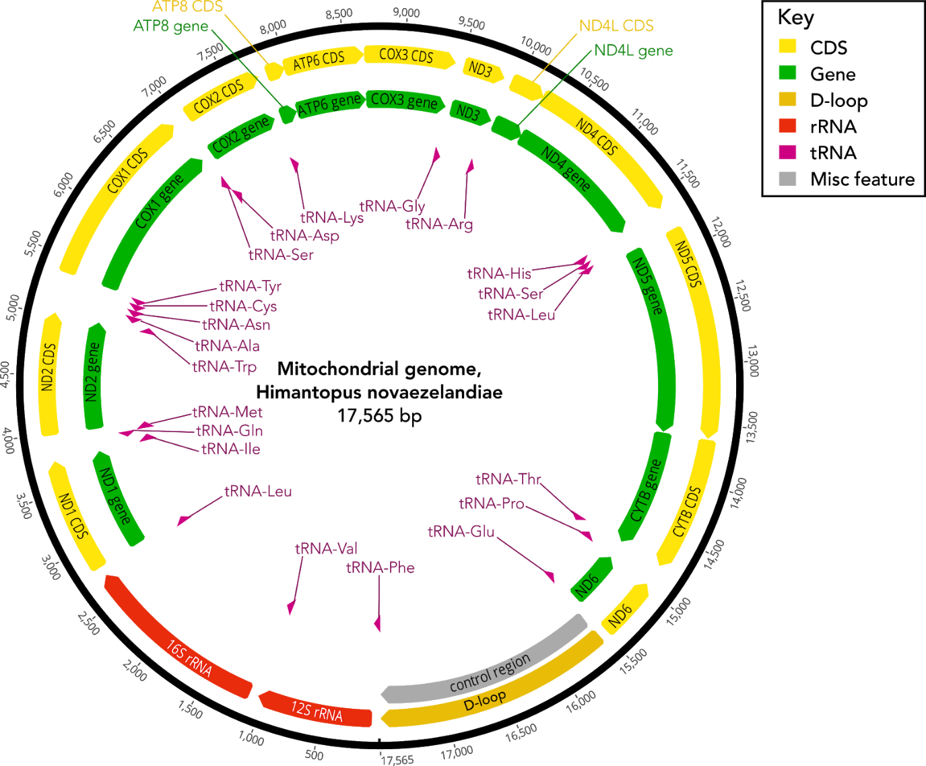
Supplementary Figure 1: Visualisation of the draft mitochondrial genome for kakī Himantopus novaezelandiae, assembled from Illumina whole-genome sequencing of a single individual with NOVOPlasty v2.7.1.This version was used for all sequence mapping and downstream analyses, and does not include the hypothesised duplicated region. Gene features were annotated with MITOS and confirmed against the annotated black-winged stilt H. himantopus mitogenome. Green corresponds to gene regions, yellow represents coding regions, red shows rRNA regions, tRNA regions are in pink, the D-loop is in gold, with miscellaneous features in grey. The numbers on the outer ring correspond to the base position on the mitogenome. Arrows indicate the direction of transcription of features.

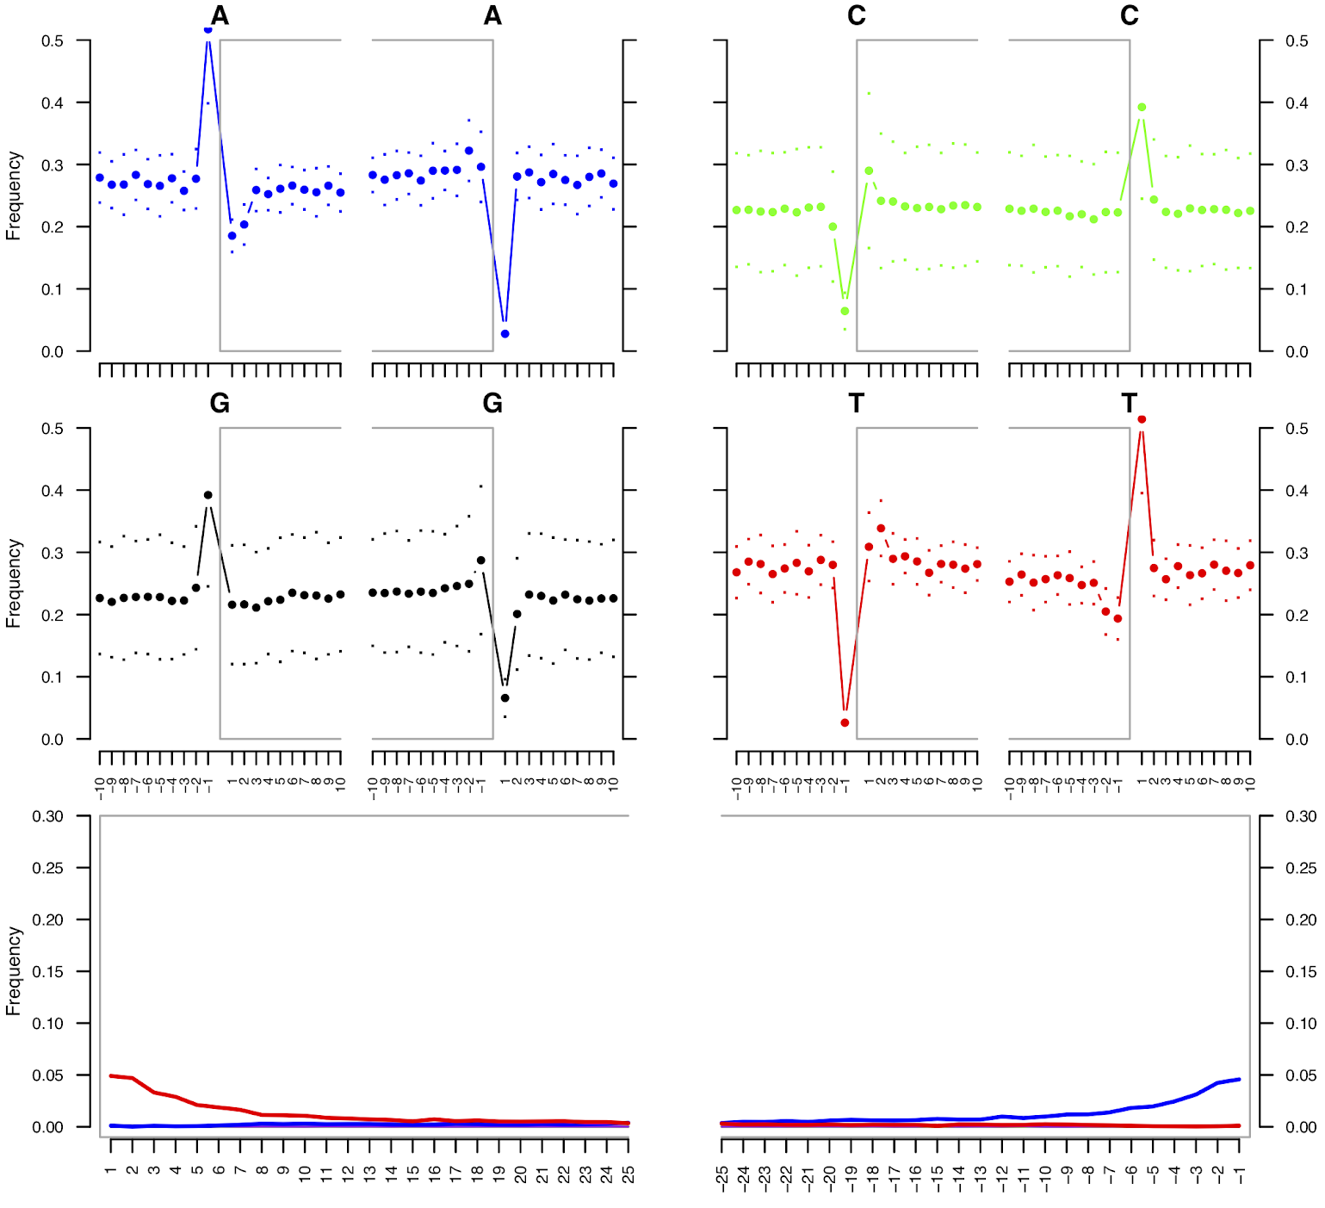
Supplementary Figure 2: Example mapDamage base misincorporation results for sequencing data for a museum specimen ID MS10986. In the lower plots, the red line represents the frequency of C-to-T substitutions while the blue line represents the frequency of G-to-A substitutions in the first and last 25 bp of sequence reads. C-to-T misincorporations are increased at the 5’ sequence end, and correspondingly G-to-A misincorporations are more frequent at the 3’ end, as expected for historical sequence data.

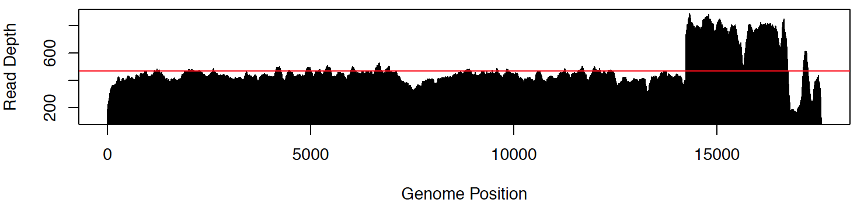
Supplementary Figure 3: Example of the mapping coverage distribution for resequenced kakī (Himantopus novaezealandiae) individual ID H01390 (100% coverage, 469.8✕ average depth), showing a putative region of duplication with approximately double the coverage depth in the region 14.2–16.5 kb.

4. Evidence of mitochondrial gene duplication in kakī

4.1 Introduction
Mitochondrial genomes (mitogenomes) are considered to be conserved among vertebrates, comprising 37 genes and the control region in a consistent order (Desjardins and Morais 1990; Boore 1999). As mitogenome sequencing and assembly methods have become more efficient and the associated costs have declined, a greater number of vertebrate mitogenomes have been sequenced, revealing a variety of alternative gene orders across a range of taxa (e.g., Qian et al. 2018; Caparroz et al. 2018; Hemmi et al. 2020). At least seven different mitochondrial gene orders that include partial or complete duplication of genes around the control region have been observed across a wide range of avian orders, including but not limited to Procellariiformes (Abbott et al. 2005; Eda et al. 2010), Charadriiformes (Verkuil et al. 2010), Pelecaniformes (Cho et al. 2009; Gibb et al. 2013; Zhou et al. 2014), Psittaciformes (Eberhard et al. 2001; Schirtzinger et al. 2012; Eberhard and Wright 2016), Sulliformes (Morris-Pocock et al. 2010), Bucerotiformes (Sammler et al. 2011), and Passeriformes (Singh et al. 2008; Gibb et al. 2015).

Such gene duplications appear to have evolved through tandem duplication and random loss, although the range of gene duplications observed in birds indicates the expected pattern of degeneration and loss may not occur, with the duplication persisting (Boore 2000). Other evolutionary processes may appear similar to gene duplication, such as heteroplasmy (genotypic variation among mitogenomes present in a single organism due to mutations occurring among the thousands of copies present in each cell; Solignac et al. (1983), Wilton et al. (2018)), numts, the transposition of mitochondrial pseudogenes into the nuclear genome (Bensasson et al. 2001; Hazkani-Covo et al. 2010), or through recombination (Tsaousis et al. 2005).Distinguishing between these processes can be complicated due to difficulties associated with sequence mapping to duplicate regions in a reference genome. Similarly, de novo assembly of duplications may collapse the duplication into a single sequence due to the close similarity between duplicate regions. As phylogenetic inferences using mitochondrial DNA rely on the assumption that the regions analysed are single-copy (Avise et al. 1987; Moritz et al. 1987; Boore 1999), incorrect identification of duplicate sequences can produce erroneous inferences.

Here we verify the presence of a mitochondrial gene duplication in kakī through implementation of methods adapted from Torres et al. (2019) including long-read MinION sequencing (Oxford Nanopore Technologies (ONT), UK) of the region of interest. We initially suspected a duplication based on variation in coverage depth mapped to a draft kakī (order: Charadriiformes, Himantopus novaezelandiae) mitogenome generated using short-read data only (Figure 1). A mitochondrial gene duplication has been described previously in the ruff (Calidris pugnax; Verkuil et al. (2010)), a species conordinal to kakī. Here we applied the methods described by Torres et al. (2019) to correct the mitogenome assembly via long-read sequencing.

Figure 1. Visualisation of the coverage distribution produced when mapping kakī resequencing data (DNA1429) to the assembled kakī mitochondrial genome derived from short-read data only. From the region 14,240–17,000 bp, a distinct increase in coverage depth is observed. The red line represents the mean coverage depth.

4.2 Methods

4.2.1 MinION long-read sequencing of the region of potential gene duplication
To produce single long reads spanning the region of hypothesised duplication, we conducted targeted long-range amplifications of the mitochondrial region of interest for kakī (sample ID: DNA1914) using primers KakiM3F and KakiM4R (see Supplementary Figure 5). The 50 μL PCR reaction contained 10 μL 5× KAPA magnesium-free Long Range buffer, 1.75 mM MgCl2, 0.3 mM dNTPs, 0.5 μM of each of KakiM3F and KakiM4R primers, 0.5 U KAPA Long Range Hotstart Polymerase, and 2 μL template DNA. The thermocycling protocol consisted of initial denaturation of 94°C for180 s, followed by ten cycles of 94°C for 25 s, 54°C for 15 s, and 68°C for 600 s, then 25 cycles of 94°C for 25 s, 54°C for 15 s, and 68°C for 600 s plus 20 s per cycle, and a final extension step of 72°C for 600 s. PCR products were visualised on a 1% agarose gel run for 45 min at 80 V, alongside BioLine HyperLadder™ 1 kb to confirm the production of a single band with the expected size. Following sample clean-up with a MinElute PCR Purification kit, DNA quantity and quality was assessed via NanoDrop. We sequenced the amplified fragment on an ONT MinION MIN106 flow cell. The amplified product was prepared for sequencing with the Nanopore Rapid Sequencing Kit (SQK-RAD004). Briefly,the LR PCR fragments were tagmented using the Fragmentation Mix, and sequencing adapters were attached to the ends. The sample was sequenced for eight hours, with simultaneous base-calling turned off.

4.2.2 Long-read sequence processing
We conducted base-calling with Guppy v3.3.0 (ONT) using the default config file based on the flow cell and sequencing kit. We assessed overall sequencing efficiency by visualising the sequencing summary outputs with pycoQC v2.5.0.15 (Leger and Leonardi 2019). Read length distribution, and quality and base frequencies for the start and end of reads were visualised with NanoQC (De Coster et al. 2018).

Reads were processed to remove adapters and low-quality sequences via Porechop (Wick 2019) and NanoFilt (De Coster et al. 2018). Reads were trimmed to remove the first 150 bp and final 50 bp based on NanoQC results showing lower average read quality scores in these regions. Trimmed reads were retained if average read quality was ≥ 8, with read length 0.2–10 kb, based on an estimated maximum region size of 10 kb.

To confirm avian mitochondrial origin of the sequence data, we converted a subset comprising the longest processed reads (length >7 kb) to FASTA format with Seqtk v1.3 (https://github.com/lh3/seqtk) for BLAST assessment. In addition, we aligned all processed reads from DNA1914 to the original kakī mitochondrial genome with the Nanopore-specific ont2d setting in BWA-MEM v0.7.17 (Li and Durbin 2009; Bayat et al. 2017), and collected mapping rates with SAMTOOLS v1.9 idxstats (Li and Durbin 2009). To visualise the alignment of the longest mapped read, we conducted BLAST pairwise alignments against the original mitochondrial genome. Properly mapped reads were then filtered with SAMTOOLS view and converted to FASTQ with SAMTOOLS fastq for downstream assembly of the region of interest.

4.2.3 Assembly of long-read sequencing data for kakī
To further validate the mitogenome assembly for kakī, we performed de novo assembly of the processed mapped reads for kakī DNA1914 with Canu v1.8 (Koren et al. 2017). Canu incorporates error correction, additional trimming, and assembly. Minimum read length was set to 300 bp based on the observed read-length distribution, with a minimum overlap length of 200 bp.

Following assembly, the output contigs were polished (error correction for the known 1% local error rate associated with MinION sequencing) using Illumina whole-genome sequencing (WGS) reads produced as part of an aligned study (Galla et al. 2019). First, we randomly subsampled 100 million reads from the processed WGS forward reads and their reverse complements with Seqtk. The contigs assembled with Canu were indexed with BWA v0.7.17, and the WGS reads were mapped to the assembled contigs with BWA-MEM, before being sorted by coordinate with Picard SortSam (Picard Toolkit 2019). We extracted mapping metrics with SAMtools stats and idxstats, and visualised sequence coverage depth with an in-house R script (see scripts at https://github.com/natforsdick/Himantopus/tree/master/Mitogenomes). The mapped BAM files produced were then passed to Pilon v1.23 (Walker et al. 2014) for polishing, with minimum coverage set to 5×.

To determine the position of the assembled sequence relative to the draft kakī mitogenome assembly, we aligned the polished contigs against the region 12,500–1,450 bp of the original mitogenome with MUSCLE v3.8.425 (Edgar 2004) implemented in Geneious®. To confirm the presence of the complete duplicated region in single reads, we aligned the longest processed MinION reads with length >7 kb against the longest polished contig. The aligned region of the original mitogenome was then manually extracted and replaced with the polished contig produced from the MinION data to complete the high-quality kakī mitogenome assembly.

Following mitogenome reassembly, we conducted additional error correction based on mapping of WGS data to our MinION-corrected mitogenome. We conducted variant-calling using the resequencing data (Galla et al. 2020), and consensus FASTA files were generated for each individual. Consensus sequences were aligned to the complete mitogenome with MUSCLE implemented in Geneious® v11.1.5, allowing identification of several additional sequence errors not previously corrected. Following error correction of the MinION-corrected kakī mitogenome, we annotated the final mitogenome assembly with MITOS and confirmed tRNA annotations with tRNAscan-SE v2 (Lowe and Chan 2016). A final alignment (20,946 bp) was produced that excluded an observed region of low coverage depth and short-tandem repeats in the final control region.

We used MashMap (Jain et al. 2018a, b) to further validate the MinION-corrected kakī mitogenome using the processed MinION long reads from kakī DNA1914. MashMap is designed for fast, efficient long-read mapping of MinION (or similar) sequences to produce estimates of sequence identity, similar to BLAST pairwise alignment. The correct version of the mitogenome should be identified as having a greater proportion of reads that successfully map and span the complete region. We mapped MinION long reads from kakī DNA1914 to both the original and the MinION-corrected kakī mitogenomes with MashMap, with the first 1 kb of the assembly appended to the end, leveraging the circular nature of the mitochondrial genome. All processed sequences for both individuals were converted to FASTA format with Seqtk for mapping, and reads <5 kb were discarded. To allow for known sequence error in raw MinION reads while ensuring high mapping accuracy, we implemented a minimum identity threshold of 95%, and visualised the results with the MashMap script generateDotPlot.pl.

4.3 Results

4.3.1 MinION long-read sequencing
MinION sequencing of the amplicon spanning the hypothesised duplicated region from kakī DNA1914 produced 1.46 million FAST5 sequence reads with an estimated total of 1.63 Gb. Guppy base-calling produced 1.46 million reads for a total of 1.490 Gb. Median read length was relatively short at 634 bp, with median read quality of 9.96. Following read
processing, a subset of FASTQ files were assessed with NanoQC for comparison with raw reads which showed improved mean quality and consistency of nucleotide distribution than the raw data.

4.3.2 Assembly of kakī mitochondrial gene duplication from MinION reads
Mapping of reads produced from DNA1914 to the kakī mitogenome resulted in 32,640 reads mapped, totalling 33.29 Mb. The presence of a duplicated region in the longest mapped read (8,752 bp) confirmed the hypothesised gene duplication in the kakī mitogenome following BLAST alignment to the original kakī mitogenome assembly.

Following trimming and error correction steps in Canu, 11,604 reads totalling 13.56 Mb were available for assembly of reads from DNA1914. Coverage depth based on an estimated region length of ≥9 kb was 1,500×, well above the recommended 100× for accurate assembly. Canu assembly produced three contigs of length 10,032 bp, 2,959 bp, and 2,897 bp. The longest contig (Tig1) was assembled from 11,283 reads, the greatest number by an order of magnitude. A BLAST search of Tig1 against the nucleotide database found the greatest similarity to the published mitochondrial genome for the congeneric black-winged stilt (Himantopus himantopus; Table 1), and BLAST pairwise alignment against the kakī mitogenome showed significant similarity (Table 2).

Mapping of WGS data from DNA1914 in preparation for contig polishing produced 7,032 properly paired mapped reads across the three contigs, totalling 1.01 Mb. Examining only Tig1, the WGS data covered 99.2% of the contig, at an average 74.6× depth. Polishing Tig1 used 7,451 mapped reads covering 96.44% of the contig with 45× mean coverage. Five SNPs, 49 small insertions, and two deletions were corrected totalling 67 bp, and one continuity break was corrected. Six continuity breaks could not be resolved, three of which included regions of tandem repeats. The polished Tig1 was 10,090 bp in length and was 99.3% identical to the raw contig. Tig1 aligned to the extracted region of the original mitogenome with identical alignments at both ends, and >98% identity overall. Tig1 was then manually inserted into the original mitogenome, with 6,666 bp of the original mitogenome sequence removed and replaced with Tig1.

Implementation of MashMap to validate the duplicated region for kakī produced inconclusive results, with similar numbers of reads aligning to both the original and the duplicated kakī mitogenomes with high identity scores. MashMap identified 72 long reads that aligned with ≥95% identity to the original kakī mitogenome, and 85 reads aligned to the resolved duplicate kakī mitogenome (Fig. 3).

Table 1. Metrics for the mitochondrial contigs assembled from MinION sequencing of kakī DNA1914 with Canu. mt = complete mitogenome, GA.C15 = genome assembly, chromosome 15.
Contig ID | Length (bp) | # reads | Coverage statistic | Top BLAST hit | BLAST score | Coverage (%) | E-value | Identity (%)
Tig1 | 10,032 | 11,283 | 5906 | Himantopus himantopus mt | 27,291 | 99 | 0 | 97
Tig2 | 2,959 | 118 | 3145.54 | Himantopus himantopus mt | 9047 | 99 | 0 | 98.49
Tig3 | 2,897 | 15 | 1922.36 | Aquila chrysaetos GA.C15 | 2966 | 99 | 0 | 84.47

Table 2. Results of BLAST pairwise alignments of the longest MinION mapped reads for each each of kakī DNA1914 and Australian pied stilt B60480 to the original and MinION-corrected kakī mitogenome assemblies. Start and end positions refer to the alignment positions of reads to the reference mitogenome, and the corresponding positions on the long reads.
 | Sample ID | DNA1914 |  | B60480
 | Length of longest sequence (bp) | 8,752 |  | 11,907
 | Reference mitogenome | Original mitogenome | MinION-corrected mitogenome | Original mitogenome | MinION-corrected mitogenome
Best match | Start position on mitogenome (bp) | 12,500 | 12,500 | 13,553 | 13,555
 | End position on mitogenome (bp) | 17,279 | 21,168 | 17,291 | 17,822
 | Start position on longest read (bp) | 8,752 | 8,752 | 6 | 6
 | End position on longest read (bp) | 3,969 | 1 | 3,695 | 4,219
 | Score (bits) | 7,099 | 10,905 | 4,833 | 5,483
 | Identity (%) | 94 | 90 | 90 | 90
 | Gaps (%) | 4 | 6 | 5 | 5
Next best match | Start position on mitogenome (bp) | 14,234 | 17,895 | 14,241 | 16,574
 | End position on mitogenome (bp) | 17,533 | 20,926 | 16,924 | 20,571
 | Start position on longest read (bp) | 3,339 | 7,006 | 4,703 | 3,416
 | End position on longest read (bp) | 1 | 3,969 | 7,336 | 7,336
 | Score (bits) | 3,061 | 4,409 | 3,482 | 5,184

Table 2 continued.
 | Sample ID | DNA1914 |  | B60480
 | Reference mitogenome | Original mitogenome | MinION-corrected mitogenome | Original mitogenome | MinION-corrected mitogenome
 | Identity (%) | 84 | 93 | 91 | 91
 | Gaps (%) | 9 | 5 | 5 | 4
Overall | Maximum score (bits) | 7,099 | 10,905 | 4,833 | 5,483
 | Total score (bits) | 20,550 | 46,554 | 19,927 | 48,337
 | Query coverage (%) | 28 | 40 | 21 | 34
 | E-value | 0 | 0 | 0 | 0
 | Identity (%) | 94.54 | 89.63 | 90.37 | 90.28

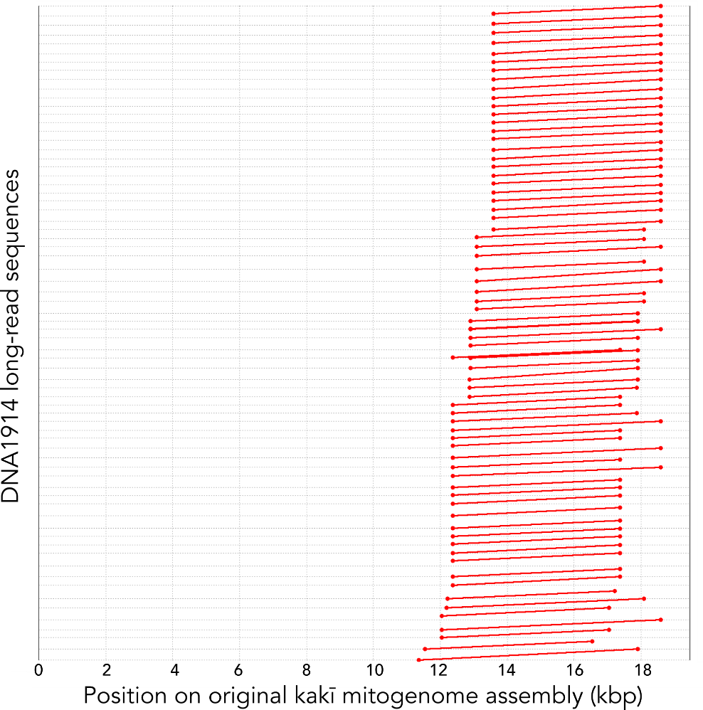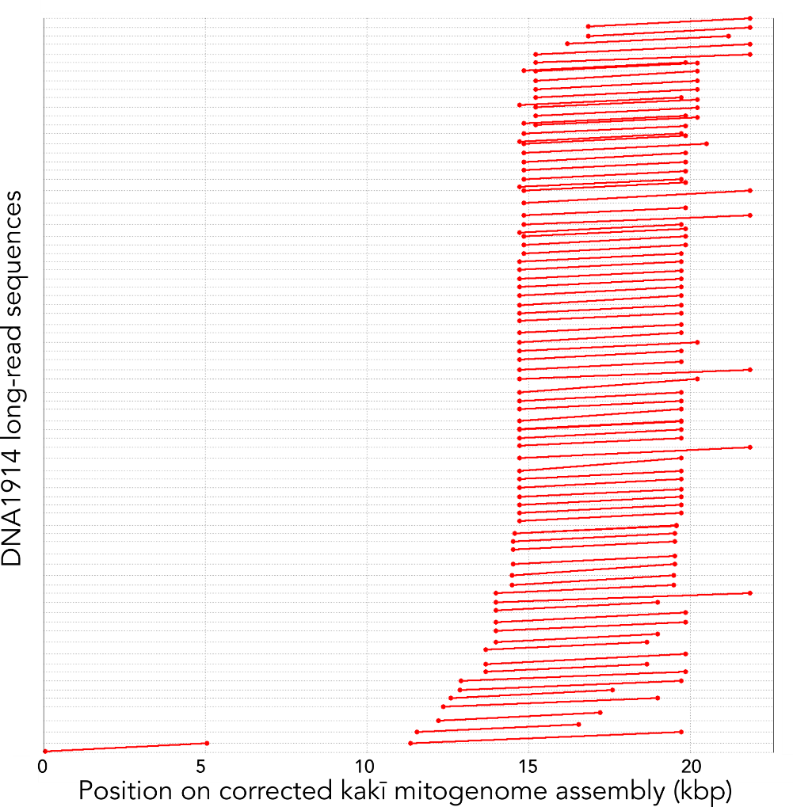
b)
a)
Figure 3. MashMap visualisation of kakī DNA1914 long-read sequence alignment to a) the original kakī mitogenome assembly, and b) the kakī mitogenome assembly including resolution of gene duplication, where the duplication occurs in the region beyond 14.5 kb. Each red line represents the alignment of a long-read sequence with ≥95% identity.

4.3.4 Sequence mapping to MinION-corrected kakī mitogenome
Mapping of resequencing data produced a more consistent coverage distribution than that observed for sequence data from the modern targeted data. Coverage depth followed the same pattern but was slightly lower than observed for the previous mitogenome assembly (Table 3 cf. Supplementary Table 5). Average depth across all individuals was 245.93× and mean coverage was 99.53%. Sequence alignment against the MinION-corrected mitogenome allowed identification of several minor sequence errors that were consistently observed in all resequenced individuals: an A at 6,860 bp, a T at 6,862 bp and a C at 7,071 bp), a dinucleotide insertion (CC at 19,252 bp), and a dinucleotide deletion (AA removed from 12,711 bp). The region 20,948–21,086 bp was poorly covered for all individuals resulting in gaps in the alignment (Fig. 4). Coverage depth was highest across the final 161 bp of the mitogenome due to a series of tetranucleotide repeats.

b)
a)
Figure 4. Examples of the coverage distributions for sequence data of three stilt samples when mapped to the MinION-corrected kakī mitogenome; a) targeted mitochondrial sequencing from a contemporary kakī sample (individual DNA1044, 98.7% coverage with average depth 1,484.3×), b) whole-genome resequencing data from a contemporary kakī sample (individual DNA1934, 99.6% coverage with average depth 262.0×).

Table 3. Results of sequence mapping to the MinION-corrected kakī mitogenome, where depth refers to the average depth of the mapped sequences. ‘Resequencing’ refers to the whole genome resequencing data, ‘targeted’ refers to the targeted long-range PCR mitogenome sequencing of modern stilts.
Data type | DNA ID | Coverage (%) | Mean depth (×)
Resequencing | DNA1376 | 99.7 | 637.1
 | DNA1377 | 99.6 | 268.0
 | DNA1429 | 99.6 | 456.5
 | DNA1469 | 99.7 | 366.8
 | DNA1565 | 99.6 | 387.2
 | DNA1659 | 99.6 | 113.9
 | DNA1661 | 99.6 | 295.2
 | DNA1738 | 98.8 | 38.3
 | DNA1872 | 99.6 | 181.4
 | DNA1892 | 99.5 | 161.4
 | DNA1934 | 99.6 | 262.0
 | DNA1936 | 99.1 | 54.5
 | DNA1980 | 99.4 | 215.2
 | DNA2012 | 99.5 | 191.2
 | DNA2023 | 99.7 | 189.1
 | DNA2032 | 99.6 | 195.8
 | DNA2035 | 99.6 | 69.4
 | DNA2074 | 99.5 | 79.3
 | DNA2091 | 99.5 | 53.2
 | DNA240 | 99.5 | 291.4
 | DNA451 | 99.6 | 264.4
 | DNA452 | 99.6 | 330.1
 | DNA453 | 99.6 | 345.0
 | DNA639 | 99.7 | 455.8
Targeted | BS40279 | 98.9 | 1,539.3
 | BS50004 | 98.9 | 1,001.6
 | BS60406 | 98.9 | 1,656.5
 | BS60480 | 99.3 | 1,432.2
 | DNA1044 | 98.7 | 1,484.3
 | DNA2094 | 98.9 | 984.2
 | DNA2113 | 99.1 | 1,098.2
 | Poaka1 | 98.9 | 1,084.9

4.3.5 Annotation of the corrected mitogenome
The final kakī mitochondrial genome is a circular sequence of 21,183 bp, comprising 31.6% A, 30.7% C, 13.0% G, and 24.7% T (Fig. 5). The final mitogenome included 22 transfer RNAs, two ribosomal RNAs, and thirteen protein-coding genes (Fig. 5, Table 4). Three transfer RNAs (tRNAThr, tRNAGlu, and tRNAPro) and two genes (partial cytb and complete ND6) were present in duplicate.

Comparison of tRNAs annotated with MITOS and tRNAscan-SE identified only 1 bp difference at a single tRNA (tRNATyr terminating at 5,308 bp according to MITOS, at 5,309 according to tRNAscan-SE). Of the protein-coding genes, eleven had the typical ATG start codon, while cytochrome-oxidase I and NADH-5 had the avian-specific start codon GTG, NADH-3 began vertebrate alternative start codon ATT, and the partial duplication of cytb began with CAC (differing from the first copy with ATG; Table 4). Nine genes had typical vertebrate stop codons TAA, AGG, or TAG, with the remainder having various other codons. From the first position of cytb to the beginning of the series of short tandem repeats, 2,485 bp are duplicated, with only 8 bp difference throughout (5 bp insertions, 1 bp deletion, 2 bp transitions).

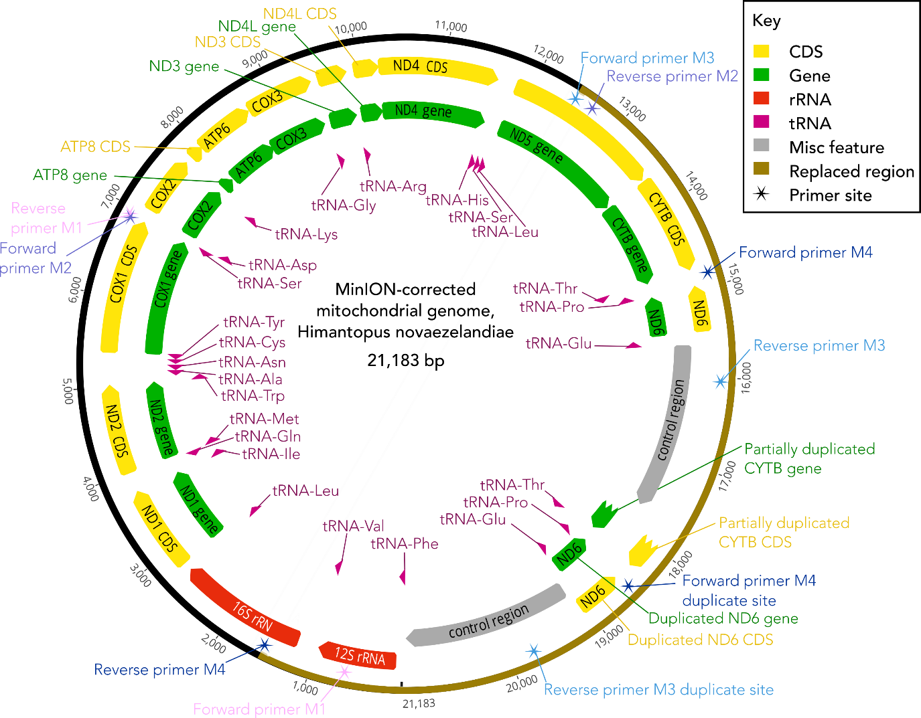
Figure 5. Visualisation of the complete mitochondrial genome for kakī following Canu assembly of MinION sequencing reads covering a region of gene duplication. The outer black ring represents the position on the mitogenome, with the gold region representing the inserted assembled long-read contig. Gene features were annotated with MITOS2, and tRNA positions verified with tRNAscan-SE. Arrows indicate the directionality of features. Regions in green denote genes, yellow indicates the associated coding region (CDS), red represents ribosomal RNAs, pink arrows indicate transfer RNAs, and stars represent locations of the primers sequences. Grey shows the control regions, adjacent to duplication of the ND6 and partial duplication of the cytochrome-b genes. COX1–3 indicates cytochrome-c oxidase subunits 1–3; CYTB, cytochrome-b; ATP6–8, ATPase subunits 6 and 8; ND1– 6/4L, NADH dehydrogenase subunits 1–6/4L. Primers M3F and M4R were used for validating the hypothesised duplicated region of the mitogenome.

Table 4. Gene features in the kakī mitogenome. Start and stop codons for the coding genes are listed. rRNA = ribosomal RNA, tRNA = transfer RNA, ND = NADH dehydrogenase subunits, COX = cytochrome-c oxidase subunits, ATP = ATP synthase subunits, COB = cytochrome-b, CR = control region. Start and end refer to the position in the mitogenome.
Gene feature | Start codon | Stop codon | Start (bp) | End (bp)
tRNAPhe |  |  | 1 | 70
12S-rRNA |  |  | 70 | 1,050
tRNAVal |  |  | 1,050 | 1,121
16S-rRNA |  |  | 1,131 | 2,709
tRNLeu2 |  |  | 2,709 | 2,782
ND1 | ATG | TTA | 2,789 | 3,759
tRNAIle |  |  | 3,765 | 3,836
tRNAGln |  |  | 3,916 | 3,846
tRNAMet |  |  | 3,916 | 3,984
ND2 | ATG | TTA | 3,985 | 5,025
tRNATrp |  |  | 5,024 | 5,093
tRNAAla |  |  | 5,163 | 5,095
tRNAAsn |  |  | 5,239 | 5,166
tRNACys |  |  | 5,308 | 5,242
tRNATyr |  |  | 5,378 | 5,308
COX1 | GTG | AGG | 5,380 | 6,930
tRNASer2 |  |  | 6,995 | 6,922
tRNAAsp |  |  | 6,998 | 7,066
COX2 | ATG | TAA | 7,068 | 7,750
tRNALys |  |  | 7,752 | 7,821
ATP8 | ATG | TAA | 7,823 | 7,990
ATP6 | ATG | TAA | 7,981 | 8,664
COX3 | ATG | CAT | 8,664 | 9,446
tRNAGly |  |  | 9,447 | 9,515
ND3 | ATT | GAA | 9,516 | 9,864
tRNAArg |  |  | 9,870 | 9,938
ND4L | ATG | TAA | 9,940 | 10,236
ND4 | ATG | CAT | 10,230 | 11,607
tRNAHis |  |  | 11,608 | 11,677
tRNASer1 |  |  | 11,678 | 11,743
tRNALeu1 |  |  | 11,743 | 11,813
ND5 | GTG | TAA | 11,793 | 13,628
COB | ATG | TAA | 13,640 | 14,782
tRNAThr |  |  | 14,787 | 14,856
tRNAPro |  |  | 14,940 | 14,871
ND6 | ATG | TAG | 15,480 | 14,960
tRNAGlu |  |  | 15,555 | 15,484

Table 4 continued.
Gene feature | Start codon | Stop codon | Start (bp) | End (bp)
CR1 |  |  | 15,947 | 17,772
COB | CAC | TAT | 17,894 | 18,430
tRNAThr |  |  | 18,438 | 18,507
tRNAPro |  |  | 18,591 | 18,522
ND6 | ATG | TAG | 19,132 | 18,611
tRNAGlu |  |  | 19,207 | 19,136
CR2 |  |  | 19,604 | 21,181

4.4 Discussion
Here we use long-read sequencing to present evidence of a gene duplication in the kakī mitogenome. The final kakī mitogenome was substantially larger than the published Charadriiformes mitogenomes included in comparative phylogenies (maximum length = 18,153 bp (pin-tailed snipe, Gallinago stenura), average length = 16,844 bp; Supplementary Table 6), and similar in size to mitogenomes of other avian species identified as having gene duplications (e.g., Audubon’s shearwater; Torres et al. (2019)). The region of the kakī mitogenome spanning from 17,895–20,379 bp represents a complete duplication of the sequence 14,244–16,724 bp, with only 8 bp total differences. This region includes partial duplication of cytochrome-b (cytb), and complete duplication of the NADH6 (ND6) gene, tRNAThr, tRNAPro and tRNAGlu, and the control region. This gene order differs from that of the ruff mitochondrial gene order only in the partial duplication of cytb (Verkuil et al., 2010).

4.4.1 Robust methods to identify and validate mitochondrial gene duplication in kakī
The methods presented here to investigate the hypothesis that increased depth spanning the region beyond 14,240 bp on the kakī mitogenome assembled in the manuscript are robust, allowing verification of the presence of gene duplication in several ways. First, we amplified the complete region of hypothesised duplication, and produced a clear single band of amplified DNA of the expected length if the duplication was present when visualised on an agarose gel. This excluded heteroplasmy as the reason for the initial patterns of WGS coverage, as heteroplasmy would result in the production of at least two bands of similar shorter lengths produced from amplification representing a duplication and the standard gene order.

This study supports the utility of long-read sequencing platforms such as MinION sequencing for identification and resolution of such regions of duplication (Torres et al., 2019). The long amplicons produced were sequenced using long-read sequencing with the aim of producing intact sequences spanning the complete region of interest. The method implemented here demonstrates the potential to use amplicon sequencing coupled with long-read sequencing for efficient mitogenome assembly. This contrasts with the method of Torres et al. (2019) that used long-read sequencing of the whole genome, followed by targeted extraction of reads with length approximating the anticipated mitogenome length. DNA quality for individual DNA1914 used for the original mitogenome assembly had deteriorated over time, and while it had been of sufficient quality for short-read WGS, whole genome assembly, and long-range PCR, quality was no longer sufficient to recover long-read WGS including complete mitogenome sequences based on the MinION specifications.

Sequence alignment of the longest processed read from kakī DNA1914 identified a duplicated region within single reads. The detection of individual reads spanning the complete region of duplication as observed through BLAST pairwise alignments against the original kakī mitogenome assembly provided confidence that this was a true duplication. This was confirmed through subsequent assembly of the MinION reads into a single contig that also spanned the region and contained the gene duplication. The corrected kakī mitogenome was further validated through sequence mapping of reads. This mapping identified a poorly resolved sequence in the final 235 bp of the mitogenome due to the presence of tandem base repeats. This duplication is unlikely to be derived from numts as the duplicate region is larger than typical for avian numts (Pereira and Baker 2004).

We hypothesise that due to the close evolutionary relationship between kakī and Australian pied stilts a mitochondrial gene duplication is likely to be present in both species and the subspecific poaka. Further work would be beneficial to determine whether this duplication has a recent origin among the Australasian stilts, or if it arose in the deeper evolutionary history of this genus.

4.4.4 The challenge of identifying and validating mitochondrial gene duplication
Duplication or repetitive elements can increase the bioinformatic challenges of genome assembly and read mapping. Assembly processes typically collapse repeats while sequence mapping across duplicates has the potential for mapping bias to one of the duplicate regions over the other (Pevzner et al. 2004; Alkan et al. 2011). Here, the power of long-read sequencing is demonstrated for resolving a short simple duplication in the kakī mitogenome.

It is important to note that without comparison between mapping results from whole genome resequencing data and targeted mitochondrial sequencing, this duplication may not have been identified. These challenges suggest that gene duplications may be more common than currently reported among the published Charadriiformes mitogenomes. Although a similar duplication was previously observed in the ruff (Calidris pugnax; (Verkuil et al. 2010), it appears absent from the complete mitogenome (Chen et al. 2020). Similarly, the mitogenome assembly available for the congeneric pied stilt does not describe any gene duplication (Yang et al. 2017), which may either be due to absence of such a duplication, or due to the challenges associated with identifying and resolving such duplications.

4.4.5 Future directions
In conclusion, a robust method such as that described above is necessary for resolving mitochondrial gene duplications with confidence. Surveying Charadriiformes species for potential mitochondrial gene duplications should be conducted to understand how widespread this duplication may be, and to improve confidence in phylogenetic analyses conducted for this order.

5. References
Abbott CL, Double MC, Trueman JWH, et al (2005) An unusual source of apparent mitochondrial heteroplasmy: duplicate mitochondrial control regions in Thalassarche albatrosses. Mol Ecol 14:3605–3613. https://doi.org/10.1111/j.1365-294X.2005.02672.x
Alkan C, Sajjadian S, Eichler EE (2011) Limitations of next-generation genome sequence assembly. Nat Methods 8:61–65. https://doi.org/10.1038/nmeth.1527
Avise JC, Arnold J, Ball RM, et al (1987) Intraspecific phylogeography: the mitochondrial DNA bridge between population genetics and systematics. Annu Rev Ecol Syst 18:489–522. https://doi.org/10.1146/annurev.es.18.110187.002421
Bayat A, Gaëta B, Ignjatovic A, Parameswaran S (2017) Improved VCF normalization for accurate VCF comparison. Bioinformatics 33:964–970. https://doi.org/10.1093/bioinformatics/btw748
Bensasson D, Zhang D-X, Hartl DL, Hewitt GM (2001) Mitochondrial pseudogenes: evolution’s misplaced witnesses. Trends Ecol Evol 16:314–321. https://doi.org/10.1016/s0169-5347(01)02151-6
Boore JL (1999) Animal mitochondrial genomes. Nucleic Acids Res 27:1767–1780. https://doi.org/10.1093/nar/27.8.1767
Boore JL (2000) The duplication/random loss model for gene rearrangement exemplified by mitochondrial genomes of deuterostome animals. In: Sankoff D, Nadeau JH (eds) Comparative Genomics: Empirical and Analytical Approaches to Gene Order Dynamics, Map Alignment and the Evolution of Gene Families. Springer Netherlands, Dordrecht, pp 133–147
Caparroz R, Rocha AV, Cabanne GS, et al (2018) Mitogenomes of two neotropical bird species and the multiple independent origin of mitochondrial gene orders in Passeriformes. Mol Biol Rep 45:279–285. https://doi.org/10.1007/s11033-018-4160-5
Chen T-Y, Zhang F, Wang G-H, et al (2020) Complete mitochondrial genome of the Ruff, Calidris pugnax (Aves, Scolopacidae). Mitochondrial DNA Part B 5:1246–1247. https://doi.org/10.1080/23802359.2020.1731356
Cho H-J, Eda M, Nishida S, et al (2009) Tandem duplication of mitochondrial DNA in the black-faced spoonbill, Platalea minor. Genes Genet Syst 84:297–305. https://doi.org/10.1266/ggs.84.297
De Coster W, D’Hert S, Schultz DT, et al (2018) NanoPack: visualizing and processing long-read sequencing data. Bioinformatics 34:2666–2669. https://doi.org/10.1093/bioinformatics/bty149
Desjardins P, Morais R (1990) Sequence and gene organization of the chicken mitochondrial genome: a novel gene order in higher vertebrates. J Mol Biol 212:599–634. https://doi.org/10.1016/0022-2836(90)90225-B
Eberhard JR, Wright TF (2016) Rearrangement and evolution of mitochondrial genomes in parrots. Mol Phylogenet Evol 94:34–46. https://doi.org/10.1016/j.ympev.2015.08.011
Eberhard JR, Wright TF, Bermingham E (2001) Duplication and concerted evolution of the mitochondrial control region in the parrot genus Amazona. Mol Biol Evol 18:1330–1342. https://doi.org/10.1093/oxfordjournals.molbev.a003917
Eda M, Kuro-o M, Higuchi H, et al (2010) Mosaic gene conversion after a tandem duplication of mtDNA sequence in Diomedeidae (albatrosses). Genes Genet Syst 85:129–139. https://doi.org/10.1266/ggs.85.129
Edgar RC (2004) MUSCLE: multiple sequence alignment with high accuracy and high throughput. Nucleic Acids Res 32:1792–1797. https://doi.org/10.1093/nar/gkh340
Galla SJ, Moraga R, Brown L, et al (2020) A comparison of pedigree, genetic and genomic estimates of relatedness for informing pairing decisions in two critically endangered birds: implications for conservation breeding programmes worldwide. Evol Appl. https://doi.org/10.1111/eva.12916
Gibb GC, England R, Hartig G, et al (2015) New Zealand passerines help clarify the diversification of major songbird lineages during the Oligocene. Genome Biol Evol 7:2983–2995. https://doi.org/10.1093/gbe/evv196
Gibb GC, Kennedy M, Penny D (2013) Beyond phylogeny: pelecaniform and ciconiiform birds, and long-term niche stability. Mol Phylogenet Evol 68:229–238. https://doi.org/10.1016/j.ympev.2013.03.021
Greig K, Boocock J, Prost S, et al (2015) Complete mitochondrial genomes of New Zealand’s first dogs. PLOS ONE 10:e0138536. https://doi.org/10.1371/journal.pone.0138536
Hazkani-Covo E, Zeller RM, Martin W (2010) Molecular poltergeists: mitochondrial DNA copies (numts) in sequenced nuclear genomes. PLoS Genet 6:e1000834. https://doi.org/10.1371/journal.pgen.1000834
Hemmi K, Kakehashi R, Kambayashi C, et al (2020) Exceptional enlargement of the mitochondrial genome results from distinct causes in different rain frogs (Anura: Brevicipitidae: Breviceps). Int J Genomics 2020:6540343. https://doi.org/10.1155/2020/6540343
Holdaway RN (1995) A fossil record of the black stilt Himantopus novaezelandiae, Gould, 1841. N Z Nat Sci 69–74
Jain C, Dilthey A, Koren S, et al (2018a) A fast approximate algorithm for mapping long reads to large reference databases. J Comput Biol 25:766–779. https://doi.org/10.1089/cmb.2018.0036
Jain C, Koren S, Dilthey A, et al (2018b) A fast adaptive algorithm for computing whole-genome homology maps. Bioinformatics 34:i748–i756. https://doi.org/10.1093/bioinformatics/bty597
Jónsson H, Ginolhac A, Schubert M, et al (2013) mapDamage2.0: fast approximate Bayesian estimates of ancient DNA damage parameters. Bioinformatics 29:1682–1684. https://doi.org/10.1093/bioinformatics/btt193
Judo MSB, Wedel AB, Wilson C (1998) Stimulation and suppression of PCR-mediated recombination. Nucleic Acids Res 26:1819–1825. https://doi.org/10.1093/nar/26.7.1819
Knapp M, Horsburgh KA, Prost S, et al (2012) Complete mitochondrial DNA genome sequences from the first New Zealanders. Proc Natl Acad Sci 109:18350–18354. https://doi.org/10.1073/pnas.1209896109
Koren S, Walenz BP, Berlin K, et al (2017) Canu: scalable and accurate long-read assembly via adaptive k-mer weighting and repeat separation. Genome Res 27:722–736. https://doi.org/10.1101/gr.215087.116
Leger A, Leonardi T (2019) pycoQC, interactive quality control for Oxford Nanopore Sequencing. J Open Source Softw 4:1236. https://doi.org/10.21105/joss.01236
Li H, Durbin R (2009) Fast and accurate short read alignment with Burrows-Wheeler transform. Bioinformatics 25:1754–1760. https://doi.org/10.1093/bioinformatics/btp324
Li H, Handsaker B, Wysoker A, et al (2009) The Sequence Alignment/Map format and SAMtools. Bioinformatics 25:2078–2079. https://doi.org/10.1093/bioinformatics/btp352
Lowe TM, Chan PP (2016) tRNAscan-SE On-line: integrating search and context for analysis of transfer RNA genes. Nucleic Acids Res 44:W54-57. https://doi.org/10.1093/nar/gkw413
Maricic T, Whitten M, Pääbo S (2010) Multiplexed DNA sequence capture of mitochondrial genomes using PCR products. PLOS ONE 5:e14004. https://doi.org/10.1371/journal.pone.0014004
Martini D (2022) Evolution and conservation of New Zealand’s kākā (Nestor meridionalis). University of Otago
Meyerhans A, Vartanian J-P, Wain-Hobson S (1990) DNA recombination during PCR. Nucleic Acids Res 18:1687–1691. https://doi.org/10.1093/nar/18.7.1687
Moritz C, Dowling TE, Brown WM (1987) Evolution of animal mitochondrial DNA: Relevance for population biology and systematics. Annu Rev Ecol Syst 18:269–292. https://doi.org/10.1146/annurev.es.18.110187.001413
Morris-Pocock JA, Taylor SA, Birt TP, Friesen VL (2010) Concerted evolution of duplicated mitochondrial control regions in three related seabird species. BMC Evol Biol 10:14. https://doi.org/10.1186/1471-2148-10-14
Odelberg SJ, Weiss RB, Hata A, White R (1995) Template-switching during DNA synthesis by Thermus aquaticus DNA polymerase I. Nucleic Acids Res 23:2049–2057. https://doi.org/10.1093/nar/23.11.2049
Pereira SL, Baker AJ (2004) Low number of mitochondrial pseudogenes in the chicken (Gallus gallus) nuclear genome: implications for molecular inference of population history and phylogenetics. BMC Evol Biol 4:17. https://doi.org/10.1186/1471-2148-4-17
Pevzner PA, Tang H, Tesler G (2004) De novo repeat classification and fragment assembly. Genome Res 14:1786–1796. https://doi.org/10.1101/gr.2395204
Picard Toolkit (2019) Picard Toolkit
Pierce RJ (1984) Plumage, morphology and hybridisation of New Zealand stilts Himantopus spp. Notornis 31:106–130
Qian L, Wang H, Yan J, et al (2018) Multiple independent structural dynamic events in the evolution of snake mitochondrial genomes. BMC Genomics 19:354. https://doi.org/10.1186/s12864-018-4717-7
Rawlence NJ, Kennedy M, Waters JM, Scofield RP (2014) Morphological and ancient DNA analyses reveal inaccurate labels on two of Buller’s bird specimens. J R Soc N Z 44:163–169. https://doi.org/10.1080/03036758.2014.972962
Sammler S, Bleidorn C, Tiedemann R (2011) Full mitochondrial genome sequences of two endemic Philippine hornbill species (Aves: Bucerotidae) provide evidence for pervasive mitochondrial DNA recombination. BMC Genomics 12:35. https://doi.org/10.1186/1471-2164-12-35
Schirtzinger EE, Tavares ES, Gonzales LA, et al (2012) Multiple independent origins of mitochondrial control region duplications in the order Psittaciformes. Mol Phylogenet Evol 64:342–356. https://doi.org/10.1016/j.ympev.2012.04.009
Schubert M, Ermini L, Sarkissian CD, et al (2014) Characterization of ancient and modern genomes by SNP detection and phylogenomic and metagenomic analysis using PALEOMIX. Nat Protoc 9:1056–1082. https://doi.org/10.1038/nprot.2014.063
Schubert M, Lindgreen S, Orlando L (2016) AdapterRemoval v2: rapid adapter trimming, identification, and read merging. BMC Res Notes 9. https://doi.org/10.1186/s13104-016-1900-2
Singh TR, Shneor O, Huchon D (2008) Bird mitochondrial gene order: insight from three warbler mitochondrial genomes. Mol Biol Evol 25:475–477. https://doi.org/10.1093/molbev/msn003
Solignac M, Monnerot M, Mounolou JC (1983) Mitochondrial DNA heteroplasmy in Drosophila mauritiana. Proc Natl Acad Sci 80:6942. https://doi.org/10.1073/pnas.80.22.6942
Steeves TE, Maloney RF, Hale ML, et al (2010) Genetic analyses reveal hybridization but no hybrid swarm in one of the world’s rarest birds. Mol Ecol 19:5090–5100. https://doi.org/10.1111/j.1365-294X.2010.04895.x
Thompson JR, Marcelino LA, Polz MF (2002) Heteroduplexes in mixed-template amplifications: formation, consequence and elimination by ‘reconditioning PCR.’ Nucleic Acids Res 30:2083–2088. https://doi.org/10.1093/nar/30.9.2083
Torres L, Welch AJ, Zanchetta C, et al (2019) Evidence for a duplicated mitochondrial region in Audubon’s shearwater based on MinION sequencing. Mitochondrial DNA Part A 30:256–263. https://doi.org/10.1080/24701394.2018.1484116
Tsaousis AD, Martin DP, Ladoukakis ED, et al (2005) Widespread recombination in published animal mtDNA sequences. Mol Biol Evol 22:925–933. https://doi.org/10.1093/molbev/msi084
Verkuil YI, Piersma T, Baker AJ (2010) A novel mitochondrial gene order in shorebirds (Scolopacidae, Charadriiformes). Mol Phylogenet Evol 57:411–416. https://doi.org/10.1016/j.ympev.2010.06.010
Verry AJF, Scarsbrook L, Scofield RP, et al (2019) Who, where, what, wren? Using ancient DNA to examine the veracity of museum specimen data: A case study of the New Zealand rock wren (Xenicus gilviventris). Front Ecol Evol 7:. https://doi.org/10.3389/fevo.2019.00496
Walker BJ, Abeel T, Shea T, et al (2014) Pilon: an integrated tool for comprehensive microbial variant detection and genome assembly improvement. PLOS ONE 9:e112963. https://doi.org/10.1371/journal.pone.0112963
Wick R (2019) Porechop
Wilton PR, Zaidi A, Makova K, Nielsen R (2018) A population phylogenetic view of mitochondrial heteroplasmy. Genetics 208:1261. https://doi.org/10.1534/genetics.118.300711
Zhou X, Lin Q, Fang W, Chen X (2014) The complete mitochondrial genomes of sixteen ardeid birds revealing the evolutionary process of the gene rearrangements. BMC Genomics 15:573–573. https://doi.org/10.1186/1471-2164-15-573

