Supplementary Figures
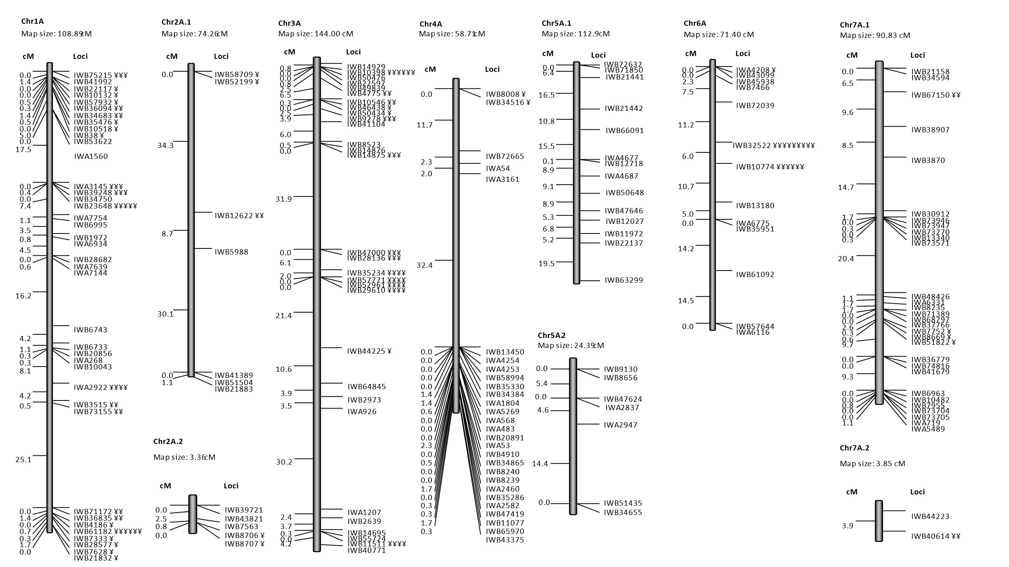

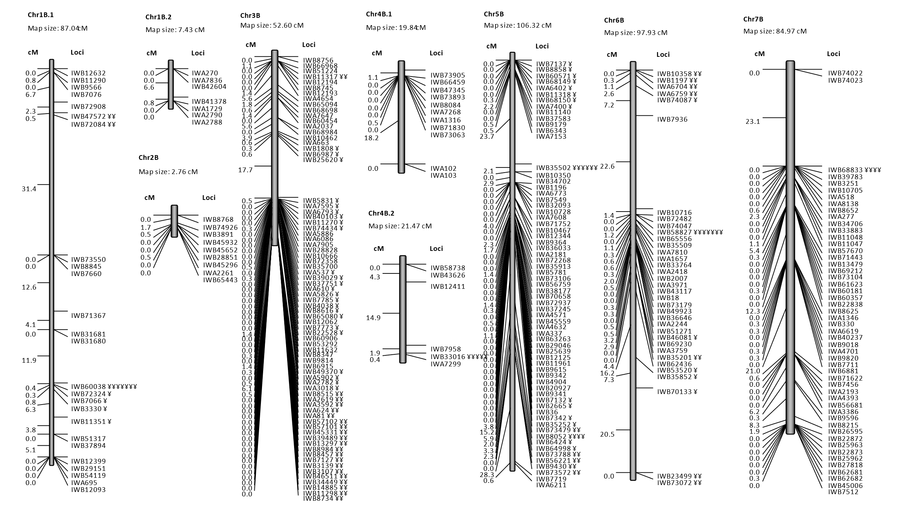

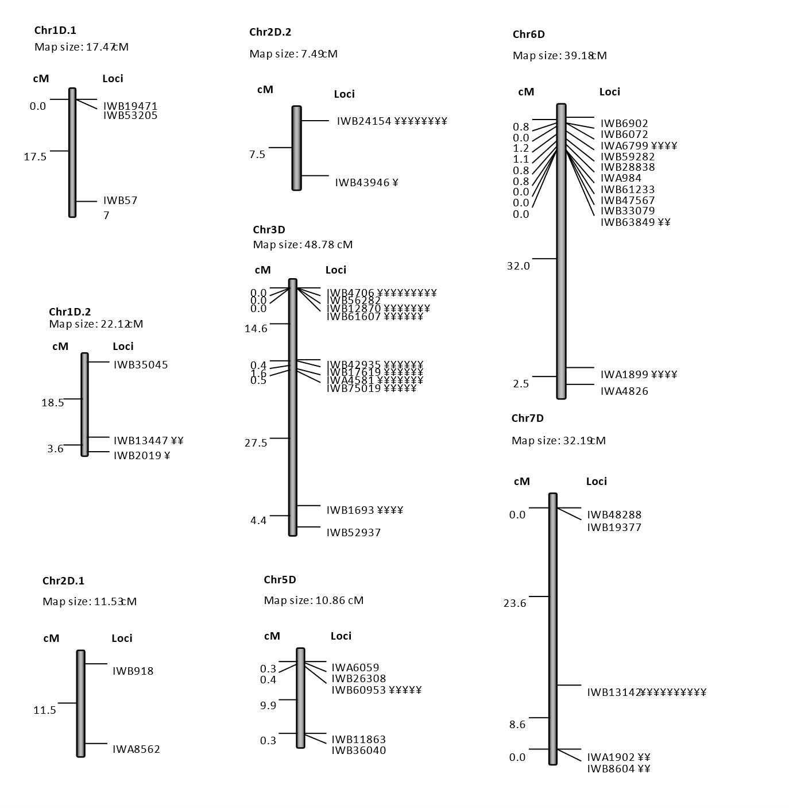
Fig. S1 Linkage maps developed in the BoostND population. Marker loci are shown along the right side of each linkage group and centimorgan (cM) distance are along the left. Markers with segregation ratios that significantly deviated from the expected segregation ratio of 1:1 are indicated with the symbol ¥ where more ¥ symbols indicates higher degrees of distortion.

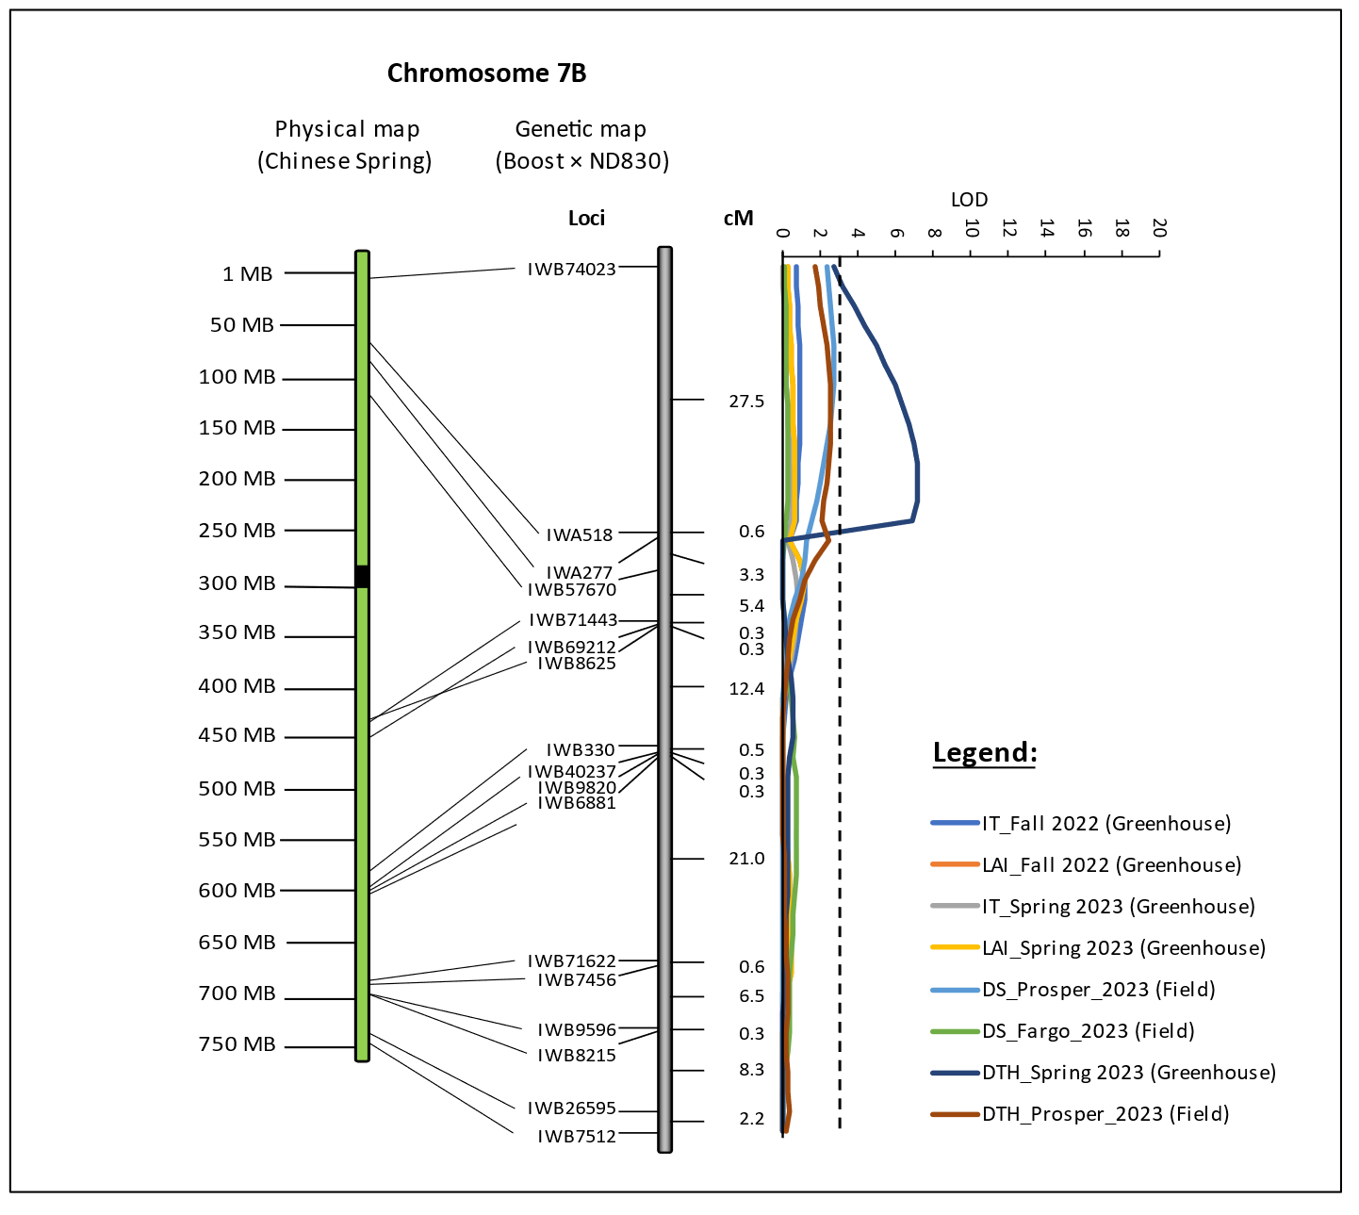
Fig. S2 QTL identified for days to heading on chromosomes 7B (QHd.fcu-7B) in the BoostND population in a greenhouse experiments. The marker loci and genetic position are shown to the left and right, respectively, along the genetic linkage maps. The physical maps with black solid box as the position of centromeres indicate the relative physical positions of the markers along the chromosomes based on the Chinese Spring RefSeq v2.1 genome assembly. A dashed line indicates a LOD cutoff of 3.0. In legends, IT stands for infection type score (0-5), LAI stands for leaf area infected in percentage (0-100%), DTH stands for days to heading, and disease severity (DS) based disease score (0-9) was used for field evaluation in Fargo and Prosper, ND.
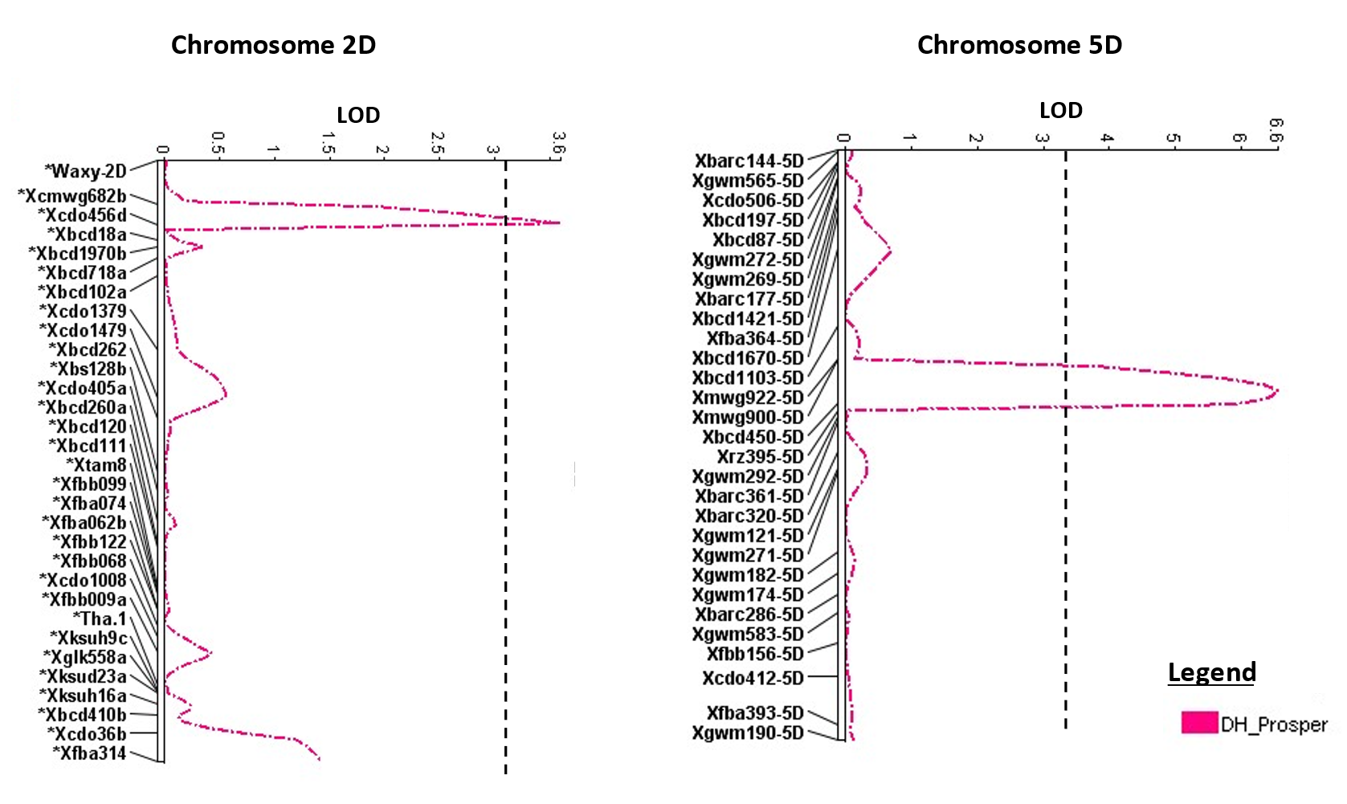
Fig. S3 QTLs for days to heading (DTH) identified on chromosomes 2D and 5D in the ITMI population in a field experiment in Prosper, ND in 2023. A dashed line indicates a LOD cutoff of 3.2 for single trait interval mapping.

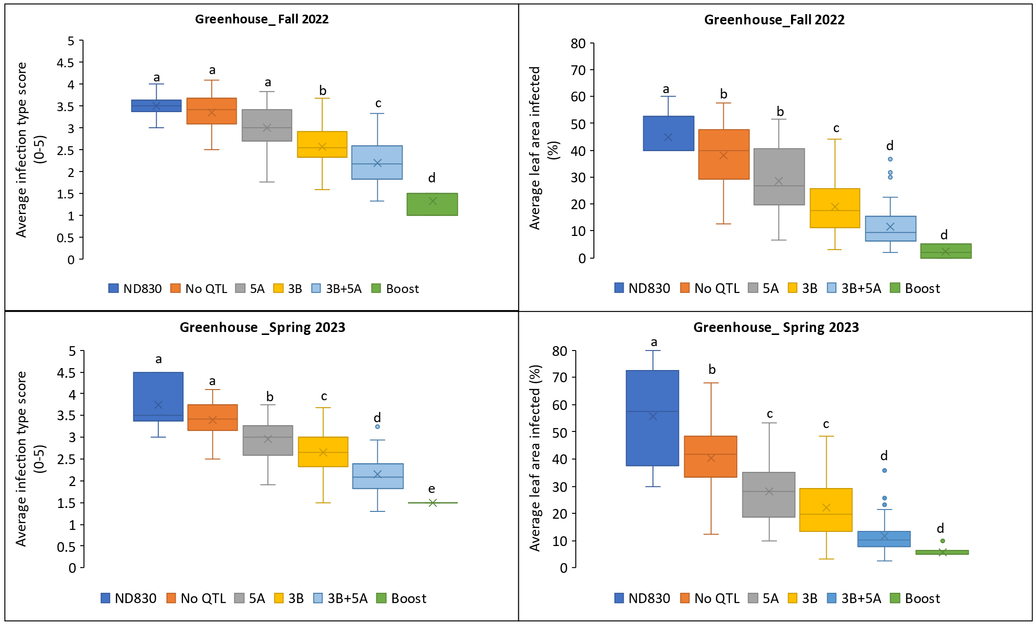
Fig. S4 Additive effects of the major QTLs for resistance to bacterial leaf streak (BLS) on chromosomes 3B (QBls.fcu-3B) and 5A (QBls.fcu-5A) in the BoostND population in different greenhouse experiments. Resistant and susceptible alleles of the peak marker of each QTL and the average BLS scores of the RILs were used for analysis. Infection type score (0-5) and leaf area infected (0-100%) were used for disease evaluation in the greenhouse. Means with the same small letters are not significantly different at P < 0.05.

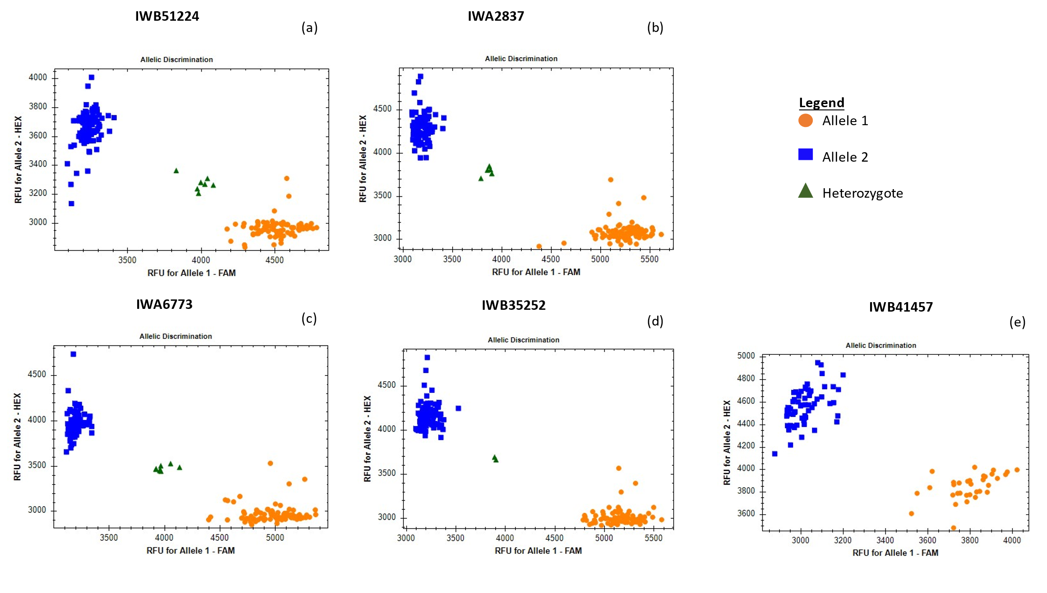
Fig. S5 Allelic discrimination plots of the five KASP markers developed from SNP markers at BLS resistance QTLs. A): KASP marker developed from SNP IWB51224 associated with QTL QBls.fcu-3B.1; B): KASP marker developed from SNP IWA2837 associated with QTL QBls.fcu-5A; C): KASP marker developed from SNP IWA6773 associated with QTL QBls.fcu-5B.1; D) KASP marker developed from SNP marker IWB35252 associated with QTL QBls.fcu-5B.2. The blue squares and orange dots represent homozygous Boost and ND830 alleles, respectively, and the green triangles representing heterozygotes. D): KASP marker developed from SNP IWB41457 associated with QTL QBls.fcu-7D in the ITMI population where blue squares are homozygous for W-7984 alleles, orange dots are homozygous for Opata 85 alleles.

