Supplementary Table 1. Bivariate of response and clinical factors.
 | ICR (N=233) | CR (N=101) | Total (N=334) | p value
Cohort |  |  |  | 0.304 (1)
MSK | 217 (93.1%) | 97 (96.0%) | 314 (94.0%)
UM | 16 (6.9%) | 4 (4.0%) | 20 (6.0%)
Sex |  |  |  | 0.193 (1)
Female | 90 (39.3%) | 47 (47.0%) | 137 (41.6%)
Male | 139 (60.7%) | 53 (53.0%) | 192 (58.4%)
Age |  |  |  | 0.114 (2)
Mean (SD) | 53.785 (13.039) | 56.248 (13.030) | 54.530 (13.066)
Tumor size (cm) |  |  |  | 0.008 (3)
Median (Q1, Q3) | 4.700 (3.800, 6.000) | 4.200 (3.200, 5.200) | 4.500 (3.600, 5.775)
Distance from av (cm) |  |  |  | 0.855 (2)
Mean (SD) | 6.710 (3.111) | 6.641 (3.060) | 6.690 (3.092)
Rectal location |  |  |  | 0.532 (1)
Lower | 47 (21.7%) | 23 (24.5%) | 70 (22.5%)
Middle | 98 (45.2%) | 36 (38.3%) | 134 (43.1%)
Upper | 72 (33.2%) | 35 (37.2%) | 107 (34.4%)
AJCC classification |  |  |  | 0.160 (1)
2 | 38 (16.3%) | 23 (22.8%) | 61 (18.3%)
3 | 195 (83.7%) | 78 (77.2%) | 273 (81.7%)
T stage |  |  |  | 0.067 (1)
2 | 5 (2.8%) | 7 (9.7%) | 12 (4.8%)
3 | 150 (84.3%) | 57 (79.2%) | 207 (82.8%)
4 | 23 (12.9%) | 8 (11.1%) | 31 (12.4%)
Ln positive |  |  |  | 0.267 (1)
No | 25 (13.7%) | 14 (19.2%) | 39 (15.2%)
Yes | 158 (86.3%) | 59 (80.8%) | 217 (84.8%)
Race |  |  |  | 0.059 (1)
Asian | 16 (7.4%) | 8 (8.2%) | 24 (7.6%)
Black | 8 (3.7%) | 7 (7.2%) | 15 (4.8%)
Others | 38 (17.5%) | 27 (27.8%) | 65 (20.7%)
White | 155 (71.4%) | 55 (56.7%) | 210 (66.9%)
Treatment |  |  |  | 0.373 (1)
CRT_Consolidation | 58 (24.8%) | 38 (33.6%) | 96 (28.8%)
CRT_Only | 44 (18.8%) | 21 (18.6%) | 65 (19.5%)
Induction_CRT | 122 (52.1%) | 50 (44.2%) | 172 (51.7%)
MSI |  |  |  | 0.233 (1)
High | 8(2.31%) | 7 (2.02%) | 15 (4.3%)
Low | 226 (65.1%) | 106 (30.6%) | 332 (95.7%)
p values were calculated by 1. Pearson’s Chi-squared, 2. ANOVA, 3. Kruskal-Wallis rank sum test

Supplementary Table 2. Significantly mutated genes (SMGs) detected by MutSig2CV in CR and ICR groups.
CR SMGs | CR SMGs qvalue | ICR SMGs | ICR SMGs qvalue
APC | 6.29E-13 | APC | 4.19E-13
TP53 | 6.29E-13 | TP53 | 4.19E-13
KRAS | 6.29E-13 | KRAS | 4.19E-13
FBXW7 | 1.05E-12 | FBXW7 | 4.19E-13
SOX9 | 5.86E-12 | NRAS | 4.19E-13
U2AF1 | 3.87E-07 | TCF7L2 | 1.02E-11
RNF43 | 4.49E-07 | SOX9 | 1.02E-11
IL7R | 1.39E-06 | ARID1A | 4.49E-11
NRAS | 1.74E-06 | SMAD4 | 4.49E-11
TCF7L2 | 1.53E-05 | BRAF | 9.45E-10
ARID1A | 1.53E-05 | SOX17 | 1.21E-09
IGF2 | 4.33E-05 | B2M | 1.62E-09
TGFBR2 | 1.31E-04 | FAM123B | 6.39E-07
EPHA3 | 3.16E-04 | RNF43 | 1.58E-06
LATS2 | 5.49E-04 | NCOR1 | 1.58E-06
CD79A | 7.62E-04 | DNMT3B | 8.70E-05
PTEN | 1.28E-03 | EPHA3 | 1.24E-04
KDR | 3.37E-03 | CTCF | 2.25E-04
MSH2 | 3.88E-03 | RAF1 | 2.34E-04
CARD11 | 5.09E-03 | ELF3 | 3.84E-04
RAD51L1 | 6.97E-03 | IKZF1 | 4.05E-04
ERBB2 | 6.97E-03 | FLCN | 1.67E-03
IRS2 | 7.65E-03 | CDC73 | 1.74E-03
CDKN2A | 1.01E-02 | SMAD3 | 1.99E-03
PBRM1 | 1.01E-02 | GLI1 | 3.69E-03
PIK3CA | 1.20E-02 | BCOR | 4.61E-03
CIC | 1.20E-02 | PTEN | 6.62E-03
NTRK1 | 1.43E-02 | ERBB2 | 7.23E-03
MLL3 | 2.40E-02 | EP300 | 7.25E-03
HGF | 2.47E-02 | MSH6 | 7.25E-03
SMAD4 | 3.17E-02 | GRID1 | 7.87E-03
PDGFRB | 3.17E-02 | PTPRS | 8.63E-03
MEN1 | 3.17E-02 | KDM6A | 8.63E-03
POLE | 3.65E-02 | PIK3CA | 8.63E-03
HIST1H1C | 3.77E-02 | TGFBR2 | 8.66E-03
PMS2 | 5.28E-02 | MCC | 8.69E-03
BRAF | 7.09E-02 | RASA1 | 8.82E-03
CTCF | 1.89E-01 | ATM | 1.12E-02
PTPRS | 2.21E-01 | CARD11 | 1.15E-02
MSH6 | 3.78E-01 | PIK3R2 | 1.15E-02
FLCN | 5.48E-01 | MAPK1 | 1.68E-02
ASXL2 | 1 | NTRK1 | 1.70E-02
DNMT3B | 1 | LRMP | 1.70E-02
FAM123B | 1 | TSC1 | 1.75E-02
B2M | 1 | ASXL2 | 1.81E-02
TSC1 | 1 | PMS2 | 2.04E-02
SMAD3 | 1 | AXIN2 | 2.37E-02
E2F3 | 1 | RB1 | 2.62E-02
AXIN2 | 1 | NF1 | 2.94E-02
RB1 | 1 | HGF | 3.13E-02
PIK3R2 | 1 | TSC2 | 3.72E-02
GLI1 | 1 | E2F3 | 4.53E-02
SOX17 | 1 | INPP4B | 4.75E-02
ERBB3 | 1 | ERBB3 | 4.99E-02
ATM | 1 | LATS2 | 6.17E-02
INPP4B | 1 | MSH2 | 7.03E-02
KDM6A | 1 | IL7R | 1.19E-01
EP300 | 1 | CIC | 4.54E-01
NF1 | 1 | POLE | 4.63E-01
ELF3 | 1 | CDKN2A | 7.33E-01
TSC2 | 1 | KDR | 9.72E-01
CDC73 | 1 | RAD51L1 | 1
NCOR1 | 1 | HIST1H1C | 1
RASA1 | 1 | PBRM1 | 1
BCOR | 1 | IRS2 | 1
GRID1 | 1 | PDGFRB | 1
IKZF1 | 1 | MEN1 | 1
LRMP | 1 | MLL3 | 1
MAPK1 | 1 | CD79A | 1
MCC | 1 | IGF2 | 1
RAF1 | 1 | U2AF1 | 1
q value is FDR-corrected (Benjamini-Hochberg) overall p-value

Supplementary Table 3. Significant mutated genes associated with response.
 | ICR (N=233) | CR (N=101) | Total (N=334) | p value
CD79A |  |  |  | 0.027
Without mutation | 233 (100.0%) | 98 (97.0%) | 331 (99.1%)
With mutation | 0 (0.0%) | 3 (3.0%) | 3 (0.9%)
HIST1H1C |  |  |  | 0.084
Without mutation | 232 (99.6%) | 98 (97.0%) | 330 (98.8%)
With mutation | 1 (0.4%) | 3 (3.0%) | 4 (1.2%)
IGF2 |  |  |  | 0.031
Without mutation | 232 (99.6%) | 97 (96.0%) | 329 (98.5%)
With mutation | 1 (0.4%) | 4 (4.0%) | 5 (1.5%)
IL7R |  |  |  | 0.058
Without mutation | 230 (98.7%) | 96 (95.0%) | 326 (97.6%)
With mutation | 3 (1.3%) | 5 (5.0%) | 8 (2.4%)
IRS2 |  |  |  | 0.025
Without mutation | 230 (98.7%) | 95 (94.1%) | 325 (97.3%)
With mutation | 3 (1.3%) | 6 (5.9%) | 9 (2.7%)
KDR |  |  |  | 0.009
Without mutation | 229 (98.3%) | 93 (92.1%) | 322 (96.4%)
With mutation | 4 (1.7%) | 8 (7.9%) | 12 (3.6%)
LATS2 |  |  |  | 0.01
Without mutation | 230 (98.7%) | 94 (93.1%) | 324 (97.0%)
With mutation | 3 (1.3%) | 7 (6.9%) | 10 (3.0%)
PBRM1 |  |  |  | 0.072
Without mutation | 229 (98.3%) | 95 (94.1%) | 324 (97.0%)
With mutation | 4 (1.7%) | 6 (5.9%) | 10 (3.0%)
POLE |  |  |  | 0.009
Without mutation | 229 (98.3%) | 93 (92.1%) | 322 (96.4%)
With mutation | 4 (1.7%) | 8 (7.9%) | 12 (3.6%)
TCF7L2 |  |  |  | 0.066
Without mutation | 216 (92.7%) | 87 (86.1%) | 303 (90.7%)
With mutation | 17 (7.3%) | 14 (13.9%) | 31 (9.3%)
p value was calculated using Fisher’s Exact Test

Supplementary Table 4. Network showing the interactions of significant mutated genes used in the model.
Node1 | Node2 | Co-expression | Experimentally  determined  interaction | Database  annotated | Automated  textmining | Combined score
CD79A | KDR | 0 | 0 | 0 | 0.473 | 0.473
CD79A | IL7R | 0.115 | 0 | 0 | 0.463 | 0.505
H1-2 | PBRM1 | 0.082 | 0.074 | 0 | 0.102 | 0.169
IGF2 | KDR | 0.066 | 0 | 0.65 | 0.614 | 0.862
IGF2 | POLE | 0.044 | 0 | 0 | 0.156 | 0.158
IGF2 | IRS2 | 0 | 0 | 0.5 | 0.58 | 0.781
IL7R | CD79A | 0.115 | 0 | 0 | 0.463 | 0.505
IL7R | KDR | 0.055 | 0 | 0 | 0.182 | 0.194
IL7R | IRS2 | 0 | 0 | 0.5 | 0.081 | 0.52
IRS2 | KDR | 0 | 0 | 0 | 0.157 | 0.157
IRS2 | IL7R | 0 | 0 | 0.5 | 0.081 | 0.52
IRS2 | IGF2 | 0 | 0 | 0.5 | 0.58 | 0.781
KDR | CD79A | 0 | 0 | 0 | 0.473 | 0.473
KDR | IRS2 | 0 | 0 | 0 | 0.157 | 0.157
KDR | IL7R | 0.055 | 0 | 0 | 0.182 | 0.194
KDR | PBRM1 | 0 | 0 | 0 | 0.268 | 0.268
KDR | POLE | 0 | 0 | 0 | 0.301 | 0.301
KDR | IGF2 | 0.066 | 0 | 0.65 | 0.614 | 0.862
LATS2 | PBRM1 | 0.121 | 0 | 0 | 0.152 | 0.222
PBRM1 | KDR | 0 | 0 | 0 | 0.268 | 0.268
PBRM1 | POLE | 0.093 | 0 | 0 | 0.376 | 0.41
PBRM1 | H1-2 | 0.082 | 0.074 | 0 | 0.102 | 0.169
PBRM1 | LATS2 | 0.121 | 0 | 0 | 0.152 | 0.222
POLE | KDR | 0 | 0 | 0 | 0.301 | 0.301
POLE | IGF2 | 0.044 | 0 | 0 | 0.156 | 0.158
POLE | PBRM1 | 0.093 | 0 | 0 | 0.376 | 0.41

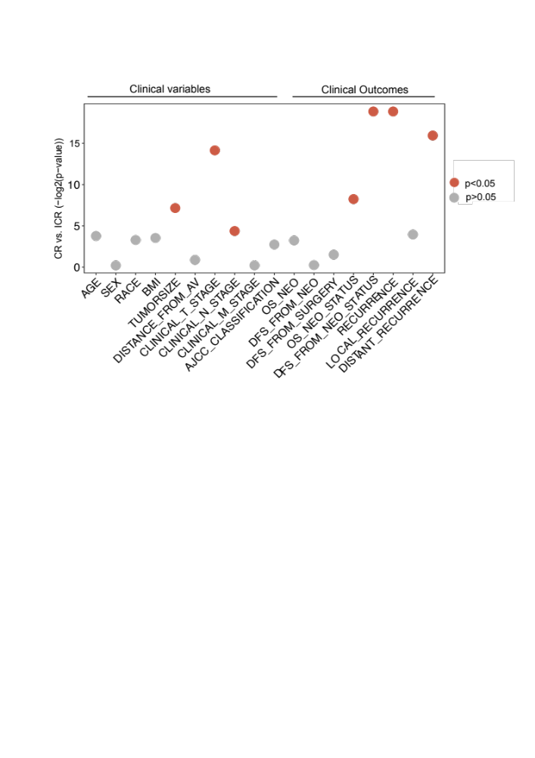
Supplementary Figure 1. Comparison of clinical factors between complete responders and incomplete responders. Statistical comparison of clinical variables (left) and clinical outcomes (right) between CR and ICR tumors.The continuous factors: age, BMI, tumor size, distance from AV, overall survival (OS), disease-free survival (DFS) from neoadjuvant therapy (NEO), DFS from surgery, were compared using Mann Whitney U test. The discrete factors: sex, race, clinical T stage, N stage, M stage, AJCC classification, OS status, DFS from NEO status, and recurrence, were compared using Chi-squared test. Factors with p < 0.05 are highlighted in red, indicating a statistically significant difference between CR and ICR groups, while those with p > 0.05 are in gray, indicating no significant difference.

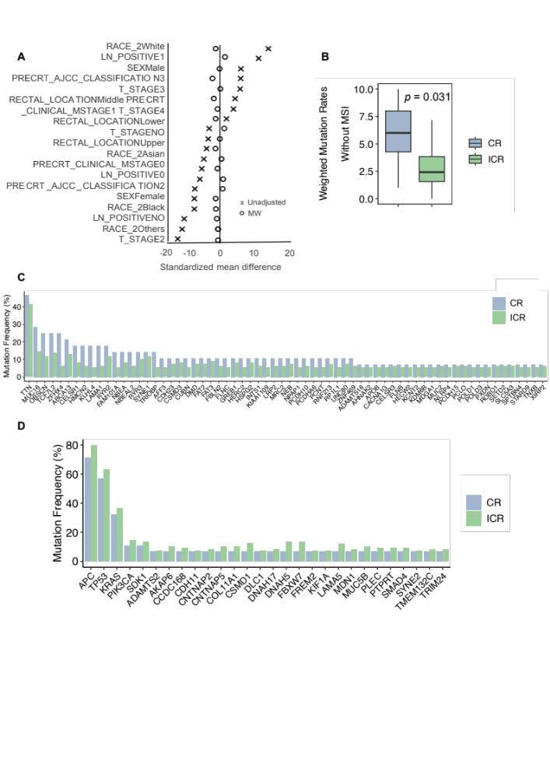
Supplementary Figure 2. Propensity Score Weighting (PSW) analysis for mutation burden and the mutation frequencies in CR and ICR tumors. A: The forest plot displays standardized mean differences of confounding factors between the groups before (Unadjusted) and after applying PSW. B: Box plot comparing mutation burden (excluding MSI-high tumors) between CR and ICR (Weighted t-test, p=0.031, n=133, with CR:26, ICR:107). C: Bar plot showing all mutated genes have higher mutation frequencies in CR (n=104) than ICR tumors (n=260). D: Bar plot showing mutated genes which have higher mutation frequencies in ICR (n=260) than CR tumors (n=104).

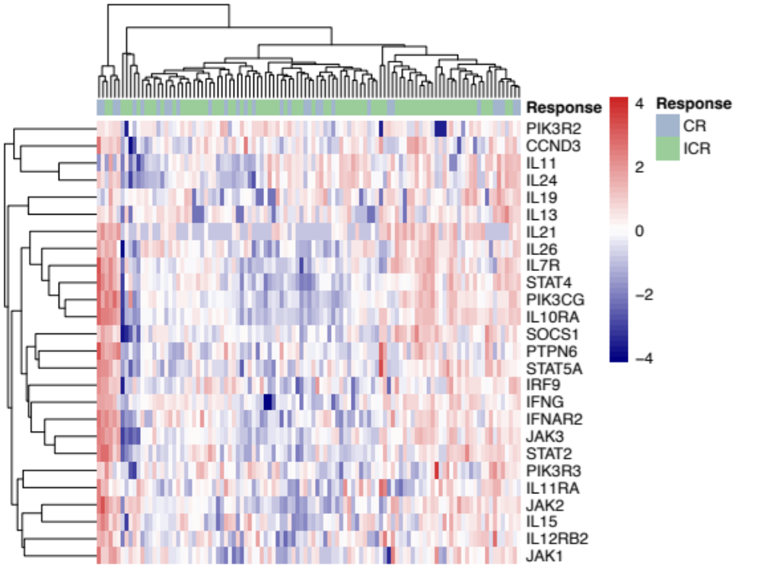
Supplementary Figure 3. Differences in transcriptomic profile between CR and ICR to nCRT. Heatmap showing the gene expression levels in immune-related pathways (n=122, with CR=36 and ICR=86).

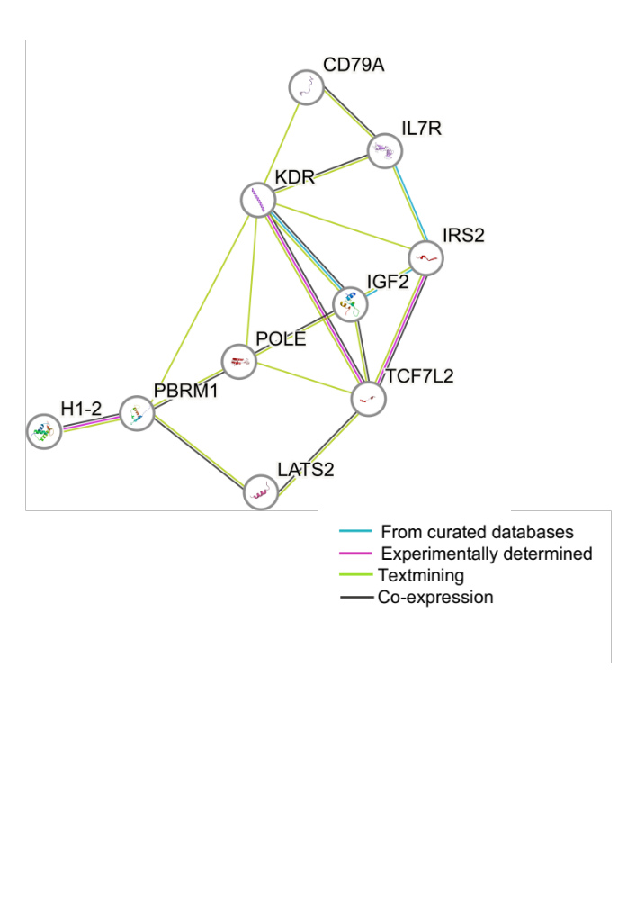

Supplementary Figure 4. Network analysis of predictive mutated genes for treatment response. Network of 10 significantly mutated genes used in the predictive model for treatment response. Connections denote various types of evidence supporting the association between genes: blue lines indicate sources from curated databases, purple lines represent experimentally determined interactions, green lines are derived from text-mining, and black lines reflect co-expression relationships.
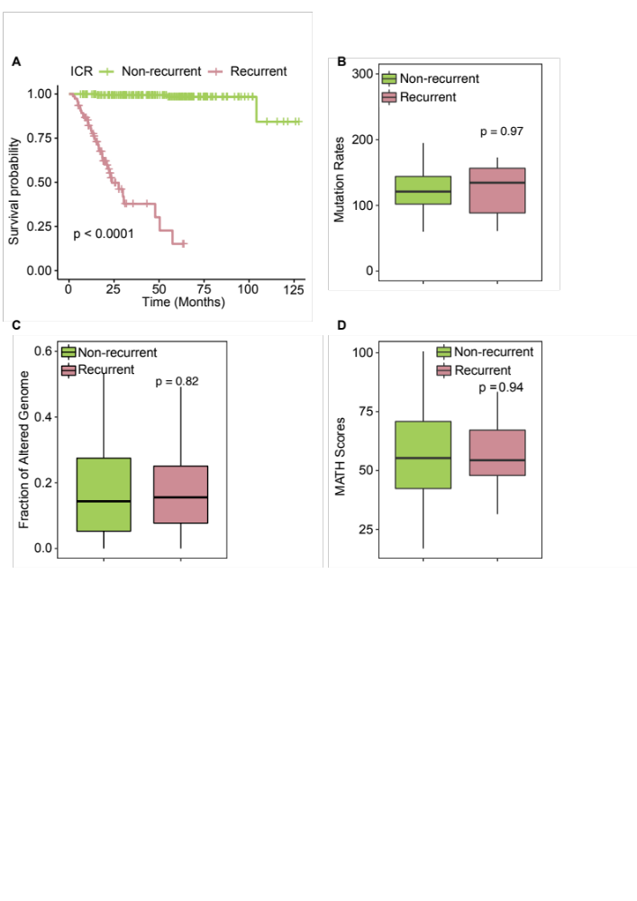
Supplementary Figure 5. Survival outcomes and genomic alternations in ICR tumors based on recurrence status. A: Kaplan-Meier survival curve showing the survival difference between recurrent (n=75) and nonrecurrent ICR tumors (n=183). B-D: Box plots showing the comparison of genomic metrics between recurrent (n=64) and nonrecurrent ICR tumors (n=165), including mutation rate (B), fraction of altered genome (C), and MATH scores (D). No statistically significant differences were observed (Mann Whitney U test, p > 0.05).
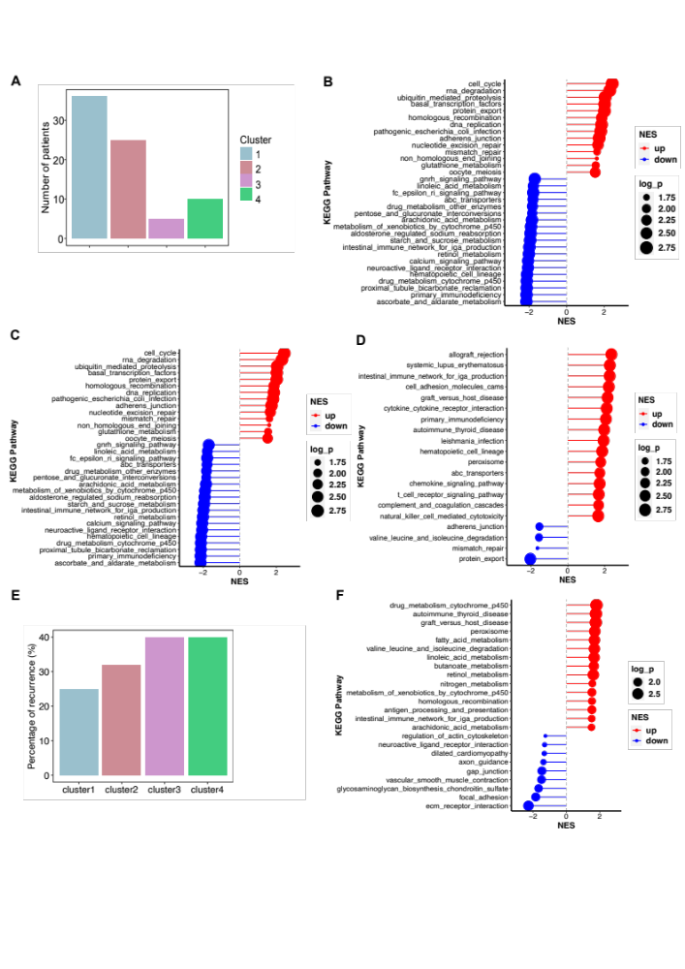
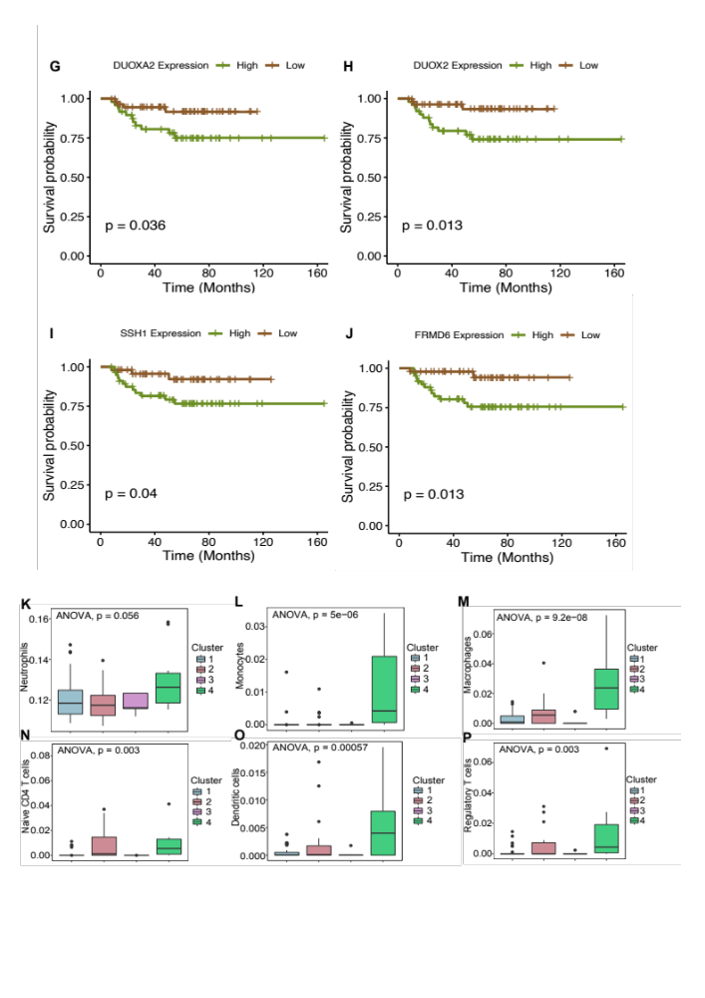
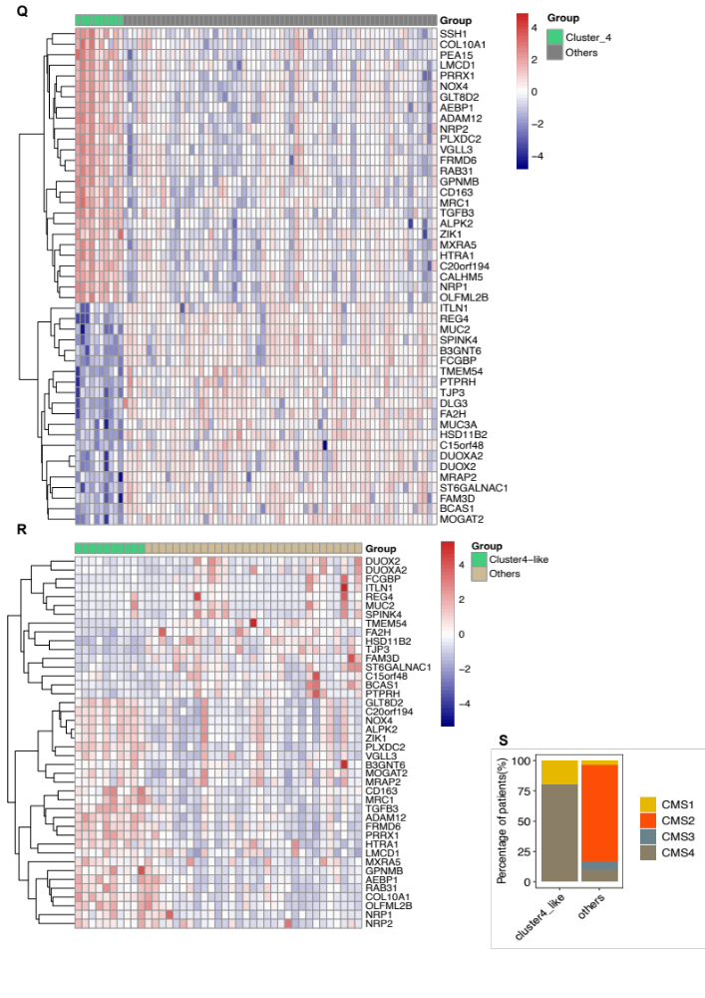
Supplementary Figure 6. Additional gene expression profiles in ICR tumor subsets. A: Distribution of patient samples across four identified subgroups. B-D, F: Pathway enrichment analysis for DEGs between specific subgroups (cluster1: C, cluster2: D, cluster3: E, and cluster4: F) and all other subgroups. E: Fraction of recurrent cases in each ICR patient subgroup. G-J: Kaplan-Meier Curve showing the survival difference between tumors with high (> median) and low (< median) expression of DUOXA2 (G, n=107, High:48, Low:59), DUOX2 (H, n=107, High:50, Low:57), SSH1 (I, n=107, High:48, Low:59), and FRMD6 (J, n=107, High:61, Low:46) genes (The Log-rank test, p < 0.05). K-P: Box plots illustrating the distribution of immune cells (neutrophils (K), monocytes (L), macrophages (M), naïve T CD4 T cell (N), dendritic cells (O), and regulatory T cells (P)) across the four ICR patient subgroups (ANOVA, p < 0.05, n=76, Cluster 1:36, Cluster 2:25, Cluster 3:5, Cluster 4:10). Q: Heatmap of the top 50 DEGs between tumors in Cluster 4 (n=10) and other clusters (n=66). R: Heatmap of the top 50 DEGs between tumors in Cluster 4-like (n=10) and other clusters (n=31) from the TCGA READ dataset. S: Composition of consensus molecular subtypes (CMS) in Cluster4-like and other clusters.

