Table 1: Color codes for HVA concentration
 | Concentration ug per 24 hr | Color
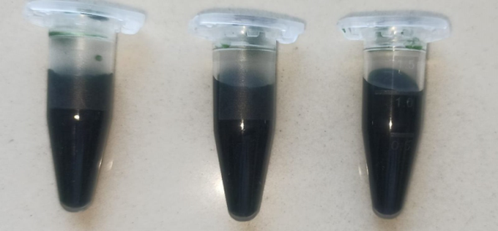 | < 50 ug | light green
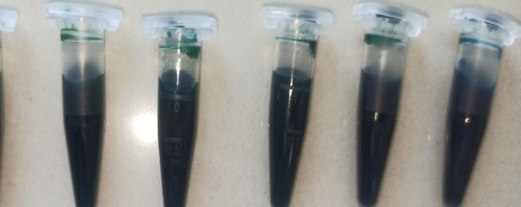 | 50- 500 ug | Dark green
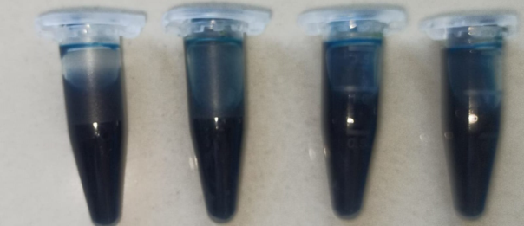 | 500- 750 ug | Blue
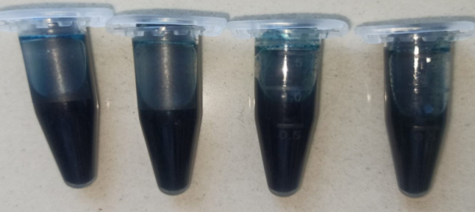 | >750 ug | Dark blue

