  - Kinetics and antimicrobial activity of gallic acid by novel bacterial co-culture system using Taguchi’s method and submerged fermentation
Subbalaxmi Selvaraj¹, Julia Moraes Amaral², Vytla Ramachandra Murty¹*
¹Department of Biotechnology, Manipal Institute of Technology, Manipal Academy of Higher Education, Manipal-576104, India.
²School of Pharmaceutical Sciences, Universidade Estadual Paulista, Brazil.

Supplementary Materials

Additional Table 1: Response table for Means.
Level | A | B | C | D | E
1 | 308.5 | 347.8 | 189.5 | 235.7 | 242.5
2 | 324.8 | 185.3 | 358.5 | 207.9 | 178.5
3 | 212.3 | 240.3 | 209.3 | 285.3 | 321.4
4 | 199.4 | 271.6 | 287.8 | 316.1 | 302.7
Delta | 125.4 | 162.5 | 169.0 | 108.3 | 142.9
Rank | 4 | 2 | 1 | 5 | 3
A, Tannic acid concentration; B, Glucose concentration; C, Agitation speed; D, Initial pH; E, Inoculum size.

Additional Table 2: The average effect of parameters at assigned levels for gallic acid production under SmF with co-culture fermentation of Bacillus gottheilii M2S2 and Bacillus cereus M1GT.
Factors | Level 1 | Level 2 | Level 3 | Level 4 | L2-L1 | L3-L1 | L4-L1 | L3-L2 | L4-L2 | L4-L3
A | 308.5 | 324.8 | 212.3 | 199.4 | 16.3 | -96.2 | -109.1 | -112.5 | -125.4 | -12.9
B | 347.8 | 185.3 | 240.3 | 271.6 | -162.5 | -107.5 | -76.2 | 55 | 86.3 | 31.3
C | 189.5 | 358.5 | 209.3 | 287.8 | 169 | 19.8 | 98.3 | -149.2 | -70.7 | 78.5
D | 235.7 | 207.9 | 285.3 | 316.1 | -27.8 | 49.6 | 80.4 | 49.6 | 108.2 | 30.8
E | 242.5 | 178.5 | 321.4 | 302.7 | -64 | 78.9 | 60.2 | 78.9 | 124.2 | -18.7
A, Tannic acid concentration; B, Glucose concentration; C, Agitation speed; D, Initial pH; E, Inoculum size.

2
.
0
1
.
5
1
.
0
0
.
5
5
1
5
0
4
9
4
8
4
7
4
6
4
5
4
4
Additional Figure 1: Main effects plot for SN ratios for the production of gallic acid with co-culture fermentation of Bacillus gottheilii M2S2 and Bacillus cereus M1GT.

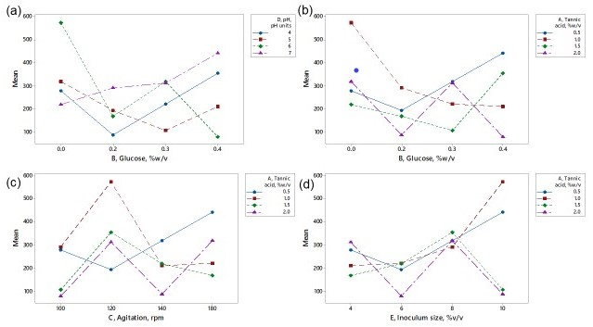 Additional Figure 2A: Minitab generated interaction plots for the selected factors. (a) D x B; (b) A X B, (c) A X C, and (d) A x E.

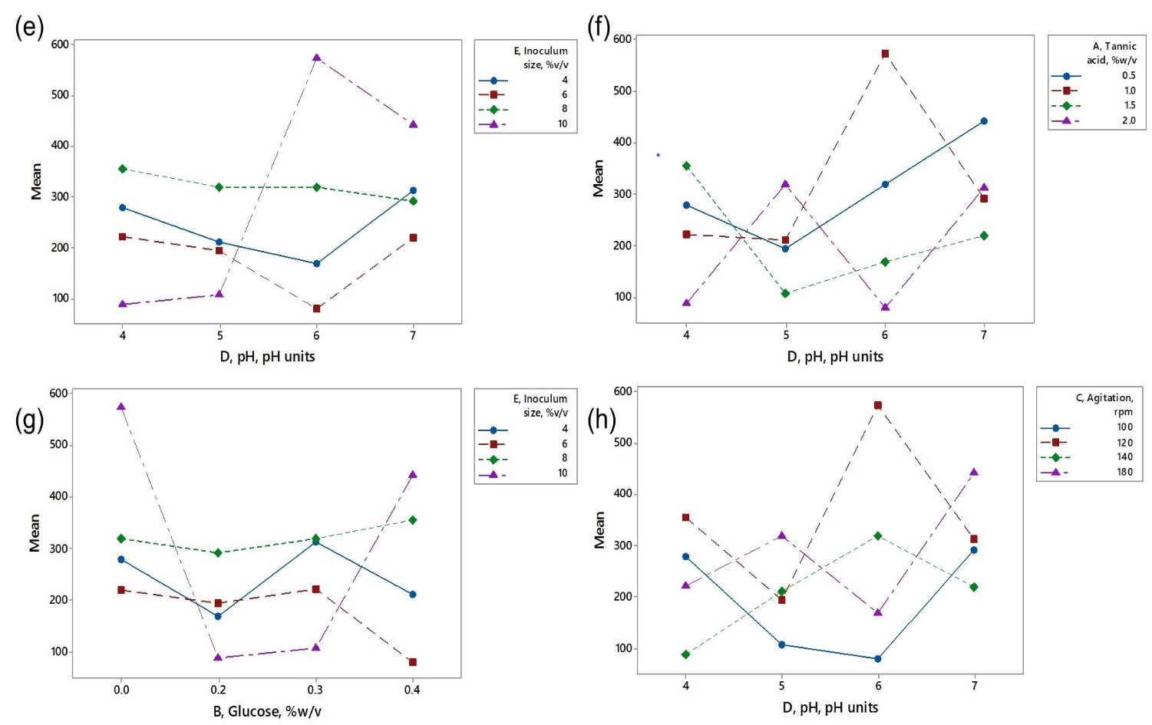
Additional Figure 2B: Minitab generated interaction plots for the selected factors.
(e) E x D; (f) A X D, (g) E X B, and (h) C x D.

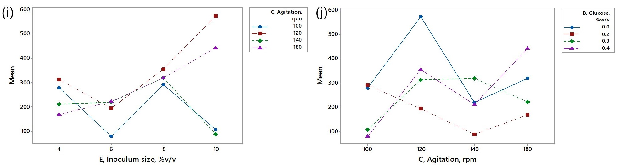 Additional Figure 2C: Minitab generated interaction plots for the selected factors.
(i) C x E; and (j) B X C.

