Supplementary Table S1. Samples analyzed in this study
Sampling locations | Short name | Province | Collection year | Number of males | Number of females | Ecozone
Central Saskatchewan | CSK | SK | 2017 | 8 | 8 | Boreal plain
Charron Lake | Char | MB | 2015 | 8 | 8 | Boreal shield
Flin Flon | Flin | SK | 2014 | 4 | 4 | Boreal plain
La Ronge | Ron | SK | 2013 | 4 | 4 | Boreal shield
Naosap-Reed | Nao | MB | 2015 | 8 | 8 | Boreal plain
The Bog | Bog | MB | 2017 | 8 | 8 | Boreal plain
Wabowden | Wab | MB | 2015 | 8 | 8 | Boreal plain

Supplementary Table S2. List of primers used in this study.
Target group | Taxonomic marker | Primer name | Sequence | Reference
Prokaryotes | 16S rRNA gene, V4-V5 region | 515F-Y | GTGYCAGCMGCCGCGGTAA | Parada et al., 2015
Prokaryotes | 16S rRNA gene, V4-V5 region | 926R | CCGYCAATTYMTTTRAGTTT | Parada et al., 2015
Eukaryotes | 18S rRNA gene, V4 region | 565F | CCAGCASCYGCGGTAATTCC | Stoeck et al., 2010
Eukaryotes | 18S rRNA gene, V4 region | 948R | ACTTTCGTTCTTGATYRA | Stoeck et al., 2010
Plants | ITS2 | ITS2F | ATGCGATACTTGGTGTGAAT | Chen et al., 2010
Plants | ITS2 | ITS3R | GACGCTTCTCCAGACTACAAT | Chen et al., 2010
Fungi | ITS2 | ITS9F | GAACGCAGCRAAIIGYGA | Menkis et al., 2012; White et al., 1990
Fungi | ITS2 | ITS4R | TCCTCCGCTTATTGATATGC | Menkis et al., 2012; White et al., 1990

Supplementary Table S3A. Effect of location and sex on the relative abundance of the 20 most abundant eukaryotic phyla (18S rRNA gene dataset)
 |  | Relative abundance |  |  |  |  |  |  |  | Relative abundance
Phylum | Location Kruskal Pvalue | Bog | Char | CSK | Flin | Nao | Ron | Wab | Sex Kruskal Pvalue | F | M
Phragmoplastophyta# | 0.045 | 0.201a* | 0.189a | 0.290a | 0.236a | 0.224a | 0.246a | 0.185a | 0.272 | 0.231 | 0.213
Archamoebae | 0.049 | 0.172ab | 0.155ab | 0.102a | 0.147ab | 0.278b | 0.122ab | 0.249ab | 0.045 | 0.212 | 0.149
Nematoda | 0.733 | 0.163 | 0.107 | 0.101 | 0.070 | 0.073 | 0.109 | 0.153 | 0.000 | 0.050 | 0.178
Chlorophyta | 0.000 | 0.194a | 0.100ab | 0.080b | 0.143ab | 0.107ab | 0.157ab | 0.063b | 0.123 | 0.121 | 0.111
Vertebrata | 0.000 | 0.068ab | 0.181c | 0.136ac | 0.126abc | 0.075ab | 0.046b | 0.098abc | 0.475 | 0.111 | 0.105
Arthropoda | 0.006 | 0.038a | 0.080a | 0.088a | 0.096a | 0.053a | 0.059a | 0.031a | 0.433 | 0.063 | 0.061
Basidiomycota | 0.000 | 0.030abc | 0.036ab | 0.055c | 0.025abc | 0.018a | 0.046bc | 0.052abc | 0.468 | 0.041 | 0.034
Neocallimastigomycota | 0.000 | 0.039abc | 0.067a | 0.011b | 0.036abc | 0.048abc | 0.084ac | 0.013bc | 0.398 | 0.037 | 0.044
Apicomplexa | 0.031 | 0.028a | 0.021a | 0.067a | 0.039a | 0.021a | 0.029a | 0.034a | 0.115 | 0.039 | 0.029
Unassigned | 0.011 | 0.017a | 0.029ab | 0.025ab | 0.024ab | 0.013a | 0.049b | 0.023ab | 0.153 | 0.026 | 0.022
SAR | 0.000 | 0.013ab | 0.006a | 0.006a | 0.020ab | 0.063b | 0.000a | 0.065ab | 0.481 | 0.030 | 0.023
Ochrophyta | 0.000 | 0.007a | 0.001b | 0.002b | 0.004ab | 0.002ab | 0.009a | 0.004ab | 0.172 | 0.004 | 0.003
Ascomycota | 0.006 | 0.013ab | 0.012ab | 0.021a | 0.007ab | 0.005b | 0.010ab | 0.011ab | 0.426 | 0.013 | 0.011
Ciliophora | 0.011 | 0.007a | 0.004a | 0.005a | 0.008a | 0.005a | 0.011a | 0.004a | 0.000 | 0.007 | 0.004
Chytridiomycota | 0.002 | 0.003ab | 0.005ab | 0.006ab | 0.012a | 0.006ab | 0.013a | 0.004b | 0.156 | 0.007 | 0.005
Mucoromycota | 0.057 | 0.001 | 0.002 | 0.001 | 0.001 | 0.001 | 0.002 | 0.001 | 0.126 | 0.001 | 0.001
Tardigrada | 0.303 | 0.001 | 0.002 | 0.001 | 0.000 | 0.003 | 0.001 | 0.004 | 0.240 | 0.002 | 0.002
Cryptomycota | 0.224 | 0.001 | 0.000 | 0.000 | 0.001 | 0.000 | 0.001 | 0.000 | 0.781 | 0.001 | 0.000
Rotifera | 0.158 | 0.001 | 0.001 | 0.002 | 0.001 | 0.001 | 0.002 | 0.000 | 0.033 | 0.002 | 0.001
Dinoflagellata | 0.014 | 0.001a | 0.000a | 0.000a | 0.001a | 0.000a | 0.001a | 0.003a | 0.614 | 0.000 | 0.001
#Bold characters identify phyla for which the Kruskal-Wallis test for location and/or sex is significant at p<0.05. *Different letters within each line indicate significant differences among locations based on Dunn post hoc test. Bog = The Bog (MB), Char = Charron Lake (MB), CSK = Central Saskatchewan (SK), Flin = Flin Flon (SK), Nao = Naosap-Reed (MB), Ron = La Ronge (SK) and Wab = Wabowden (MB).

Supplementary Table S3B. Effect of sampling location and sex on eukaryotic alpha diversity (18S rRNA gene dataset)
 | Chao# |  | Shannon
Location Kruskal Pvalue | 0.000 |  | 0.015
Bog | 88.063 | a* | 2.836 | a
Char | 80.118 | a | 2.907 | ab
CSK | 97.063 | ab | 3.129 | ab
Flin | 105.500 | ab | 3.233 | ab
Nao | 82.625 | a | 3.130 | ab
Ron | 131.125 | b | 3.512 | b
Wab | 72.800 | a | 2.846 | a
Sex Kruskal Pvalue | 0.045 |  | 0.027
F | 95.271 |  | 3.163
M | 84.542 |  | 2.912

#Bold characters identify alpha diversity indices for which the Kruskal-Wallis test for location and/or sex is significant at p<0.05. *Different letters within a column indicate significant differences among locations based on Dunn post hoc test. Bog = The Bog (MB), Char = Charron Lake (MB), CSK = Central Saskatchewan (SK), Flin = Flin Flon (SK), Nao = Naosap-Reed (MB), Ron = La Ronge (SK) and Wab = Wabowden (MB).
Supplementary Table S3C. Adonis pairwise comparison of eukaryotic beta diversity between locations (18S rRNA gene dataset)
ADONIS pairwise comparison | Df | SumsOfSqs | F.Model | R2 | p.value | p.adjusted
The Bog (MB) vs Naosap-Reed (MB)# | 1 | 0.747 | 3.958 | 0.117 | 0.001 | 0.021
The Bog (MB) vs Wabowden (MB) | 1 | 0.727 | 3.319 | 0.103 | 0.002 | 0.042
The Bog (MB) vs Charron Lake (MB) | 1 | 0.868 | 4.366 | 0.123 | 0.001 | 0.021
The Bog (MB) vs Central Saskatchewan (SK) | 1 | 1.090 | 4.992 | 0.143 | 0.001 | 0.021
The Bog (MB) vs Flin Flon (SK) | 1 | 0.438 | 2.041 | 0.085 | 0.018 | 0.378
The Bog (MB) vs La Ronge Lake (SK) | 1 | 0.698 | 3.295 | 0.130 | 0.002 | 0.042
Naosap-Reed (MB) vs Wabowden (MB) | 1 | 0.598 | 3.183 | 0.099 | 0.004 | 0.084
Naosap-Reed (MB) vs Charron Lake (MB) | 1 | 0.742 | 4.376 | 0.124 | 0.001 | 0.021
Naosap-Reed (MB) vs Central Saskatchewan (SK) | 1 | 1.432 | 7.613 | 0.202 | 0.001 | 0.021
Naosap-Reed (MB) vs Flin Flon (SK) | 1 | 0.390 | 2.249 | 0.093 | 0.003 | 0.063
Naosap-Reed (MB) vs La Ronge Lake (SK) | 1 | 0.658 | 3.857 | 0.149 | 0.001 | 0.021
Wabowden (MB) vs Charron Lake (MB) | 1 | 0.668 | 3.369 | 0.101 | 0.001 | 0.021
Wabowden (MB) vs Central Saskatchewan (SK) | 1 | 0.961 | 4.401 | 0.132 | 0.001 | 0.021
Wabowden (MB) vs Flin Flon (SK) | 1 | 0.411 | 1.914 | 0.084 | 0.039 | 0.819
Wabowden (MB) vs La Ronge Lake (SK) | 1 | 0.875 | 4.134 | 0.164 | 0.001 | 0.021
Charron Lake (MB) vs Central Saskatchewan (SK) | 1 | 1.031 | 5.198 | 0.144 | 0.001 | 0.021
Charron Lake (MB) vs Flin Flon (SK) | 1 | 0.316 | 1.680 | 0.068 | 0.032 | 0.672
Charron Lake (MB) vs La Ronge Lake (SK) | 1 | 0.553 | 2.986 | 0.115 | 0.001 | 0.021
Central Saskatchewan (SK) vs Flin Flon (SK) | 1 | 0.695 | 3.249 | 0.129 | 0.001 | 0.021
Central Saskatchewan (SK) vs La Ronge Lake (SK) | 1 | 1.122 | 5.316 | 0.195 | 0.001 | 0.021
Flin Flon (SK) vs La Ronge Lake (SK) | 1 | 0.398 | 1.979 | 0.124 | 0.005 | 0.105
#Bold characters identify significant Adonis pairwise comparisons (adjusted p<0.05). Bog = The Bog (MB), Char = Charron Lake (MB), CSK = Central Saskatchewan (SK), Flin = Flin Flon (SK), Nao = Naosap-Reed (MB), Ron = La Ronge (SK) and Wab = Wabowden (MB).

Supplementary Table S3D. Effect of location and sex on the number of ASVs from parasites (18S rRNA gene dataset)
Parasite | All parasites  ASVs# |  | Blastocystis  ASVs |  | Eimeria  ASVs | Entamoeba  ASVs |  | Nematodirella ASVs |  | Parelaphostrongylus  ASVs
Location Kruskal Pvalue | 0.000 |  | 0.000 |  | 0.695 | 0.000 |  | 0.001 |  | 0.599
Bog | 6.438 | a* | 0.688 | ab | 0.000 | 4.250 | a | 0.063 | ab | 1.438
Char | 6.588 | a | 0.235 | a | 0.059 | 5.118 | ab | 0.412 | ab | 0.647
CSK | 6.563 | a | 0.625 | ab | 0.063 | 4.750 | ab | 0.250 | ab | 0.813
Flin | 8.125 | ab | 1.250 | b | 0.000 | 6.375 | abc | 0.000 | ab | 0.500
Nao | 9.250 | b | 1.250 | b | 0.000 | 7.375 | c | 0.000 | b | 0.563
Ron | 6.500 | a | 0.000 | a | 0.000 | 5.750 | abc | 0.000 | ab | 0.750
Wab | 7.867 | ab | 0.800 | ab | 0.000 | 6.133 | bc | 0.000 | b | 0.933
Sex Kruskal Pvalue | 0.272 |  | 0.482 |  | 0.155 | 0.208 |  | 0.002 |  | 0.000
F | 7.167 |  | 0.750 |  | 0.042 | 5.958 |  | 0.021 |  | 0.375
M | 7.479 |  | 0.646 |  | 0.000 | 5.250 |  | 0.229 |  | 1.292
#Bold characters identify groups for which the Kruskal-Wallis test for location and/or sex is significant at p<0.05. *Different letters within a column indicate significant differences among locations based on Dunn post hoc test. Bog = The Bog (MB), Char = Charron Lake (MB), CSK = Central Saskatchewan (SK), Flin = Flin Flon (SK), Nao = Naosap-Reed (MB), Ron = La Ronge (SK) and Wab = Wabowden (MB).
Supplementary Table S3E. Effect of location and sex on the number of Neocallimastigomycota ASVs (18S rRNA gene and fungal ITS2 dataset)
 | 18S |  | ITS fungi
Location Kruskal Pvalue | 0,013 |  | 0,155
Bog | 1,375 | a* | 3,375
Char | 1,000 | ab | 2,118
CSK | 0,563 | b | 1,937
Flin | 1,125 | ab | 2,375
Nao | 1,438 | a | 3
Ron | 1,250 | ab | 2,714
Wab | 0,867 | ab | 2,5
Sex Kruskal Pvalue | 0,482 |  | 0,125
F | 1,125 |  | 2,792
M | 1,021 |  | 2,354

*Different letters indicate significant differences among locations based on Dunn post hoc test. Bog = The Bog (MB), Char = Charron Lake (MB), CSK = Central Saskatchewan (SK), Flin = Flin Flon (SK), Nao = Naosap-Reed (MB), Ron = La Ronge (SK) and Wab = Wabowden (MB).

Supplementary Table S4A. Effect of location and sex on the relative abundance of the 20 most abundant plant families (plant ITS2 dataset)
Plant Family | Location Kruskal Pvalue | Bog | Char | CSK | Flin | Nao | Ron | Wab | Sex Kruskal  Pvalue | F | M
Ericaceae# | 0.000 | 0.691a* | 0.280b | 0.679a | 0.210b | 0.279b | 0.171b | 0.229b | 0.889 | 0.400 | 0.385
Cyperaceae | 0.000 | 0.021a | 0.171b | 0.115b | 0.243b | 0.347b | 0.225b | 0.127ab | 0.717 | 0.183 | 0.154
Unassigned | 0.000 | 0.045ab | 0.179c | 0.096abc | 0.046abc | 0.017a | 0.018ab | 0.135bc | 0.878 | 0.071 | 0.101
Sphagnaceae | 0.000 | 0.030ab | 0.141c | 0.012a | 0.081abcd | 0.070bcd | 0.023abd | 0.123cd | 0.792 | 0.072 | 0.073
Hylocomiaceae | 0.000 | 0.025ab | 0.063ac | 0.014b | 0.041abc | 0.044ac | 0.145ac | 0.075c | 0.593 | 0.049 | 0.054
Betulaceae | 0.007 | 0.026ab | 0.051ab | 0.011ab | 0.005a | 0.076b | 0.068ab | 0.085ab | 0.206 | 0.040 | 0.055
Salicaceae | 0.006 | 0.019a | 0.034a | 0.015a | 0.017a | 0.044a | 0.143a | 0.075a | 0.668 | 0.054 | 0.033
Menyanthaceae | 0.015 | 0.000a | 0.001a | 0.020a | 0.226a | 0.045a | 0.000a | 0.048a | 0.322 | 0.039 | 0.037
Rosaceae | 0.000 | 0.035ab | 0.008c | 0.004ac | 0.104b | 0.045b | 0.029abc | 0.021abc | 0.612 | 0.033 | 0.027
Polytrichaceae | 0.000 | 0.004a | 0.028ab | 0.005a | 0.011a | 0.005a | 0.133b | 0.003a | 0.650 | 0.018 | 0.019
Juncaginaceae | 0.049 | 0.039a | 0.000a | 0.000a | 0.000a | 0.000a | 0.000a | 0.042a | 0.463 | 0.015 | 0.012
Sarraceniaceae | 0.000 | 0.045a | 0.001b | 0.002b | 0.000b | 0.000b | 0.000b | 0.000b | 0.652 | 0.004 | 0.012
Pinaceae | 0.629 | 0.005 | 0.006 | 0.003 | 0.002 | 0.013 | 0.015 | 0.009 | 0.110 | 0.005 | 0.009
Ptilidiaceae | 0.000 | 0.001a | 0.016b | 0.002a | 0.001ab | 0.001ab | 0.018ab | 0.014b | 0.191 | 0.006 | 0.009
Poaceae | 0.550 | 0.000 | 0.002 | 0.018 | 0.001 | 0.001 | 0.008 | 0.001 | 0.711 | 0.002 | 0.007
Cornaceae | 0.696 | 0.000 | 0.010 | 0.000 | 0.000 | 0.001 | 0.000 | 0.000 | 0.155 | 0.004 | 0
Asteraceae | 0.743 | 0.003 | 0.002 | 0.001 | 0.001 | 0.001 | 0.000 | 0.000 | 0.472 | 0.001 | 0.002
Cupressaceae | 0.153 | 0.003 | 0.000 | 0.000 | 0.001 | 0.001 | 0.000 | 0.001 | 0.519 | 0.000 | 0.002
Urticaceae | 0.310 | 0.000 | 0.000 | 0.000 | 0.000 | 0.005 | 0.000 | 0.000 | 0.543 | 0.000 | 0.002
Myricaceae | 0.002 | 0.004a | 0.000b | 0.000b | 0.000ab | 0.001ab | 0.000ab | 0.000b | 0.089 | 0.000 | 0.002
#Bold characters identify plant families for which the Kruskal-Wallis test for location and/or sex is significant at p<0.05. *Different letters within each line indicate significant differences among locations based on Dunn post hoc test. Bog = The Bog (MB), Char = Charron Lake (MB), CSK = Central Saskatchewan (SK), Flin = Flin Flon (SK), Nao = Naosap-Reed (MB), Ron = La Ronge (SK) and Wab = Wabowden (MB).

Supplementary Table S4B. Effect of location and sex on plant alpha diversity (plant ITS2 dataset)
 | Chao# |  | Shannon
Location Kruskal Pvalue | 0.005 |  | 0.028
Bog | 41.125 | a | 2.564 | ab
Char | 39.000 | a | 2.673 | ab
CSK | 50.125 | a | 2.531 | ab
Flin | 46.625 | a | 2.774 | ab
Nao | 51.188 | a | 3.020 | b
Ron | 45.143 | a | 2.726 | ab
Wab | 40.188 | a | 2.705 | ab
Sex Kruskal Pvalue | 0.391 |  | 0.687
F | 45.771 |  | 2.737
M | 43.271 |  | 2.676
#Bold characters identify alpha diversity indices for which the Kruskal-Wallis test for location and/or sex is significant at p<0.05. *Different letters within a column indicate significant differences among locations based on Dunn post hoc test. Bog = The Bog (MB), Char = Charron Lake (MB), CSK = Central Saskatchewan (SK), Flin = Flin Flon (SK), Nao = Naosap-Reed (MB), Ron = La Ronge (SK) and Wab = Wabowden (MB).

Supplementary Table S4C. Adonis pairwise comparison of plant beta diversity between locations (plant ITS2 dataset)
ADONIS Pairwise comparison | Df | SumsOfSqs | F.Model | R2 | p.value | p.adjusted
The Bog (MB) vs Naosap-Reed (MB)# | 1 | 1.465 | 5.816 | 0.162 | 0.001 | 0.021
The Bog (MB) vs Wabowden (MB) | 1 | 1.628 | 6.543 | 0.179 | 0.001 | 0.021
The Bog (MB) vs Charron Lake (MB) | 1 | 1.625 | 6.451 | 0.172 | 0.001 | 0.021
The Bog (MB) vs Central Saskatchewan (SK) | 1 | 0.898 | 4.312 | 0.126 | 0.003 | 0.063
The Bog (MB) vs Flin Flon (SK) | 1 | 1.224 | 4.815 | 0.180 | 0.001 | 0.021
The Bog (MB) vs La Ronge Lake (SK) | 1 | 2.220 | 9.643 | 0.315 | 0.001 | 0.021
Naosap-Reed (MB) vs Wabowden (MB) | 1 | 0.764 | 2.510 | 0.077 | 0.001 | 0.021
Naosap-Reed (MB) vs Charron Lake (MB) | 1 | 1.149 | 3.761 | 0.108 | 0.001 | 0.021
Naosap-Reed (MB) vs Central Saskatchewan (SK) | 1 | 1.667 | 6.322 | 0.174 | 0.001 | 0.021
Naosap-Reed (MB) vs Flin Flon (SK) | 1 | 0.487 | 1.479 | 0.063 | 0.084 | 1
Naosap-Reed (MB) vs La Ronge Lake (SK) | 1 | 1.278 | 4.134 | 0.164 | 0.001 | 0.021
Wabowden (MB) vs Charron Lake (MB) | 1 | 0.831 | 2.746 | 0.081 | 0.001 | 0.021
Wabowden (MB) vs Central Saskatchewan (SK) | 1 | 1.896 | 7.273 | 0.195 | 0.001 | 0.021
Wabowden (MB) vs Flin Flon (SK) | 1 | 0.686 | 2.107 | 0.087 | 0.001 | 0.021
Wabowden (MB) vs La Ronge Lake (SK) | 1 | 1.317 | 4.320 | 0.171 | 0.001 | 0.021
Charron Lake (MB) vs Central Saskatchewan (SK) | 1 | 1.437 | 5.459 | 0.150 | 0.001 | 0.021
Charron Lake (MB) vs Flin Flon (SK) | 1 | 0.805 | 2.468 | 0.097 | 0.001 | 0.021
Charron Lake (MB) vs La Ronge Lake (SK) | 1 | 1.222 | 3.987 | 0.153 | 0.001 | 0.021
Central Saskatchewan (SK) vs Flin Flon (SK) | 1 | 1.203 | 4.452 | 0.168 | 0.001 | 0.021
Central Saskatchewan (SK) vs La Ronge Lake (SK) | 1 | 1.887 | 7.641 | 0.267 | 0.001 | 0.021
Flin Flon (SK) vs La Ronge Lake (SK) | 1 | 1.038 | 2.980 | 0.186 | 0.001 | 0.021
#Bold characters identify significant Adonis pairwise comparisons (adjusted p<0.05). Bog = The Bog (MB), Char = Charron Lake (MB), CSK = Central Saskatchewan (SK), Flin = Flin Flon (SK), Nao = Naosap-Reed (MB), Ron = La Ronge (SK) and Wab = Wabowden (MB).

Supplementary Table S4D. Effect of location and sex on the number of plant ASVs (plant ITS2 dataset)
 | Total number of ASVs composing the diet | Number of herbaceous plant ASVs# |  | Number of non-vascular plant ASVs |  | Number of lignified plant ASVs
Location Kruskal Pvalue | 0.102 | 0.000 |  | 0.000 |  | 0.000
Bog | 13.438 | 2.000 | a* | 1.625 | ab | 10.375 | ab
Char | 11.941 | 2.412 | a | 4.000 | c | 6.412 | ac
CSK | 14.438 | 2.938 | abc | 0.938 | a | 10.938 | b
Flin | 10.625 | 5.875 | bc | 1.625 | ab | 3.750 | c
Nao | 15.188 | 6.625 | b | 2.125 | abc | 7.313 | abc
Ron | 12.571 | 3.429 | abc | 5.429 | c | 4.571 | c
Wab | 12.000 | 3.125 | ac | 3.063 | bc | 6.750 | ac
Sex Kruskal Pvalue | 0.382 | 0.205 |  | 0.060 |  | 0.912
F | 13.458 | 4.063 |  | 2.458 |  | 7.667
M | 12.729 | 3.167 |  | 2.604 |  | 7.688
#Bold characters identify groups for which the Kruskal-Wallis test for location and/or sex is significant at p<0.05. *Different letters within a column indicate significant differences among locations based on Dunn post hoc test. Bog = The Bog (MB), Char = Charron Lake (MB), CSK = Central Saskatchewan (SK), Flin = Flin Flon (SK), Nao = Naosap-Reed (MB), Ron = La Ronge (SK) and Wab = Wabowden (MB).
Supplementary Table S5A. Effect of location and sex on the relative abundance of fungal phyla (fungal ITS2 dataset)
Phylum | Location Kruskal  Pvalue | Bog | Char | CSK | Flin | Nao | Ron | Wab | Sex Kruskal  Pvalue | F | M
Ascomycota# | 0.00056 | 0.656a* | 0.615a | 0.783b | 0.657ab | 0.649ab | 0.528a | 0.613a | 0.10307 | 0.675 | 0.630
Neocallimastigomycota | 0.00152 | 0.069a | 0.117a | 0.017b | 0.056ab | 0.097a | 0.157ab | 0.050ab | 0.80880 | 0.068 | 0.084
Basidiomycota | 0.00152 | 0.169ab | 0.166ab | 0.129ab | 0.151ab | 0.126a | 0.226ab | 0.236b | 0.29051 | 0.154 | 0.184
Mortierellomycota | 0.00111 | 0.003ab | 0.006ab | 0.002a | 0.007ab | 0.009b | 0.002a | 0.004ab | 0.85754 | 0.004 | 0.005
Basidiobolomycota | 0.09232 | 0.000 | 0.000 | 0.000 | 0.000 | 0.000 | 0.000 | 0.000 | 0.32240 | 0.000 | 0.000
Chytridiomycota | 0.00013 | 0.003ab | 0.003ab | 0.001a | 0.007b | 0.008b | 0.007ab | 0.003ab | 0.34056 | 0.004 | 0.004
Mucoromycota | 0.33217 | 0.001 | 0.002 | 0.005 | 0.003 | 0.006 | 0.002 | 0.003 | 0.37365 | 0.004 | 0.002
Olpidiomycota | 0.00064 | 0.000a | 0.001ab | 0.002b | 0.002ab | 0.002ab | 0.001ab | 0.000a | 0.08900 | 0.001 | 0.001
Rozellomycota | 0.33625 | 0.000 | 0.000 | 0.000 | 0.000 | 0.000 | 0.000 | 0.000 | 0.53097 | 0.000 | 0.000
#Bold characters identify phyla for which the Kruskal-Wallis test for location and/or sex is significant at p<0.05. *Different letters within each line indicate significant differences among locations based on Dunn post hoc test. Bog = The Bog (MB), Char = Charron Lake (MB), CSK = Central Saskatchewan (SK), Flin = Flin Flon (SK), Nao = Naosap-Reed (MB), Ron = La Ronge (SK) and Wab = Wabowden (MB).

Supplementary Table S5B. Effect of location and sex on fungal alpha diversity (fungal ITS2 dataset)
 | #Chao |  | Shannon
Location Kruskal Pvalue | 0.00014 |  | 0.06598
Bog | 232.250 | a* | 4.366
Char | 265.647 | ab | 4.445
CSK | 331.438 | b | 4.791
Flin | 262.000 | ab | 4.678
Nao | 237.600 | a | 4.603
Ron | 280.429 | ab | 4.330
Wab | 246.750 | a | 4.555
Sex Kruskal Pvalue | 0.02578 |  | 0.03851
F | 279.979 |  | 4.653
M | 248.896 |  | 4.439
#Bold characters identify alpha diversity indices for which the Kruskal-Wallis test for location and/or sex is significant at p<0.05. *Different letters within a column indicate significant differences among locations based on Dunn post hoc test. Bog = The Bog (MB), Char = Charron Lake (MB), CSK = Central Saskatchewan (SK), Flin = Flin Flon (SK), Nao = Naosap-Reed (MB), Ron = La Ronge (SK) and Wab = Wabowden (MB).

Supplementary Table S5C. Adonis pairwise comparison of plant beta diversity between locations (fungal ITS2 dataset)
 | Df | SumsOfSqs | F.Model | R2 | p.value | p.adjusted
La Ronge Lake (SK) vs Flin Flon (SK)# | 1 | 0.610 | 2.000 | 0.133 | 0.001 | 0.021
La Ronge Lake (SK) vs Central Saskatchewan (SK) | 1 | 1.526 | 6.466 | 0.235 | 0.001 | 0.021
La Ronge Lake (SK) vs Wabowden (MB) | 1 | 0.742 | 2.322 | 0.100 | 0.001 | 0.021
La Ronge Lake (SK) vs The Bog (MB) | 1 | 1.086 | 3.590 | 0.146 | 0.001 | 0.021
La Ronge Lake (SK) vs Naosap-Reed (MB) | 1 | 0.855 | 2.845 | 0.125 | 0.001 | 0.021
La Ronge Lake (SK) vs Charron Lake (MB) | 1 | 0.711 | 2.305 | 0.095 | 0.001 | 0.021
Flin Flon (SK) vs Central Saskatchewan (SK) | 1 | 1.418 | 5.987 | 0.214 | 0.001 | 0.021
Flin Flon (SK) vs Wabowden (MB) | 1 | 0.368 | 1.163 | 0.050 | 0.103 | 1.000
Flin Flon (SK) vs The Bog (MB) | 1 | 0.515 | 1.716 | 0.072 | 0.007 | 0.147
Flin Flon (SK) vs Naosap-Reed (MB) | 1 | 0.314 | 1.050 | 0.048 | 0.327 | 1.000
Flin Flon (SK) vs Charron Lake (MB) | 1 | 0.497 | 1.623 | 0.066 | 0.002 | 0.042
Central Saskatchewan (SK) vs Wabowden (MB) | 1 | 1.771 | 6.680 | 0.182 | 0.001 | 0.021
Central Saskatchewan (SK) vs The Bog (MB) | 1 | 2.294 | 9.057 | 0.232 | 0.001 | 0.021
Central Saskatchewan (SK) vs Naosap-Reed (MB) | 1 | 2.052 | 8.199 | 0.220 | 0.001 | 0.021
Central Saskatchewan (SK) vs Charron Lake (MB) | 1 | 2.108 | 8.135 | 0.208 | 0.001 | 0.021
Wabowden (MB) vs The Bog (MB) | 1 | 0.824 | 2.645 | 0.081 | 0.001 | 0.021
Wabowden (MB) vs Naosap-Reed (MB) | 1 | 0.532 | 1.712 | 0.056 | 0.001 | 0.021
Wabowden (MB) vs Charron Lake (MB) | 1 | 0.661 | 2.095 | 0.063 | 0.001 | 0.021
The Bog (MB) vs Naosap-Reed (MB) | 1 | 0.670 | 2.247 | 0.072 | 0.001 | 0.021
The Bog (MB) vs Charron Lake (MB) | 1 | 0.968 | 3.181 | 0.093 | 0.001 | 0.021
Naosap-Reed (MB) vs Charron Lake (MB) | 1 | 0.643 | 2.121 | 0.066 | 0.001 | 0.021
#Bold characters are used to identify significant Adonis pairwise comparisons (adjusted p<0.05). Bog = The Bog (MB), Char = Charron Lake (MB), CSK = Central Saskatchewan (SK), Flin = Flin Flon (SK), Nao = Naosap-Reed (MB), Ron = La Ronge (SK) and Wab = Wabowden (MB).

Supplementary Table S5D. Effect of sex and location on the number of lichen ASVs (fungal ITS2 dataset)
 | Number of lichen ASVs composing the diet# |  | Number of crustose ASVs |  | Number of epiphyte foliose ASVs |  | Number of epiphyte fruticose ASVs |  | Number of foliose ASVs | Number of fruticose ASVs
Location Kruskal Pvalue | 0.00122 |  | 0.00000 |  | 0.00000 |  | 0.00000 |  | 0.65380 | 0.00001
Bog | 13.688 | a* | 0.188 | ab | 1.00 | a | 3.375 | a | 0.063 | 9.063 | ab
Char | 20.235 | ab | 0.529 | abc | 1.294 | a | 3.765 | a | 0.059 | 14.588 | a
CSK | 24.500 | b | 1.125 | c | 5.188 | b | 13.938 | b | 0.188 | 4.063 | b
Flin | 18.250 | ab | 0.000 | ab | 1.625 | ab | 2.625 | a | 0.125 | 13.875 | a
Nao | 16.375 | ab | 0.000 | a | 0.750 | a | 3.125 | a | 0.000 | 12.599 | a
Ron | 25.143 | b | 0.714 | bc | 1.571 | ab | 2.571 | a | 0.143 | 20.143 | a
Wab | 20.750 | ab | 0.063 | ab | 1.4375 | a | 3.5625 | a | 0.125 | 15.563 | a
Sex Kruskal Pvalue | 0.14630 |  | 0.49680 |  | 0.10770 |  | 0.45100 |  | 0.08158 | 0.47880
F | 20.896 |  | 0.333 |  | 2.104 |  | 5.604 |  | 0.146 | 12.708
M | 18.083 |  | 0.417 |  | 1.646 |  | 4.542 |  | 0.042 | 9.04
#Bold characters are used to identify groups for which the Kruskal-Wallis test for location and/or sex is significant at p<0.05. *Different letters within a column indicate significant differences among locations based on Dunn post hoc test. Bog = The Bog (MB), Char = Charron Lake (MB), CSK = Central Saskatchewan (SK), Flin = Flin Flon (SK), Nao = Naosap-Reed (MB), Ron = La Ronge (SK) and Wab = Wabowden (MB).

Supplementary Table S6A. Effect of location and sex on the relative abundance of prokaryotic phyla (16S rRNA gene dataset)
Phylum | Location Kruskal  Pvalue | Bog | Char | CSK | Flin | Nao | Ron | Wab | Sex Kruskal  Pvalue | F | M
Firmicutes | 0.08843 | 0.724 | 0.738 | 0.726 | 0.739 | 0.709 | 0.755 | 0.703 | 0.15510 | 0.718 | 0.731
Bacteroidota# | 0.04057 | 0.228a* | 0.218a | 0.238a | 0.221a | 0.254a | 0.217a | 0.259a | 0.20439 | 0.242 | 0.230
Proteobacteria | 0.06645 | 0.008 | 0.011 | 0.009 | 0.009 | 0.007 | 0.008 | 0.009 | 0.67949 | 0.008 | 0.009
Verrucomicrobiota | 0.00286 | 0.016a | 0.008ab | 0.006b | 0.010ab | 0.010ab | 0.003b | 0.009ab | 0.32033 | 0.009 | 0.010
Cyanobacteria | 0.02912 | 0.006ab | 0.007ab | 0.004ab | 0.007ab | 0.007a | 0.002b | 0.007a | 0.08686 | 0.007 | 0.005
Euryarchaeota | 0.00014 | 0.004abc | 0.006ab | 0.006a | 0.002c | 0.004abc | 0.004abc | 0.003bc | 0.54649 | 0.005 | 0.004
Spirochaetota | 0.09778 | 0.006 | 0.005 | 0.001 | 0.005 | 0.003 | 0.004 | 0.002 | 0.75359 | 0.004 | 0.003
Acidobacteriota | 0.34582 | 0.002 | 0.002 | 0.002 | 0.001 | 0.001 | 0.002 | 0.001 | 0.34590 | 0.001 | 0.001
Desulfobacterota | 0.03574 | 0.002a | 0.002a | 0.003a | 0.002a | 0.002a | 0.003a | 0.002a | 0.34798 | 0.002 | 0.002
Chloroflexi | 0.65488 | 0.001 | 0.001 | 0.001 | 0.001 | 0.001 | 0.001 | 0.001 | 0.61500 | 0.001 | 0.001
Planctomycetota | 0.03030 | 0.001a | 0.001a | 0.001a | 0.001a | 0.001a | 0.000a | 0.002a | 0.37935 | 0.001 | 0.001
Actinobacteriota | 0.00006 | 0.001ab | 0.001a | 0.002b | 0.000a | 0.000a | 0.000a | 0.001a | 0.44065 | 0.001 | 0.001
Halobacterota | 0.01916 | 0.000a | 0.000ab | 0.000ab | 0.000ab | 0.001b | 0.000ab | 0.000ab | 0.48188 | 0.000 | 0.000
Methylomirabilota | 0.11805 | 0.000 | 0.000 | 0.000 | 0.000 | 0.000 | 0.000 | 0.000 | 0.39772 | 0.000 | 0.000
Unknown | 0.04447 | 0.000ab | 0.000a | 0.000b | 0.000ab | 0.000ab | 0.000ab | 0.000ab | 0.12932 | 0.000 | 0.000
Myxococcota | 0.69626 | 0.000 | 0.000 | 0.000 | 0.000 | 0.000 | 0.000 | 0.000 | 0.76487 | 0.000 | 0.000
Nitrospirota | 0.23019 | 0.000 | 0.000 | 0.000 | 0.000 | 0.000 | 0.000 | 0.000 | 0.14355 | 0.000 | 0.000
Cloacimonadota | 0.03716 | 0.000a | 0.000ab | 0.000ab | 0.000ab | 0.000b | 0.000ab | 0.000ab | 0.65690 | 0.000 | 0.000
Gemmatimonadota | 0.15151 | 0.000 | 0.000 | 0.000 | 0.000 | 0.000 | 0.000 | 0.000 | 0.72102 | 0.000 | 0.000
Elusimicrobiota | 0.34203 | 0.000 | 0.000 | 0.000 | 0.000 | 0.000 | 0.000 | 0.000 | 0.49829 | 0.000 | 0.000
#Bold characters identify phyla for which the Kruskal-Wallis test for location and/or sex is significant at p<0.05. *Different letters within each line indicate significant differences among locations based on Dunn post hoc test. Bog = The Bog (MB), Char = Charron Lake (MB), CSK = Central Saskatchewan (SK), Flin = Flin Flon (SK), Nao = Naosap-Reed (MB), Ron = La Ronge (SK) and Wab = Wabowden (MB).

Supplementary Table S6B. Effect of location and sex on the relative abundance of the twenty most abundant prokaryotic genera (16S rRNA gene dataset)
Genus | Location Kruskal  Pvalue | Bog | Char | CSK | Flin | Nao | Ron | Wab | Sex Kruskal Pvalue | F | M
{ Firmicutes } UCG-005# | 0.00016 | 0.194abc | 0.211ab | 0.224a | 0.187abc | 0.175c | 0.228a | 0.179bc | 0.55900 | 0.194 | 0.203
{ Firmicutes } | 0.00003 | 0.153ab | 0.161a | 0.136b | 0.163ab | 0.160a | 0.172a | 0.143ab | 0.33694 | 0.152 | 0.155
{ Bacteroidota } Bacteroides | 0.25633 | 0.120 | 0.116 | 0.129 | 0.100 | 0.130 | 0.112 | 0.123 | 0.10706 | 0.125 | 0.116
{ Firmicutes } UCG-010 | 0.00008 | 0.095a | 0.087ab | 0.068b | 0.110a | 0.101a | 0.081ab | 0.106a | 0.86114 | 0.092 | 0.092
{ Firmicutes } Christensenellaceae_R-7_group | 0.00003 | 0.049a | 0.047a | 0.065b | 0.049ab | 0.053ab | 0.061ab | 0.047a | 0.50765 | 0.053 | 0.052
{ Firmicutes } [Eubacterium]_coprostanoligenes_group | 0.01070 | 0.043a | 0.042a | 0.037ab | 0.037ab | 0.036ab | 0.031b | 0.042ab | 0.12333 | 0.038 | 0.040
{ Bacteroidota } Prevotella | 0.00000 | 0.049a | 0.047a | 0.001b | 0.039a | 0.041a | 0.052a | 0.026ab | 0.87242 | 0.035 | 0.035
{ Firmicutes } RF39 | 0.17215 | 0.034 | 0.032 | 0.035 | 0.033 | 0.038 | 0.029 | 0.026 | 0.92291 | 0.033 | 0.033
{ Bacteroidota } Muribaculaceae | 0.00010 | 0.024a | 0.039abc | 0.061b | 0.026ac | 0.033abc | 0.045bc | 0.030ac | 0.85821 | 0.037 | 0.038
{ Firmicutes } Clostridia_UCG-014 | 0.01500 | 0.029ab | 0.026ab | 0.038ab | 0.032ab | 0.030ab | 0.039a | 0.022b | 0.92291 | 0.030 | 0.030
{ Firmicutes } Roseburia | 0.14465 | 0.022 | 0.022 | 0.019 | 0.021 | 0.016 | 0.024 | 0.021 | 0.80019 | 0.020 | 0.021
{ Firmicutes } Monoglobus | 0.00045 | 0.016a | 0.020ab | 0.027b | 0.013a | 0.018ab | 0.013a | 0.017ab | 0.19395 | 0.020 | 0.018
{ Firmicutes } uncultured | 0.00073 | 0.016ab | 0.019a | 0.012b | 0.014ab | 0.014ab | 0.014ab | 0.014ab | 0.10071 | 0.014 | 0.016
{ Bacteroidota } Prevotellaceae_UCG-004 | 0.00893 | 0.017ab | 0.003a | 0.022b | 0.025ab | 0.013ab | 0.001ab | 0.012ab | 0.35762 | 0.012 | 0.015
{ Bacteroidota } Rikenellaceae_RC9_gut_group | 0.00000 | 0.007ab | 0.003a | 0.009ab | 0.015abc | 0.019bc | 0.000a | 0.039c | 0.59784 | 0.015 | 0.012
{ Firmicutes } Clostridia_vadinBB60_group | 0.00000 | 0.011a | 0.009ab | 0.003b | 0.015a | 0.011a | 0.003b | 0.014a | 0.74045 | 0.010 | 0.010
{ Cyanobacteria } Gastranaerophilales | 0.02912 | 0.006ab | 0.007ab | 0.004ab | 0.007ab | 0.007a | 0.002b | 0.007a | 0.08686 | 0.007 | 0.005
{ Firmicutes } Lachnospiraceae_AC2044_group | 0.16554 | 0.009 | 0.007 | 0.005 | 0.014 | 0.006 | 0.007 | 0.007 | 0.05338 | 0.006 | 0.009
{ Bacteroidota } Alistipes | 0.00000 | 0.003ab | 0.001a | 0.006bc | 0.005abc | 0.008c | 0.001ab | 0.010c | 0.27994 | 0.006 | 0.005
{ Verrucomicrobiota } Akkermansia | 0.29537 | 0.005 | 0.007 | 0.004 | 0.007 | 0.006 | 0.003 | 0.007 | 0.13555 | 0.005 | 0.007
#Bold characters identify genera for which the Kruskal-Wallis test for location and/or sex is significant at p<0.05. *Different letters within each line indicate significant differences among locations based on Dunn post hoc test. Bog = The Bog (MB), Char = Charron Lake (MB), CSK = Central Saskatchewan (SK), Flin = Flin Flon (SK), Nao = Naosap-Reed (MB), Ron = La Ronge (SK) and Wab = Wabowden (MB).

Supplementary Table S6C. Effect of location and sex on prokaryotic alpha diversity (16S rRNA gene dataset)
 | Chao# |  | Shannon
Location Kruskal Pvalue | 0.00005 |  | 0.00000
Bog | 492.688 | ab | 5.191 | abc
Char | 482.706 | ab | 5.140 | ab
CSK | 453.875 | a | 5.030 | a
Flin | 531.500 | b | 5.311 | bc
Nao | 543.063 | b | 5.384 | c
Ron | 406.714 | a | 4.831 | a
Wab | 561.067 | b | 5.350 | bc
Sex Kruskal Pvalue | 0.074 |  | 0.217
F | 517.396 |  | 5.235
M | 483.404 |  | 5.157
#Bold characters identify alpha diversity indices for which the Kruskal-Wallis test for location and/or sex is significant at p<0.05. *Different letters within a column indicate significant differences among locations based on Dunn post hoc test. Bog = The Bog (MB), Char = Charron Lake (MB), CSK = Central Saskatchewan (SK), Flin = Flin Flon (SK), Nao = Naosap-Reed (MB), Ron = La Ronge (SK) and Wab = Wabowden (MB).

Supplementary Table S6D. Adonis pairwise comparison of prokaryotic beta diversity between locations (16S rRNA gene dataset)
 | Df | SumsOfSqs | F,Model | R2 | p,value | p,adjusted
The Bog (MB) vs Naosap-Reed (MB) | 1 | 0,456 | 2,679 | 0,082 | 0,001 | 0,021
The Bog (MB) vs Wabowden (MB) | 1 | 0,646 | 3,514 | 0,108 | 0,001 | 0,021
The Bog (MB) vs Charron Lake (MB) | 1 | 0,575 | 3,476 | 0,101 | 0,001 | 0,021
The Bog (MB) vs Central Saskatchewan (SK) | 1 | 1,111 | 6,791 | 0,185 | 0,001 | 0,021
The Bog (MB) vs Flin Flon (SK) | 1 | 0,256 | 1,456 | 0,062 | 0,011 | 0,231
The Bog (MB) vs La Ronge Lake (SK) | 1 | 0,547 | 3,267 | 0,135 | 0,001 | 0,021
Naosap-Reed (MB) vs Wabowden (MB) | 1 | 0,435 | 2,491 | 0,079 | 0,001 | 0,021
Naosap-Reed (MB) vs Charron Lake (MB) | 1 | 0,571 | 3,642 | 0,105 | 0,001 | 0,021
Naosap-Reed (MB) vs Central Saskatchewan (SK) | 1 | 1,202 | 7,765 | 0,206 | 0,001 | 0,021
Naosap-Reed (MB) vs Flin Flon (SK) | 1 | 0,285 | 1,744 | 0,073 | 0,003 | 0,063
Naosap-Reed (MB) vs La Ronge Lake (SK) | 1 | 0,557 | 3,602 | 0,146 | 0,001 | 0,021
Wabowden (MB) vs Charron Lake (MB) | 1 | 0,803 | 4,740 | 0,136 | 0,001 | 0,021
Wabowden (MB) vs Central Saskatchewan (SK) | 1 | 0,922 | 5,500 | 0,159 | 0,001 | 0,021
Wabowden (MB) vs Flin Flon (SK) | 1 | 0,432 | 2,376 | 0,102 | 0,001 | 0,021
Wabowden (MB) vs La Ronge Lake (SK) | 1 | 0,667 | 3,847 | 0,161 | 0,001 | 0,021
Charron Lake (MB) vs Central Saskatchewan (SK) | 1 | 1,337 | 8,891 | 0,223 | 0,001 | 0,021
Charron Lake (MB) vs Flin Flon (SK) | 1 | 0,413 | 2,622 | 0,102 | 0,001 | 0,021
Charron Lake (MB) vs La Ronge Lake (SK) | 1 | 0,386 | 2,600 | 0,106 | 0,001 | 0,021
Central Saskatchewan (SK) vs Flin Flon (SK) | 1 | 0,789 | 5,108 | 0,188 | 0,001 | 0,021
Central Saskatchewan (SK) vs La Ronge Lake (SK) | 1 | 0,680 | 4,688 | 0,182 | 0,001 | 0,021
Flin Flon (SK) vs La Ronge Lake (SK) | 1 | 0,373 | 2,419 | 0,157 | 0,002 | 0,042
#Bold characters identify significant Adonis pairwise comparisons (adjusted p<0.05). Bog = The Bog (MB), Char = Charron Lake (MB), CSK = Central Saskatchewan (SK), Flin = Flin Flon (SK), Nao = Naosap-Reed (MB), Ron = La Ronge (SK) and Wab = Wabowden (MB).

Supplementary Table S6E. Envfit function results (16S rRNA gene dataset)
Variables | NMDS1 | NMDS2 | r2 | Pvalue
Blastocystis# | -0.347 | 0.292 | 0.206 | 0.001
Entamoeba | -0.288 | 0.322 | 0.187 | 0.001
Parelaphostrongylus | 0.040 | -0.216 | 0.048 | 0.112
Total number of parasite ASVs | -0.333 | 0.228 | 0.163 | 0.001
Crustose | 0.211 | -0.107 | 0.056 | 0.069
Epiphyic.Foliose | 0.553 | 0.543 | 0.601 | 0.001
Epiphytic.Fruticose | 0.645 | 0.332 | 0.526 | 0.001
Foliose | 0.058 | 0.060 | 0.072 | 0.739
Fruticose | -0.334 | -0.232 | 0.165 | 0.002
Total number of lichen ASVs | 0.188 | 0.086 | 0.043 | 0.143
Herbaceous | -0.323 | 0.147 | 0.126 | 0.003
Lignified | 0.142 | 0.172 | 0.050 | 0.084
Non-vascular | -0.107 | -0.279 | 0.089 | 0.010
Total number of plant ASVs | -0.115 | 0.109 | 0.025 | 0.315
#Bold characters identify significant variables (p<0.05). Bog = The Bog (MB), Char = Charron Lake (MB), CSK = Central Saskatchewan (SK), Flin = Flin Flon (SK), Nao = Naosap-Reed (MB), Ron = La Ronge (SK) and Wab = Wabowden (MB).

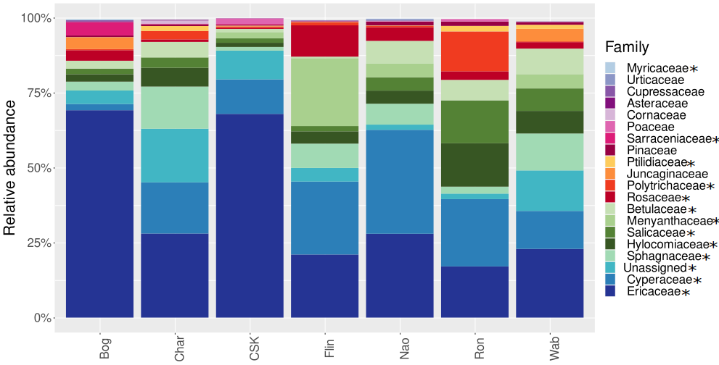
Supplementary Figure S1. Relative abundance of the twenty most abundant plant families detected in caribou fecal DNA based on the sequencing of the plant ITS2 region, by location. Bog = The Bog (MB), Char = Charron Lake (MB), CSK = Central Saskatchewan (SK), Flin = Flin Flon (SK), Nao = Naosap-Reed (MB), Ron = La Ronge (SK) and Wab = Wabowden (MB). Black stars indicate phyla for which the Kruskal-Wallis test was significant at p<0.05.
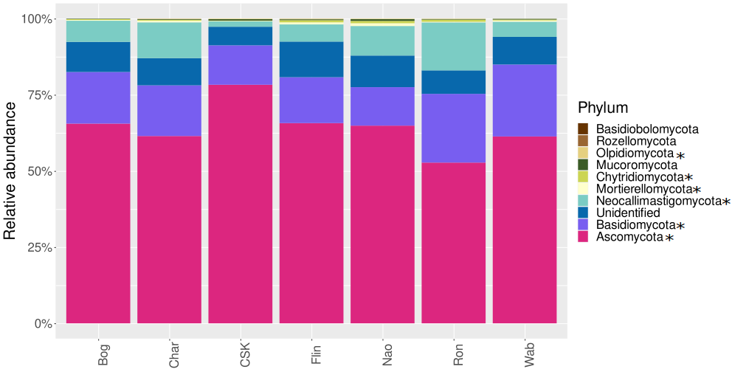
Supplementary Figure S2. Relative abundance of fungal phyla detected in caribou fecal DNA based on the sequencing of the fungal ITS2 region, by location. Bog = The Bog (MB), Char = Charron Lake (MB), CSK = Central Saskatchewan (SK), Flin = Flin Flon (SK), Nao = Naosap-Reed (MB), Ron = La Ronge (SK) and Wab = Wabowden (MB). Black stars indicate phyla with significantly different relative abundances between locations.
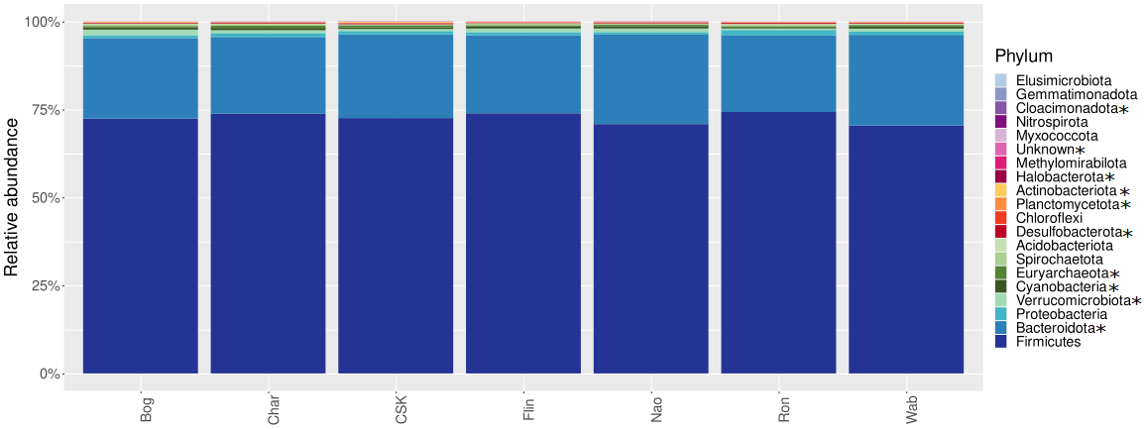
Supplementary Figure S3. Relative abundance of bacterial phyla detected in caribou fecal DNA based on the sequencing of the 16S rRNA gene, by location. Bog = The Bog (MB), Char = Charron Lake (MB), CSK = Central Saskatchewan (SK), Flin = Flin Flon (SK), Nao = Naosap-Reed (MB), Ron = La Ronge (SK) and Wab = Wabowden (MB). Black stars indicate phyla with significantly different relative abundances between locations.

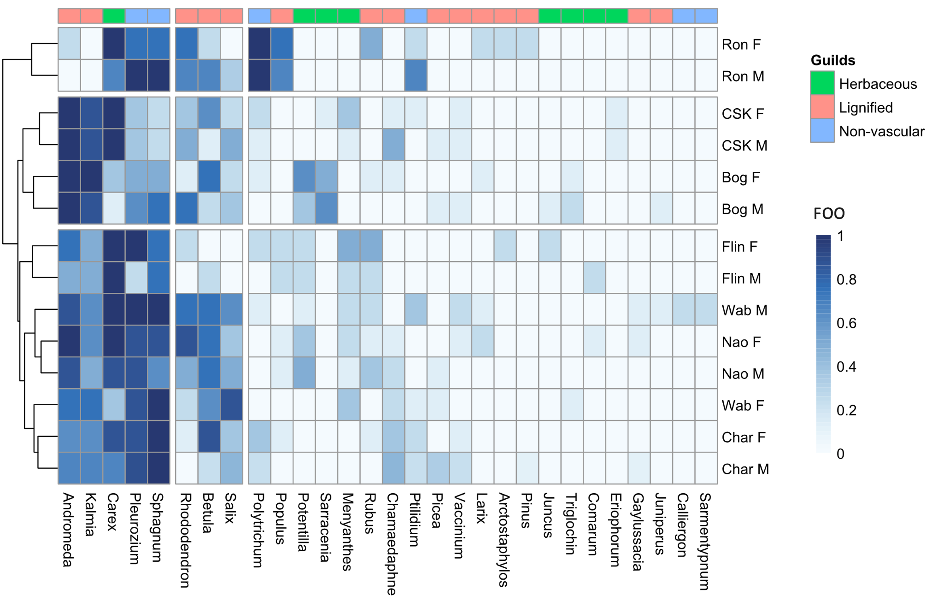
Supplementary Figure S4. Heatmap of the frequency of occurrence of plant genera composing the caribou diet based on the sequencing of the plant and fungal ITS2 regions from fecal DNA, by location and sex. Bog = The Bog (MB), Char = Charron Lake (MB), CSK = Central Saskatchewan (SK), Flin = Flin Flon (SK), Nao = Naosap-Reed (MB), Ron = La Ronge (SK) and Wab = Wabowden (MB). F = Female, M = Male.

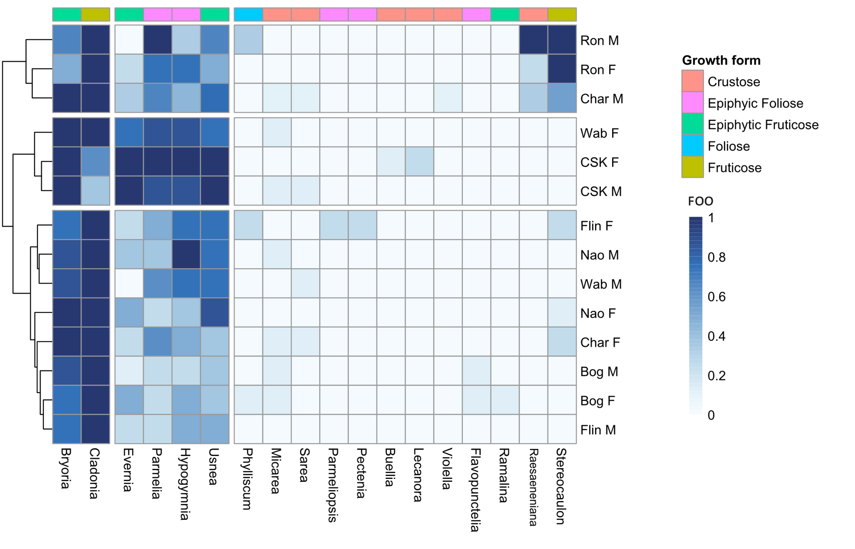
Supplementary Figure S5. Heatmap of the frequency of occurrence of lichen genera composing the caribou diet based on the sequencing of the plant and fungal ITS2 regions from fecal DNA, by location and sex. Bog = The Bog (MB), Char = Charron Lake (MB), CSK = Central Saskatchewan (SK), Flin = Flin Flon (SK), Nao = Naosap-Reed (MB), Ron = La Ronge (SK) and Wab = Wabowden (MB). F = Female, M = Male.
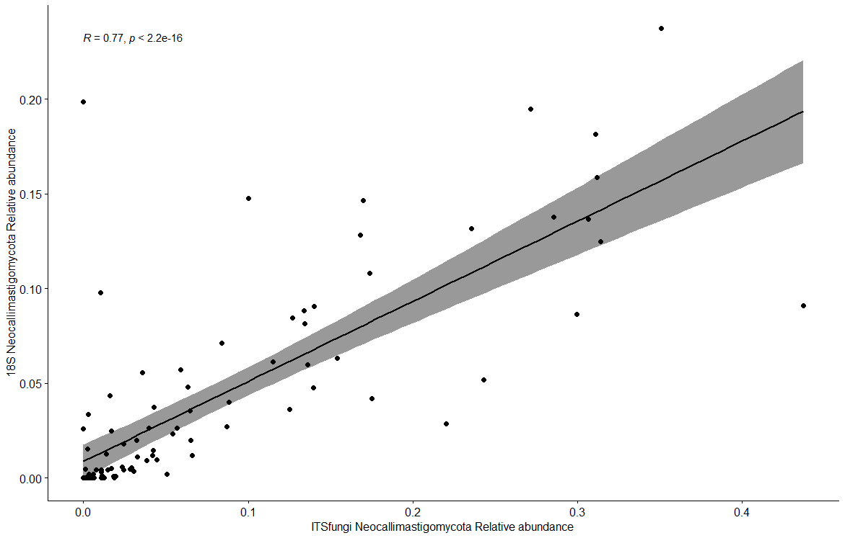
Supplementary Figure S6. Pearson correlation between the relative abundance of the Neocallimastigomycota phylum based on sequencing of the ITS2 region (X-axis) and the 18S rRNA gene (Y-axis).

