Supplemental Figures
Figure S1: COG classification of the identified succinylated proteins.
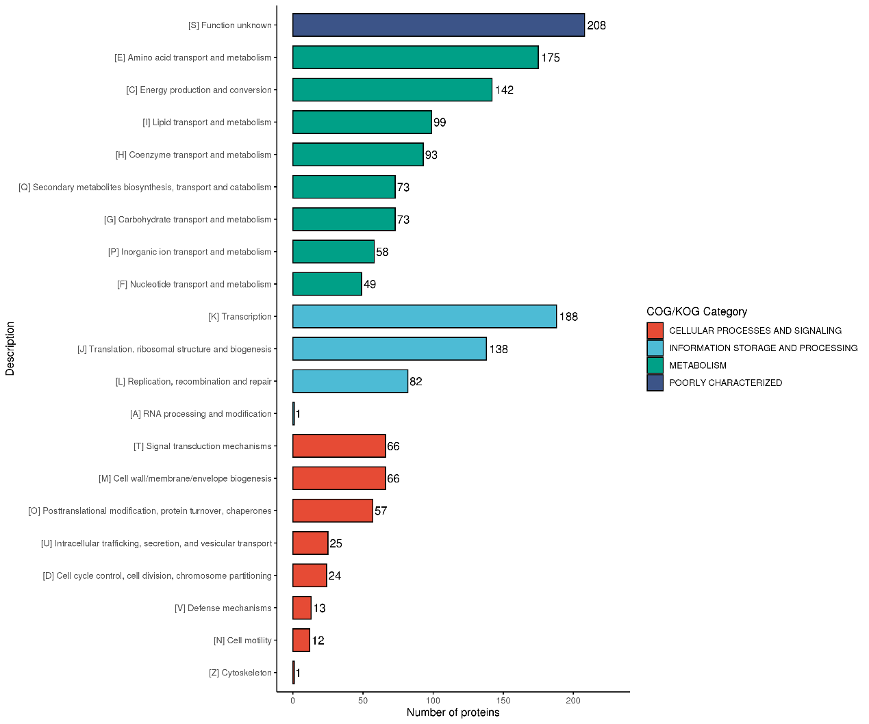

Figure S2 KEGG enrichment analysis of the acetylated proteins in S. erythraea. A two-tailed Fisher's exact test was used, p-value < 0.05 were considered significant
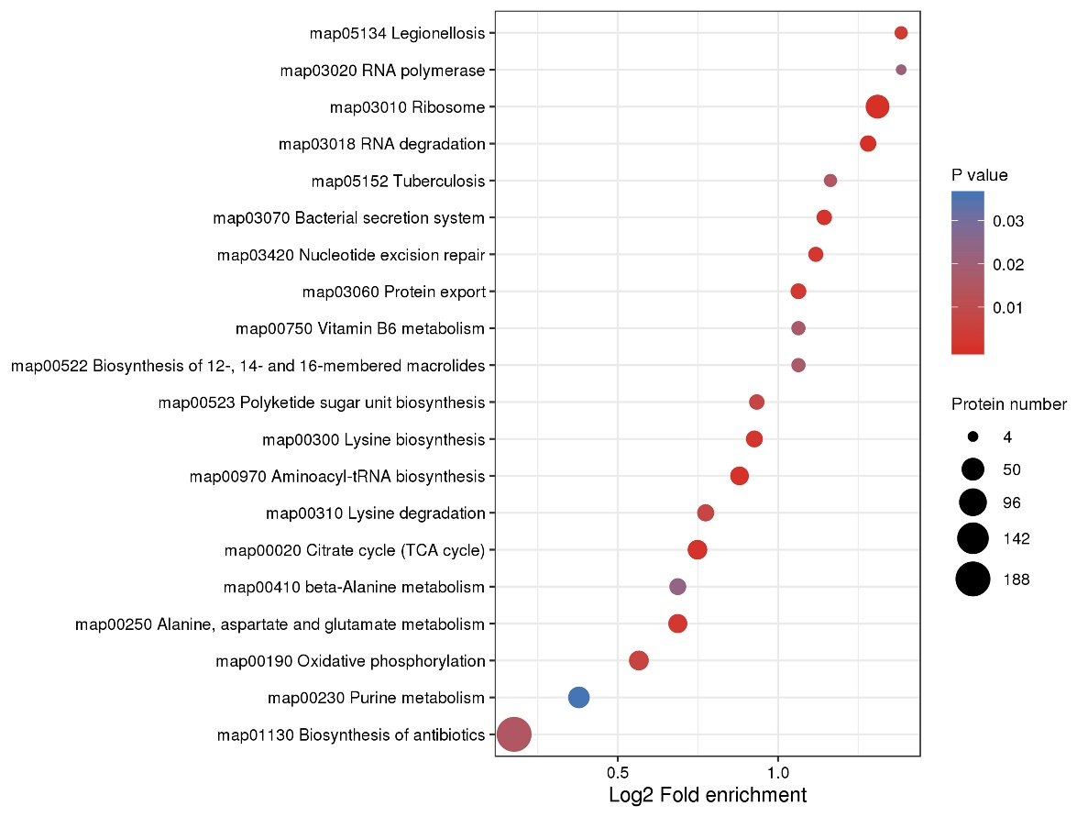
. Figure S3: Domain enrichment analysis of the succinylated proteins in
S. erythraea.
