Appendix A
eFigure 1. The flow chart of the selection of study participants. QI, quality indicator.
eFigure 2. The QIs estimates results FE model ($σ^{2}$) by bootstrap method.
eFigure 3. Trends in QIs FE model estimates ($σ^{2}$) from 2019 to 2023 by bootstrap method.

eFigure 1. The flow chart of the selection of study participants.
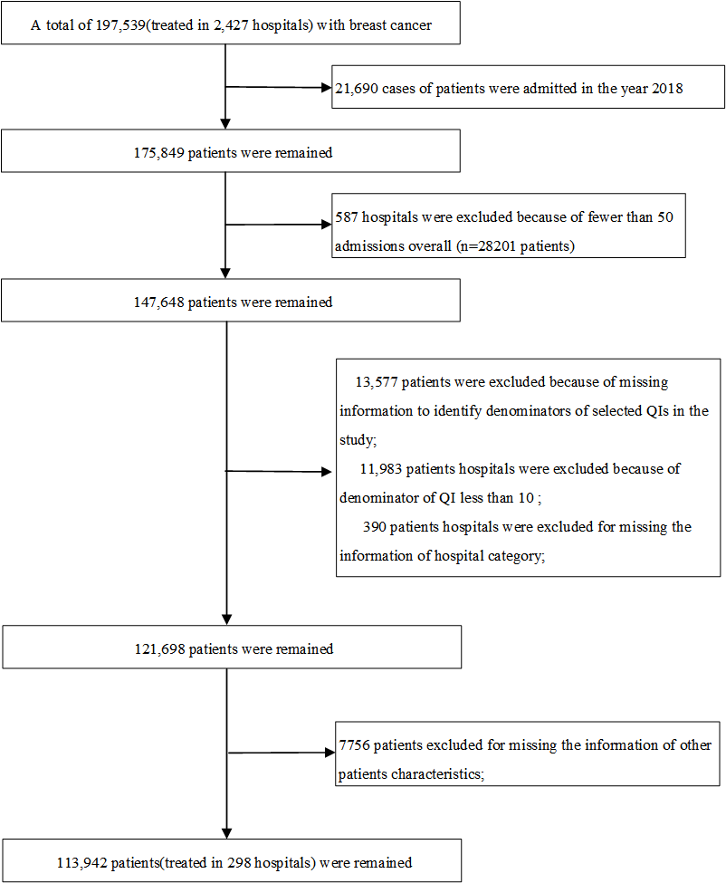

eFigure 2. The QIs estimates results FE model ($σ^{2}$) by bootstrap method.
* The red dots are the results of the raw data for this study, the blue horizontal line the median of the bootstrap sampling results, and the blue dashed line the Q1 and Q3 of the bootstrap sampling results.

eFigure 3. Trends in QIs FE model estimates ($σ^{2}$) from 2019 to 2023 by bootstrap method.

