Table 1. Molecular weight, Molecular formula, and structure of selected phytochemicals of Z. armatum.
Ligand name | PubChem CID | Molecular formula | Molecular weight | Structure
α -Fenchol | CID 439711 | C₁₀H₁₈O | 154.25g/mol | 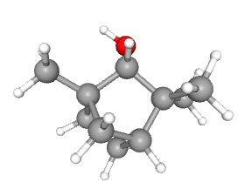
α -Terpinene | CID 7462 | C₁₀H₁₆ | 136.23 g/mol | 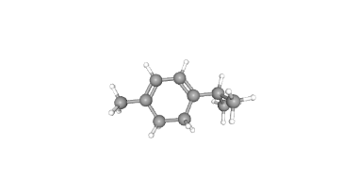
α -Thujene | CID 6451618 | C₁₀H₁₆ | 136.23 g/mol | 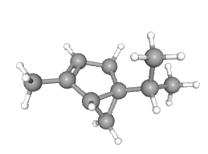
α --Thujone | CID 261491 | C₁₀H₁₆O | 152.23 g/mol | 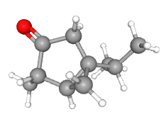
α-Pinene | CID 6654 | C₁₀H₁₆ | 136.23 g/mol | 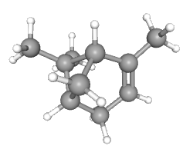
α-Terpineol | CID 17100 | C₁₀H₁₈O | 154.25 g/mol | 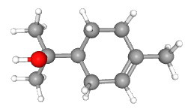
β-Terpineol | CID 8748 | C₁₀H₁₈O | 154.25 g/mol | 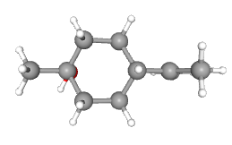
Camphor | CID 2537 | C₁₀H₁₆O | 152.23 g/mol | 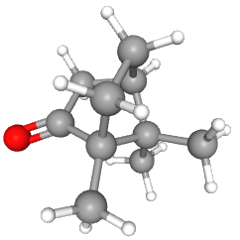
Citral | CID 638011 | C₁₀H₁₆O | 152.23 g/mol | 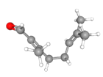
Citronellol | CID 8842 | C₁₀H₂₀O | 156.26 g/mol | 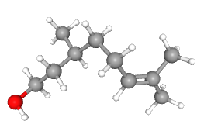
Citronellal | CID 7794 | C₁₀H₁₈O | 154.25 g/mol | 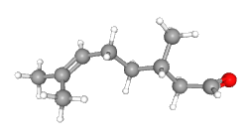
1,8-cineole | CID2758 | C₁₀H₁₈O | 154.25 g/mol | 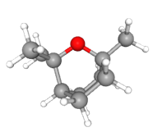
Cis -ocimene | CID 5320250 | C₁₀H₁₆ | 136.23 g/mol | 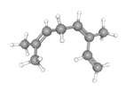
Geraniol | CID637566 | C₁₀H₁₈O | 154.25 g/mol | 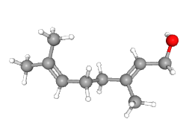
$Ɣ$-terpinene | CID7461 | C₁₀H₁₆ | 136.23 g/mol | 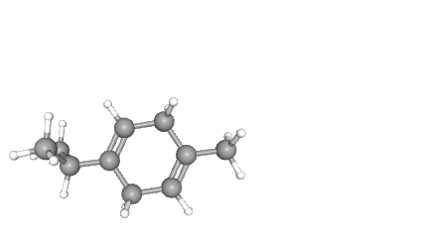
Limonene | CID22311 | C₁₀H₁₆ | 136.23 g/mol | 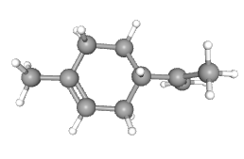
Linalool | CID6549 | C₁₀H₁₈O | 154.25 g/mol | 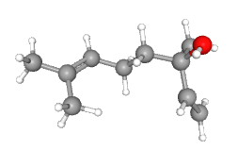
Myrcene | CID31253 | C₁₀H₁₆ | 136.23 g/mol | 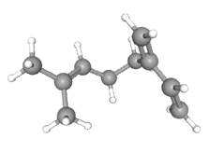
Nerol | CID643820 | C₁₀H₁₈O | 154.25 g/mol | 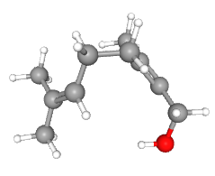
P-cymene | CID7463 | C₁₀H₁₄ | 134.22 g/mol | 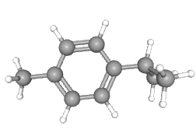
Piperitone | CID 6987 | C₁₀H₁₆O | 152.23 g/mol | 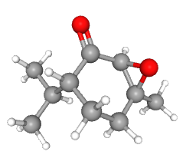
Sabinene | CID 18818 | C₁₀H₁₆ | 136.23 g/mol | 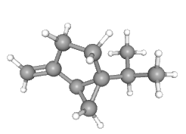
Tagetonol | CID 522417 | C₁₀H₁₈O2 | 170.25 g/mol | 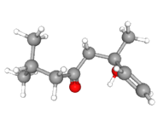
Terpinen-4-ol | CID11230 | C₁₀H₁₈O | 154.25 g/mol | 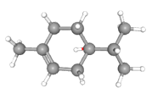
(Z)-Sabinene hydrate | CID62367 | C₁₀H₁₈O | 154.25 g/mol | 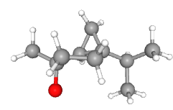
(Z)-Linalool oxide | CID6431477 | C₁₀H₁₈O2 | 170.25g/mol | 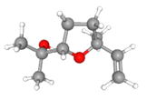
Allo-Aromadenderene | CID10899740 | C₁₅H₂₄ | 204.35 g/mol | 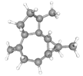
β-caryophllene | CID 5281515 | C₁₅H₂₄ | 204.35 g/mol | 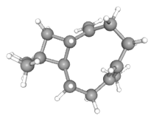
(E)-nerolidol | CID 5284507 | C₁₅H₂₆O | 222.37g/mol | 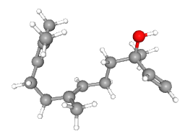
α-Amyrins | CID 73170 | C₃₀H₅₀O | 426.7g/mol | 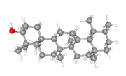
lupeol | CID259846 | C₃₀H₅₀O | 426.7g/mol | 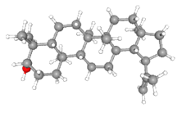
Cuminal | CID325 | C₁₀H₁₄O | 150.22 g/mol | 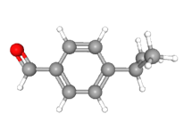
Cinnamic aldehyde | CID637511 | C₉H₈O | 132.16g/mol | 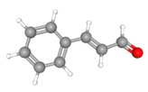
Phellandral | CID 89488 | C₁₀H₁₆O | 152.23g/mol | 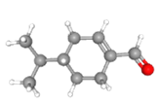
2-Tridecanone | CID 11622 | C₁₃H₂₆O | 198.34g/mol | 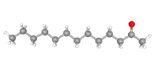
Berberine | CID2353 | C₂₀H₁₈NO₄⁺ | 336.4g/mol | 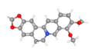
Dictamnine | CID 68085 | C₁₂H₉NO₂ | 199.20g/mol | 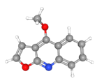
Haplopine | CID5281846 | C₁₃H₁₁NO₄ | 245.13g/mol | 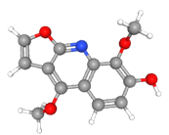
Magnoflorine | CID 73337 | C₂₀H₂₄NO₄⁺ | 342.4g/mol | 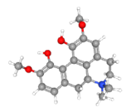
Nitidine | CID 4501 | C₂₀H₂₄NO₄⁺ | 342.4g/mol | 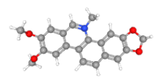
Nevadensin | CID160921 | C₁₈H₁₆O₇ | 344.3g/mol | 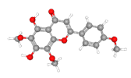
Robustinee | CID164950 | C₁₂H₉NO₃ | 215.20g/mol | 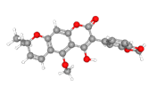
Sanguinarine | CID5154 | C₂₀H₁₄NO₄⁺ | 332.3g/mol | 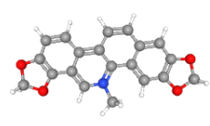
Skimmianine | CID6760 | C₁₄H₁₃NO₄ | 259.26 g/mol | 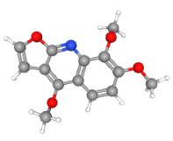
Zanthonitrile | CID 5315425 | C₁₃H₁₅NO | 201.26g/mol | 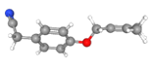
Bergapten | CID 2355 | C₁₂H₈O₄ | 216.19g/mol | 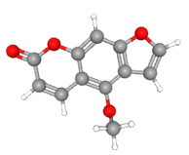
Umbelliferon | CID5281426 | C₉H₆O₃ | 162.14 g/mol | 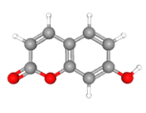
3,5-Diacetyltambulin | CID5316626 | C₂₂H₂₀O₉ | 428.4 g/mol | 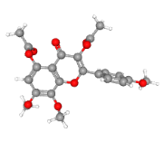
Kaempferol | CID5280863 | C₅₁H₁₀O₆ | 286.24 g/mol | 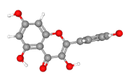
Tambulin | CID5281700 | C₁₈H₁₆O₇ | 344.3 g/mol | 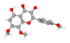
Tambuletin | CID 9936050 | C₂₃H₂₄O₁₃ | 508.4g/mol | 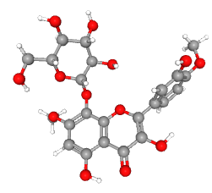

Table 5. Predicted toxicity of risk assessment of phytoconstituents of Zanthoxylum armatum

Phytoconstituents | Mutagenicity | hepatoxicity | immunotoxicity | cytotoxicity | carcinogenicity
α-Fenchol
Α-Terpinene
Α-Thujene
Α-Thujone
Α-Pinene
Α-Terpineol
Betα-Terpineol
Camphor

Citral
Citronellal
Citronellol
1,8-cineolee
Cis-ocimene
Geraniol
Gammα-terpinene
(E) linalool
Limonene
Linalool
Nerol
p-cymene
Piperitone
Sabinene
Tagetonol
(z)-sabinene hydrate
(z)-linalool
Oxide
Alloarmadendrene
Betα-cryophyllene
Nerolidol
Lupeol
Α-Amyrins
Cuminal
Cinnamic aldehyde
Cinnamic aldehyde
Phellandral
2-tridecanone
Berberine
Dictamnine
Haplopine
Magnoflorine
Nitidine
Nevadensin
Robustine
Sanguinarine
Skimmiamine
Zanthonitrile
Bergapten
Umbelliferon
Tambulin
Tambuletin
Kaempferol
3,5-diacetyltumbulin

Strongly toxic

Strongly non-toxic

Less non-toxic

Less toxic

