Supplementary materials

A
Prevalence (%)
B

Supplementary Figure 1. Yearly malaria prevalence by polymerase chain reaction (PCR) and Microscopy. A) Ungoye. B) Mfangano island. Error bars represent 95% confidence intervals. No surveys were conducted in 2016.

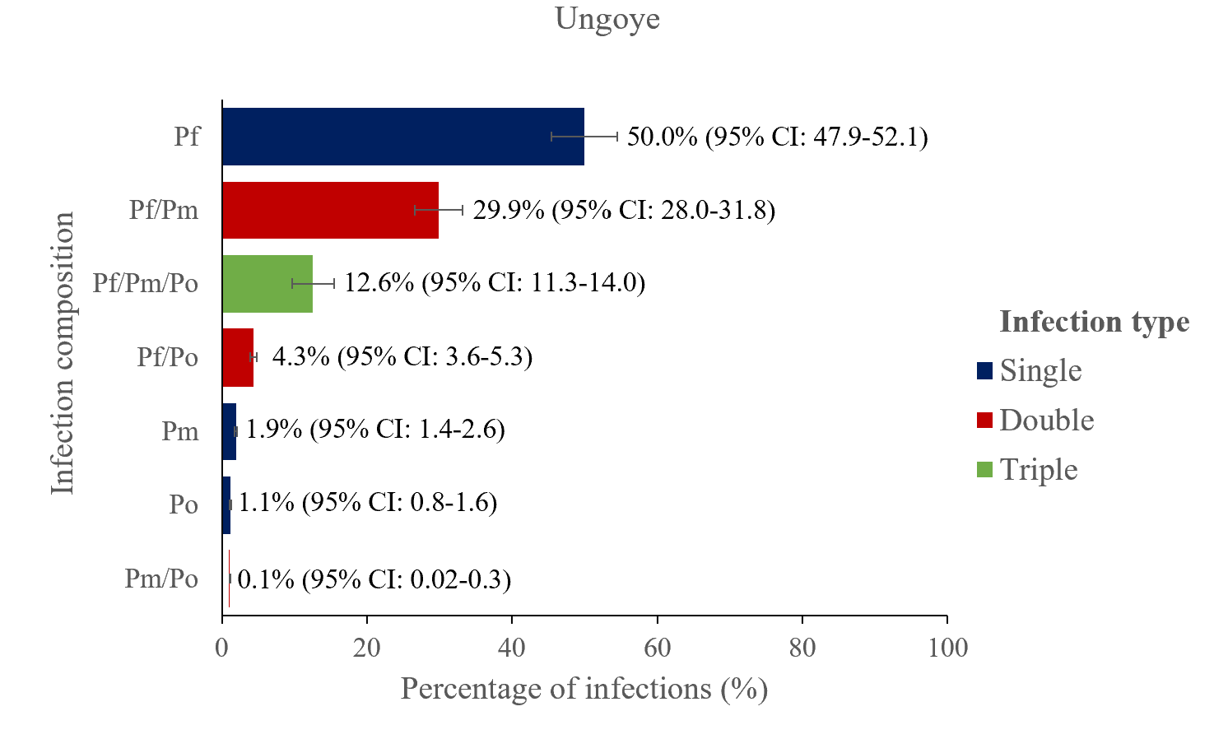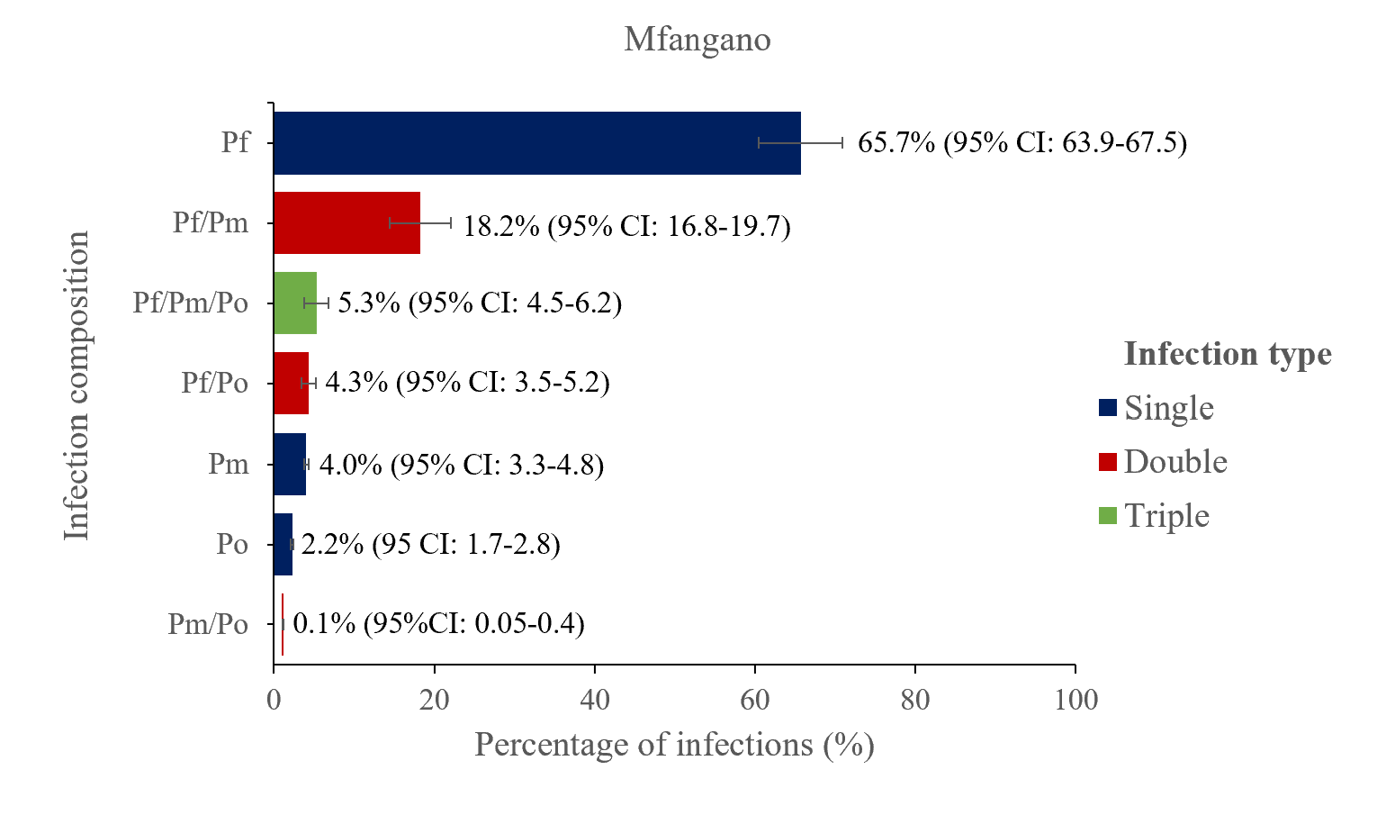Suplementary Figure 2. The proportion of Plasmodium mono and mixed-species infections among the positive cases by polymerase chain reaction in Mfangano island (n=2709) and Ungoye (n=2260). The error bars represent a 95% confidence interval (CI). Abbreviations; CI, confidence interval; Pf, Plasmodium falciparum; Pm, Plasmodium malariae; Po, Plasmodium ovale.
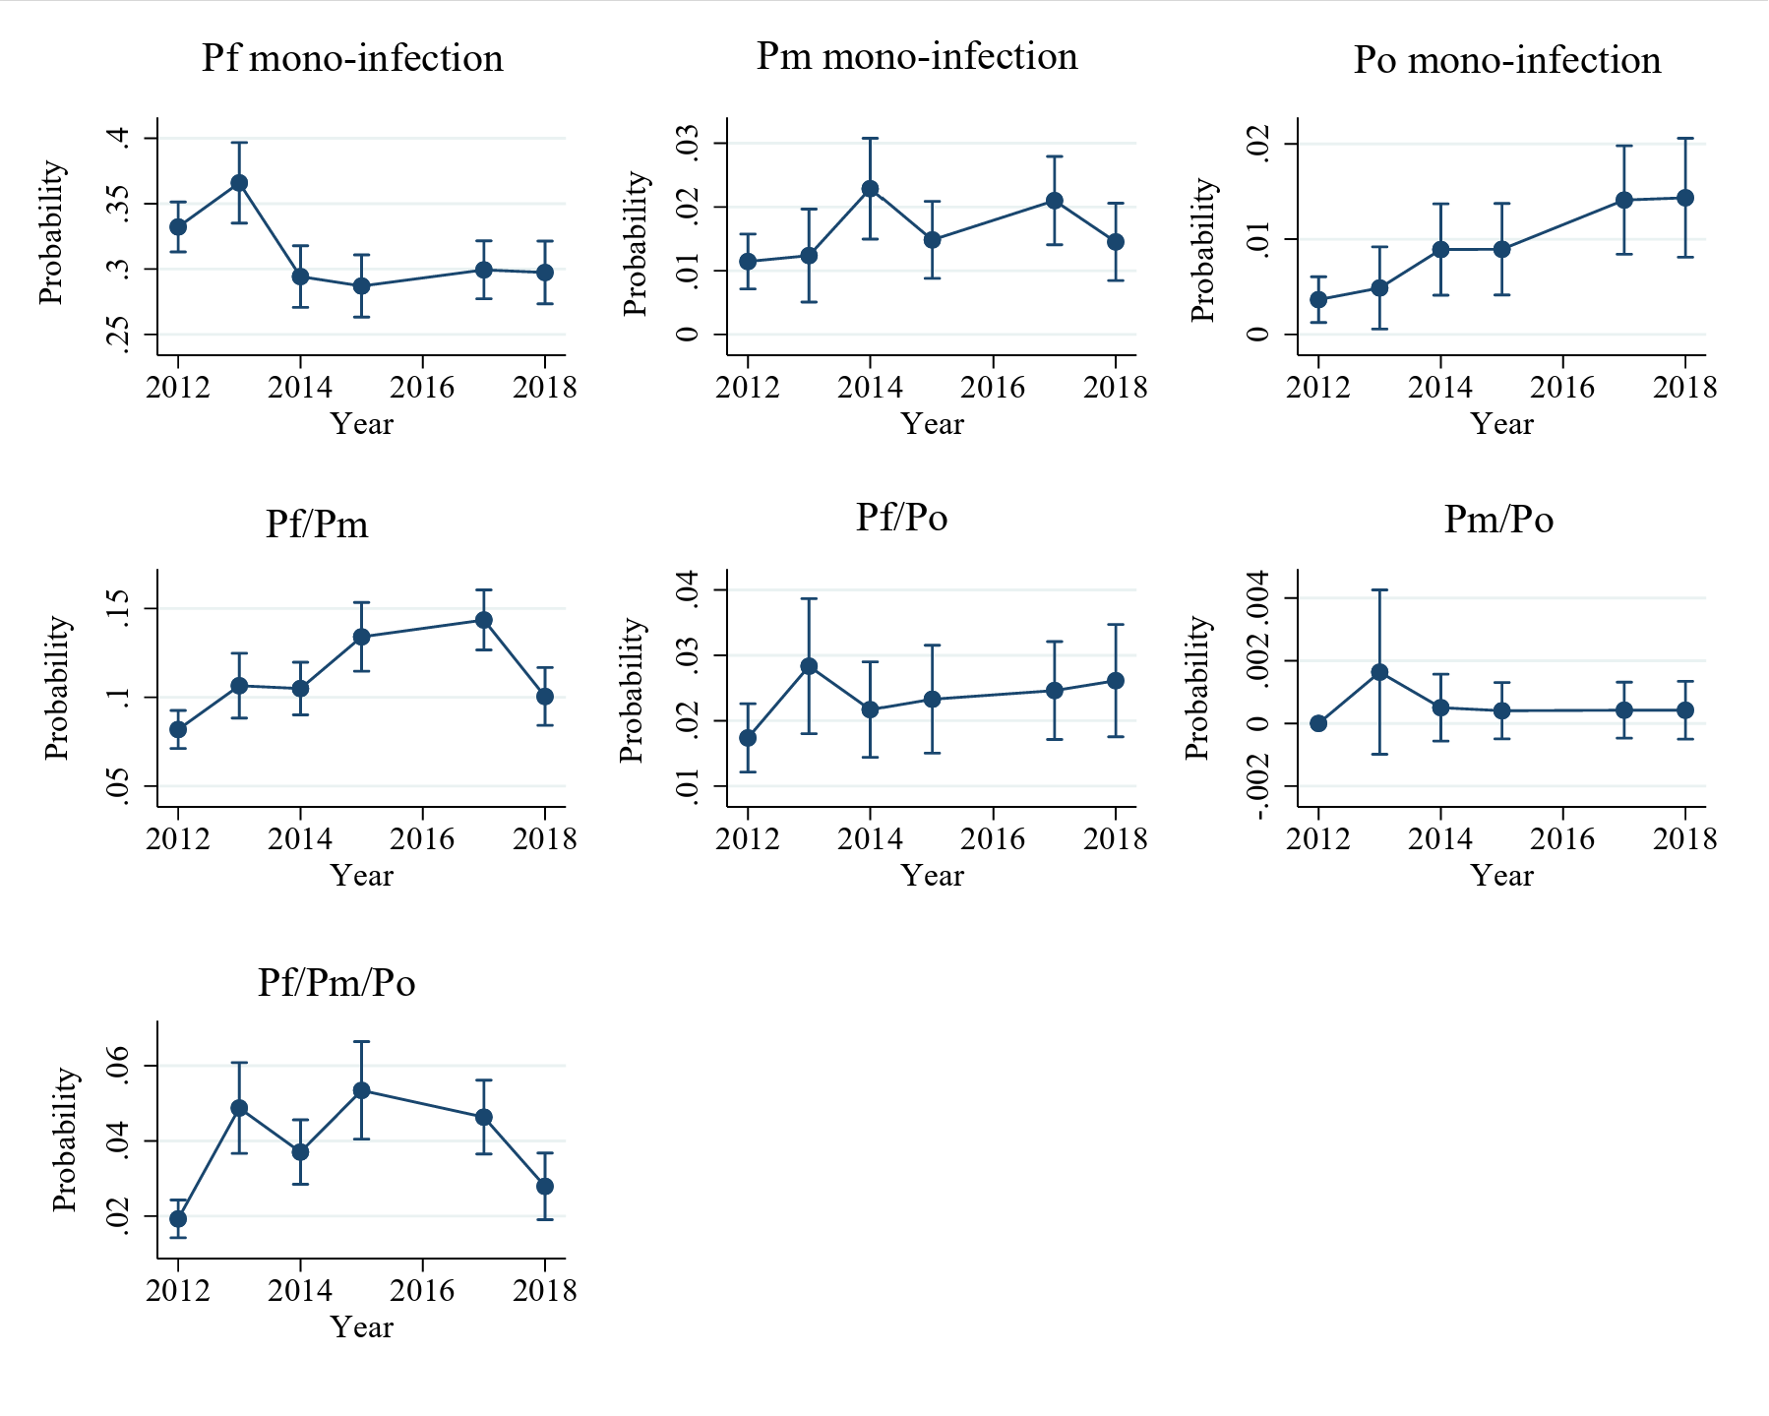
G
F
E
D
A
B
C
Supplementary Figure 3. Multinomial logistic model adjusted predicted probabilities Plasmodium infections overtime. A) P. falciparum mono-infection, B) P. malariae mono-infection, C) P. ovale mono-infection, D) P. falciparum + P. malariae mixed infection, E) P. falciparum + P. ovale mixed infection, F) P. malariae + P. ovale mixed infection, G) P. falciparum + P. malariae + P. ovale mixed infection. The model predicted the probability of infection over time. Predictions are adjusted for age, sex and study site with all covariates at their respective means. The error bars indicate the 95% confidence interval of the prediction. No surveys were conducted in 2016.

