Table S1 Cell vibration exposure conditions in vitro
Frequency（Hz） | 10 | 15 | 20 | 25 | 40 | 80 | 100 | 120 | 125 | 130 | 150 | 180 | 195 | 200 | 205 | 500
Acceleration（m·s-2） | 6.9 | 5.9 | 16.1 | 6.7 | 13.3 | 6.6 | 6.5 | 6.4 | 6.4 | 6.2 | 5.8 | 5.1 | 5.2 | 5.3 | 5.4 | 3.1

Table S2 Primer sequences for PCR Gene-Human
Gene |  | Primer sequences
MEG3 |  | Forward:5'-CCTGCTGCCCATCTACACCTC-3'
 |  | Reverse:5'-CCTCTTCATCCTTTGCCATCCTGG-3'
NEAT1 |  | Forward:5'-TGGCTAGCTCAGGGCTTCAG-3'
 |  | Reverse:5'-TCTCCTTGCCAAGCTTCCTTC-3'
MALAT1 |  | Forward:5'-TAGGAAGACAGCAGCAGACAGG-3'
 |  | Reverse: 5'-TTGCTCGCTTGCTCCTCAGT-3'
TUG1 |  | Forward:5'-TGAGCAAGCACTACCACCAG-3'
 |  | Reverse:5'-GGAGTGGAGGTAAAGGCCAC-3'
GAPDH |  | Forward:5'-TGAAGGTCGGAGTCAACGGATTTGGT-3'
 |  | Reverse:5'-CATGTGGGCCATGAGGTCCACCAC-3'

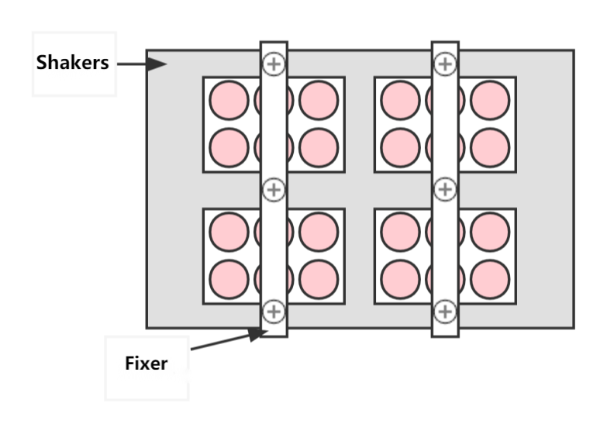
Figure S1 Schematic diagram of cell vibration experiment

