Table S1. The detailed quantitative metrics of the animal and clinical CV model
Model | DSC | TPR | PPV | HD-95
Animal train set
Animal CV model 1 | 0.96(0.95-0.96) | 0.96(0.95-0.97) | 0.96(0.96-0.97) | 5.14(4.23-6.20)
Animal CV model 2 | 0.95(0.95-0.96) | 0.95(0.94-0.95) | 0.97(0.97-0.97) | 5.90(4.73-7.27)
Animal CV model 3 | 0.96(0.95-0.96) | 0.96(0.95-0.97) | 0.97(0.97-0.97) | 5.75(4.30-7.35)
Animal validation set
Animal CV model 1 | 0.97(0.97-0.97) | 0.97(0.97-0.98) | 0.97(0.97-0.97) | 5.77(3.89-7.97)
Animal CV model 2 | 0.97(0.97-0.97) | 0.96(0.96-0.97) | 0.98(0.97-0.98) | 6.23(3.35-9.90)
Animal CV model 3 | 0.95(0.93-0.96) | 0.95(0.93-0.97) | 0.96(0.96-0.97) | 12.37(5.98-20.30)
Animal test set
Animal CV model 1 | 0.90(0.86-0.94) | 0.91(0.86-0.95) | 0.95(0.93-0.96) | 5.61(2.47-9.50)
Animal CV model 2 | 0.91(0.86-0.94) | 0.89(0.85-0.93) | 0.95(0.93-0.97) | 4.57(2.54-7.41)
Animal CV model 3 | 0.91(0.86-0.95) | 0.91(0.87-0.95) | 0.95(0.93-0.97) | 9.48(3.13-18.33)
Animal train set
Clinical CV model 1 | 0.98(0.97-0.98) | 0.98(0.97-0.98) | 0.98(0.98-0.98) | 1.64(1.45-1.85)
Clinical CV model 2 | 0.97(0.97-0.97) | 0.98(0.97-0.98) | 0.97(0.96-0.97) | 2.40(1.71-3.60)
Clinical CV model 3 | 0.96(0.94-0.98) | 0.96(0.94-0.98) | 0.98(0.98-0.98) | 1.61(1.43-1.82)
Animal validation set
Clinical CV model 1 | 0.90(0.86-0.94) | 0.88(0.82-0.93) | 0.94(0.89-0.98) | 19.45(7.59-34.14)
Clinical CV model 2 | 0.87(0.81-0.93) | 0.85(0.77-0.92) | 0.91(0.86-0.95) | 20.81(8.37-36.05)
Clinical CV model 3 | 0.88(0.83-0.93) | 0.87(0.81-0.93) | 0.91(0.86-0.96) | 13.08(4.00-26.17)
Animal test set
Clinical CV model 1 | 0.73(0.65-0.81) | 0.79(0.72-0.87) | 0.73(0.64-0.82) | 18.33(11.29-26.37)
Clinical CV model 2 | 0.75(0.67-0.83) | 0.80(0.73-0.87) | 0.74(0.65-0.82) | 21.65(12.11-33.04)
Clinical CV model 3 | 0.73(0.64-0.81) | 0.80(0.72-0.88) | 0.75(0.65-0.83) | 15.13(9.69-21.12)
TPR: true positive rate; PPV: true positive rate; HD-95: 95% Hausdorff distance; CV: cross-validation.

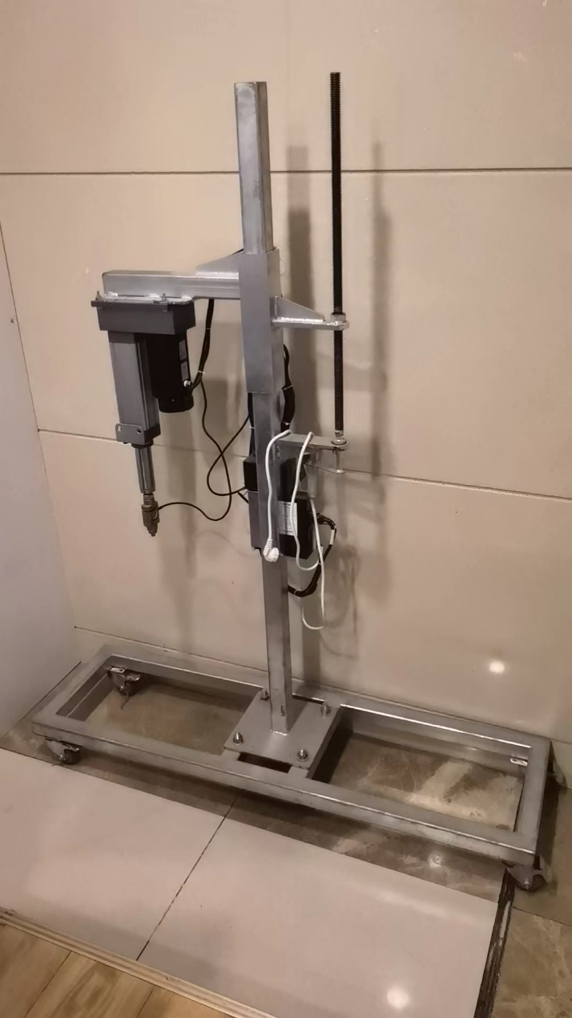
Supplementary Figure S1. The self-made percussion device to establish the liver parenchyma contusion and laceration model.

Supplementary Method

Detailed Classification Model
The RefineNet [1] was used as a segmentation model for GS US images. The detailed construction of the proposed model is described below.

Model Construction

RefineNet
The Structure of RefineNet [1] is shown in Figure S1, including ResNet101 [2] module, 4 RefineBlock, and two Residual Convolution Units. The structure of ResNet101 module is shown in the next part. The RefineBlock is constructed by three or five Residual Convolution Units, a Multi-Resolution Fusion Unit, and a Chained Residual Pooling Unit.
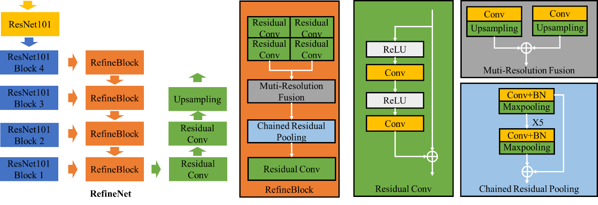
Supplementary Fig S2. The Structure of RefineNet. The whole model is constructed by 2D Convolution Layers, Batch Normalization Layers, ReLu Activation Layers, MaxPooling Layers, and Upsampling Layers.

ResNet101
The structure of ResNet101, including a combination of convolution blocks and identity blocks, is shown in Figure S2. The whole model is constructed by Zeros Padding Layers, 2D Convolution Layers, Batch Normalization Layers, ReLu Activation Layers, MaxPooling Layers, Average Pooling Layers, Flatten Layers, and Full Connection Layers.

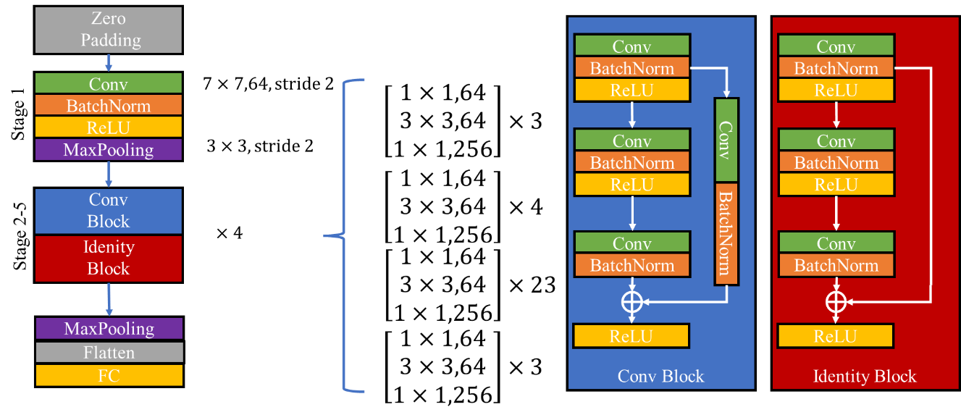
Supplementary Fig S3. The Structure of ResNet101. The whole model is constructed by Zeros Padding Layers, 2D Convolution Layers, Batch Normalization Layers, ReLu Activation Layers, MaxPooling Layers, Average Pooling Layers, Flatten Layers, and Full Connection Layers.

Mathematic of Layers

Convolution
Convolution is a basic operation to extract the local features in an image [1], which can be expressed as
$$g\left(i,j\right)=\sum_{k,l}{f\left(i+k,j+l\right)h(k,l)},$$
where $f(i,j)$ is the original image (e.g. GS US image in this task), $h(k,l)$ is the convolution kernel, and $g(i,j)$ is the feature image.

Batch normalization
Batch normalization (BN) is a non-parametric operation used to accelerate the training process and deal with the over-fit problem [4]. The BN is a practical method to normalize the model and enable higher learning rates. The formula can be expressed as
$$\hat{x}=\frac{x-E\left[x\right]}{\sqrt{Var\left[x\right]+ϵ}}$$
where $E\left[x\right]$ is the expectation over training mini-batches, and $Var\left[x\right]=\frac{m}{m-1}\dot{E_{B}}\left[σ_{B}^{2}\right]$ is the unbiased variance estimate over training mini-batches of size $m$ and sample variances $σ_{B}^{2}$.

Non-linear activation
Non-linear activation is a non-linear function that can transform the linear system into a non-linear one. The operation is usually a map function to enhance the fitting ability of the model. Sigmoid function and ReLU function [5] were utilized in our models (both element-wise). The sigmoid function is formulated as

$$f\left(x\right)=\frac{1}{1+e^{-x}}$$
and this activation was used in the last convolution layer. The ReLU function is expressed as
$$f\left(x\right)=\max\left(x,0\right)$$
and this operation was usually utilized after the batch normalization layer.

Pooling
The pooling operation is a method to reduce the parameters and redundant information. Because of the static property of the image, local features can be described by statistics of the local region. Thus, the operation paid more attention to the whole image domain and ignored the local information, which led to the invariance in translation, rotation, and scale. In this study, we use 2D max pooling, 2D average pooling.

Upsampling
The upsampling operation is an inverse pooling method, mainly used to interpolate the input images. The model can obtain the same size image before the pooling operation through the upsampling operation.

Detailed Training
The training process is an optimization process to obtain the parameters in the DL model. In our study, the DL model was trained in two steps. First, the animal deep learning model was trained by animal US images via 3-fold cross-validation. Second, three animal CV models were fine-tuned by a few clinical US images and ensembled as the final DL model. The data underwent augmentation to overcome the overfit in the training process. The augmentation included randomly flipping vertically and horizontally. The segmentation model was aimed at locating the ROI. Dice loss was utilized for segmentation, which can be expressed as

$$L=(2*\sum_{n}{\left[x*y\right]})/(\sum_{n}{\left[x\right]}+\sum_{n}{\left[y\right]})$$
where the sample number is $n$, x is the prediction, and y is the ground truth. An algorithm for first-order gradient-based optimization of stochastic objective functions, based on adaptive estimates of lower-order moments (Adam) [7], served as an optimizer. The detailed training information is listed in Table S1.

Table S1. Training information
Animal Cross Validation Model
Learning Rate | 1e-04 | Batch Size | 8
Epoch | 80 | augmentation | 1
Pretrained | ImageNet | Finetuned | Last 12 Layers
Clinical Model
Learning Rate | 1e-05 | Batch Size | 16
Epoch | 100 | augmentation | 2
Pretrained | ImageNet | Finetuned | Last 7 Layers

References
[1]. Lin, Guosheng, et al. "Refinenet: Multi-path refinement networks for high-resolution semantic segmentation." Proceedings of the IEEE conference on computer vision and pattern recognition. 2017.
[2]. He, Kaiming, et al. "Deep residual learning for image recognition." Proceedings of the IEEE conference on computer vision and pattern recognition. 2016.
[3] LeCun, Yann, and Yoshua Bengio. "Convolutional networks for images, speech, and time series." The handbook of brain theory and neural networks 3361.10 (1995): 1995.
[4] Ioffe, Sergey, and Christian Szegedy. "Batch normalization: Accelerating deep network training by reducing internal covariate shift." arXiv preprint arXiv:1502.03167 (2015).
[5] Glorot X, Bordes A, Bengio Y (2011) Deep sparse rectifier networks. AISTATS 315-323.
[6] Hochreiter, Sepp, and Jürgen Schmidhuber. "Long short-term memory." Neural computation 9.8 (1997): 1735-1780.
[7] Kingma, Diederik P., and Jimmy Ba. "Adam: A method for stochastic optimization." arXiv preprint arXiv:1412.6980 (2014).

