Table S1. Baseline characteristic of all participants before propensity score matching.
Variables | No AKI | AKI | P-value
Variables | N=317 | N=1118 | P-value
Age, year | 68.29 (14.39) | 69.88 (13.56) | 0.069
Gender (Female), n (%) | 151 (47.6) | 500 (44.7) | 0.392
Ethnicity, n (%) |  |  | 0.855
White | 236 (74.4) | 836 (74.8)
Black | 23 (7.3) | 78 (7.0)
Hispanic | 14 (4.4) | 38 (3.4)
Asian | 7 (2.2) | 20 (1.8)
Other | 37 (11.7) | 146 (13.1)
Admission type, n (%) |  |  | 0.803
Elective | 49 (15.5) | 157 (14.0)
Emergency | 259 (81.7) | 931 (83.3)
Urgent | 9 (2.8) | 30 (2.7)
Married, n (%) | 163 (51.4) | 574 (51.3) | >0.99
Vital signs, mean (SD) or Median (IQR)
Heart rate (bpm) | 85.14 (13.86) | 85.40 (14.28) | 0.772
Respiration rate (bpm) | 18.23 (4.35) | 17.66 (4.45) | 0.043
Systolic blood pressure (mmHg) | 130.55 (22.39) | 131.69 (23.49) | 0.445
Diastolic blood pressure (mmHg) | 67.85 (12.89) | 67.73 (14.70) | 0.895
PaO2 (mmHg) | 200.40 (144.80, 271.70) | 202.00 (133.00, 299.00) | 0.800
PaCO2 (mmHg) | 39.53 (6.25) | 40.80 (6.94) | 0.003
SpO2 (%) | 97.93 (2.23) | 98.11 (2.44) | 0.258
Laboratory tests, mean (SD) or Median (IQR)
WBC count (×10⁹) | 11.54 (4.39) | 12.25 (5.13) | 0.026
Hb (g/L) | 11.30 (2.03) | 10.74 (2.28) | <0.001
Glucose, mg/dL | 138.35 (46.91) | 151.32 (51.12) | <0.001
Scr (mg/dL) | 0.90 (0.70, 1.20) | 1.00 (0.70, 1.40) | 0.001
Sodium (mmol/L) | 138.58 (3.99) | 138.26 (4.23) | 0.226
Potassium (mmol/L) | 4.09 (0.65) | 4.18 (0.73) | 0.047
APTT (seconds) | 29.50 (25.70, 36.40) | 31.70 (26.70, 40.38) | 0.001
PT (seconds) | 14.16 (2.16) | 14.89 (2.32) | <0.001
INR | 1.27 (0.28) | 1.36 (0.31) | <0.001
TC (mg/dL) | 154.12 (141.00, 172.30) | 151.30 (135.00, 167.18) | 0.018
TG (mg/dL) | 135.80 (100.40, 172.00) | 128.10 (97.40, 167.78) | 0.165
HDL-C (mg/dL) | 43.70 (37.00, 52.40) | 41.25 (34.40, 50.00) | 0.001
LDL-C (mg/dL) | 80.80 (67.00, 94.20) | 81.88 (68.52, 93.48) | 0.649
Complications, n (%)
Hyperlipidemia | 152 (47.9) | 515 (46.1) | 0.596
Hypertension | 205 (64.7) | 667 (59.7) | 0.122
AMI | 52 (16.4) | 255 (22.8) | 0.017
DM | 103 (32.5) | 459 (41.1) | 0.007
Thrombolytic Agent, n (%) | 35 (11.0) | 97 (8.7) | 0.198
Saps II score (IQR) | 32.00 (25.00, 42.00) | 38.00 (31.00, 47.00) | <0.001
SOFA score (IQR) | 3.00 (1.00, 5.00) | 4.00 (3.00, 7.00) | <0.001
Abbreviation: SpO2, pulse oxygen saturation; PaO2, partial pressure of oxygen; PaCO2, partial pressure of carbon dioxide; WBC, white blood cell; Hb, hemoglobin; Scr, serum creatinine; PT, prothrombin time; APTT, activated partial thromboplastin time; INR, international normalized ratio; TC, total cholesterol; TG, triglycerides; HDL-C, high-density lipoprotein cholesterol; LDL-C, low-density lipoprotein cholesterol; AMI, acute myocardial infarction; DM, diabetes mellitus; SAPS, simplified acute physiology score; SOFA, sequential organ failure assessment; AKI, acute kidney injury; SD, standard deviation; IQR; interquartile range.

Table S2. Stepwise linear regression analyzes the relationship between serum lactate level and serum glucose among patients with acute ischemic stroke.
Model | Beta (95% CI) | P-value
Model 1 | 0.004 (0.002-0.005) | <0.001
Model 2 | 0.004 (0.003-0.006) | <0.001
Model 3 | 0.004 (0.003-0.006) | <0.001
Model 1 adjusted for age, sex, ethnicity, admission type, married.
Model 2 adjusted for age, sex, ethnicity, admission type, married, HR, RR, PaO2, PaCO2, SpO2, Systolic blood pressure, diastolic blood pressure, WBC, Hb, SCr, sodium, potassium, APTT, PT, INR, TC, TG, HDL-C, LDL-C.
Model 3 adjusted for age, sex, ethnicity, admission type, married, HR, RR, PaO2, PaCO2, SpO2, Systolic blood pressure, diastolic blood pressure, WBC, Hb, SCr, sodium, potassium, APTT, PT, INR, TC, TG, HDL-C, LDL-C, hyperlipidemia, hypertension, AMI, DM, thrombolytic agent, SAPS II score, SOFA score.
Abbreviation: SpO2, pulse oxygen saturation; PaO2, partial pressure of oxygen; PaCO2, partial pressure of carbon dioxide; WBC, white blood cell; Hb, hemoglobin; Scr, serum creatinine; PT, prothrombin time; APTT, activated partial thromboplastin time; INR, international normalized ratio; TC, total cholesterol; TG, triglycerides; HDL-C, high-density lipoprotein cholesterol; LDL-C, low-density lipoprotein cholesterol; AMI, acute myocardial infarction; DM, diabetes mellitus; SAPS, simplified acute physiology score; SOFA, sequential organ failure assessment.

Table S3. Stepwise logistic regression analyzes the relationship between serum lactate level and acute kidney injury among patients with acute ischemic stroke.
Model | OR (95% CI) | P-value
Model 1 | 1.809 (1.548-2.115) | <0.001
Model 2 | 1.986 (1.588-2.483) | <0.001
Model 3 | 2.115 (1.491-3.001) | <0.001
Model 1 adjusted for age, sex, ethnicity, admission type, married.
Model 2 adjusted for age, sex, ethnicity, admission type, married, HR, RR, PaO2, PaCO2, SpO2, Systolic blood pressure, diastolic blood pressure, WBC, Hb, SCr, sodium, potassium, APTT, PT, INR, TC, TG, HDL-C, LDL-C.
Model 3 adjusted for age, sex, ethnicity, admission type, married, HR, RR, PaO2, PaCO2, SpO2, Systolic blood pressure, diastolic blood pressure, WBC, Hb, SCr, sodium, potassium, APTT, PT, INR, TC, TG, HDL-C, LDL-C, hyperlipidemia, hypertension, AMI, DM, thrombolytic agent, SAPS II score, SOFA score.
Abbreviation: SpO2, pulse oxygen saturation; PaO2, partial pressure of oxygen; PaCO2, partial pressure of carbon dioxide; WBC, white blood cell; Hb, hemoglobin; Scr, serum creatinine; PT, prothrombin time; APTT, activated partial thromboplastin time; INR, international normalized ratio; TC, total cholesterol; TG, triglycerides; HDL-C, high-density lipoprotein cholesterol; LDL-C, low-density lipoprotein cholesterol; AMI, acute myocardial infarction; DM, diabetes mellitus; SAPS, simplified acute physiology score; SOFA, sequential organ failure assessment.

Table S4. Subgroup for the relationship between serum lactate level and serum glucose and the relationship between AKI and serum lactate level.
 | Model 1 |  |  | Model 2 |  | Model 3
 | Beta/OR (95% CI) |  | P-value | Beta/OR (95% CI) | P-value | Beta/OR (95% CI) |  |  | P-value
Lactate acid-glucose
Age, year
≤65 | 0.005(0.002,0.008) |  | 0.001 | 0.004(0.001,0.007) | 0.008 | 0.005(0.002,0.009) |  |  | 0.004
>65 | 0.004(0.003, 0.006) |  | <0.001 | 0.004(0.002, 0.006) | <0.001 | 0.004(0.002, 0.006) |  |  | <0.001
Sex
Male | 0.004(0.002,0.006) |  | <0.001 | 0.003(0.001,0.005) | 0.002 | 0.004(0.002, 0.006) |  |  | <0.001
Female | 0.005(0.003,0.008) |  | <0.001 | 0.004(0.002, 0.007) | <0.001 | 0.005(0.002, 0.007) |  |  | <0.001
Hyperlipidemia
No | 0.005(0.002,0.007) |  | <0.001 | 0.005(0.002,0.007) | <0.001 | 0.005(0.003, 0.008) |  |  | <0.001
Yes | 0.004(0.002, 0.007) |  | <0.001 | 0.004(0.001, 0.006) | 0.003 | 0.004(0.001,0.006) |  |  | 0.005
Hypertension
No | 0.006(0.003, 0.008) |  | <0.001 | 0.004(0.002, 0.007) | <0.001 | 0.005(0.002, 0.007) |  |  | <0.001
Yes | 0.003(0.001,0.005) |  | 0.004 | 0.003(0.000,0.005) | 0.023 | 0.003(0.001,0.005) |  |  | 0.017
AMI
No | 0.004(0.002, 0.006) |  | <0.001 | 0.003(0.001,0.005) | 0.003 | 0.003(0.001, 0.005) |  |  | 0.001
Yes | 0.006(0.002,0.009) |  | <0.001 | 0.006(0.003,0.010) | 0.001 | 0.007(0.003, 0.011) |  |  | <0.001
DM
No | 0.009(0.006,0.011) |  | <0.001 | 0.007(0.004,0.009) | <0.001 | 0.006(0.004,0.009) |  |  | <0.001
Yes | 0.003(0.000, 0.005) |  | 0.018 | 0.003(0.000, 0.005) | 0.025 | 0.003(0.000,0.005) |  |  | 0.03
Thrombolytic agent
No | 0.005(0.003, 0.006) |  | <0.001 | 0.004(0.002, 0.006) | <0.001 | 0.004(0.003, 0.006) |  |  | <0.001
Yes | 0.005(-0.001,0.011) |  | 0.091 | 0.000(-0.010, 0.009) | 0.962 | 0.002(-0.011, 0.015) |  |  | 0.779
AKI-lactate acid
Age, year
≤65 | 1.885(1.416,2.569) |  | <0.001 | 3.034(1.615, 6.623) | 0.002 | 38.746(3.270,10989.520) |  |  | 0.053
>65 | 1.713(1.403,2.117) |  | <0.001 | 1.805(1.352, 2.452) | <0.001 | 3.597(1.976, 7.411) |  |  | <0.001
Sex
Male | 1.556(1.256,1.951) |  | <0.001 | 1.691(1.226, 2.375) | 0.002 | 2.056(1.227, 3.652) |  |  | 0.009
Female | 1.958(1.531,2.553) |  | <0.001 | 2.274(1.532, 3.551) | <0.001 | 3.200(1.513, 8.386) |  |  | 0.006
Hyperlipidemia
No | 1.742(1.403,2.196) |  | <0.001 | 1.801(1.327, 2.501) | <0.001 | 2.181(1.280, 4.032) |  |  | 0.007
Yes | 1.712(1.346,2.207) |  | <0.001 | 1.743(1.105, 2.841) | 0.02 | 1.931(0.886, 4.770) |  |  | 0.118
Hypertension
No | 1.557(1.218,2.027) |  | <0.001 | 1.878(1.252, 2.912) | 0.003 | 2.562(1.329, 5.599) |  |  | 0.009
Yes | 1.969(1.577,2.492) |  | <0.001 | 2.107(1.503, 3.038) | <0.001 | 3.993(1.975, 9.775) |  |  | <0.001
AMI
No | 2.017(1.656,2.485) |  | <0.001 | 2.272(1.675, 3.157) | <0.001 | 3.418(2.032, 6.387) |  |  | <0.001
Yes | 1.269(0.929,1.767) |  | 0.144 | 1.490(0.827, 2.825) | 0.195 | 0.986(0.354, 2.620) |  |  | 0.977
DM
No | 2.058(1.649,2.606) |  | <0.001 | 2.267(1.605, 3.291) | <0.001 | 6.333(2.645, 21.201) |  |  | <0.001
Yes | 1.477(1.148,1.935) |  | 0.003 | 1.700(1.126, 2.668) | 0.015 | 1.225(0.742, 2.089) |  |  | 0.438
Thrombolytic agent
No | 1.814(1.528,2.172) |  | <0.001 | 2.084(1.610, 2.744) | <0.001 | 2.679(1.802, 4.203) |  |  | <0.001
Yes | 1.122(0.637,1.904) |  | 0.672 | 1.167(0.541, 2.634) | 0.694 | 0.993(0.332, 2.908) |  |  | 0.990
Model 1 adjusted for age, sex, ethnicity, admission type, married.
Model 2 adjusted for age, sex, ethnicity, admission type, married, HR, RR, PaO2, PaCO2, SpO2, Systolic blood pressure, diastolic blood pressure, WBC, Hb, SCr, sodium, potassium, APTT, PT, INR, TC, TG, HDL-C, LDL-C.
Model 3 adjusted for age, sex, ethnicity, admission type, married, HR, RR, PaO2, PaCO2, SpO2, Systolic blood pressure, diastolic blood pressure, WBC, Hb, SCr, sodium, potassium, APTT, PT, INR, TC, TG, HDL-C, LDL-C, hyperlipidemia, hypertension, AMI, DM, thrombolytic agent, SAPS II score, SOFA score.
Abbreviation: SpO2, pulse oxygen saturation; PaO2, partial pressure of oxygen; PaCO2, partial pressure of carbon dioxide; WBC, white blood cell; Hb, hemoglobin; Scr, serum creatinine; PT, prothrombin time; APTT, activated partial thromboplastin time; INR, international normalized ratio; TC, total cholesterol; TG, triglycerides; HDL-C, high-density lipoprotein cholesterol; LDL-C, low-density lipoprotein cholesterol; AMI, acute myocardial infarction; DM, diabetes mellitus; SAPS, simplified acute physiology score; SOFA, sequential organ failure assessment.
Figure S1. Mediation analysis for serum lactate level among with ischemic stroke. The solid line represents glucose level.
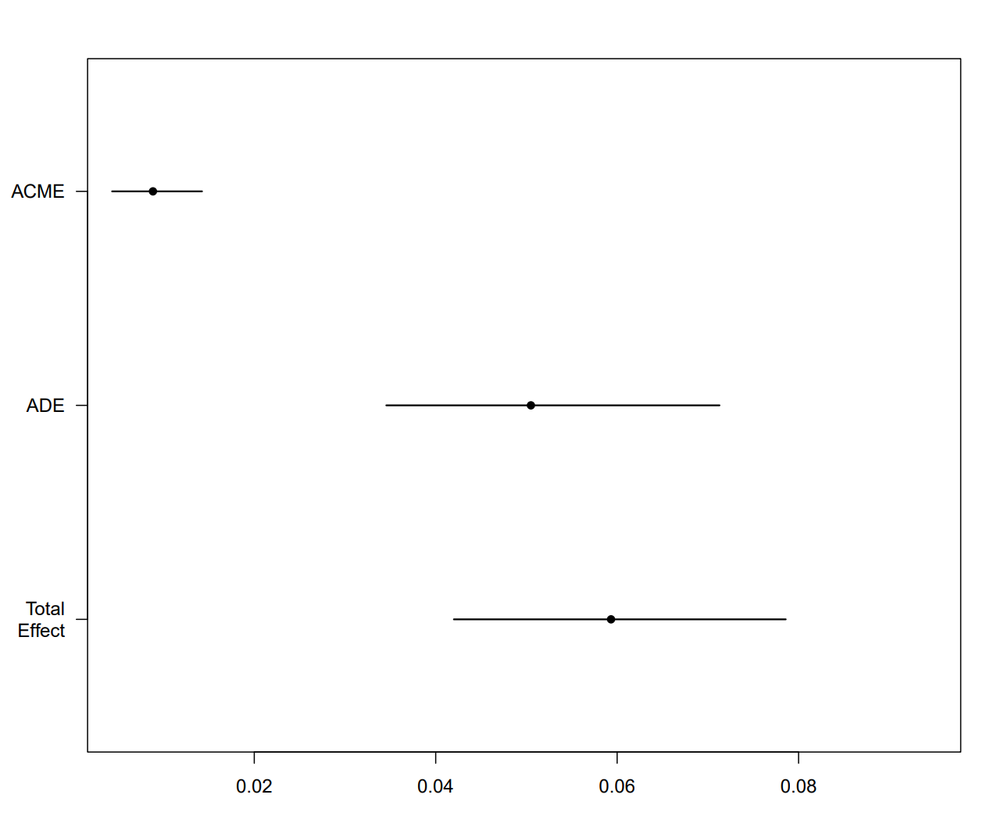

Figure S2. Mediation analysis for serum lactate level among with ischemic stroke and diabetes mellitus. The solid line represents glucose level.
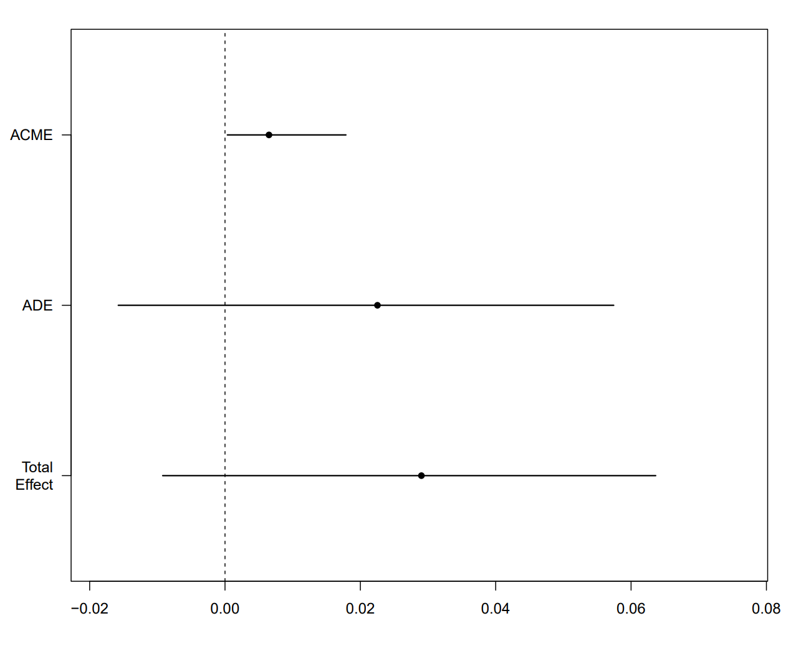

Figure S3. Mediation analysis for serum lactate level among with ischemic stroke and without diabetes mellitus. The solid line represents glucose level.
