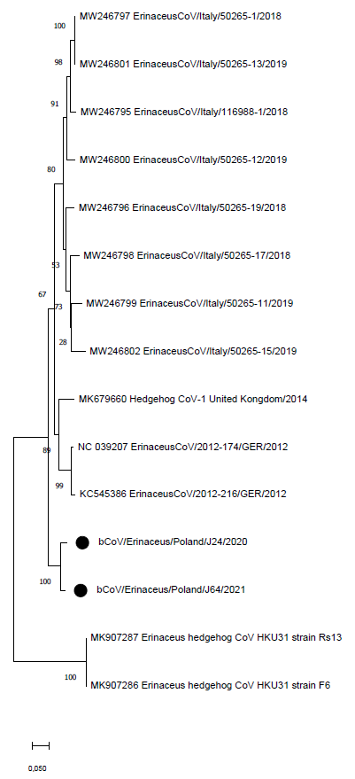
Additional file 3 Phylogenetic tree of European and Asian hedgehogs merbecoviruses based on the Spike protein. The tree was generated via MEGA X using the maximum likelihood analysis based on JTT+G model and 1000 bootstrap replicates (bootstrap values shown on the tree). Polish hedgehog merbecoviruses marked with black dot

