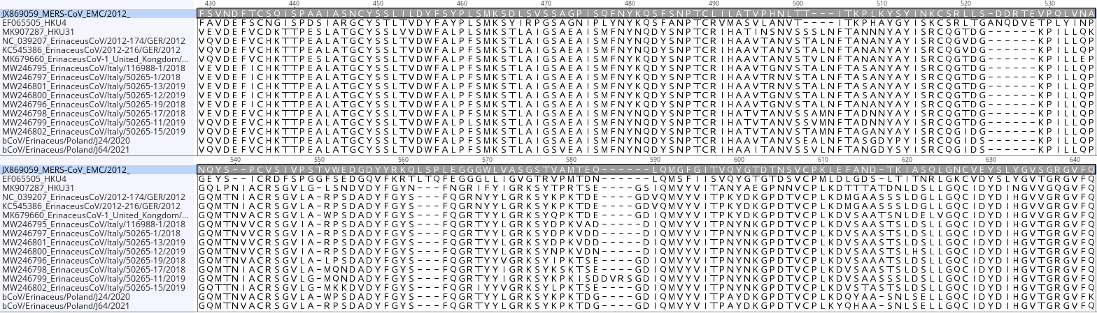
Additional file 4 Alignment of multiple sequences of the receptor binding domain (RBD) showing variation in key amino acids. Critical residues and critical bond formation residues are contained in red boxes. Numbering above alignment confers to the MERS-CoV sequence

