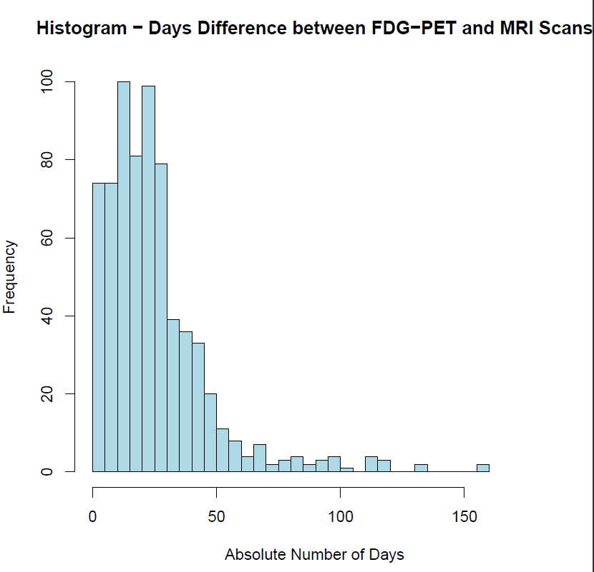
Supplementary Figure 1: Histogram of absolute number of days between FDG-PET and MRI scans. The counts of the absolute number of days between initial scans used in this study were plotted. The mean number of absolute days was 25 days. In the current sample, initial FDG-PET scans were performed: prior (10%), after (85%), and same day (5%) as MRI scans.

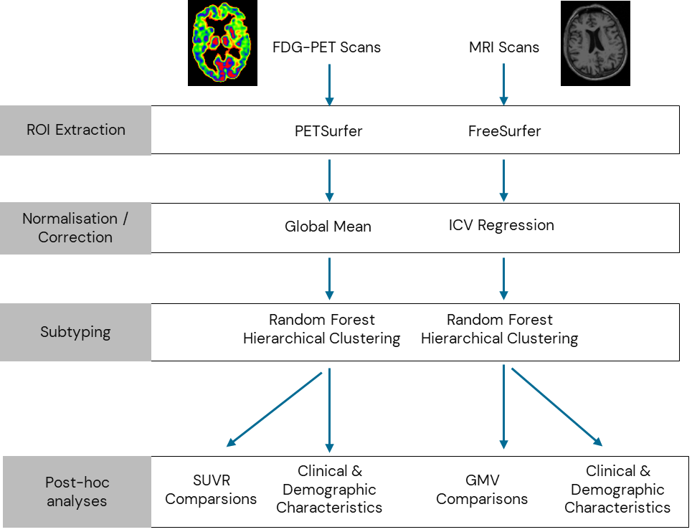

Supplementary Figure 2: Experimental Pipeline. Steps carried out for each modality in parallel. Regional values were extracted using PETSurfer and FreeSurfer version 6.0.0. Intensity normalisation using the global mean per individual for FDG-PET values and for MRI, head-size correction was carried out. This data was then used for the random forest hierarchical clustering (Suppl. Fig. 2 for full pipeline). Once groups were defined, they were characterised by biological, clinical and demographic information. Abbreviations: ICV: intracranial volume, SUVR: standard uptake value ratios, GMV: grey matter volume.

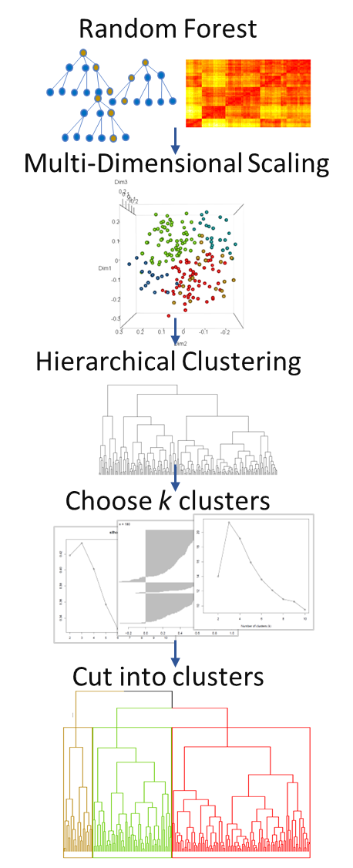
Supplementary Figure 3: Random forest hierarchical clustering pipeline. The steps carried out for the random forest clustering method on regional FDG-PET SUVR and MRI grey matter volumes. Random forest models were run using regional data which was then reduced to lower dimensionality. This output was then used for the agglomerative hierarchical clustering. The number of clusters was selected using various cluster validation indices and groups were cut with the selected number.
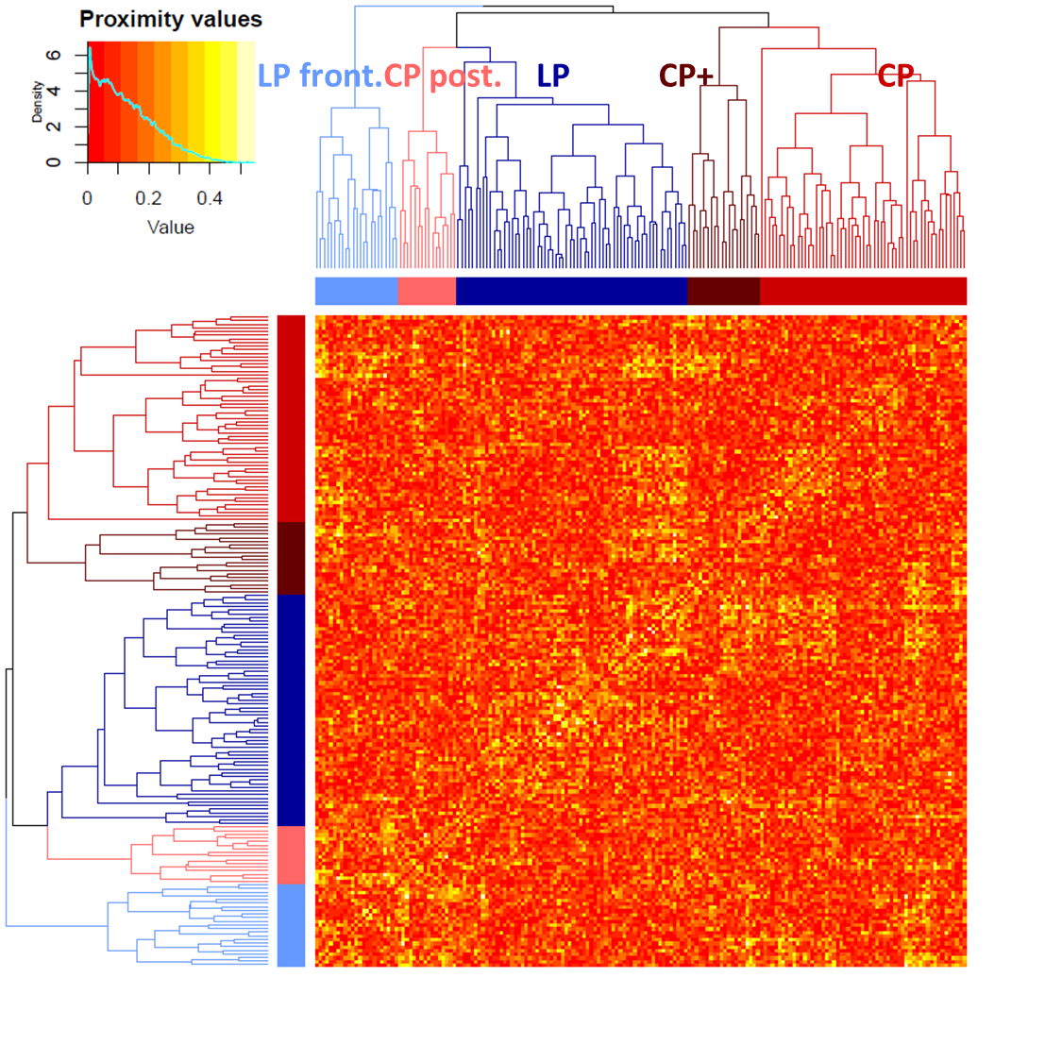 Supplementary Figure 4: Proximity matrix assessment of FDG-PET model. The histogram in the upper left corner represents a scale from 0 to 1 for the average difference between the proximity matrix and 100 simulated random forest matrices. The heatmap shows the similarity within and between clusters with the corresponding dendrogram. Within the heatmap are the proximity differences whereby lower values indicate more stability in red and higher values indicate less stability in yellow. Overall, the heatmap shows that the model is robust and stable.

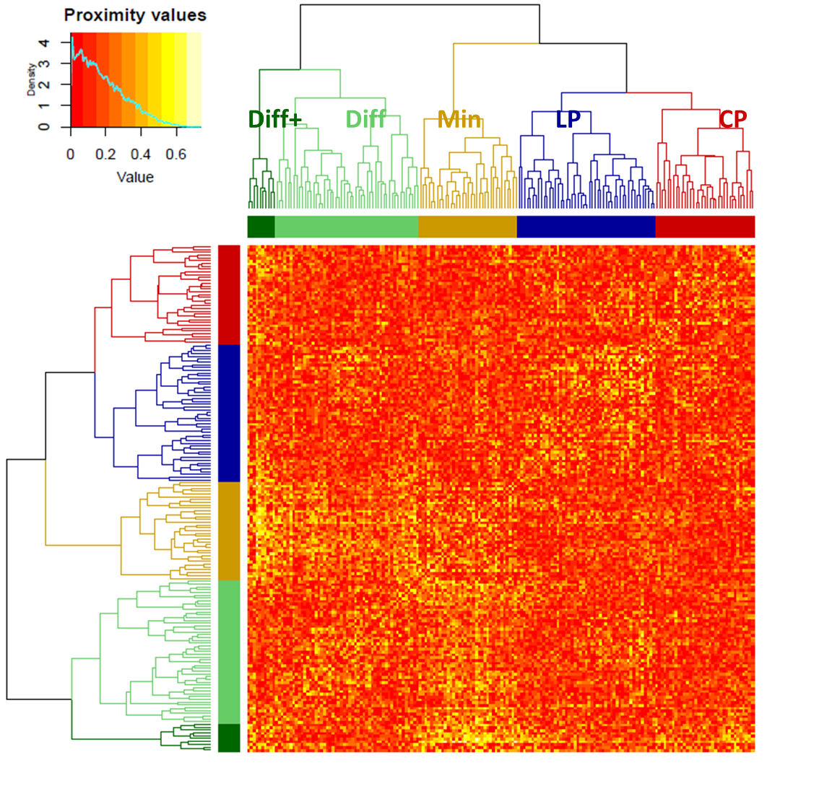
Supplementary Figure 5: Proximity matrix assessment of MRI model. The histogram in the upper left corner represents a scale from 0 to 1 for the average difference between the proximity matrix and 100 simulated random forest matrices. The heatmap shows the similarity within and between clusters with the corresponding dendrogram. Within the heatmap are the proximity differences whereby lower values indicate more stability in red and higher values indicate less stability in yellow. Overall, the heatmap shows that the model is robust and stable. Patches of lesser stability can be observed, especially between Minimal and Diffuse+.
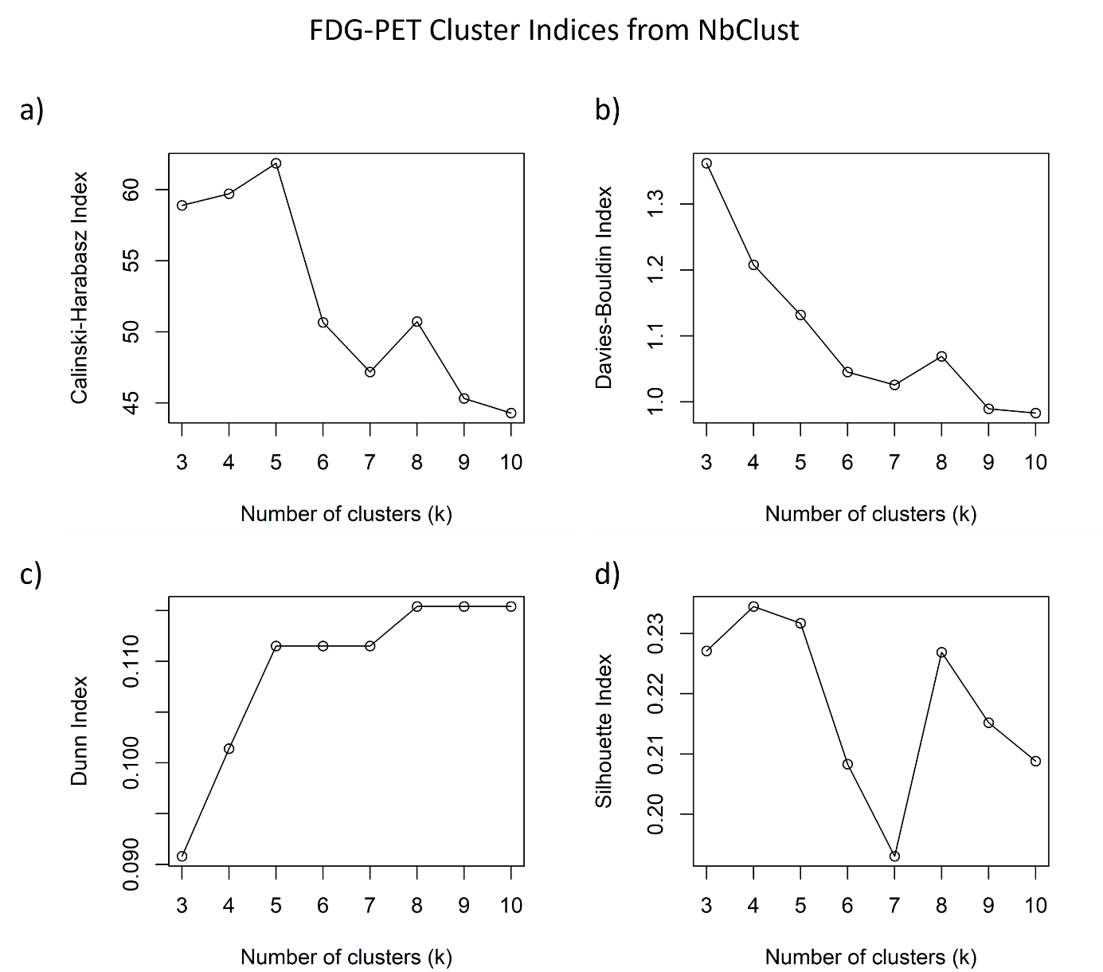
Supplementary Figure 6: Cluster validation indices plots for FDG-PET random forest output. Four indices were assessed to evaluate the optimal number of clusters for the FDG-PET random forest hierarchical clustering model. Plots display values for: a) Calinski-Harabasz, b) Davies-Bouldin, c) Dunn, d) Silhouette indices. The output from the NbClust package for each of these indices can be found in additional text files.

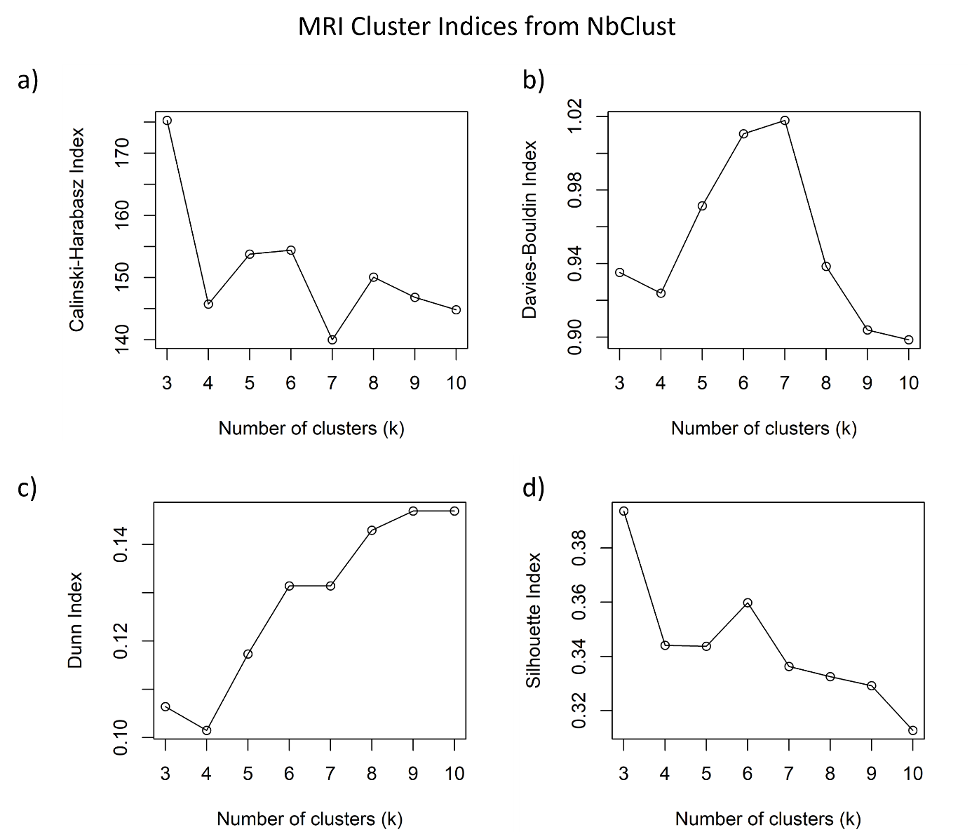
Supplementary Figure 7: Cluster validation indices plots for MRI random forest output. Four indices were assessed to evaluate the optimal number of clusters for the MRI random forest hierarchical clustering model. Plots display values for: a) Calinski-Harabasz, b) Davies-Bouldin, c) Dunn, d) Silhouette indices. The output from the NbClust package for each of these indices can be found in additional text files.

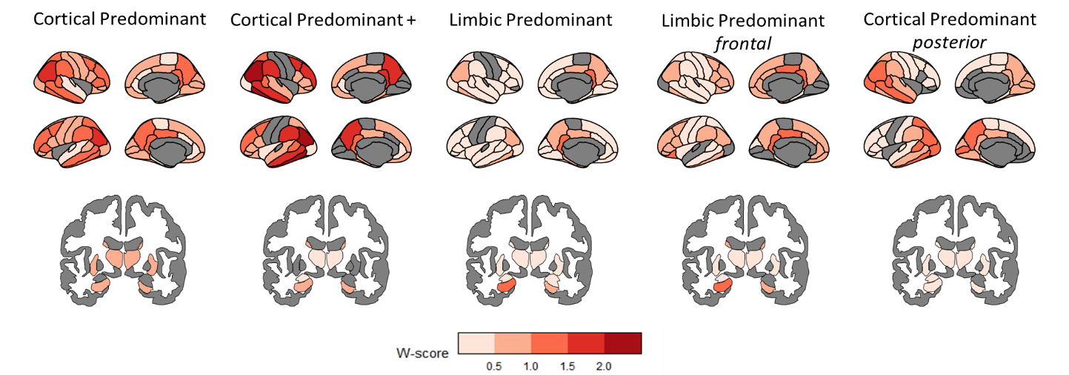

Supplementary Figure 8: Brain maps of FDG-PET subtypes. Brain maps for FDG-PET subtypes using partially volume corrected FDG-PET data with the pons as the reference region for w-score calculation.

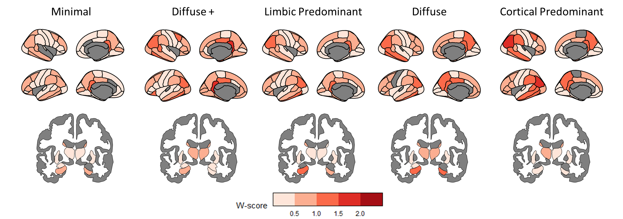

Supplementary Figure 9: Corresponding hypometabolism brain maps of MRI subtypes. Corresponding hypometabolism brain maps for MRI subtypes using partially volume corrected FDG-PET data with the pons as the reference region for w-score calculation.

