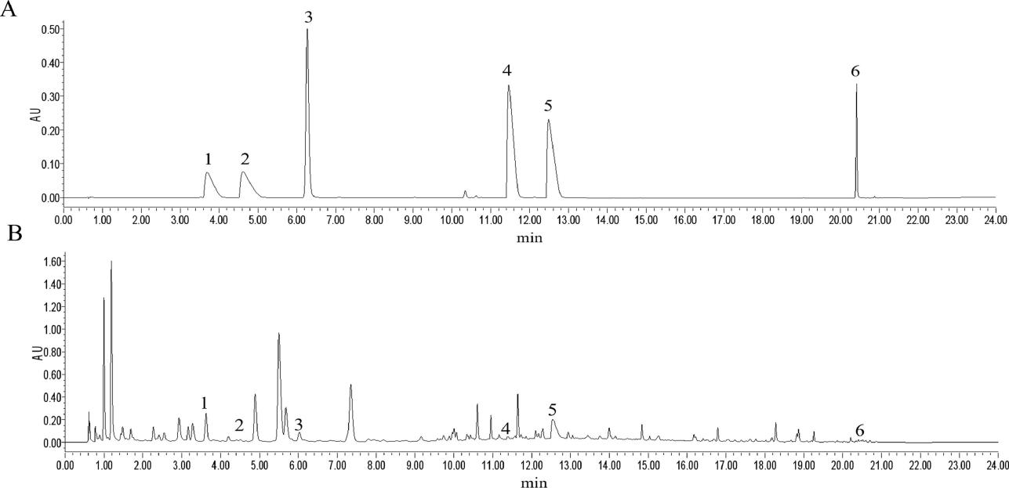
Phytochemical analysis of the EMS extracts by UPLC are shown in Supplementary Fig. 1. (A) EMS extracts. (B) Mixed reference substance. 1: Phellodendrine; 2: Magnoflorine; 3: 7-Hydroxycoumarine; 4: Jatrorrhizine; 5: Berberine; 6: Atractylenolide I. This figure was produced by our research team using the identical batch of medicinal materials as described in the literature[1].

Reference:
[1] S. Chen, J. Wang, J. Wang, et al. Wnt/β-catenin signaling pathway promotes abnormal activation of fibroblast-like synoviocytes and angiogenesis in rheumatoid arthritis and the intervention of Er Miao San[J]. Phytomedicine 120 2023, 155064. doi: 10.1016/j.phymed.2023.155064.

The transfection efficiency of NEK7 siRNA and Mus NEK7 was detected by Westwrm blot, and the results showed that NEK7 siRNA2 and Mus NEK7 were better (Figure. S2A-B). Therefore, NEK7 siRNA2 and Mus NEK7 were selected for the subsequent experiments.

Supplementary Fig. 2. Transfection efficiency detection of NEK7 siRNA and Mus NEK7.
- NEK7 siRNA transfection efficiency. (B)Mus NEK7 transfection efficiency.**P <0.01 vs. the Control group (x̅±s, n=4).

Supplementary Fig. 3. Pharmacodynamic assay of EMS-containing serums.
(A) EMS-containing serum safety concentration assay (x̅±s, n=5). (B-C) Effect of different concentrations of EMS on NEK7 expression in RAW264.7 cells, ##P <0.01 vs. Control group, **P <0.01 vs. LPS+ATP group (x̅±s, n=3).

