Supporting Information
Modulation of the oxygen sensing properties of iridium (III) complexes by changing their substitution groups
Merve Zeyrek Ongun¹, Murat Sahin², Sibel Oguzlar³, Tuğçe Akbal Aytan², Devrim Atilla^{2,}*, Sevinc Zehra Topal^{2,}*

¹ Dokuz Eylul University, Izmir Vocational High School, Chemistry Technology Program, Izmir, Turkey
² Gebze Technical University, Faculty of Science, Department of Chemistry, Kocaeli, Turkey
³ Dokuz Eylul University, Center for Fabrication and Application of Electronic Materials, Izmir, Turkey

Corresponding authors
E-mail addresses: datilla@gtu.edu.tr, sztopal@gtu.edu.tr

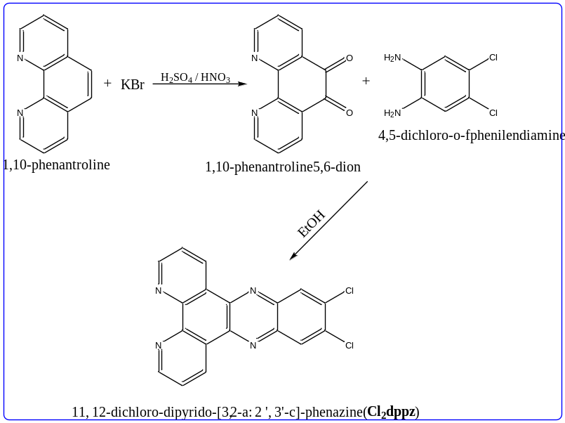
Scheme S1. Synthetic pathway of Cl₂dppz.

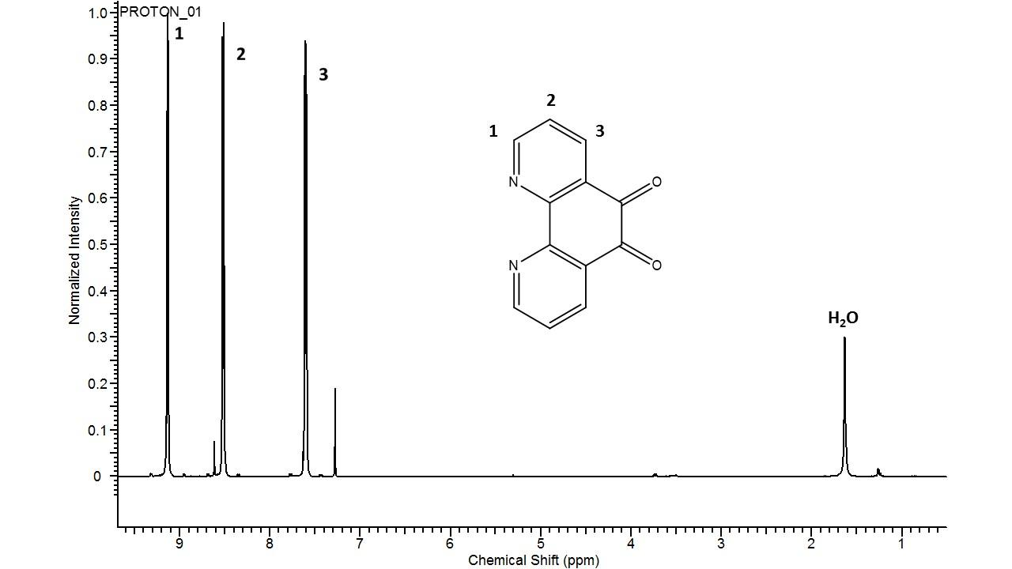
Fig.S1. ¹H NMR spectrum of 1,10-phenantroline-5,6-dion.

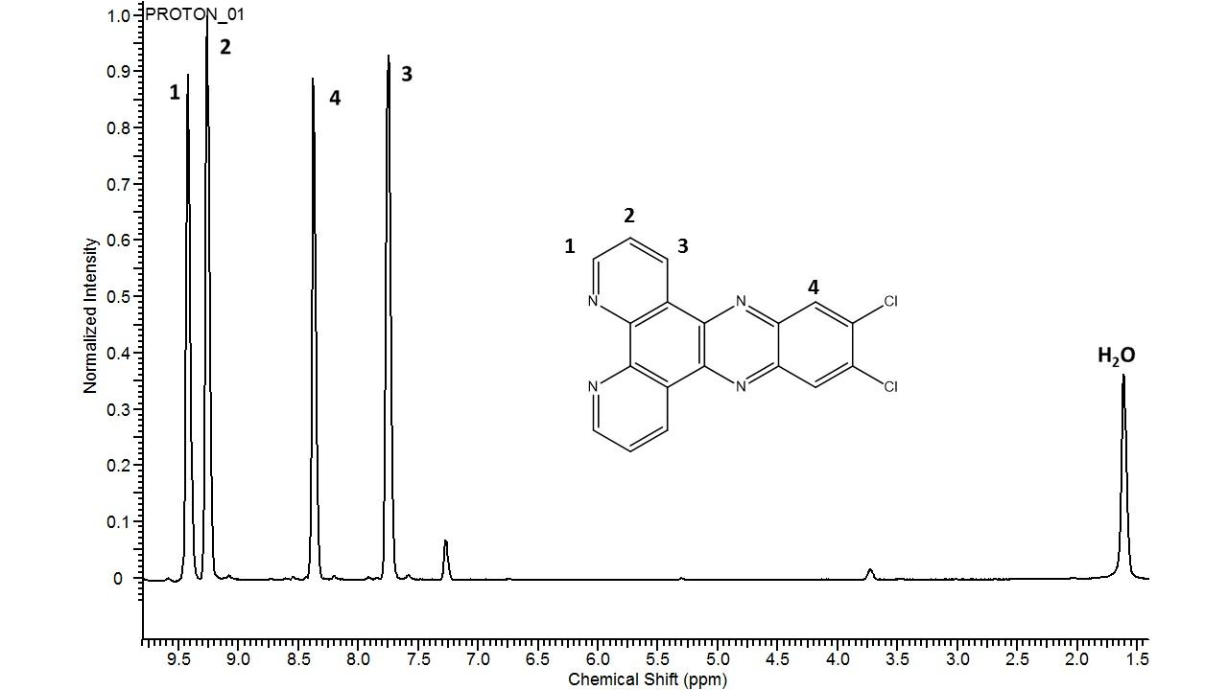
Fig.S2. ¹H NMR spectrum of Cl₂dppz.

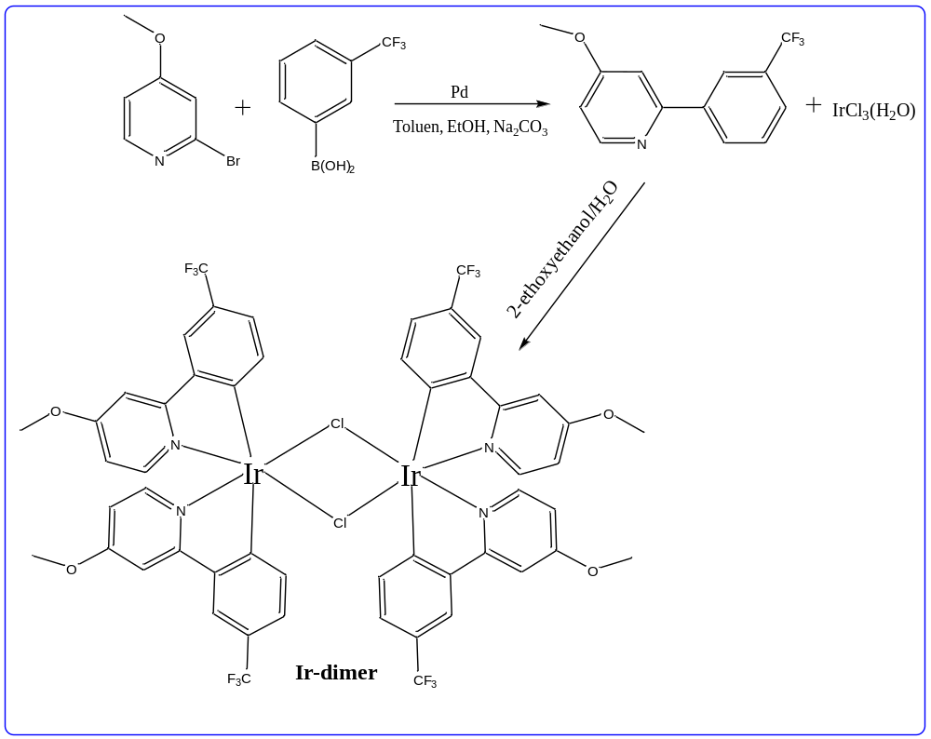
Scheme S2. Synthetic pathway of Ir-dimer.

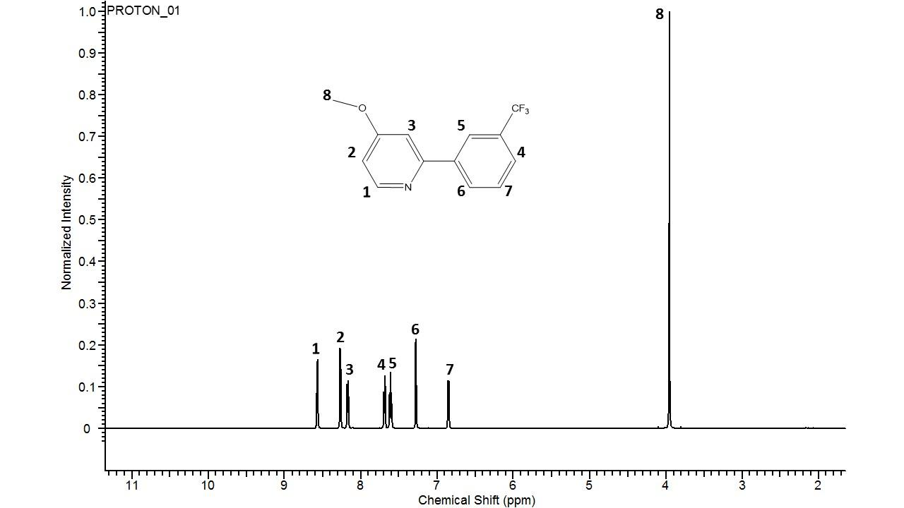
Fig.S3. ¹H NMR spectrum of 2-(3-trifloromethyl-phenyl)-4-methoxypyridin.

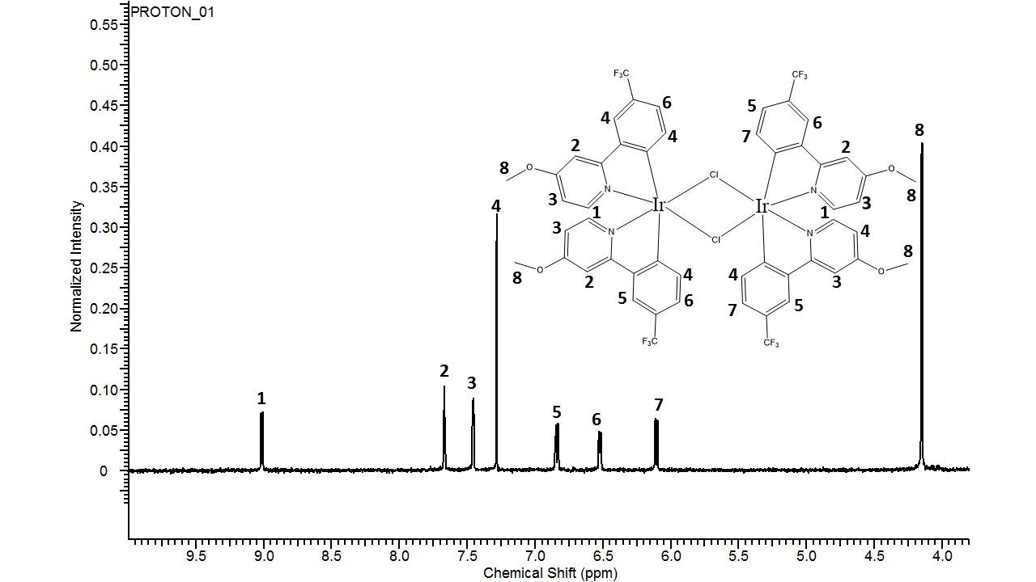
Fig.S4. ¹H NMR spectrum of Ir-Dimmer.

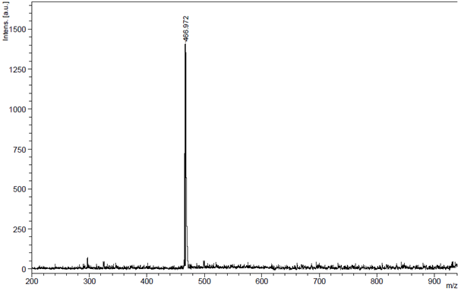
Fig.S5. The mass spectrum of L1.

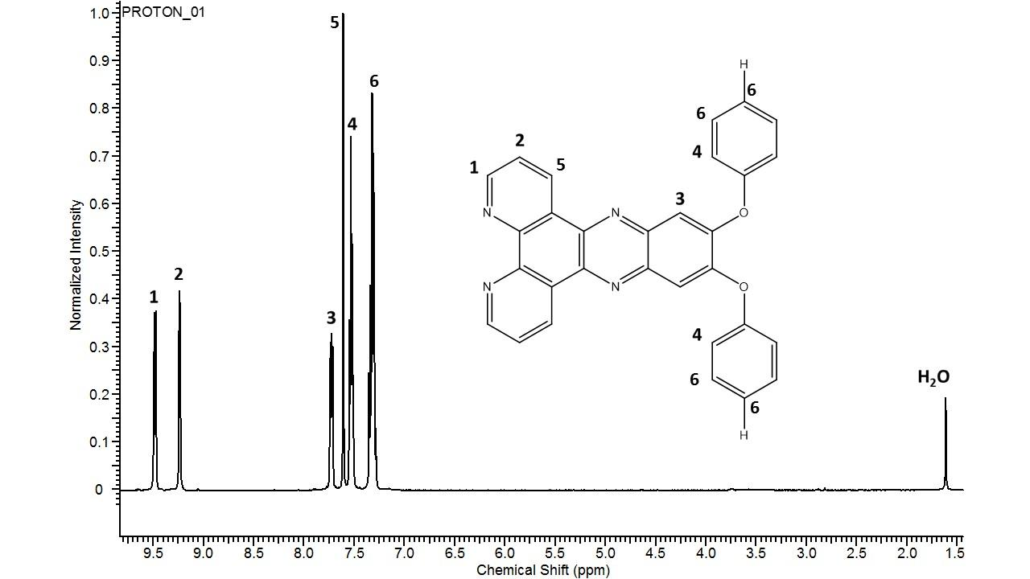
Fig.S6. ¹H NMR spectrum of L1 in CDCl₃.

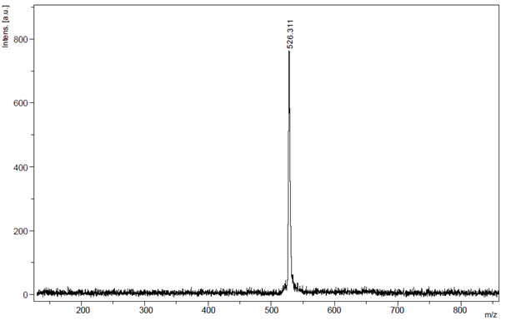
Fig.S7. The mass spectrum of L2.

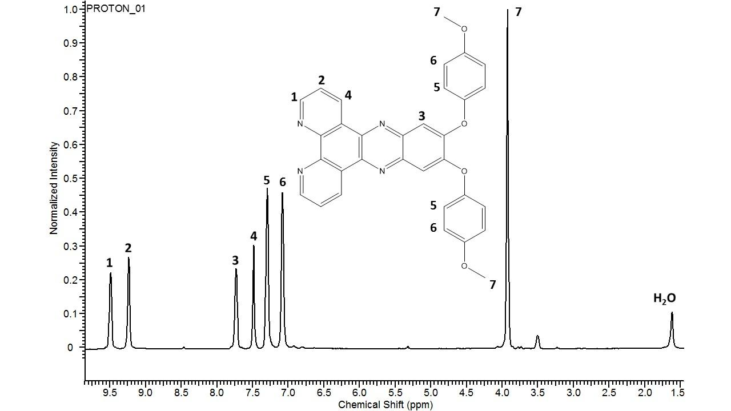
Fig.S8. ¹H NMR spectrum of L2 in CDCl₃.

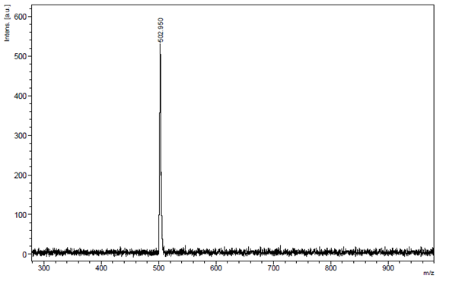
Fig.S9. The mass spectrum of L3.

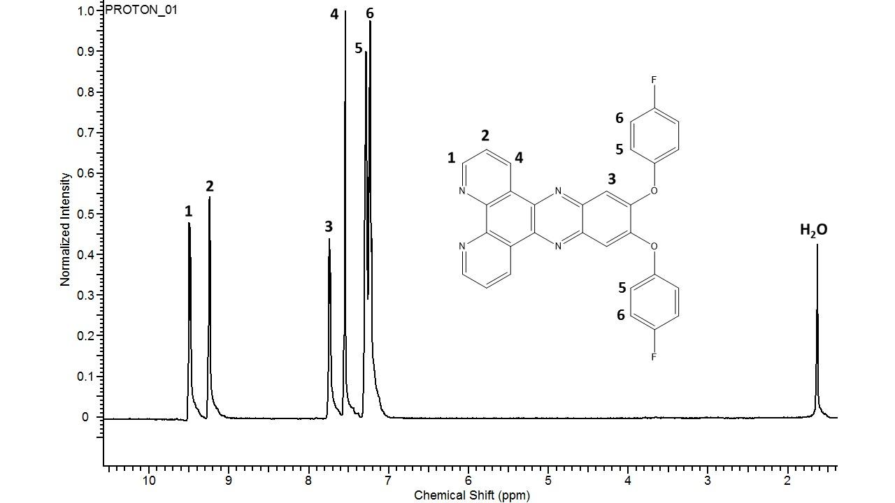
Fig.S10. ¹H NMR spectrum of L3 in CDCl₃.

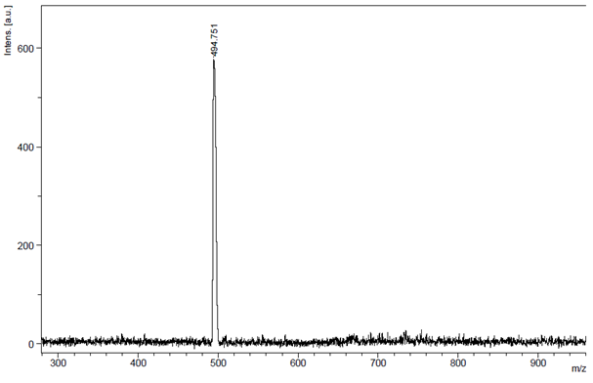
Fig.S11. The mass spectrum of L4.

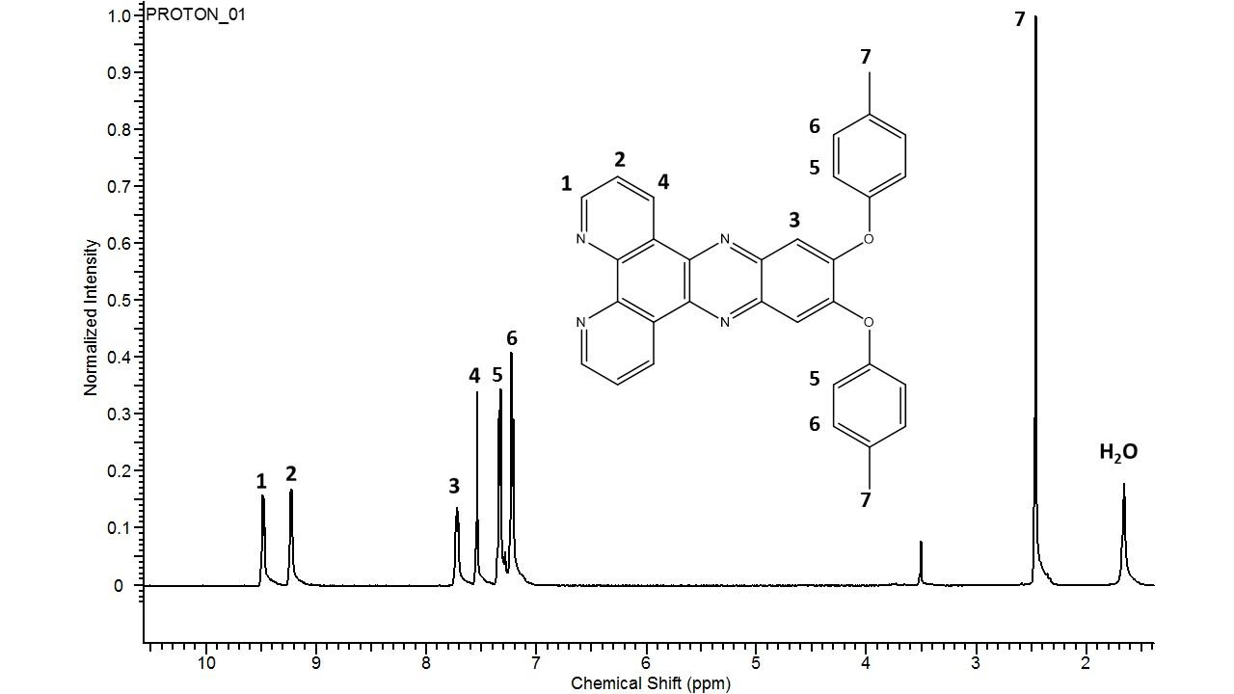
Fig.S12. ¹H NMR spectrum of L4 in CDCl₃.

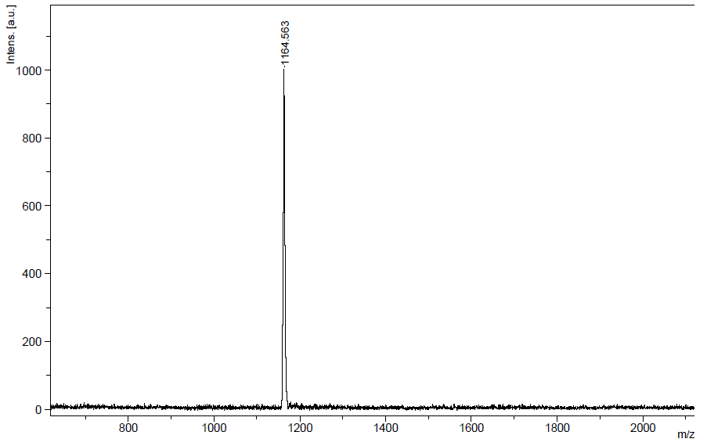
Fig.S13. The mass spectrum of Ir-1.

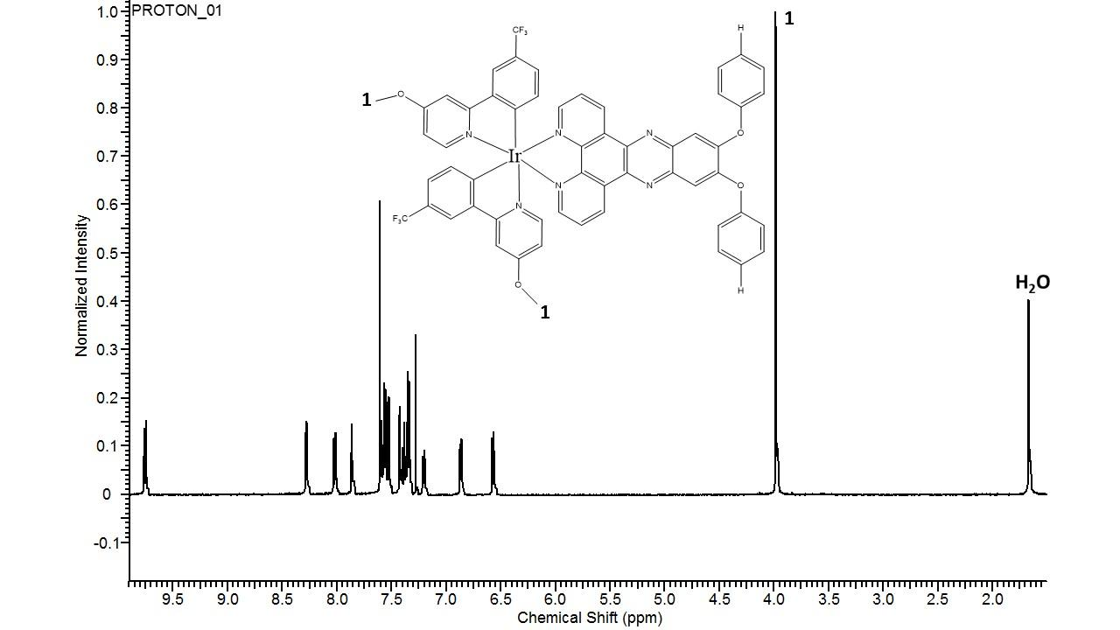
Fig.S14. ¹H NMR spectrum of Ir-1 in CDCl₃.

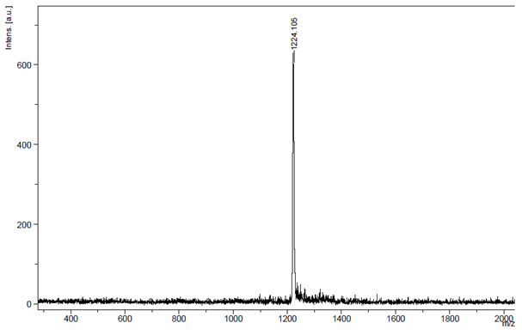
Fig.S15. The mass spectrum of Ir-2.

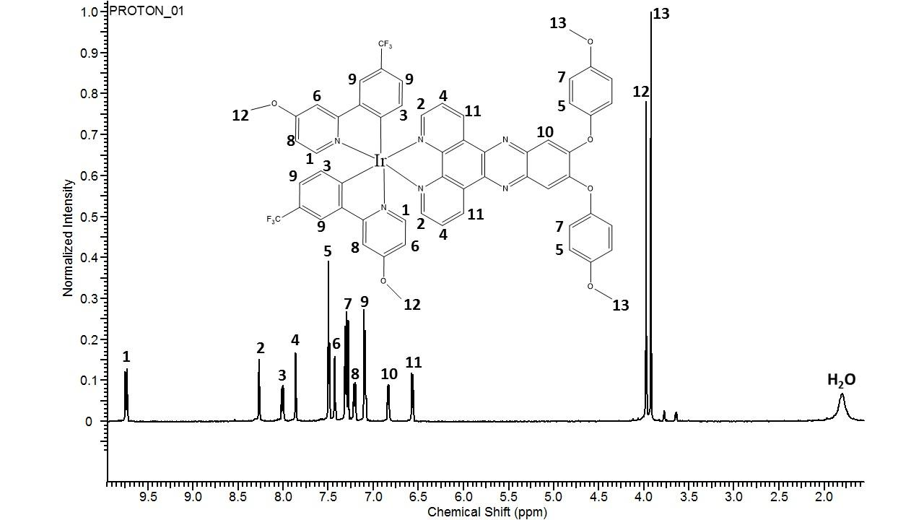
Fig.S16. ¹H NMR spectrum of Ir-2 in CDCl₃.

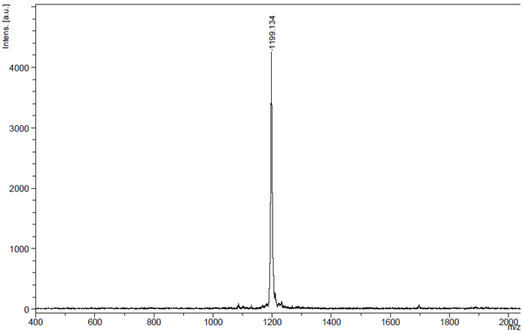
Fig.S17. The mass spectrum of Ir-3.

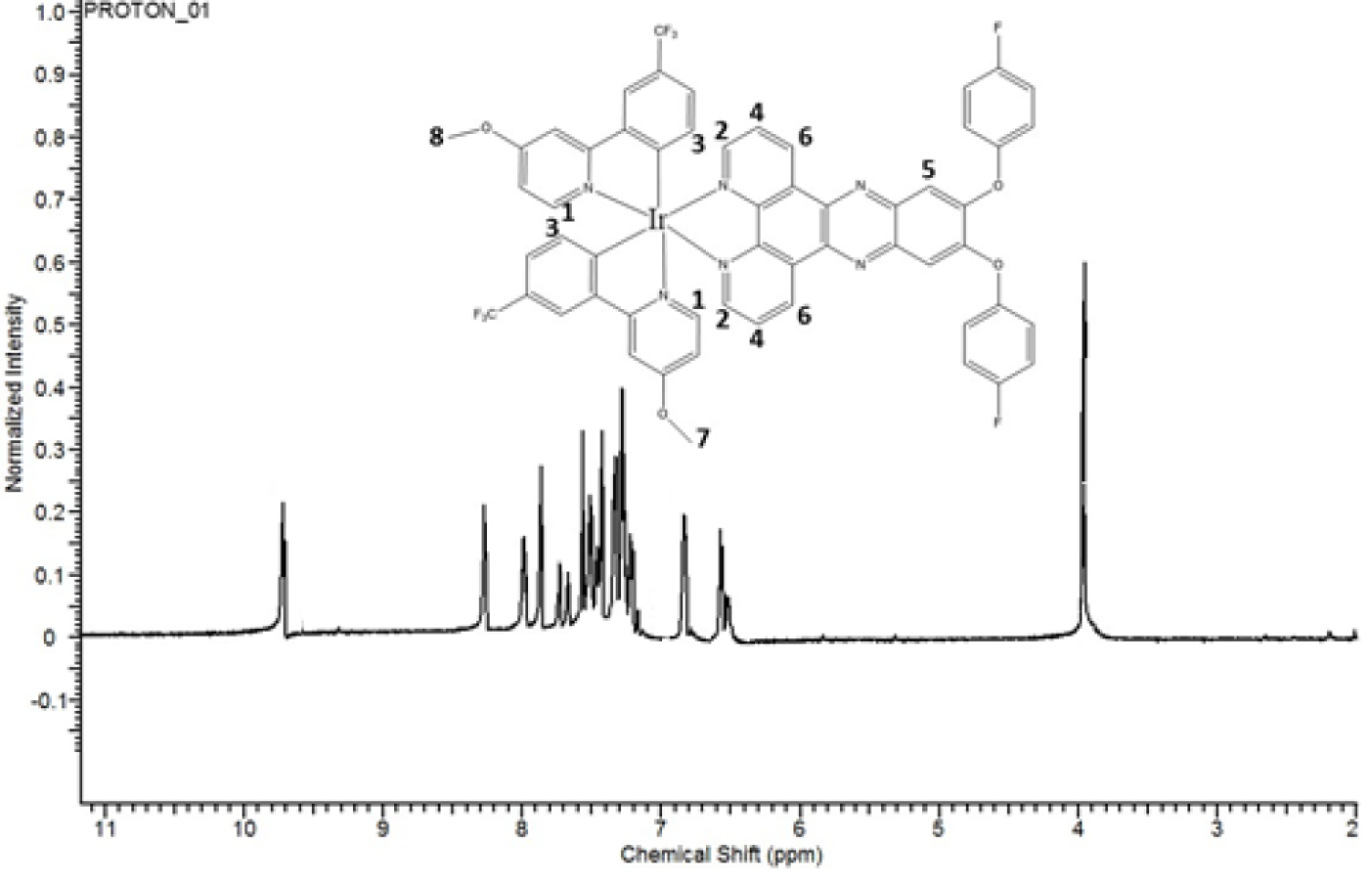
Fig.S18. ¹H NMR spectrum of Ir-3 in CDCl₃.

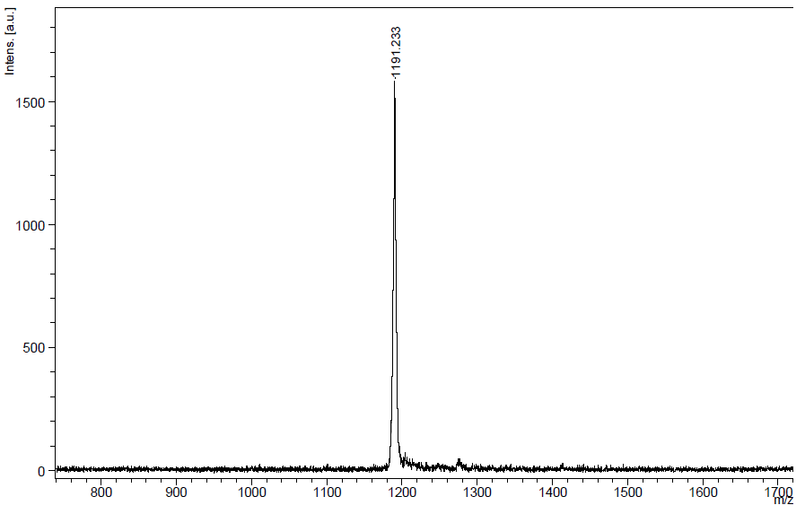
Fig. S19. The mass spectrum of Ir-4.

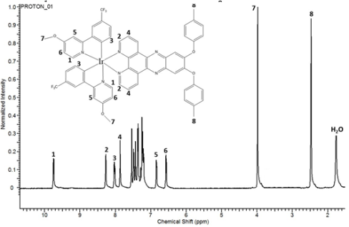
Fig.S20. ¹H NMR spectrum of Ir-4 in CDCl₃.

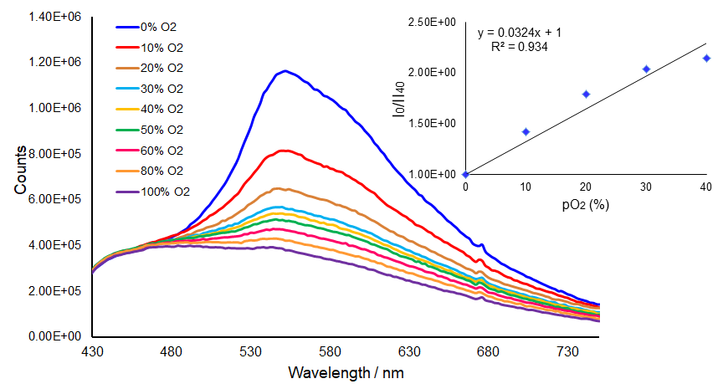
Fig.S21. Oxygen induced phosphorescence emission spectra of Ir-1 in EC thin film under various oxygen partial pressure conditions, inset: Stern-Volmer plot for oxygen.

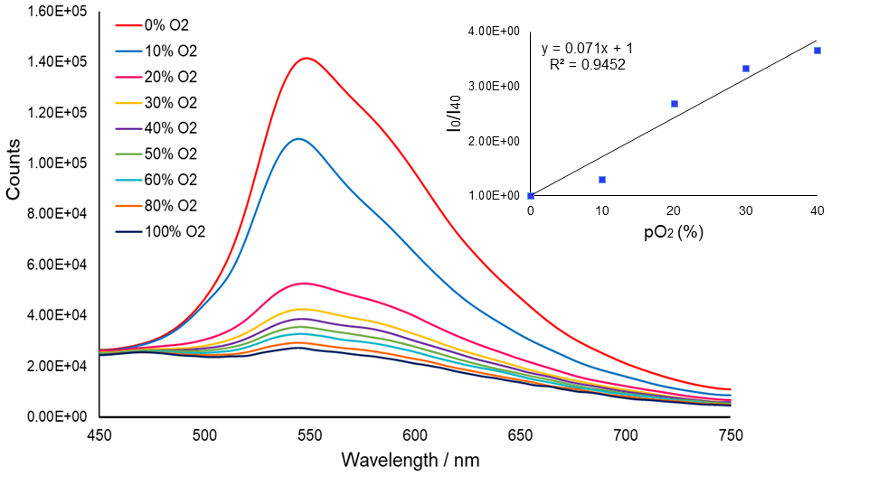
Fig.S22. Oxygen induced phosphorescence emission spectra of Ir-2 in EC thin film under various oxygen partial pressure conditions, inset: Stern-Volmer plot for oxygen.

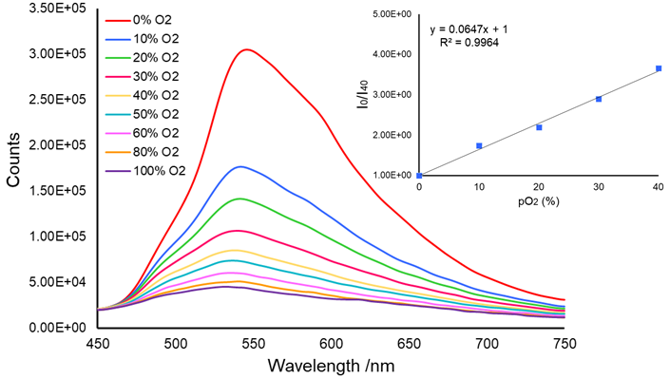
Fig.S23. Oxygen induced phosphorescence emission spectra of Ir-3 in EC thin film under various oxygen partial pressure conditions, inset: Stern-Volmer plot for oxygen.

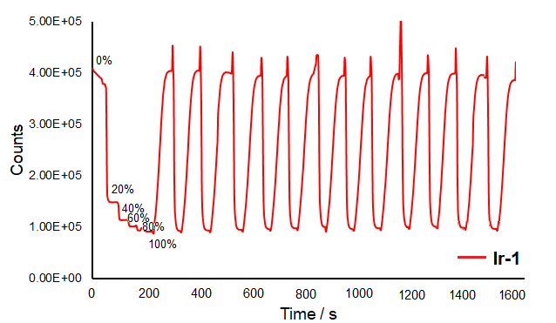
Fig.S24. Time-based kinetic response of Ir-1 in thin film in an alternating atmosphere of 100.0% N₂ and 100.0% O₂.
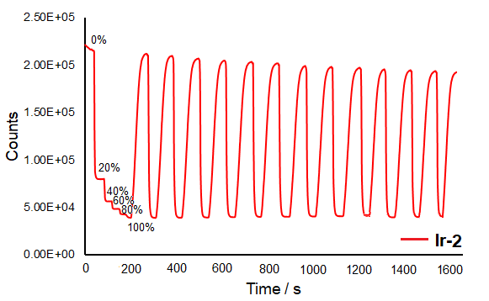
Fig.S25. Time-based kinetic response of Ir-2 in thin film in an alternating atmosphere of 100.0% N₂ and 100.0% O₂.

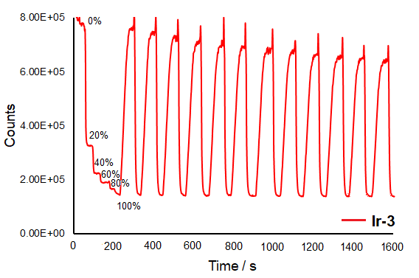
Fig.S26. Time-based kinetic response of Ir-3 in thin film in an alternating atmosphere of 100.0% N₂ and 100.0% O₂.

Table S1. Decay-times of Ir-1-4 complexes in THF and EC-based thin films in the absence and presence of the oxygen.
Dye |  | EC |  |  |  |  |  | THF
Dye |  | N₂ |  |  | O₂ |  |  | N₂ |  |  | O₂
Dye |  | Decay Time  (µs) | Std.Dev.  (µs) | Rel. (%) | Decay Time  (µs) | Std.Dev.  (µs) | Rel. (%) | Decay Time  (µs) | Std.Dev.  (µs) | Rel. (%) | Decay Time  (µs) | Std.Dev.  (µs) | Rel. (%)
Ir-1 | τ₁ | 52.24 | 0.48 | 20.54 | 2.95 | 0.18 | 17.53 | 11.33 | 0.07 | 70.41 | 3.28 | 0.23 | 41.67
Ir-1 | τ₂ | 210.62 | 1.46 | 48.66 | 15.95 | 0.17 | 64.31 | 67.75 | 0.72 | 29.59 | 11.59 | 0.31 | 58.33
Ir-1 | τ₃ | 875.32 | 4.52 | 30.81 | 98.03 | 1.65 | 18.16 | - | - | - | - | - | -
Ir-1 | τ_{avr} | 382.82 |  |  | 28.57 |  |  | 28.02 |  |  | 8.13
Ir-2 | τ₁ | 37.38 | 0.39 | 16.66 | 20.09 | 0.29 | 59.58 | 4.59 | 0.06 | 53.91 | 2.70 | 0.27 | 37.74
Ir-2 | τ₂ | 201.87 | 1.87 | 42.59 | 111.28 | 2.33 | 40.42 | 16.38 | 0.12 | 46.09 | 11.42 | 0.27 | 62.26
Ir-2 | τ₃ | 813.23 | 5.02 | 40.75 | - | - | - | - | - | - | - | - | -
Ir-2 | τ_{avr} | 423.59 |  |  | 56.95 |  |  | 10.02 |  |  | 8.13
Ir-3 | τ₁ | 73.81 | 0.50 | 19.66 | 13.47 | 0.14 | 56.15 | 29.81 | 0.0274 | 99.22 | 2.89 | 0.26 | 40.22
Ir-3 | τ₂ | 292.40 | 1.76 | 47.47 | 55.59 | 1.33 | 33.34 | 171.97 | 6.5271 | 0.78 | 11.84 | 0.32 | 59.78
Ir-3 | τ₃ | 986.88 | 4.00 | 32.86 | 206.94 | 6.44 | 10.52 | - | - | - | - | - | -
Ir-3 | τ_{avr} | 477.61 |  |  | 47.86 |  |  | 30.92 |  |  | 8.24
Ir-4 | τ₁ | 95.74 | 0.7982 | 24.83 | 3.74 | 0.08 | 40.13 | 10.67 | 0.0157 | 90.83 | 10.54 | 0.04 | 100.00
Ir-4 | τ₂ | 310.07 | 2.4124 | 51.73 | 17.53 | 0.25 | 48.49 | 77.22 | 0.4326 | 9.17 | - | - | -
Ir-4 | τ₃ | 995.81 | 6.4305 | 23.45 | 101.90 | 2.05 | 11.37 | - | - | - | - | - | -
Ir-4 | τ_{avr} | 417.68 |  |  | 21.59 |  |  | 16.77 |  |  | 10.54

