Tab.S1 Sensitivity analysis of causal relation between immune cell phenotype and OS
Exposure | Horizontal pleiotropy test |  | Heterogeneity test
Exposure | MR-Egger intercept | MR-Egger Intercept P value | IVW  Q_P value | MR-Egger Q_P value
BAFF-R on IgD⁺ CD38⁻ unsw mem | -0.08191 | 0.480 | 0.667 | 0.638
CD20 on IgD⁻ CD38⁻ | 0.03969 | 0.732 | 0.173 | 0.145
CX3CR1 on CD14⁻ CD16⁻ | 0.02352 | 0.807 | 0.465 | 0.401
CD25 on CD45RA⁻ CD4 not Treg | 0.07186 | 0.400 | 0.633 | 0.620
Naive CD4⁺ %T cell | 0.00169 | 0.980 | 0.793 | 0.754
CD45 on HLA DR⁺ CD8^{br} | 0.13659 | 0.109 | 0.919 | 0.978
CD28⁺CD45RA⁺CD8^{br} %CD8^{br} | -0.02218 | 0.704 | 0.559 | 0.518
Tab.S2 Sensitivity analysis of causal relation between 60 blood metabolites and OS
Exposure | Horizontal pleiotropy test |  | Heterogeneity test
Exposure | MR-Egger intercept | MR-Egger Intercept P value | IVW  Q_P value | MR-Egger Q_P value
5-hydroxylysine | -0.13245 | 0.149 | 0.782 | 0.840
1,5-anhydroglucitol | 0.02584 | 0.773 | 0.279 | 0.241
1-oleoylglycerol | -0.01555 | 0.900 | 0.907 | 0.881
3-carboxy-4-methyl-5-propyl-2-furanpropanoate | 0.01452 | 0.938 | 0.292 | 0.232
N1-methylinosine | -0.13176 | 0.343 | 0.979 | 0.982
5alpha-androstan-3beta,17beta-diol disulfate | 0.05954 | 0.419 | 0.573 | 0.556
5alpha-pregnan-3beta,20alpha-diol disulfate | -0.16177 | 0.136 | 0.898 | 0.938
Chiro-inositol | 0.05278 | 0.810 | 0.652 | 0.577
5alpha-androstan-3alpha,17beta-diol monosulfate | 0.07606 | 0.333 | 0.421 | 0.420
Formiminoglutamate | -0.11896 | 0.178 | 0.390 | 0.442
S-methylcysteine sulfoxide | 0.06338 | 0.624 | 0.480 | 0.432
4-methylcatechol sulfate | 0.10241 | 0.464 | 0.935 | 0.929
Dimethyl sulfone | 0.11589 | 0.360 | 0.464 | 0.456
Indolin-2-one | 0.02683 | 0.840 | 0.675 | 0.608
Etiocholanolone glucuronide | -0.17335 | 0.100 | 0.776 | 0.885
Eugenol sulfate | 0.06210 | 0.568 | 0.675 | 0.638
Sphingomyelin | -0.08215 | 0.425 | 0.844 | 0.836
1-palmitoyl-2-docosahexaenoyl-gpc | 0.04099 | 0.786 | 0.666 | 0.612
1-stearoyl-2-docosahexaenoyl-gpc | 0.06030 | 0.572 | 0.453 | 0.416
N-palmitoyl-sphingadienine | 0.10376 | 0.494 | 0.558 | 0.523
Cerotoylcarnitine | 0.02002 | 0.827 | 0.381 | 0.334
Ximenoylcarnitine | 0.10733 | 0.288 | 0.782 | 0.794
Lithocholate sulfate | 0.03181 | 0.814 | 0.773 | 0.725
Cis 3,4-methyleneheptanoate | -0.06760 | 0.461 | 0.605 | 0.579
3,5-dichloro-2,6-dihydroxybenzoic acid | -0.07369 | 0.573 | 0.568 | 0.524
N-acetyl-L-alanine | -0.10648 | 0.341 | 0.523 | 0.521
2-aminobutyrate | 0.17893 | 0.246 | 0.795 | 0.828
Gamma-glutamylleucine | 0.23468 | 0.078 | 0.248 | 0.398
N-formylmethionine | -0.13565 | 0.328 | 0.880 | 0.888
Methylsuccinate | -0.23250 | 0.027 | 0.520 | 0.813
Creatinine | 0.04606 | 0.641 | 0.751 | 0.713
Cystine | 0.14470 | 0.373 | 0.844 | 0.845
Betaine | 0.08160 | 0.513 | 0.563 | 0.530
Xylose | -0.00941 | 0.937 | 0.932 | 0.909
Mannose | 0.072 | 0.510 | 0.919 | 0.908
X-12283 | 0.14615 | 0.196 | 0.431 | 0.473
X-12680 | 0.01862 | 0.920 | 0.888 | 0.847
X-16964 | 0.14651 | 0.259 | 0.797 | 0.836
X-17367 | -0.00401 | 0.978 | 0.324 | 0.271
X-19299 | 0.00791 | 0.948 | 0.749 | 0.682
X-23587 | 0.11643 | 0.407 | 0.752 | 0.742
X-23593 | -0.04760 | 0.720 | 0.492 | 0.436
X-23739 | 0.00448 | 0.963 | 0.889 | 0.858
X-24418 | -0.04854 | 0.707 | 0.385 | 0.338
N-acetylphenylalanine | -0.09690 | 0.276 | 0.757 | 0.775
Citrulline to dimethylarginine | -0.22068 | 0.040 | 0.571 | 0.783
Spermidine to phosphate | 0.07367 | 0.569 | 0.368 | 0.328
Glutamate to kynurenine | -0.26691 | 0.070 | 0.889 | 0.967
Adenosine 5'-diphosphate to valine | -0.10524 | 0.361 | 0.566 | 0.559
Aspartate to phosphate | 0.01101 | 0.944 | 0.625 | 0.553
Adenosine 5'-monophosphate to tyrosine | -0.08591 | 0.549 | 0.733 | 0.697
phosphate to asparagine | -0.11939 | 0.122 | 0.649 | 0.732
Taurine to cysteine | 0.07295 | 0.609 | 0.887 | 0.862
Uridine to 2'-deoxyuridine | -0.00004 | 1.000 | 0.936 | 0.915
N-stearoyl-sphingosine to N-palmitoyl-sphinganine | -0.06069 | 0.607 | 0.399 | 0.363
Adenosine 5'-diphosphate to cytidine | 0.00768 | 0.958 | 0.550 | 0.482
Glucose-to-mannose | -0.02721 | 0.798 | 0.832 | 0.795
Cytidine to N-acetylglucosamine to N-acetylgalactosamine | 0.12736 | 0.454 | 0.200 | 0.185
Caffeine to paraxanthine | -0.08265 | 0.504 | 0.589 | 0.559
Bilirubin to etiocholanolone glucuronide | 0.03444 | 0.709 | 0.674 | 0.629
Tab.S3 Sensitivity analysis of causal relation between CX3CR1 on CD14⁻ CD16⁻ in monocyte panel and DMSO, and between CX3CR1 on CD14⁻ CD16⁻ in monocyte panel and X-12680
Outcome | Horizontal pleiotropy test |  | Heterogeneity test
Outcome | MR-Egger intercept | MR-Egger Intercept P value | IVW  Q_P value | MR-Egger Q_P value
dimethyl sulfone | 0.00513 | 0.547 | 0.524 | 0.481
X-12680 | 0.00473 | 0.576 | 0.484 | 0.438
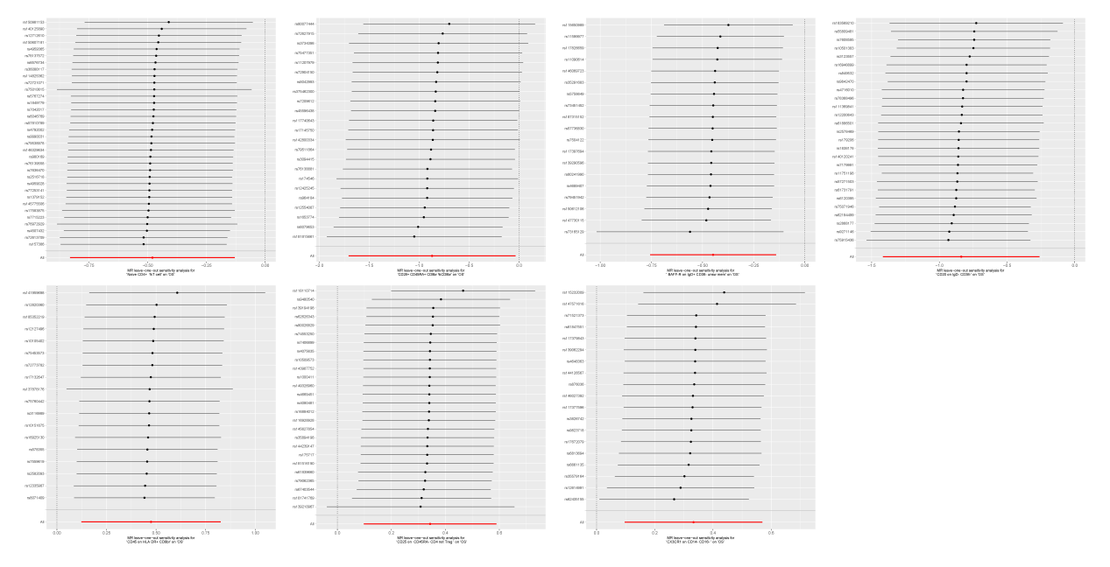
Fig. S1 The leave-one-out sensitivity analysis of the MR analysis of 7 immune cells on OS
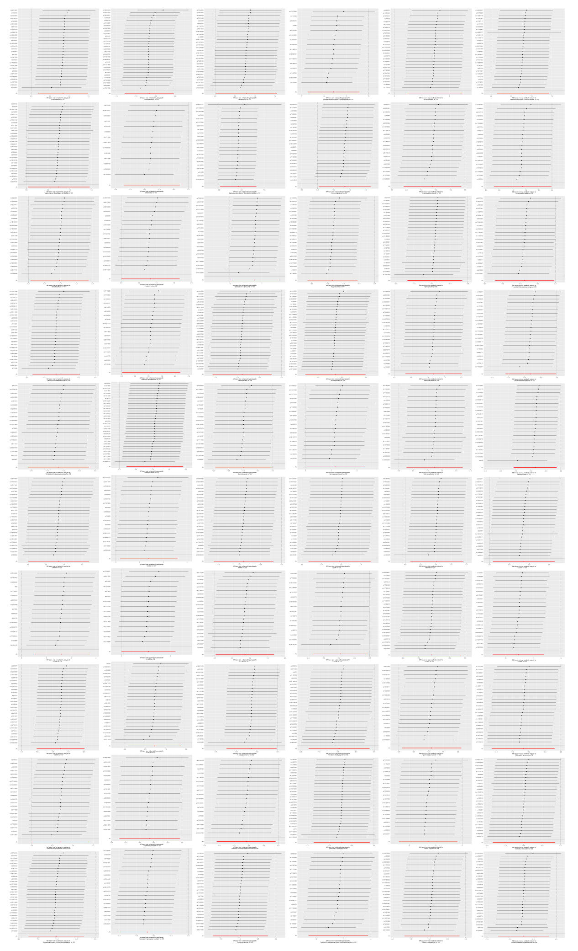
Fig. S2 The leave-one-out sensitivity analysis of the MR analysis of 60 metabolites on OS.

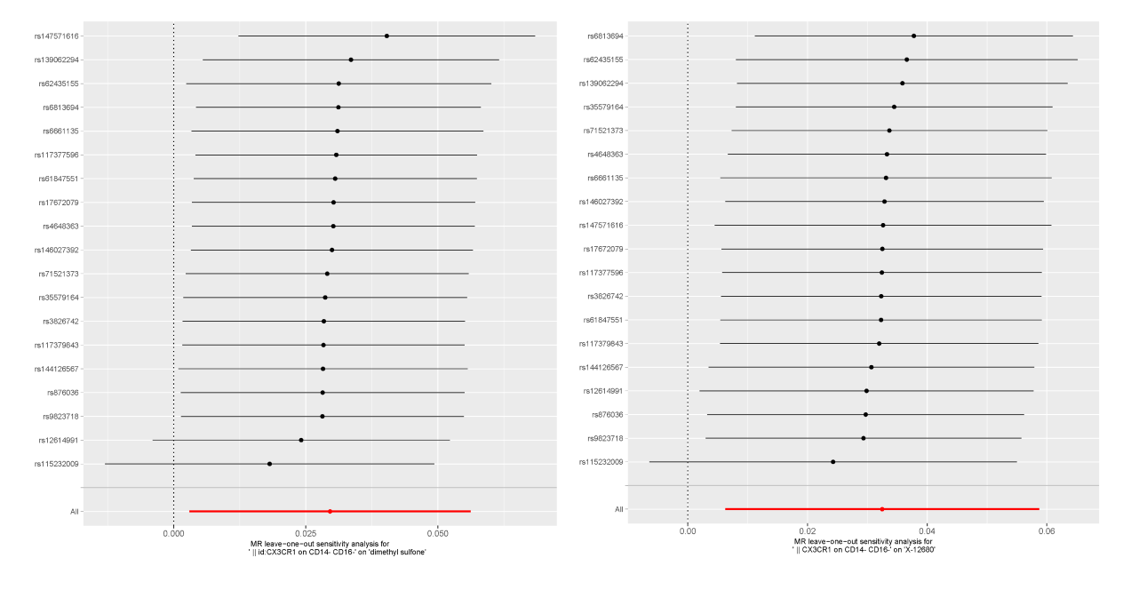
Fig.S3 The leave-one-out sensitivity analysis of the MR analysis of CX3CR1 on CD14⁻ CD16⁻ in monocyte panel on dimethyl sulfone and X-12680

