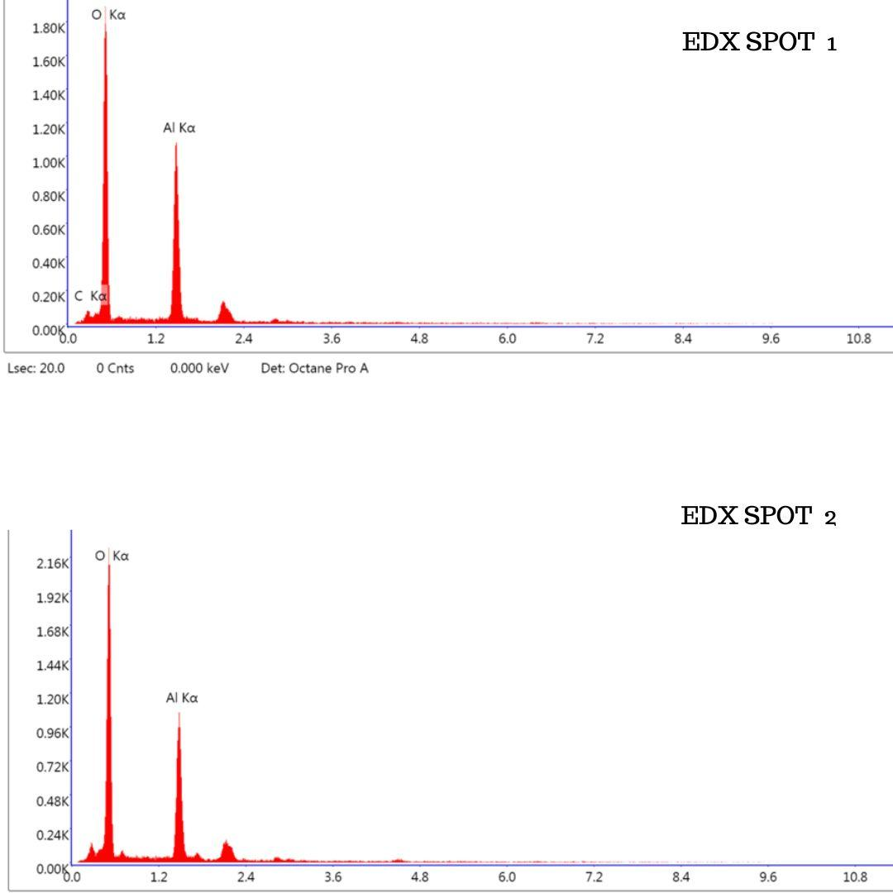

Graph 1 EDX spectra of spot 1 and spot 2. Indicating the high peaks for Aluminium and Oxygen.

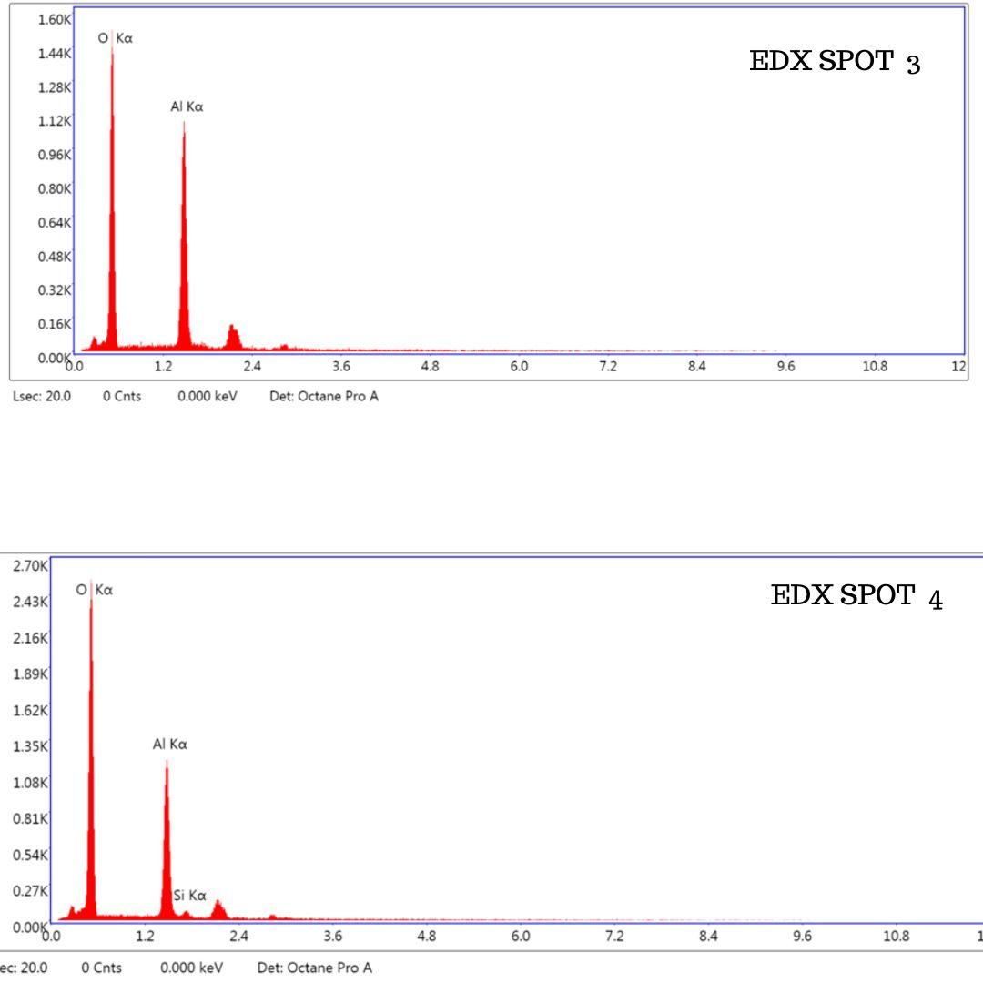

Graph 2 Spot 3 and Spot 4 gave peaks for Aluminium, Silica and Oxygen.

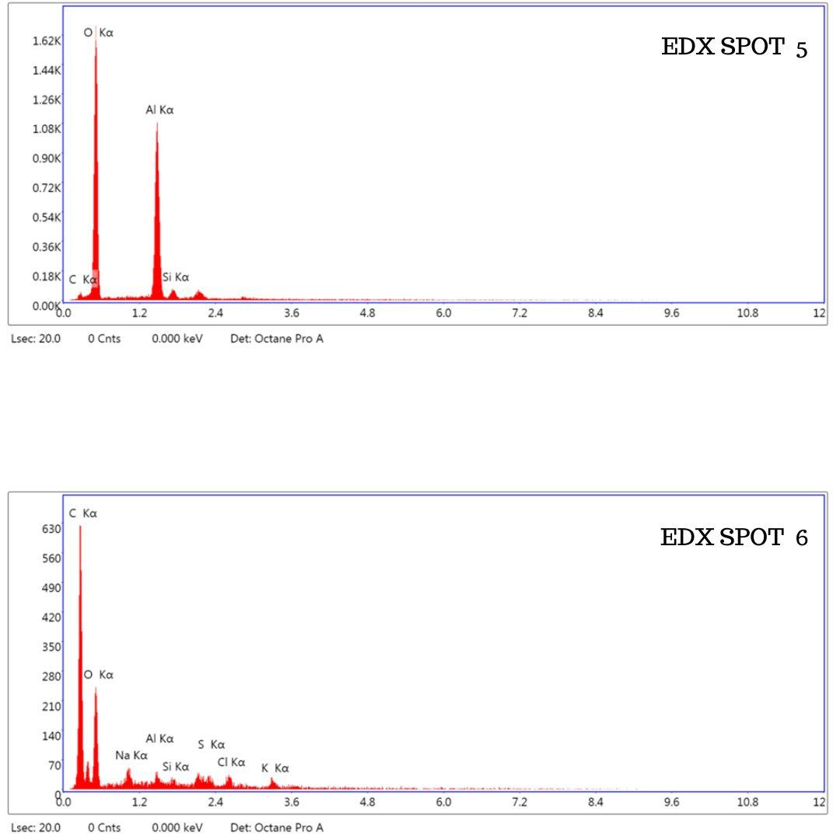
Graph 3 Spot 5 and Spot 6, the EDX spectra now include some peaks for Sodium (Na) Aluminium(Al) Silica (Si), Chlorine (Cl) and Potassium (K). The highest peaking region belongs to Oxygen (O) and Calcium ( Ca).

