Supplementary material

Holm et al.

Supplementary methods

Feature inclusion and pre-processing of the Danish training and test set
For each patient we extracted the following data: all diagnosis codes (ICD-10) and procedure codes (SKS/NOMESCO) assigned to at least 1% of the cohort between 1st of January 1994 and the time of the coronary angiography (from DNPR); all results from laboratory tests taken on at least 5% of the cohort between 5 years prior-to and up until the time of the coronary angiography (from BTH); 23 other clinical features such as sex, age, smoking status, coronary pathology, etc. (from EDHR + BTH). Moreover, for 37.4% of the cohort a panel of 19 different PRSs was included (see below). In case of repeated tests/measurements/assignments the one closest to the time of the coronary angiography was used. No data originating after the index coronary angiography were used. Laboratory test results and sex- and age adjusted (if applicable) reference ranges were originally stored in the regional laboratory information management systems “Labka” and “BCC” and in this study obtained through BTH⁴³. Tests were either annotated in accordance with the Nomenclature, Properties and Units ontology (NPU) or various local coding systems⁴⁴. Using the sex- and age adjusted reference ranges, results of the biochemical tests were discretized to the categories below, within, above, and if a given test had not been taken a category called missing. Discretization of biochemical tests using the adjusted reference ranges was a pragmatic alternative to normalizing the many different biochemical tests in a manner that adequately takes both intra- and interdepartmental variance into account, which both might be related to for instance differences in patient population and/or equipment and machinery.
Consequences of the choices above, including discretization were alluded to in Table 1. Here it is evident that the missingness of the continuous creatine feature creatinine was less than that of the discretized version because we allow measurements 21-days in the “future” relative to time zero. For the discretized version, we did not include those measurements, and consequently the missingness is higher. All continuous features were Z-score normalized and missing values were encoded with a value of zero. All categorical features were one-hot encoded and an additional category for missing values was added if applicable²⁵.
During model development, we tested and optimized various feature specific hyperparameters. We tested including diagnosis codes as either level-4, level-3, block, or chapter codes representing different steps in the ICD-10 hierarchy⁴⁵. With the hypothesis that codes and results assigned many years prior to time zero time might carry less information, we introduced three “shelf-life” hyperparameters and filtered out diagnosis codes, procedure codes, and biochemical tests assigned/taken more than n years prior to the coronary angiography.

Cohort characteristics
For the cohort characteristics presented in Table 1, comorbidities were defined from the ICD-10 codes assigned before or at the index date: diabetes was defined as E10 or E11; hypertension was defined as I10, I11, I12, I13, I14, or I15; COPD was defined as J44; and dyslipidemia was defined as E78.0, E78.1, E78.2, E78.3, E78.4, E78.5, and E78.9. The medication use was defined from prescriptions given prior to or at the index-date, using the same definition as used in Kiiskinen et al. (1), that is: lipid-lowering drugs is ATC class C10; anti-hypertensive drugs is C02, C03, C07, C08, and C09; type-2 diabetes drugs is A10B; and insulin is A10A.
For continuous features (age, height, etc.) the mean is given along with 95% bootstrap confidence intervals (CI) and, if applicable, the amount of missingness in parentheses – mean [low, high] (missingness). The mean and CI are calculated using only the non-missing features. For categorical features the raw counts and relative frequencies are both specified.

Downscaled version for external validation
Due to data availability, the model was downscaled for the external validation on Icelandic data. The features that were left out in the down-scaling were all procedure codes (n=154) since they were encoded using another non-compatible coding scheme; five biochemical tests which were not used in the Icelandic system; and seven different clinical features for which data could not be obtained: “arrest”, “enzymes”, “abnormal-ekg”, “abnormal-qrs-st”, “coronary artery dominance”, “ischemia test”, and “NYHA-class”.
Polygenic risk scores
PRSs were calculated based on GWAS summary statistics data from 19 traits relevant for cardiometabolic health, obtained from 17 GWAS meta-analyses: acute myocardial infarction(2), atrial fibrillation(3), coronary artery disease(4,5), heart failure(4), dilated cardiomyopathy(6), hypertrophic cardiomyopathy(6), systolic and diastolic blood pressure(7), stroke(8), total cholesterol and triglyceride levels(9), non-alcoholic fatty liver disease(10), immune-mediated inflammatory diseases(11), chronic kidney disease(12), body mass index(13), type 2 diabetes with adjustment for BMI(14), frailty index(15).
Autosomal genotypes from 188,462 individuals in the CHB Cardiovascular Disease Cohort were filtered to only include variants present in the HapMap3 set of 1,120,696 reference variants. Any missing genotype information was conservatively imputed to be the affected locus’ reference allele. We identified a set of 978,246 genotyped variants present in both genotype and GWAS summary statistics data that we subsequently subjected to Ldpred2’s recommended standard deviation quality control. After variant matching and quality control, a mean of 969,607 (S.D. 8,777) variants remained for per-chromosome risk score calculation for each of the 19 traits. We used the Ldpred2-auto algorithm with 30 Gibbs sampling chains, 1,000 burn-in iterations and 500 iterations after burn-in. The initial values for the 30 sampling chains were a) the LDSC regression estimate for heritability h² (same for all chains); b) one of 30 initial values for the proportion of causal variants p, evenly spaced on a logarithmic scale from 10⁻⁴ to 0.9. Final per-chromosome effect sizes were calculated from each set of 30 sampling chains (per trait and chromosome) through a three-step process, which serves to ensure that the model (spanning 30 chains) converged: 1) computing the standard deviations of each chains’ predicted scores, 2) keeping only the chains within three median absolute deviations from the median standard deviation, 3) averaging the effect sizes of the remaining chains. Across the 418 per-chromosome models (19 traits times 22 chromosomes), 26.89 chains were included in the final score on average. The lowest number of included chains was 18. Finally, the resulting per-chromosome risk scores were added together into genome-wide polygenic scores.
Neural network architecture
The neural network architecture is a relatively simple feed-forward neural network with between one and three densely connected hidden layers with rectified linear units as the activation function and with a dropout layer after each hidden layer. The output layer has 30 outputs – one for each time bin – and is being fed through a softmax activation function to produce probabilities. The neural network architecture is sketched out in figure S5.
Hyperparameter optimization
For hyperparameter optimization we used the Optuna hyperparameter optimization package for python (16). For all hyperparameter sweeps, we ran 2500 trials. For each trial, hyperparameters were sampled using the TPE (Tree-structured Parzen Estimator) algorithm as implemented in Optuna using 400 startup trials and otherwise all other arguments left on default settings(17). To prune unpromising trials, we used the hyperband pruner, with a minimum resource of 20, and a reduction factor of 3.
Resiliency of PMHnet to missingness
Finally, the resiliency of the model was assessed as described in Methods. Across the 584 features, age was the only single feature, where the change in tdAUC changed significantly when artificially removed. In the case of model calibration, missingness of six individual features significantly affected the performance. These features were troponins, LVEF, age, smoking status, abnormal ECG, and coronary pathology. Taken together, these results are evidence that PMHnet is quite resilient to missing data.
Supplementary figures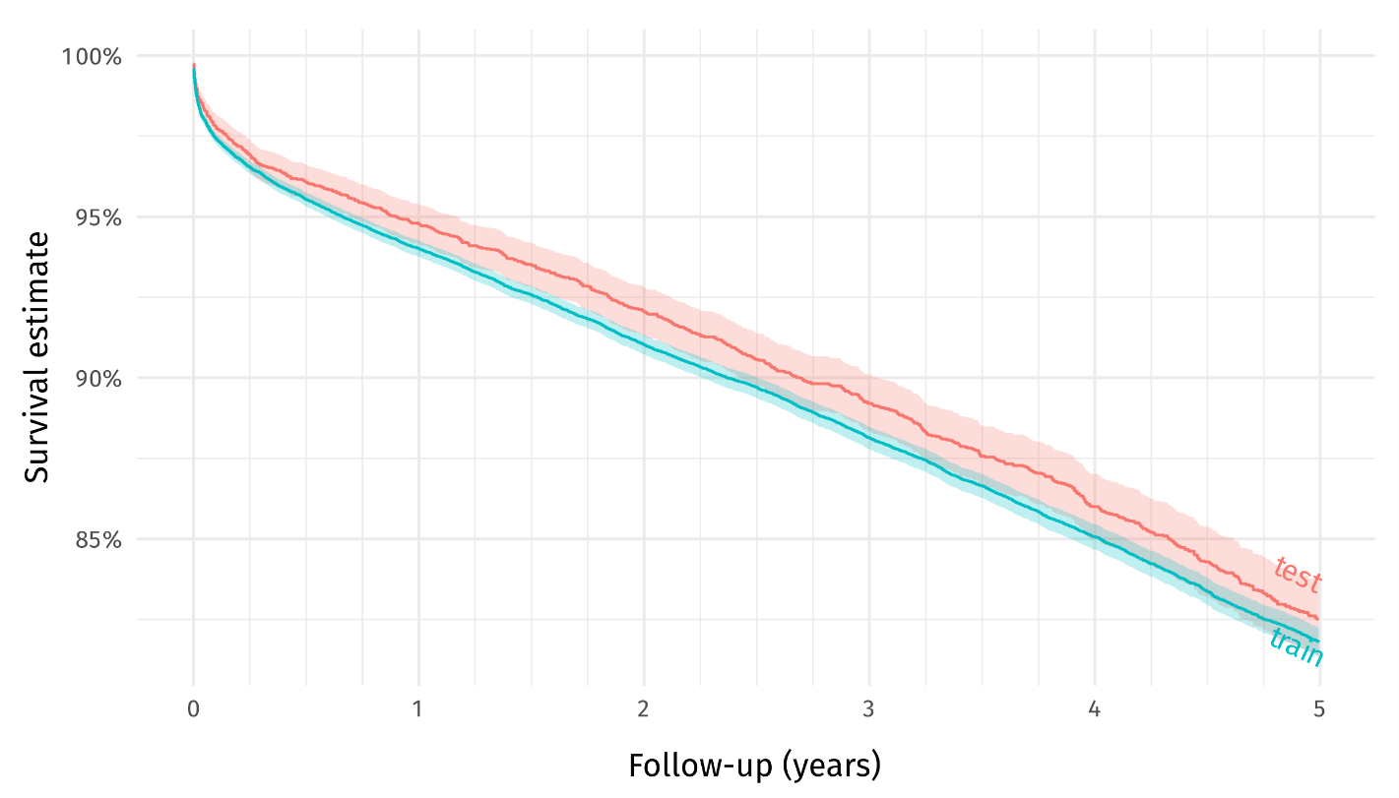
Figure S1: Kaplan-Meier estimates for the PMHnet derivation cohort. Kaplan-Meier estimates for the training (blue) and testing (red) set of 34,749 and 5,000 patients, respectively.
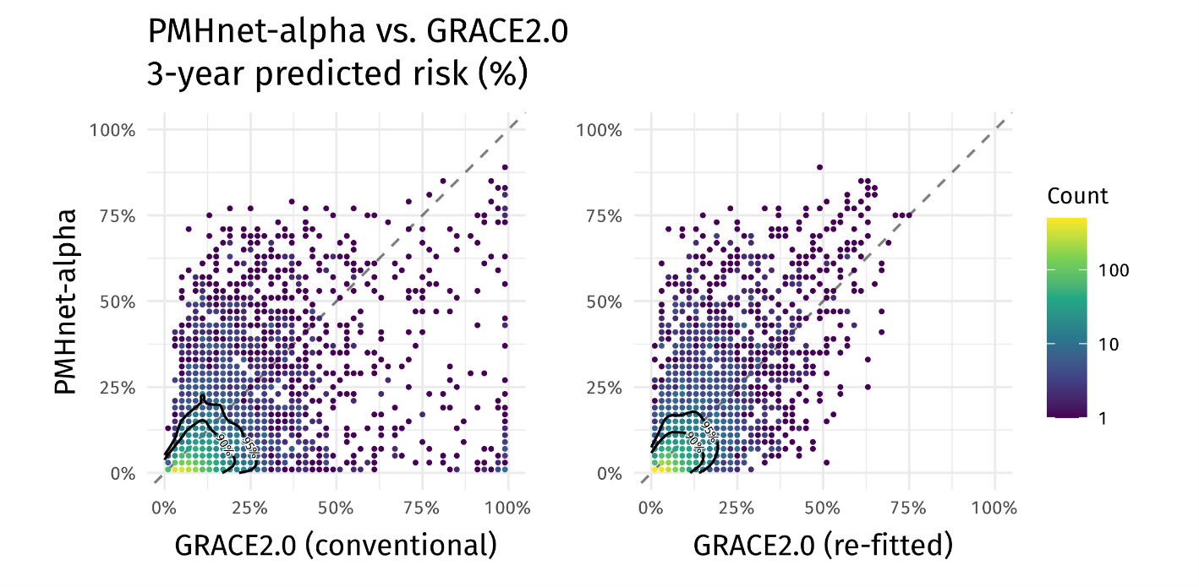
Figure S2: Difference in predicted risk between PMHnet and GRACE2.0. Binned scatterplot showing the difference between the 3-year predicted risk by PMHnet (y-axis) and GRACE2.0 (conventional) [left-panel, x-axis] or GRACE2.0 (re-fitted) [right-panel, x-axis]. Points are colored according to how many patients in the test set fall in that bin. Contour lines indicate 90%- and 95%-point densities. 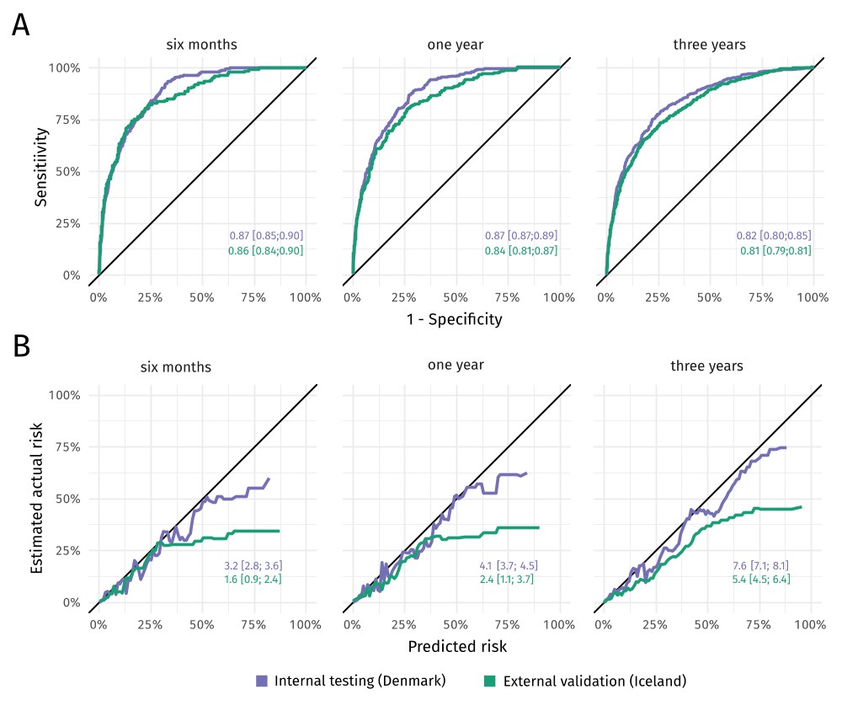Figure S3: External validation of PMHnet on Icelandic data. A) Time-dependent ROC curves at three different prediction horizons for PMHnet evaluated on the Danish test set and the Icelandic external validation set, respectively. Text labels show the corresponding tdAUC scores. B) Calibration curves showing the relation between predicted risk and the estimated actual risk. Labels show the Brier score for each of datasets. Lower scores are associated with better calibration and discrimination of predictions. Data for both type of plots and scores were generated using riskRegression and visualized using ggplot2.

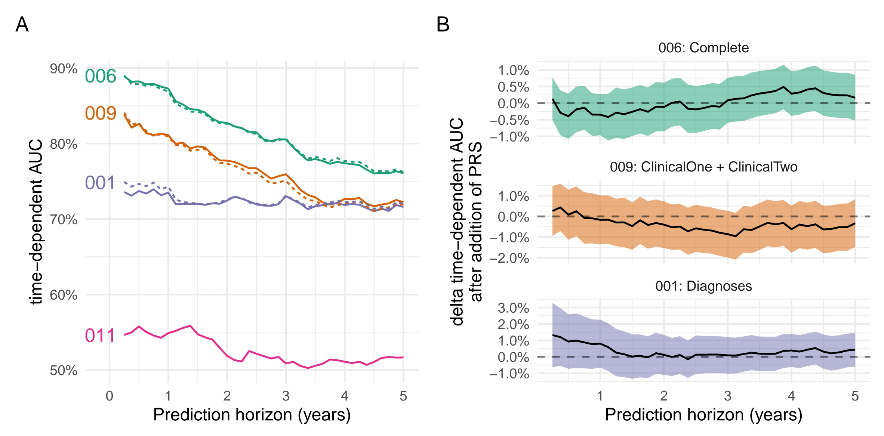
Figure S4: Effect of including polygenic risk scores to clinical features.
[A] The time-dependent AUC values for different models evaluated on the subset of the hold-out test set where genetic information could be obtained. From top to bottom, the first two lines show the performance of the complete model (“006”) with and without PRS features added. The next sets of two correspond to a model only using clinical features (“009”, ClinicalOne + ClinicalTwo) and a model only using diagnosis codes (“001”). Finally, the last line is the performance of a model that is using PRSs as the sole predictors. [B] A formal test of ΔtdAUC obtained by adding PRS information to each of the models in panel A)._Ribbon shows confidence interval obtained through the “Score” function from the riskRegression R-package.

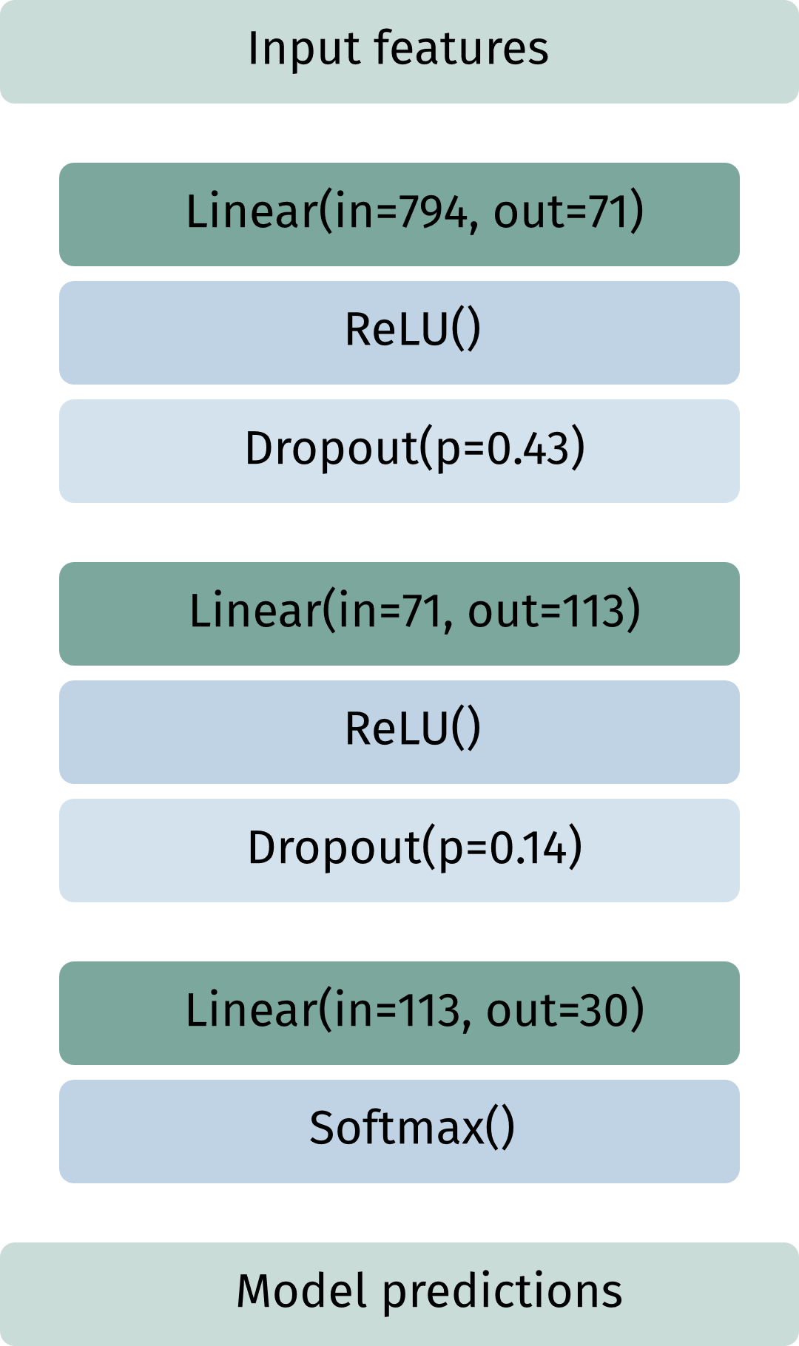
Figure S5: Neural network architecture of PMHnet (full version).
Using the PyTorch machine learning framework for python, the illustrated neural network architecture was implemented. The architecture hyperparameters, number of layers; number of units; and droprate, were determined from the hyperparameter search performed using the Optuna hyperparameter optimization framework as detailed in the methods section.

Supplementary tables
ClinicalOne features | training | testing
Systolic blood pressure | 18% | 18%
Elevated cardiac enzymes | 39% | 40%
Cardiac arrest | 0% | 0%
Age | 0% | 0%
STEMI | 0% | 0%
Heart rate | 20% | 21%
Creatinine | 10% | 11%
Killip-class | 57% | 56%
ClinicalTwo features | training | testing
Abnormal ECG | 0% | 0%
Abnormal QRS-ST | 0% | 0%
Canadian cardiovascular score | 8.6% | 8.8%
Diastolic blood pressure | 33.5% | 34%
Dominance | 3.7% | 3.8%
Familial IHD | 0% | 0%
Height | 6.4% | 6.4%
ICD-or-PM | 0% | 0%
Ischemia test | 0% | 0%
LVEF | 0% | 0%
NYHA | 75.9% | 76.8%
Sex | 0% | 0%
Smoking | 9.2% | 9.0%
Vessel status | 0% | 0%
Weight | 4.3% | 4.1%
Table S1: Missingness across clinical features for the Danish derivation data.
Outcomes | Training set | Test set | External validation set
RMST(1825), days  KM-estimate, 6 months  KM-estimate, 1 year  KM-estimate, 3 years  KM-estimate, 5 years | 1635, SE: 2.58  95.5% [95.3; 95.8]  94.0% [93.8; 94.3]  88.1% [87.8; 88.5]  81.8% [81.4; 82.2] | 1651, SE: 6.49  96.1% [95.5; 96.6]  94.8% [94.2; 95.4]  89.2% [88.3; 90.1]  82.5% [81.3; 83.6] | 1697, SE: 3.82  98.1% [97.9; 98.4]97.3% [97.0; 97.7]93.7% [93.2; 94.2]89.6% [88.9; 90.2]
Table S2: Outcomes and Kaplan-Meier estimates across training, test, and external validation data.

Table S3: Hyperparameters search space and final configuration

Hyperparameter | Search space | Best trial
Biochemical inclusion window |  | 2.5 years
Diagnosis inclusion window |  | 13.5 years
Procedures inclusion window |  | 3.5 years
Number of hidden layers |  | 2
Number of units per hidden layer |  | Layer 1: 71,  Layer 2: 113
Droprate per hidden layer |  | Layer 1: 42.8%  Layer 2: 14.0%
Learning rate
Momentum

References
1. Kiiskinen T, Helkkula P, Krebs K, Karjalainen J, Saarentaus E, Mars N, et al. Genetic predictors of lifelong medication-use patterns in cardiometabolic diseases. Nat Med. 2023 Jan;29(1):209–18.
2. Jiang L, Zheng Z, Fang H, Yang J. A generalized linear mixed model association tool for biobank-scale data. Nat Genet. 2021 Nov;53(11):1616–21.
3. Nielsen JB, Thorolfsdottir RB, Fritsche LG, Zhou W, Skov MW, Graham SE, et al. Biobank-driven genomic discovery yields new insight into atrial fibrillation biology. Nat Genet. 2018 Sep;50(9):1234–9.
4. Nikpay M, Goel A, Won HH, Hall LM, Willenborg C, Kanoni S, et al. A comprehensive 1000 Genomes–based genome-wide association meta-analysis of coronary artery disease. Nat Genet. 2015 Oct;47(10):1121–30.
5. van der Harst P, Verweij N. Identification of 64 Novel Genetic Loci Provides an Expanded View on the Genetic Architecture of Coronary Artery Disease. Circ Res. 2018 Feb 2;122(3):433–43.
6. Sakaue S, Kanai M, Tanigawa Y, Karjalainen J, Kurki M, Koshiba S, et al. A cross-population atlas of genetic associations for 220 human phenotypes. Nat Genet. 2021 Oct;53(10):1415–24.
7. Hoffmann TJ, Ehret GB, Nandakumar P, Ranatunga D, Schaefer C, Kwok PY, et al. Genome-wide association analyses using electronic health records identify new loci influencing blood pressure variation. Nat Genet. 2017 Jan;49(1):54–64.
8. Malik R, Chauhan G, Traylor M, Sargurupremraj M, Okada Y, Mishra A, et al. Multiancestry genome-wide association study of 520,000 subjects identifies 32 loci associated with stroke and stroke subtypes. Nat Genet. 2018 Apr;50(4):524–37.
9. Surakka I, Horikoshi M, Mägi R, Sarin AP, Mahajan A, Lagou V, et al. The impact of low-frequency and rare variants on lipid levels. Nat Genet. 2015 Jun;47(6):589–97.
10. Anstee QM, Darlay R, Cockell S, Meroni M, Govaere O, Tiniakos D, et al. Genome-wide association study of non-alcoholic fatty liver and steatohepatitis in a histologically characterised cohort☆. J Hepatol. 2020 Sep 1;73(3):505–15.
11. Acosta-Herrera M, Kerick M, González-Serna D, Consortium MG, Consortium SG, Wijmenga C, et al. Genome-wide meta-analysis reveals shared new loci in systemic seropositive rheumatic diseases. Ann Rheum Dis. 2019 Mar 1;78(3):311–9.
12. Wuttke M, Li Y, Li M, Sieber KB, Feitosa MF, Gorski M, et al. A catalog of genetic loci associated with kidney function from analyses of a million individuals. Nat Genet. 2019 Jun;51(6):957–72.
13. Yengo L, Sidorenko J, Kemper KE, Zheng Z, Wood AR, Weedon MN, et al. Meta-analysis of genome-wide association studies for height and body mass index in ∼700000 individuals of European ancestry. Hum Mol Genet. 2018 Oct 15;27(20):3641–9.
14. Mahajan A, Taliun D, Thurner M, Robertson NR, Torres JM, Rayner NW, et al. Fine-mapping type 2 diabetes loci to single-variant resolution using high-density imputation and islet-specific epigenome maps. Nat Genet. 2018 Nov;50(11):1505–13.
15. Atkins JL, Jylhävä J, Pedersen NL, Magnusson PK, Lu Y, Wang Y, et al. A genome-wide association study of the frailty index highlights brain pathways in ageing. Aging Cell. 2021;20(9):e13459.
16. Akiba T, Sano S, Yanase T, Ohta T, Koyama M. Optuna: A Next-generation Hyperparameter Optimization Framework [Internet]. arXiv; 2019 Jul. Report No.: 1907.10902. Available from: https://arxiv.org/abs/1907.10902
17. Bergstra J, Bardenet R, Bengio Y, Kégl B. Algorithms for Hyper-Parameter Optimization. In: Advances in Neural Information Processing Systems [Internet]. Curran Associates, Inc.; 2011 [cited 2023 Jun 14]. Available from: https://proceedings.neurips.cc/paper_files/paper/2011/hash/86e8f7ab32cfd12577bc2619bc635690-Abstract.html

