Supplementary Information
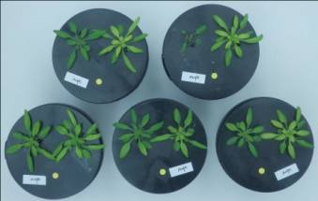
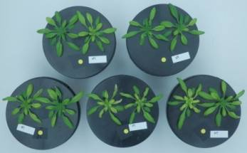
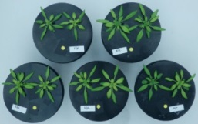
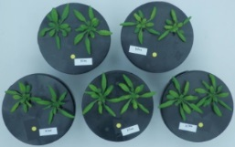
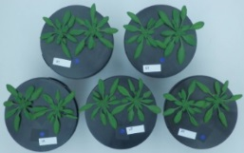
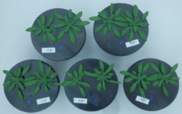
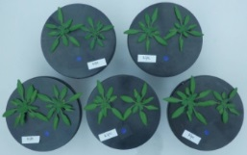
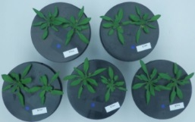
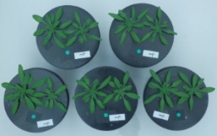
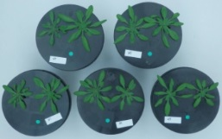
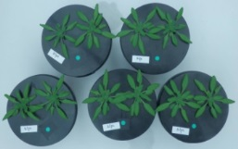
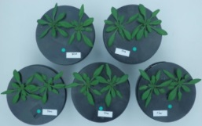
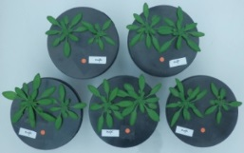
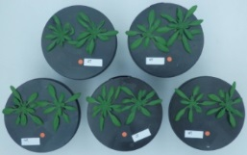
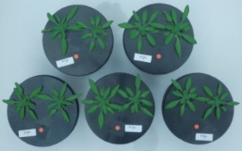
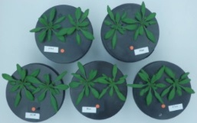
Wt
klpc
unpc
klnn
0
2
5
20

Figure S1. Growth and phenotype of plants grown at different Fe concentrations (0, 2, 5 and 20 µM Fe).

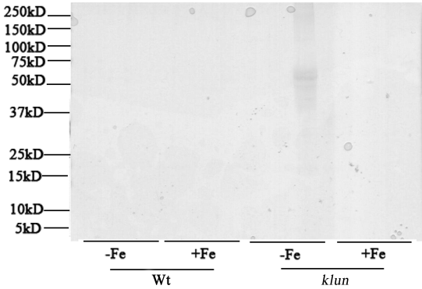
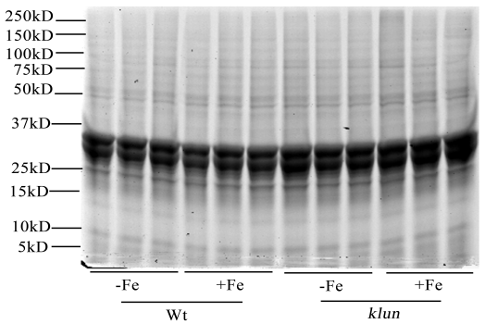
A B
Background-empty beads
Pull down-14-3-3 coating beads
14-3-3
protein mixture

Figure S2. Coomassie-stained SDS-PAGE gel of proteins isolated by 14-3-3 pull-down. CBB-stained gel was used as the loading control. A. Pull-down assay with empty beads and Fe-deficiency treated root extracts. B. Pull-down assay with At14-3-3 coated beads and extracts of roots grown under Fe-deficient condition. The numbers in the panel show the molecular weights of the protein ladder marker. For the pull-down assay nickel-beads were coated with N-terminally His-labelled 14-3-3 KAPPA, LAMBDA, NU and UPSILON in equimolar ratios (1:1:1:1:1). Roots were treated with or without 20 μM Fe-EDTA for 24 hours. Eluted fractions were separated on 10% SDS-PAGE.

Table S1. Proteins identified in pull-down assay with At14-3-3 coated beads and Wt root extracts (+ and –Fe). Merging of all identified proteins in six independent pull-downs resulted in a list of 117 interacting proteins with unused value >2.
No.^{a)} | ATG ^{b)} | Protein name | Number of replicates ^{c)} | Max unused ^{d)} | Identified in previous 14-3-3 interactome studies ^{e)} | protein changes in Fe deficiency proteomics study ^{f)}
Carbohydrate and energy metabolism (24)
23 | AT5G08670 | mitochondrial ion transporting ATP synthase beta-subunit | 6 | 24.62 | B,D
24 | AT4G31340 | myosin heavy chain-related protein | 6 | 2.02
26 | AT1G79530 | GAPCP-1 (glyceraldehyde-3-phosphate dehydrogenase of plastid 1 | 6 | 6.38
34 | AT3G52930 | FBA8 (Fructose-bisphosphate aldolase 8) | 6 | 2.14 | B,C | G
35 | AT1G27450 | APT1（Isoform 2 of Adenine phosphoribosyltransferase 1） | 4 | 6
36 | AT1G13440 | GAPC2 (glyceraldehyde-3-phosphate dehydrogenase c2) | 6 | 32.12 | B,C,D
38 | AT4G35810  AT2G17720 | 2OG-Fe(II) oxygenase family protein | 2 | 2.04
39 | AT1G23490 | ARF1 (ADP-ribosylation factor 1) | 6 | 2
49 | AT1G48030 | mtLPD1 (Dihydrolipoyl dehydrogenase 1) | 2 | 2 |  | F
56 | AT1G51470 | BGLU35 (Beta glucosidase 35) | 2 | 2.59
59 | AT5G08530 | CI51 (NADH dehydrogenase flavoprotein 1) | 6 | 2.82
79 | AT1G24280 | G6PD3 (Glucose-6-phosphate 1-dehydrogenase 3) | 6 | 9.22 | A | F (0.60)
86 | AT1G09430 | ACLA-3 (ATP-citrate synthase alpha chain protein 3) | 4 | 2
88 | AT3G04120 | GAPC1 (Glyceraldehyde-3-phosphate dehydrogenase) | 6 | 6.38 | B,C,D
94 | AT1G35580 | CINV1 (cytosolic invertase 1) | 6 | 46.07 | A,D | G
96 | AT4G04040  AT1G12000 | MEE51 (maternal effect embryo arrest 51) | 6 | 2.18
108 | AT3G02090 | MPPBETA (Isoform 1 of Probable mitochondrial-processing peptidase subunit beta) | 6 | 10
110 | AT4G09510 | CINV2 (cytosolic invertase2) | 6 | 31.32
134 | AT5G13450 | ATP5 (ATP synthase subunit delta) | 6 | 10.92 | C
151 | AT4G35260 | IDH1 (Isocitrate dehydrogenase regulatory subunit 1) | 6 | 2.43
159 | AT4G34860 | beta-fructofuranosidase invertase | 3 | 2.7 | D | G
164 | AT1G63000 | UDP-4-keto-6-deoxy-glucose-3,5-epimerase | 3 | 3.4
170 | AT3G19820 | DWF1 (Delta(24)-sterol reductase) | 6 | 6
175 | ATMG01190  AT2G07698 | ATP1 (ATP synthase subunit alpha) | 6 | 7.53
Metabolism (19)
42 | AT4G35790 | ATPLDDELTA (phospholipase D) | 2 | 2.21
47 | AT2G34470 | UREG (urease accessory protein g) | 6 | 5.4 |  | F
61 | AT4G39980 | DHS1 (Phospho-2-dehydro-3-deoxyheptonate aldolase 1) | 6 | 6.59 | A
65 | AT4G14360 | PMT3 (Probable methyltransferase 3) | 2 | 2.17
66 | AT5G17920 | ATMS1 (5-methyltetrahydropteroyltriglutamate--homocysteine methyltransferase) | 6 | 16.05 | B,D | G
85 | AT1G52760 | LysoPL2 (lysophospholipase 2) | 6 | 2
91 | AT2G36880 | SAM3, MAT3 (S-adenosylmethionine synthase 3) | 6 | 14.01 | C | E, F (1.47)
93 | AT5G13640 | PDAT (Phospholipid:diacylglycerol acyltransferase 1) | 6 | 5.31
100 | AT4G01850 | SAM2 (S-adenosylmethionine synthase 2) | 2 | 2.45 |  | F (1.36)
111 | AT5G43780 | APS4 (ATP sulfurylase 4, chloroplastic) | 6 | 6.01
115 | AT4G13930 | SHM4 (serine hydroxymethyltransferase 4) | 6 | 14
126 | AT1G22410 | 2-dehydro-3-deoxyphosphoheptonate aldolase | 6 | 10.1
129 | AT3G17390 | MTO3 (S-adenosylmethionine synthase 4) | 6 | 9.98
146 | AT2G38040 | CAC3 (acetyl co-enzyme a carboxylase carboxyltransferase alpha subunit) | 4 | 2.39
147 | AT2G13360 | AGT (Serine-glyoxylate aminotransferase) | 6 | 2.89
149 | AT5G46290 | KAS I (Isoform 2 of 3-oxoacyl-[acyl-carrier-protein] synthase I) | 6 | 2.04
158 | AT4G13430 | IIL1 (3-isopropylmalate dehydratase) | 6 | 2.4
163 | AT1G02500 | SAM1, MAT1 (S-adenosylmethionine synthase 1) | 6 | 3.51 |  | F (1.61)
168 | AT5G54810 | TSB1 (Tryptophan synthase beta chain 1) | 4 | 2
Stress response (18)
25 | AT5G54430 | PHOS32 | 6 | 3.29
32 | AT5G45490 | Probable disease resistance protein | 6 | 4
33 | AT2G20990 | SYTA (Synaptotagmin A) | 3 | 2.6
50 | AT5G01600 | FER1 (Ferritin-1) | 6 | 2.85 |  | F (0.30)
55 | AT4G35090 | CAT2 (catalase 2) | 6 | 6.3 | A
60 | AT4G34050 | CCoAOMT1 (caffeoyl-CoA O-methyltransferase) | 6 | 8.59 |  | F (1.45)
67 | AT5G64100 | Peroxidase 69 | 6 | 12.72
69 | AT5G38940 | Germin-like protein subfamily 1 member 11 | 5 | 14
133 | AT1G09560 | Germin-like protein subfamily 1 member 5, GLP5 | 6 | 14 |  | E ,F (4.50)
82 | AT5G45510 | Isoform 2 of Probable disease resistance protein | 2 | 4.01
99 | AT3G15950 | NAI2 | 6 | 14.95
119 | AT4G24800 | MA3 domain-containing protein | 4 | 4.01
139 | AT5G14030 | TRAPB (translocon-associated protein beta) | 3 | 2
142 | AT4G23690 | AtDIR6 (Arabidopsis thaliana dirigent protein 6) | 3 | 2
145 | AT4G21960 | PRXR1 (Peroxidase 42) | 6 | 5.25
162 | AT4G27320 | PHOS34 | 6 | 6.3
173 | AT1G49570 | Peroxidase 10 | 3 | 4.12
176 | AT1G72330 | ALAAT2 (Alanine aminotransferase 2) | 5 | 2.01 |  | F
Protein synthesis (7)
31 | AT1G56070 | LOS1 (Elongation factor EF-2) | 6 | 6.06 | B,D
54 | AT4G20360 | RABFAFFEOYL | 2 | 4.27
 |  | E1b (Elongation factor Tu)
63 | AT3G13920 | EIF4A1 (eukaryotic translation initiation factor 4A1) | 6 | 8.01 | A,B
64 | AT1G63660 | GMP synthase (glutamine amidotransferase) | 6 | 22.27
95 | AT4G02930 | Elongation factor Tu | 6 | 10.7
153 | AT1G26630 | FBR12 (Eukaryotic translation initiation factor 5A-2) | 6 | 9.77 | B
172 | AT1G07920 | GTP binding Elongation factor Tu family protein | 6 | 29.58 | B,D
Protein folding, transport and degradation (13)
41 | AT3G15980 | Isoform 1 of Coatomer subunit beta-3 | 3 | 3.3
62 | AT3G11830 | TCP-1/cpn60 chaperonin family protein, eta subunit | 6 | 11.19
102 | AT3G03960 | TCP-1/cpn60 chaperonin family protein, theta subunit | 2 | 2
103 | AT3G18190 | TCP-1/cpn60 chaperonin family protein, delta subunit | 5 | 3
112 | AT5G26360 | TCP-1/cpn60 chaperonin family protein, gamma subunit | 2 | 2
117 | AT1G67760 | TCP-1/cpn60 chaperonin family protein, epsilon subunit | 6 | 2.64
118 | AT3G53110 | LOS4 (low expression of osmotically responsive genes 4) | 4 | 2.13
121 | AT5G56030 | HSP81-2 (Heat shock protein 81-2) | 6 | 4.85 | A,B,D
122 | AT5G20890 | TCP-1/cpn60 chaperonin family protein | 6 | 2.83
140 | AT2G47470 | UNE5 (unfertilized embryo sac 5) | 2 | 2
141 | AT5G61790 | CNX1 (Calnexin homolog 1) | 6 | 4.31
156 | AT5G02500 | HSC70-1 (heat shock cognate protein 70-1) | 6 | 6.01 | B,C
166 | AT3G08580 | AAC1 (ATP carrier protein 1) | 6 | 6.76
Membrane and Transport proteins (5)
37 | AT1G30630 | Coatomer subunit epsilon-1 | 6 | 4
70 | AT1G76030 | V-type proton ATPase subunit B1 | 3 | 2.04
81 | AT1G78900 | VHA-A (V-type proton ATPase catalytic subunit A) | 2 | 4
127 | AT4G32285 | Probable clathrin assembly protein | 2 | 2
144 | AT4G11150 | TUF (V-type proton ATPase subunit E1) | 3 | 2
Cell structure (9)
27 | AT1G75780 | TUB1 (Tubulin beta-1) | 6 | 14.93
53 | AT4G14960 | TUA6 (Tubulin/FtsZ family protein) | 6 | 16.37 | A
72 | AT3G18780 | ACT2 (Actin-2) | 6 | 12
73 | AT5G09810 | ACT7 (Actin-7) | 6 | 9.22 | A,B
92 | AT1G11580 | PMEPCRA (/pectinesterase inhibitor 18) | 6 | 4 | B
98 | AT5G19770 | TUA3 (Tubulin alpha-3 chain) | 6 | 4.14 |  | G
152 | AT5G44340 | TUB4 (Tubulin beta-4 chain) | 6 | 14.93
167 | AT5G55480 | SVL1 (Probable glycerophosphoryl diester phosphodiesterase 1) | 2 | 2
169 | AT1G04820 | TUA2 (Tubulin alpha-2) | 6 | 18.73 | B | G
Signaling (10)
40 | AT1G56330 | GTP-binding protein (Fragment) | 3 | 2 | B
52 | AT3G52990 | pyruvate kinase family protein | 6 | 2.02
75 | AT4G35310 | CPK5 (Calcium-dependent protein kinase 5) | 4 | 3.41
89 | AT1G14000 | VIK F16A14.22 | 6 | 3.85
97 | AT4G23650 | CDPK6 (Calcium-dependent protein kinase 3) | 6 | 14.04
105 | AT2G20900 | DGK5 (diacylglycerol kinase 5) | 5 | 2
113 | AT3G63260 | ATMRK1 (protein serine/threonine/tyrosine kinase) | 2 | 2.06
114 | AT3G52400 | SYP122 (Syntaxin-122) | 6 | 6
120 | AT4G18950 | ankyrin protein kinase, putative | 6 | 6.95
148 | AT5G63190 | MA3 domain-containing protein | 4 | 2
Transcription related (9)
43 | AT4G29830 | VIP3 (vernalization independence 3) | 6 | 2
74 | AT2G14120 | DRP3B (dynamin-like protein 3b) | 6 | 5.1
78 | AT5G44500 | small nuclear ribonucleoprotein associated protein B | 2 | 2.06
106 | AT4G32720 | La1 AtLa1 (Arabidopsis thaliana La protein 1) | 6 | 18.06
123 | AT1G09760 | U2A U2 small nuclear ribonucleoprotein A | 6 | 2.04
132 | AT4G38680 | GRP2, CSP2 (Cold shock protein 2 | 3 | 2
138 | AT5G23540 | 26S proteasome regulatory subunit, putative | 6 | 2.02 | B
157 | AT2G24420 | DNA repair ATPase-related protein | 2 | 4.01
174 | AT4G38220 | N-acyl-L-amino-acid amidohydrolase, putative | 6 | 4.21
Miscellaneous (2)
109 | AT1G58270 | ZW9 | 6 | 3.64
51 | AT5G26290 | meprin and TRAF homology domain-containing protein | 3 | 2
14-3-3s (1)
116 | AT4G09000 | GRF1 (14-3-3-like protein GF14 chi) | 3 | 2.01
a) Order of identified protein in the protein list searched against the Uniprot proteomics database.
b) ATG number: the accession number of Arabidopsis genes.
c) Number of replicates: how often a protein was identified among different replicates.
d) Max unused: the maximum unused value among different replicates.
e) Identified in previous 14-3-3 interactome study: proteins that have been reported in previous 14-3-3 interactome studies. A=Chang et al, 2009; B=Paul et al,2009; C=Shin et al.,2011; D=Swatek et al., 2011.
f) Proteins whose abundance changes during Fe deficiency (F; Lan et al., 2011 and López-Millán et al., 2013; in brackets the fold-change) and proteins that show enhanced phosphorylation under Fe-deficiency conditions (G = Lan et al., 2012).

Table S2. Interaction network analysis of identified proteins using the STRING software and database (http://string.embl.de), based on known and predicted interactions. Lines of different colors represent different types of evidence for the associations. Three major protein complexes were identified: mFoF1-synthase, V-ATPase, Tubulin. Four functional networks were identified: elongation factors, chaperones, glycolysis and TCA cycle and cysteine/methionine metabolism.
Categories | ATG | Network
mFoF1-synthase  complex | AT3G02090  AT5G13450  AT5G08670  ATMG01190  AT2G07698  AT5G08530 | 
V-ATPase complex | AT1G76030  AT4G11150  AT1G78900 | 
Tubulin complex | AT1G75780  AT4G14960  AT3G18780  AT5G09810  AT5G19770  AT5G44340  AT1G04820 | 
Elongation factor network | AT1G07920  AT4G20360  AT3G13920  AT4G02930  AT1G26630  AT1G56070 | 
Chaperone network | AT5G56030  AT5G20890  AT2G47470  AT5G61790  AT5G02500  AT3G11830  AT3G03960  AT3G18190  AT5G26360  AT1G67760 | 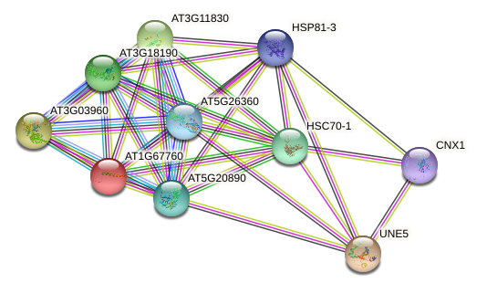
Glycolysis and TCA cycle | AT1G79530  AT3G52930  AT1G13440  AT1G48030  AT1G24280  AT1G09430  AT3G04120  AT4G04040  AT4G35260 | 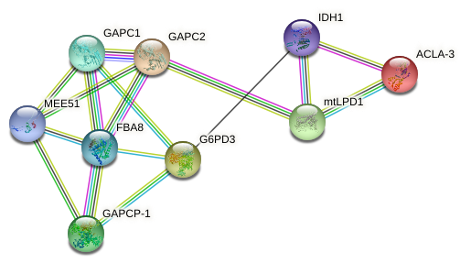
Cysteine and methionine metabolism network | AT5G17920  AT2G36880  AT4G01850  AT4G13930  AT3G17390  AT1G02500 | 

Table S3. Primer pairs used for qRT-PCR according to Yang et al ^{4.}
Gene | Locus | Primers
IRT1 | AtU27590 | fw:5'-GCGACTTGTAGTGCGGCTATG-3'
 |  | rev:5'-CGTTGCACGAGCGATTCTG-3'
FRO2 | At1g01580 | fw:5'-GGAGAAGGTGTTGCTCCATCTC-3'
 |  | rev:5'-GGTTAGGCAAGTTTAAGCTCTG-3'
AHA2 | At4g30190 | fw:5'-TTTGCCGGAGTCTTCCCAGGT-3'
 |  | rev:5'-GGGGCATCATTGACACCATCACCAG-3'
FIT | At2g28160 | fw:5'-GTATCAATCCTCCTGCTT-3'
 |  | rev:5'-TCTCGGTTACATCATCACT-3'
14-3-3 omicron | At1g34760 | fw:5'-CTATCACTCAAGGCGTATG-3'
 |  | rev:5'-GTATGGCTCCGTAACTAAG-3'
UBQ10 | At4g05320 | fw:5'- GTCTTCGTGGTGGTTTCTAAATCT -3'
 |  | rev:5'- TTATTCATCAGGGATTATACAAGG -3'

