Supplementary File
1. Morphological Parameters used for the morphometry of toads
- SVL: Snout-vent length HL Head length (from back of mandible to tip of snout)
- HW: Head width (left side back of mandible to right side back of mandible)
- STL: Snout-tympanum length (tip of snout to front of tympanum)
- MSL: Mouth angle-snout length (tip of snout to end of mouth opening)
- NS: Nostril-snout length (distance from nostril to tip of snout)
- NTL: Nostril tympanum length (distance between nostril and front of tympanum)
- EN: Distance from front of eye to nostril
- TEL: Tympanum eye length (distance between end of eye to front of tympanum)
- TD: Tympanum diameter (maximum diameter)
- IN: Internarial distance (distance between 2 nostrils)
- EL: Eye length (greatest diameter of the eye including upper eyelids)
- IOD: Interorbital distance
- FAL: Forearm length (from elbow to base of outer palmer tubercle)
- HLL: Hind limb length
- THIGHL: Thigh length
- TL: Tibia length
- 3FL: Third finger length
- 1FL: First finger length
- 4FL: Fourth finger length

Table 1: Morphometric Data of Toads from Large, Medium and Small Groups
(a) Large Toads
Toad No. | I | II | III | IV | V | VI
Body wt. (gms) | 82.651 | 97.563 | 70.174 | 94.246 | 92.986 | 89.352
SVL (cms) | 9.35 | 9.75 | 8.98 | 9.30 | 9.16 | 9.11
HL (cms) | 2.40 | 1.80 | 1.90 | 1.92 | 1.91 | 1.90
HW (cms) | 3.23 | 3.40 | 3.14 | 3.25 | 3.24 | 3.19
STL (cms) | 2.03 | 2.06 | 2.00 | 2.17 | 2.15 | 2.11
MSL (cms) | 2.22 | 2.17 | 2.00 | 2.50 | 2.43 | 2.34
NS (cms) | 0.47 | 0.32 | 0.34 | 0.40 | 0.42 | 0.46
NTL (cms) | 1.48 | 1.65 | 1.26 | 1.64 | 1.62 | 1.59
EN (cms) | 0.47 | 0.50 | 0.25 | 0.53 | 0.51 | 0.48
TEL (cms) | 0.06 | 0.13 | 0.12 | 0.10 | 0.09 | 0.07
TD (cms) | 0.46 | 0.60 | 0.54 | 0.70 | 0.64 | 0.60
IN (cms) | 0.54 | 0.38 | 0.31 | 0.46 | 0.50 | 0.54
EL (cms) | 1.13 | 0.96 | 0.85 | 0.85 | 0.91 | 0.94
IOD (cms) | 0.96 | 0.95 | 0.86 | 0.86 | 0.89 | 0.91
FAL (cms) | 3.14 | 3.41 | 3.87 | 5.22 | 5.05 | 4.97
HLL (cms) | 4.02 | 6.09 | 6.16 | 7.32 | 7.11 | 7.02
THIGHL (cms) | 2.24 | 2.83 | 2.12 | 2.17 | 2.18 | 2.23
TL (cms) | 1.54 | 1.80 | 1.03 | 1.67 | 1.61 | 1.58
3FL (cms) | 0.20 | 0.50 | 0.31 | 0.35 | 0.31 | 0.27
1FL (cms) | 0.12 | 0.15 | 0.10 | 0.18 | 0.15 | 0.12
4FL (cms) | 1.05 | 0,90 | 0.96 | 1.16 | 1.12 | 1.09
Skin wt (gms) | 10.157 | 11.918 | 9.749 | 11.393 | 11.286 | 10.967

(b) Medium Toads
Toad No. | I | II | III | IV | V | VI
Body wt. (gms) | 32.726 | 30.479 | 45.984 | 30.029 | 31.264 | 30.098
SVL (cms) | 7.06 | 6.71 | 7.39 | 6.64 | 6.98 | 6.67
HL (cms) | 1.50 | 1.50 | 2.00 | 1.51 | 1.47 | 1.53
HW (cms) | 2.50 | 2.39 | 3.00 | 2.35 | 2.44 | 2.33
STL (cms) | 1.60 | 1.60 | 1.58 | 1.58 | 1.56 | 1.60
MSL (cms) | 1.86 | 1.59 | 1.89 | 1.51 | 1.76 | 1.56
NS (cms) | 0.12 | 0.23 | 0.20 | 0.19 | 0.11 | 0.21
NTL (cms) | 1.18 | 1.24 | 1.25 | 1.22 | 1.09 | 1.24
EN (cms) | 0.20 | 0.24 | 0.28 | 0.23 | 0.11 | 0.27
TEL (cms) | 0.01 | 0.03 | 0.02 | 0.03 | 0.01 | 0.02
TD (cms) | 0.39 | 0.40 | 0.48 | 0.42 | 0.37 | 0.46
IN (cms) | 0.31 | 0.38 | 0.33 | 0.39 | 0.29 | 0.42
EL (cms) | 0.72 | 0.83 | 0.90 | 0.79 | 0.71 | 0.79
IOD (cms) | 0.63 | 0.53 | 0.70 | 0.59 | 0.60 | 0.63
FAL (cms) | 3.58 | 3.60 | 3.70 | 3.62 | 3.54 | 3.69
HLL (cms) | 5.71 | 5.10 | 5.96 | 5.47 | 5.65 | 5.52
THIGHL (cms) | 1.90 | 2.00 | 1.80 | 2.43 | 1.83 | 2.49
TL (cms) | 1.26 | 0.59 | 0.86 | 0.60 | 1.22 | 0.73
3FL (cms) | 0.66 | 0.45 | 0.55 | 0.46 | 0.58 | 0.46
1FL (cms) | 0.20 | 0.15 | 0.22 | 0.15 | 0.19 | 0.17
4FL (cms) | 1.05 | 0.85 | 1.00 | 0.89 | 1.05 | 0.92
Skin wt (gms) | 5.427 | 4.329 | 6.392 | 4.197 | 4.286 | 4.134

(c) Small Toads
Toad No. | I | II | III | IV | V | VI
Body wt. (gms) | 19.965 | 16.657 | 17.334 | 20.276 | 16.289 | 19.145
SVL (cms) | 5.82 | 5.89 | 6.00 | 5.79 | 5.84 | 5.81
HL (cms) | 1.86 | 1.40 | 1.46 | 1.87 | 1.36 | 1.89
HW (cms) | 2.08 | 1.93 | 1.90 | 2.10 | 1.89 | 2.11
STL (cms) | 1.40 | 1.32 | 1.37 | 1.46 | 1.29 | 1.42
MSL (cms) | 1.60 | 1.59 | 1.58 | 1.67 | 1.54 | 1.66
NS (cms) | 0.29 | 0.12 | 0.40 | 0.34 | 0.08 | 0.31
NTL (cms) | 1.03 | 1.06 | 1.09 | 1.11 | 1.01 | 1.06
EN (cms) | 0.30 | 0.27 | 0.20 | 0.48 | 0.22 | 0.34
TEL (cms) | 0.04 | 0.07 | 0.05 | 0.03 | 0.04 | 0.05
TD (cms) | 0.32 | 0.34 | 0.26 | 0.36 | 0.33 | 0.38
IN (cms) | 0.16 | 0.20 | 0.35 | 0.17 | 0.17 | 0.19
EL (cms) | 0.70 | 0.60 | 0.53 | 0.69 | 0.56 | 0.76
IOD (cms) | 0.49 | 0.49 | 0.47 | 0.51 | 0.44 | 0.55
FAL (cms) | 3.12 | 2.47 | 2.76 | 3.17 | 2.36 | 3.13
HLL (cms) | 5.16 | 4.36 | 4.76 | 5.20 | 4.28 | 5.19
THIGHL (cms) | 1.89 | 1.50 | 1.55 | 1.91 | 1.44 | 1.93
TL (cms) | 0.75 | 0.82 | 0.70 | 0.77 | 0.79 | 0.80
3FL (cms) | 0.44 | 0.31 | 0.46 | 0.44 | 0.32 | 0.48
1FL (cms) | 0.10 | 0.12 | 0.15 | 0.11 | 0.12 | 0.17
4FL (cms) | 0.70 | 0.76 | 0.90 | 0.75 | 0.79 | 0.76
Skin wt (gms) | 2.716 | 2.238 | 2.480 | 2.893 | 2.016 | 2.376

2. HPTLC Chromatograms:

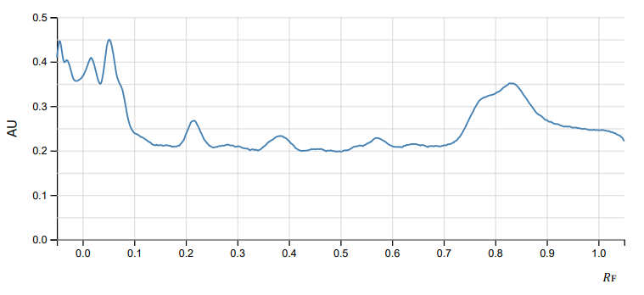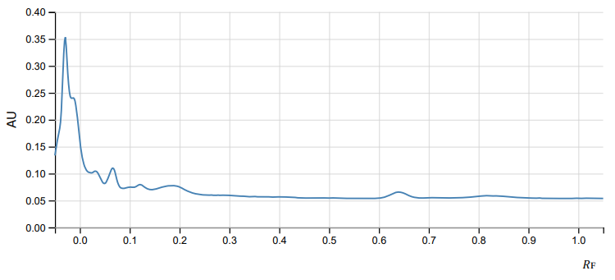
(a) (b)
Fig. 1. Chromatograms of derivatized HPLTC plate of DMSE (10 mg/ml) from small toads at 254 nm in solvent systems - (a) ethyl acetate-methanol-water (100:13.5:10) and (b) ethyl acetate-methanol-ethanol-water (81:11:4:8)

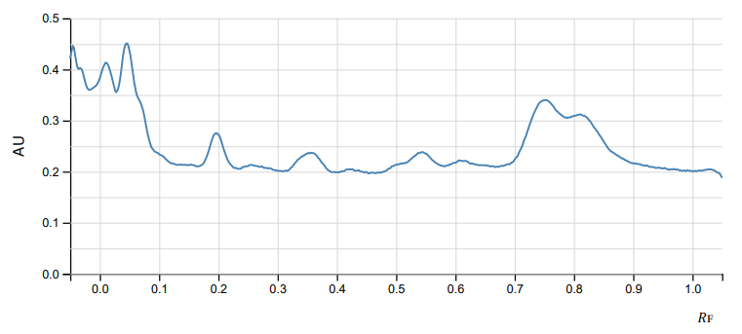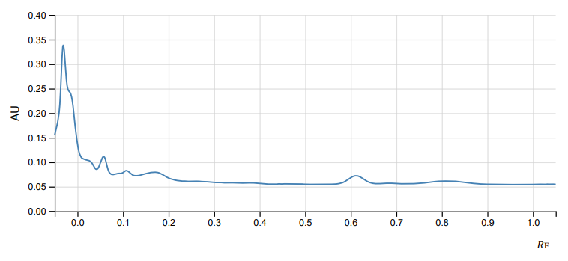
(a) (b)
Fig. 2. Chromatograms of derivatized HPLTC plate of DMSE (10 mg/ml) from small toads at 366 nm in solvent systems - (a) ethyl acetate-methanol-water (100:13.5:10) and (b) ethyl acetate-methanol-ethanol-water (81:11:4:8)

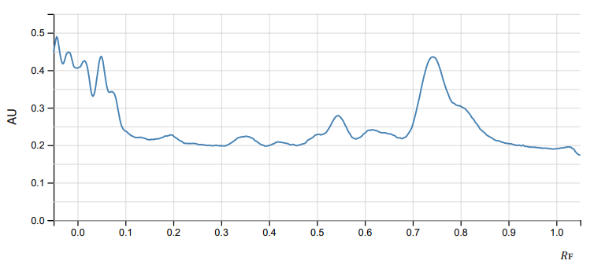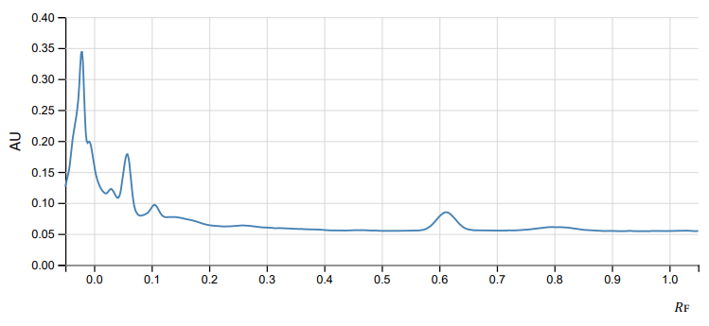
(a) (b)
Fig. 3. Chromatograms of derivatized HPLTC plate of DMSE (10 mg/ml) from medium toads at 254 nm in solvent systems - (a) ethyl acetate-methanol-water (100:13.5:10) and (b) ethyl acetate-methanol-ethanol-water (81:11:4:8)

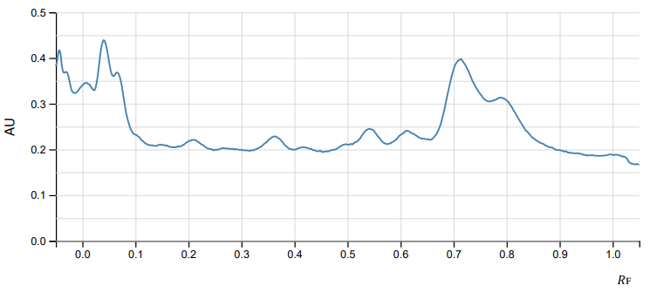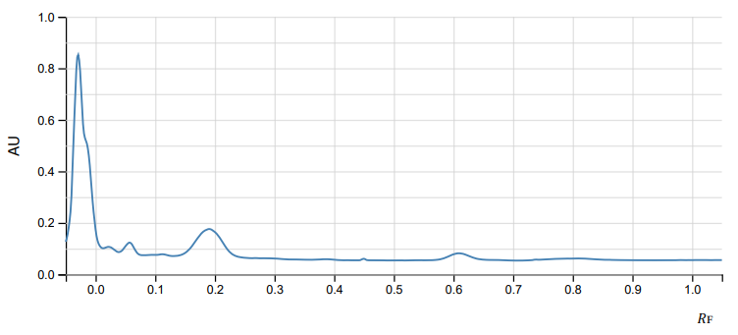
(a) (b)
Fig. 4. Chromatograms of derivatized HPLTC plate of DMSE (10 mg/ml) from medium toads at 366 nm in solvent systems - (a) ethyl acetate-methanol-water (100:13.5:10) and (b) ethyl acetate-methanol-ethanol-water (81:11:4:8)

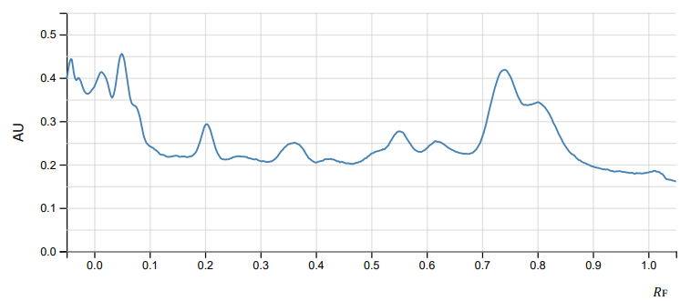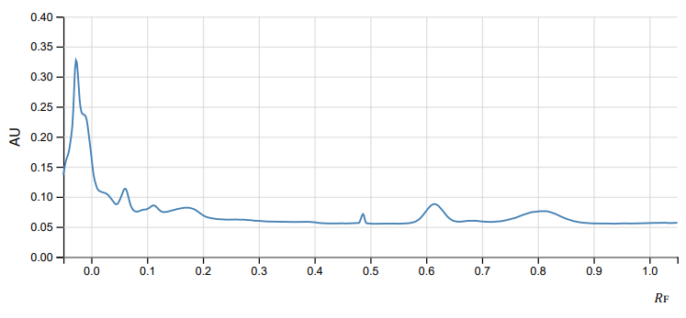
(a) (b)
Fig. 5. Chromatograms of derivatized HPLTC plate of DMSE (10 mg/ml) from large toads at 254 nm in solvent systems - (a) ethyl acetate-methanol-water (100:13.5:10) and (b) ethyl acetate-methanol-ethanol-water (81:11:4:8)

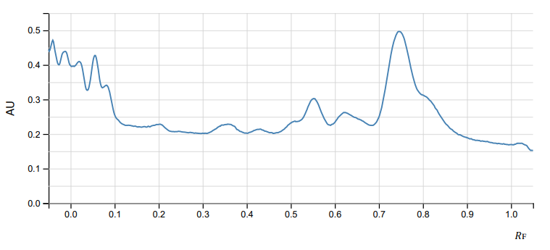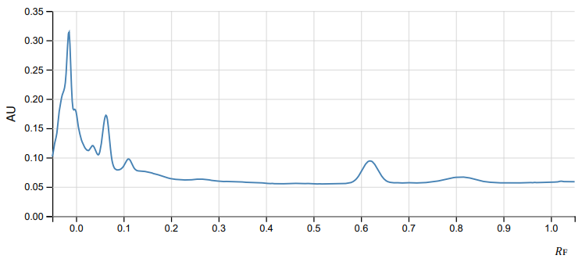
(a) (b)
Fig. 6. Chromatograms of derivatized HPLTC plate of DMSE (10 mg/ml) from large toads at 366 nm in solvent systems - (a) ethyl acetate-methanol-water (100:13.5:10) and (b) ethyl acetate-methanol-ethanol-water (81:11:4:8)

3. UPLC-MS/MS Chromatograms:

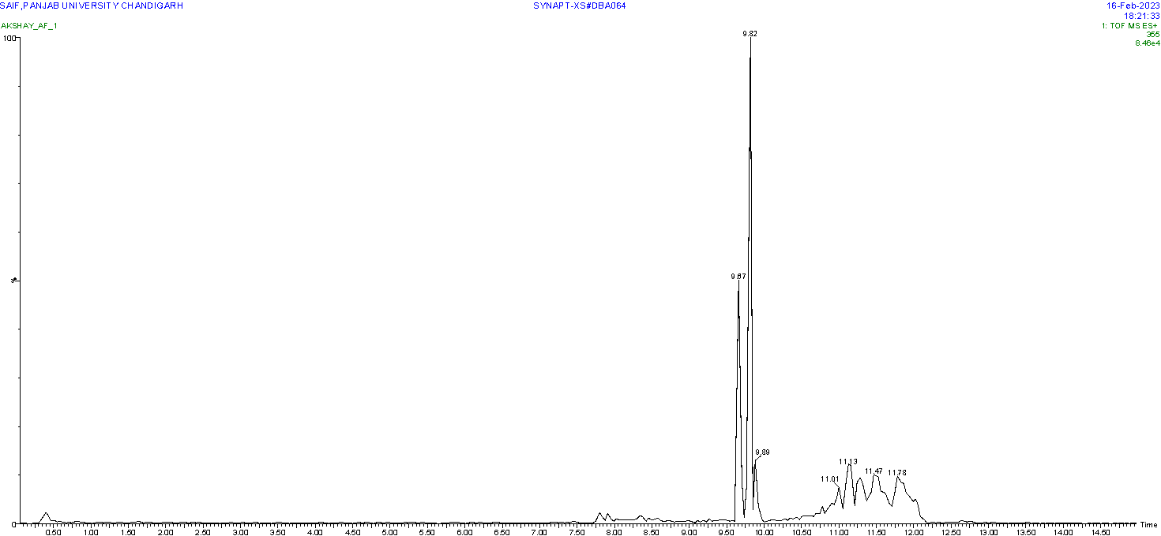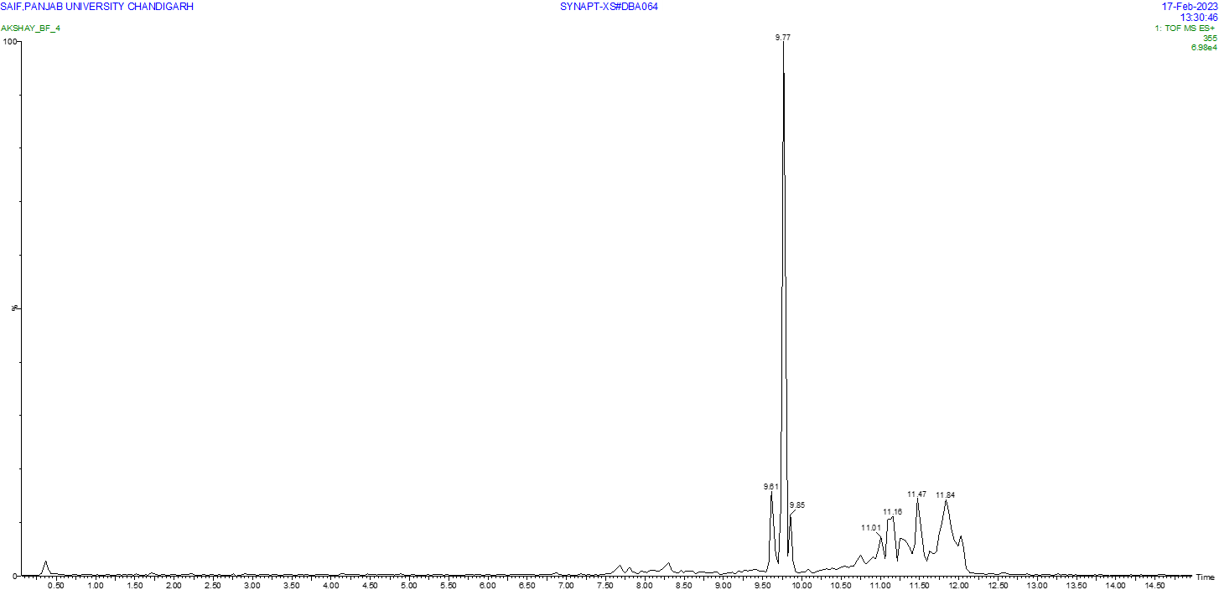
(a) (b)
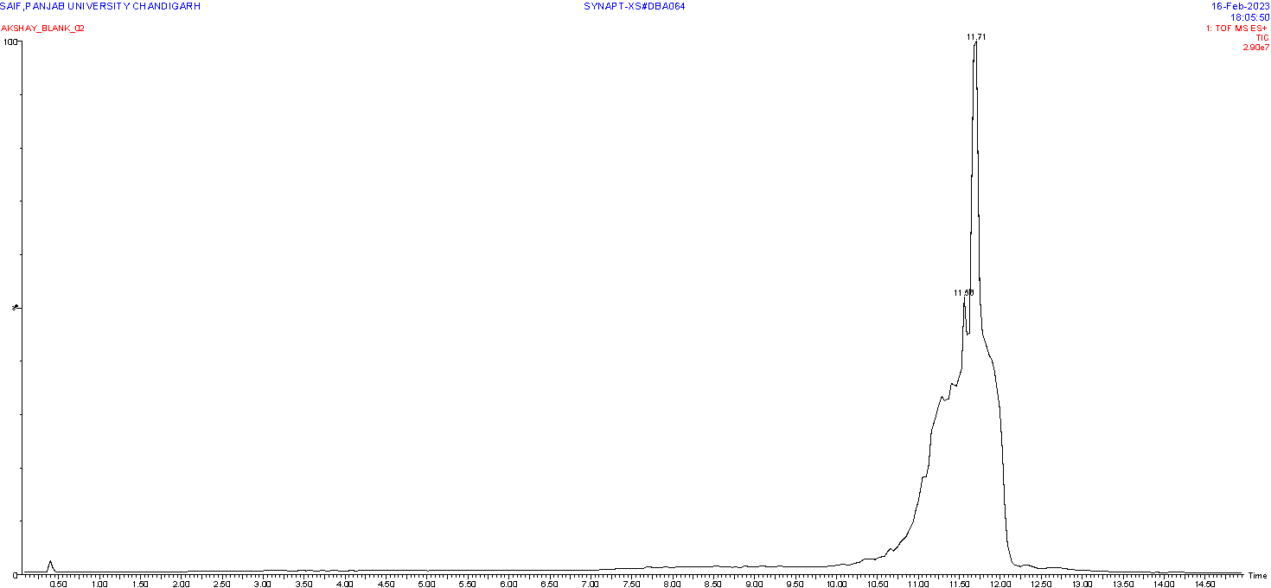
(c)
Fig. 7. UPLC-MS/MS chromatogram of band having R_{f} value 0.64 from DMSE of (a) small, (b) medium, and (c) large toads

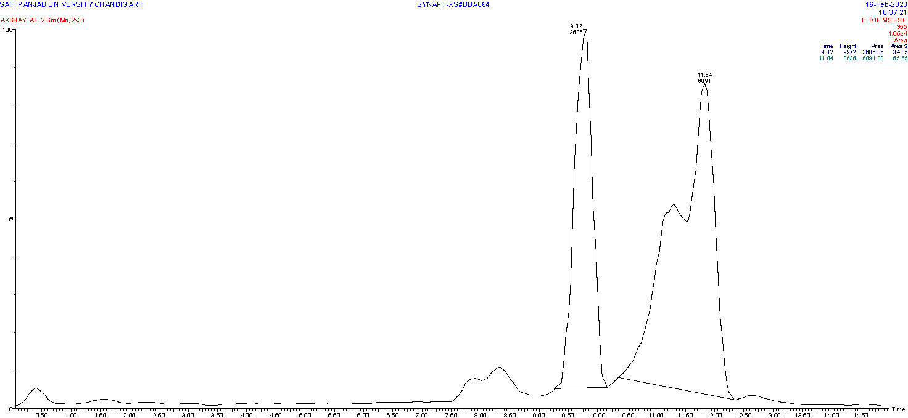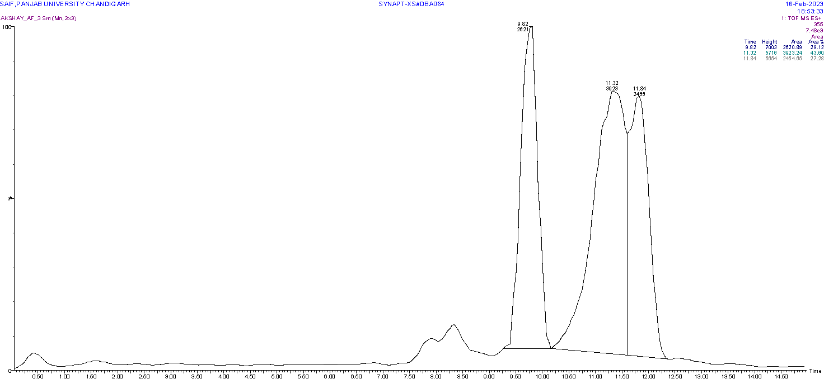
(a) (b)
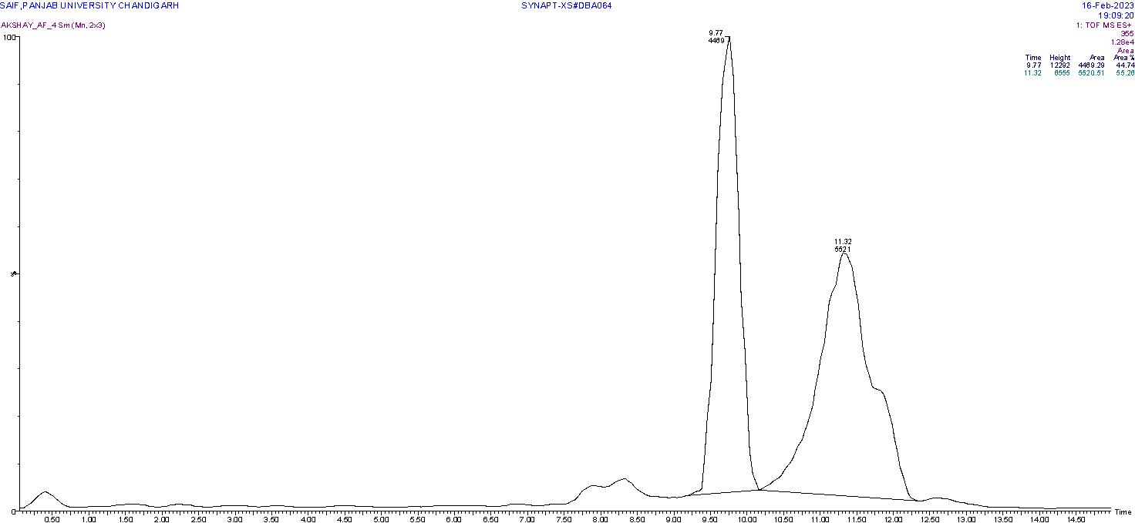
(c)
Fig. 8. UPLC-MS/MS chromatogram of band having R_{f} value 0.47 from DMSE of (a) small, (b) medium, and (c) large toads

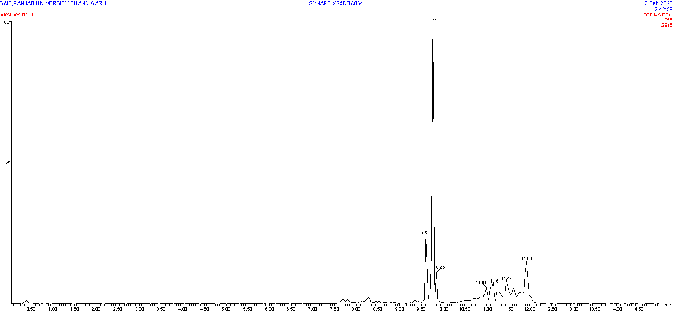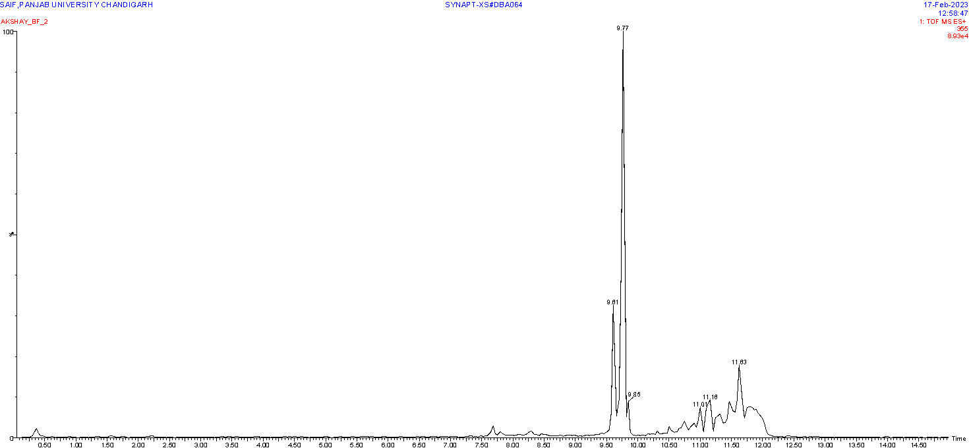
(a) (b)
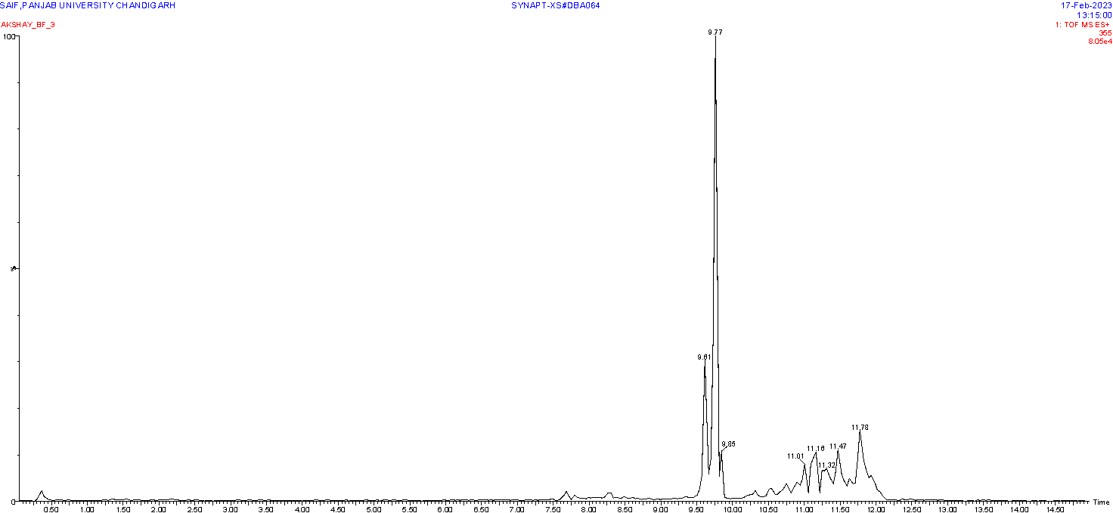
(c)
Fig. 9. UPLC-MS/MS chromatogram of band having R_{f} value 0.34 from DMSE of (a) small, (b) medium, and (c) large toads

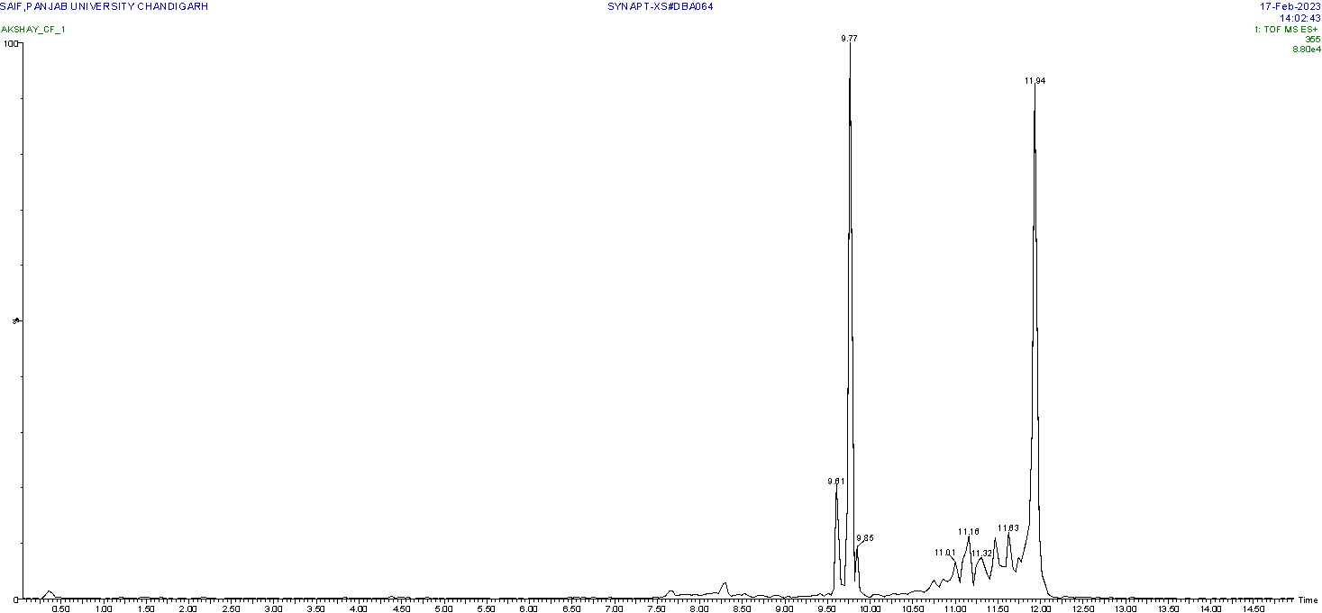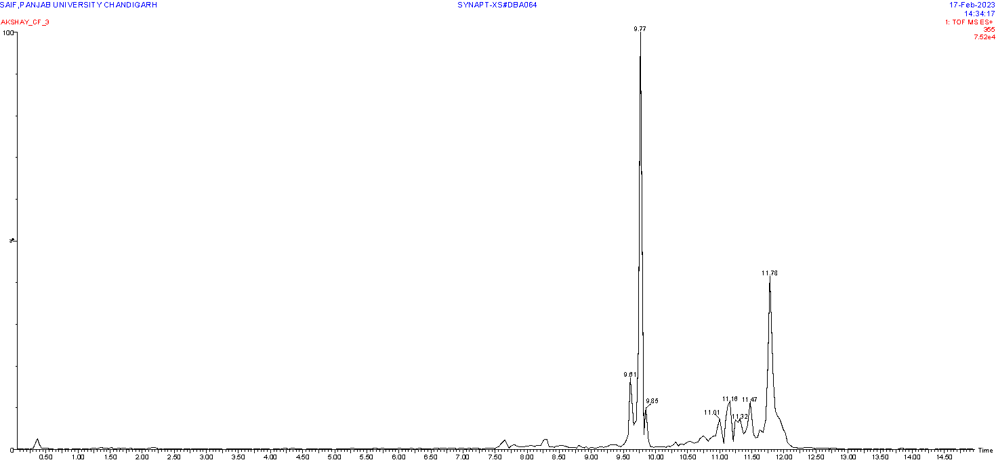
(a) (b)
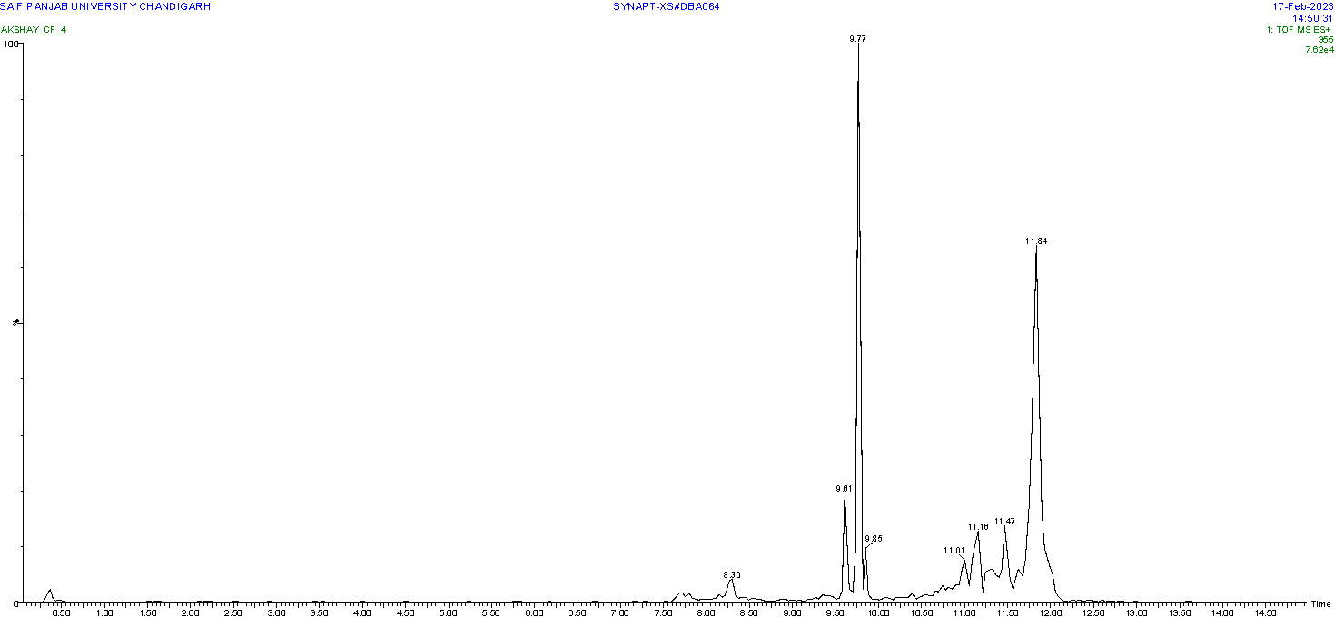
(c)
Fig. 10. UPLC-MS/MS chromatogram of band having R_{f} value 0.21 from DMSE of (a) small, (b) medium, and (c) large toads

