Supplementary table
Supplementary Figure 1. Methods of diaphragm ultrasound finding measurement
(a) How to measure the diaphragm thickness (DT) was displayed in Supplementary figure 1. DT was defined by the distance between the diaphragmatic pleura and the peritoneal membrane. It was measured in the zone of opposition in the right hemithorax over the mid-axillary line between eighth and eleventh intercostal spaces. (b) Diaphragm excursion (DE) was the amplitude during inspiration. It was measured in the costal margin at the mid-clavicular line. (c) Linear probe was used in measurement of DT at the zone of opposition. Convex probe was used in measurement of DE at the anterior costal margin over the mid-clavicular line.

- Diaphragm thickness
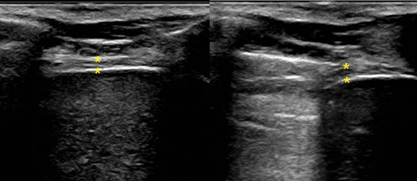

- Diaphragm excursion
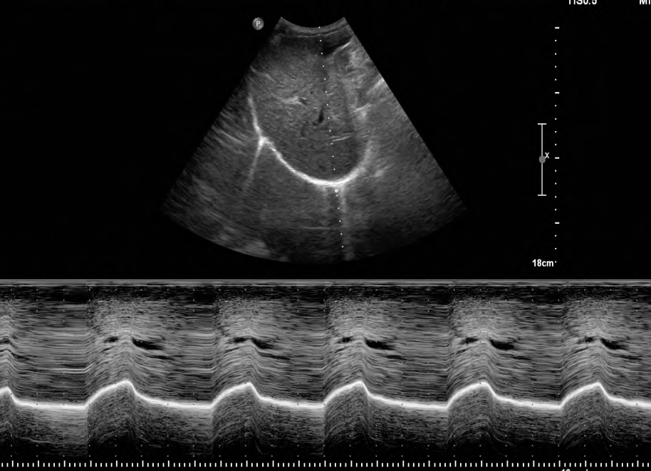
- Probe positioning
