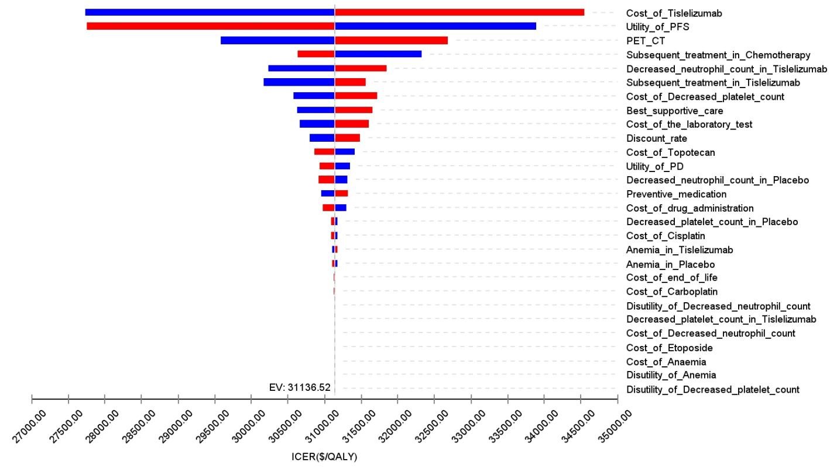
Supplemental Figure 1. The tornado diagram of one-way sensitivity analysis (China)

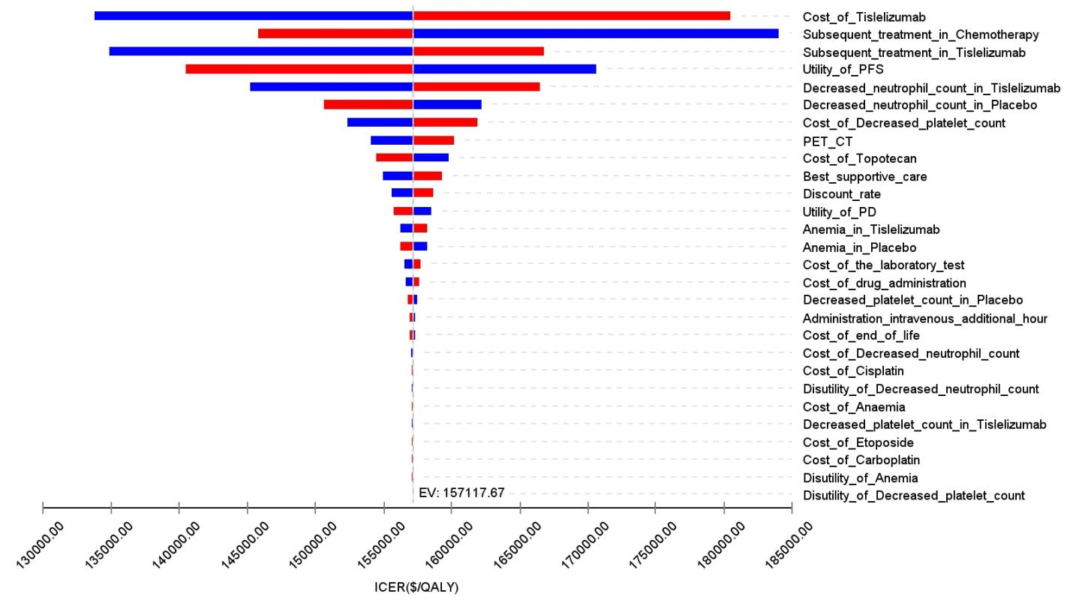
Supplemental Figure 2. The tornado diagram of one-way sensitivity analysis (The US)

