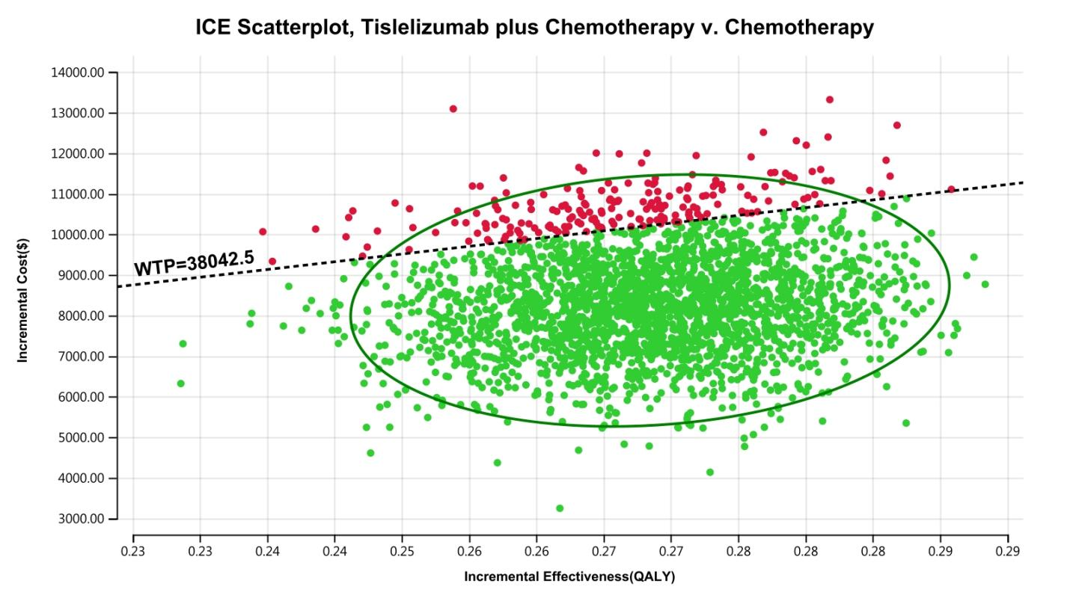
Supplemental Figure 5. The cost-effectiveness probabilistic scatter plot (China)

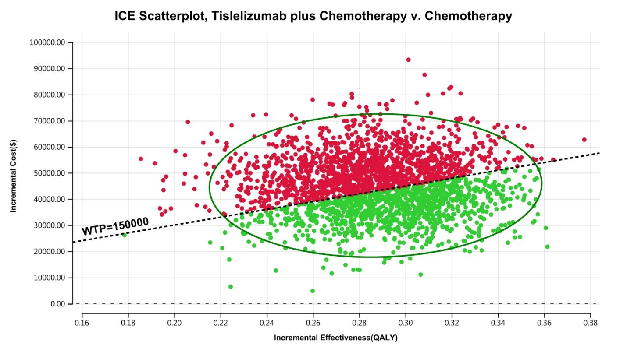
Supplemental Figure 6. The cost-effectiveness probabilistic scatter plot (The US)

