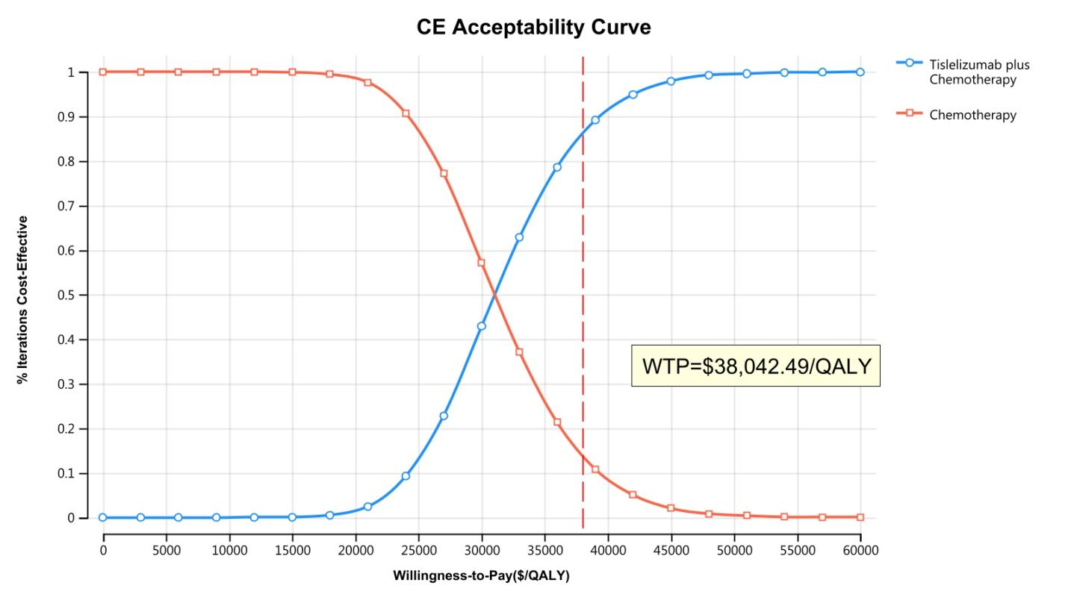
Supplemental Figure 3. The cost-effectiveness acceptability curve (China)

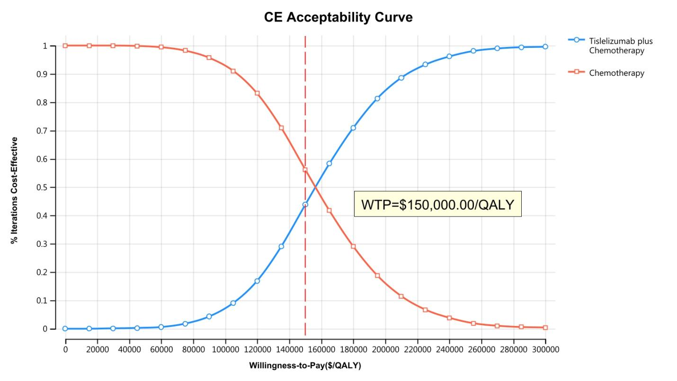
Supplemental Figure 4. The cost-effectiveness acceptability curve (The US)

