Supplementary information

In vivo evaluation of the redox alteration in Duchenne muscular dystrophy in mdx mice using dynamic nuclear polarization magnetic resonance imaging

Hinako Eto¹, Masaharu Murata¹, Takahito Kawano¹, Yoko Tachibana¹, Yoshifumi Noda², Hiroki Kato², Masayuki Matsuo², Fuminori Hyodo^{3,4*}

¹Center for Advanced Medical Open Innovation, Kyushu University, 3-1-1 Maidashi, Higashi-ku, Fukuoka 812-8582, Japan
²Department of Radiology, Gifu University, 1-1 Yanagido, Gifu 501-1194, Japan
³Department of Pharmacology, Graduate School of Medicine, Gifu University, 1-1 Yanagido, Gifu 501-1194, Japan
⁴Center for One Medicine Innovative Translational Research, Institute for Advanced Study, Gifu University, Gifu, Japan

*Correspondence should be addressed to Fuminori Hyodo
Department of Pharmacology, Graduate School of Medicine, Gifu University, 1-1 Yanagido, Gifu 501-1194, Japan
Tel.: +81-58-230-6214, Fax: +81-58-230-6215
E-mail: hyodo.fuminori.i4@f.gifu-u.ac.jp

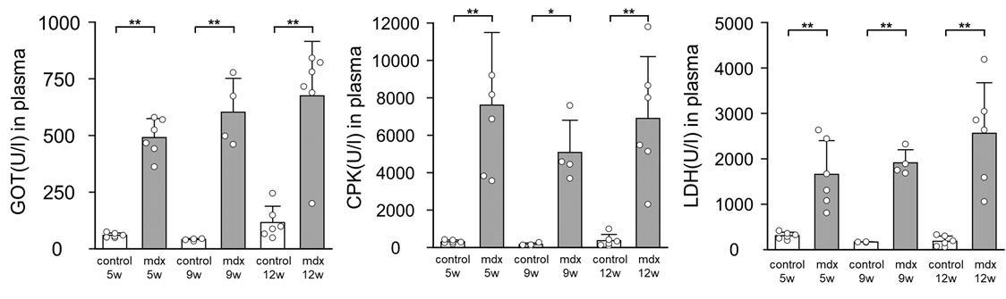
Supplementary Figure 1

Blood biochemical evaluation in control and mdx mice.
Glutamic oxaloacetic transaminase (GOT), creatine phosphokinase (CPK), and lactate dehydrogenase (LDH) plasma concentrations in normal control mice (n = 6, 4, and 6 ) and mdx mice at 5-, 9-, and 12-week old (n = 6, 4, and 6) Data were presented as mean ± SD. ** p < 0.01.

