Supplementary Information

Micro-engineered Nanowire Electron Source for Atomic Resolution Imaging
Han Zhang^{1*}, Yu Jimbo², Akira Niwata², Akihiro Ikeda², Akira Yasuhara², Cretu Ovidiu¹, Koji Kimoto¹, Takeshi Kasaya³, Hideki T. Miyazaki³, Naohito Tsujii⁴, Hongxin Wang¹, Yasushi Yamauchi¹, Daisuke Fujita¹, Shin-ichi Kitamura², Hironobu Manabe²
- Research center for advanced material characterization, National Institute for Materials Science, Tsukuba, Ibaraki, Japan;
- JEOL ltd., Akishima, Tokyo, Japan;
- Research center for functional materials, National Institute for Materials Science, Tsukuba, Ibaraki, Japan;
- International center for materials nanoarchitectonics, National Institute for Materials Science, Tsukuba, Ibaraki, Japan;
* to whom correspondence should be sent: ZHANG.han@nims.go.jp

- HRTEM image taken at 800kx magnification
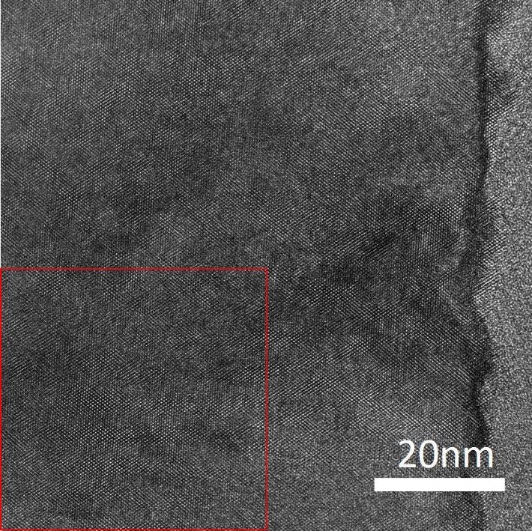
Sfigure1. The 800kx HRTEM image taken by using the LaB₆ NW emitter. Red rectangle marked the region where the FFT diffractogram of figure 2e is created from.

- Probe size determination
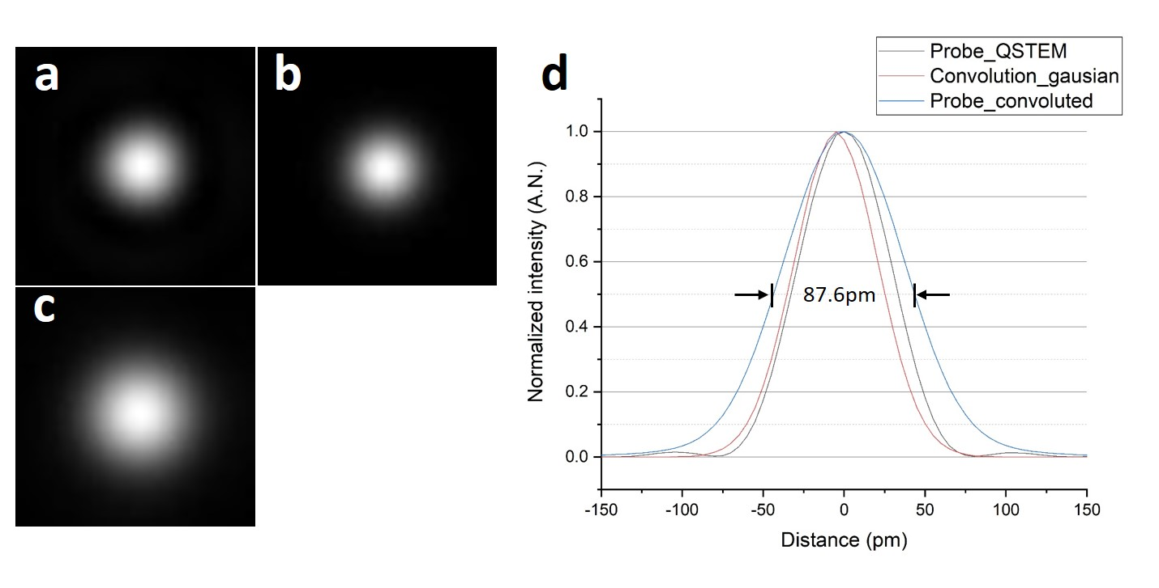
Sfigure2. (a) 2D electron probe profile simulated using QSTEM based on diffraction and lens aberration conditions of the experiment. Image width: 200pm; (b) A gaussian-shaped beam profile simulating additional probe broadening effect through instrument instability and source size. Image width: 200pm; (c) Theoretical probe profile simulated by convoluting (a) with (b). Image width: 200pm; (d) Line profiles of (a), (b), (c), showing the 87.6pm FWHM of the convoluted probe.

- Lowest un-monochromated EELS ZLP
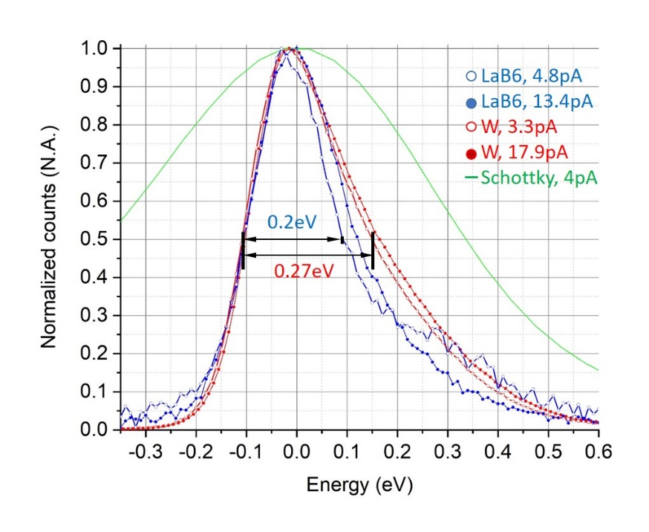
Sfigure3. Un-monochromated EELS ZLP comparison among LaB₆ nanowire emitter, W (310) emitter and Schottky emitter, used in aberration corrected TEMs. 0.2eV and 0.27 eV are the lowest possible FWHM energy spreads measured for LaB₆ nanowire emitter and W (310) emitter in the same NeoArm200F TEM.

