Supplementary Table S1: Number of cells in each cluster at resolution 0.3

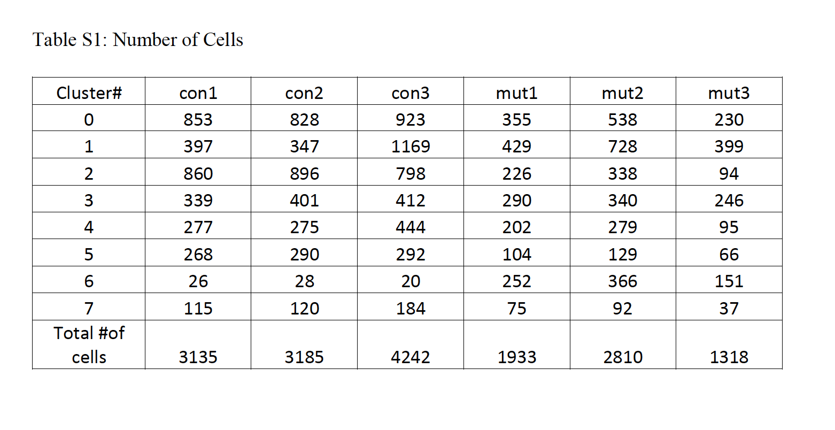
Supplementary Table S2: Proportion of Cells in each cluster

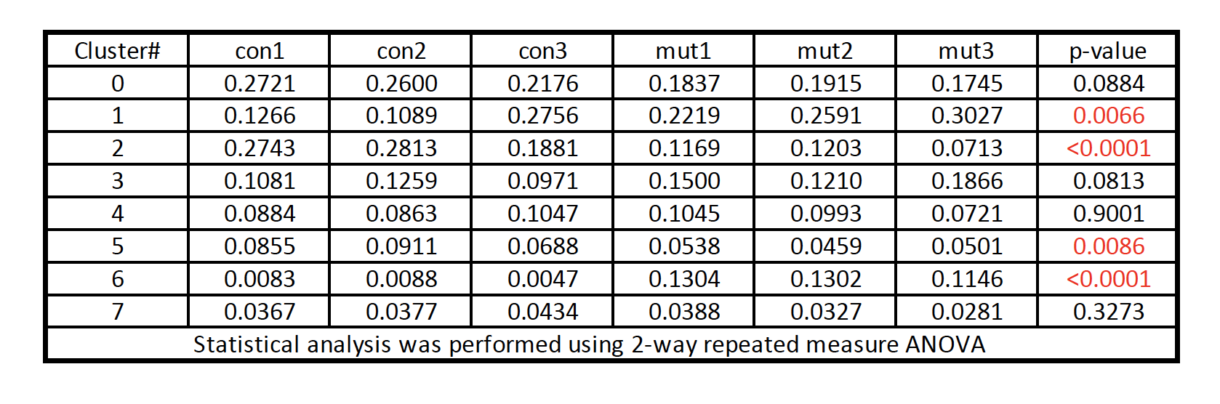

Supplementary Figure 1: Sc-RNA seq analysis. A) UMAP of clusters in the control and Idh1 mutant biological replicates. B) Heat map showing top 5 differentially expressed genes in each cluster.
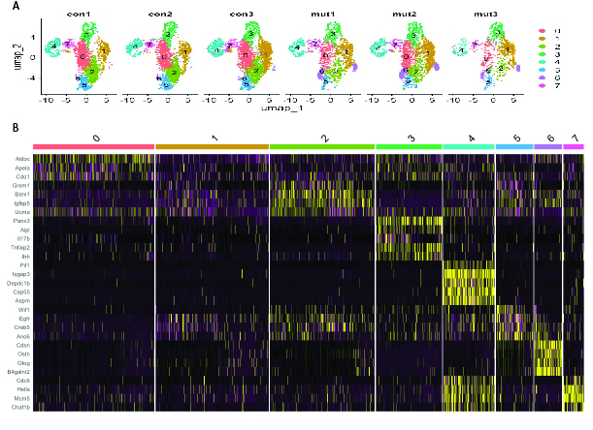

Supplementary Figure 2: Violin plots of top genes from each cluster. Chondrocyte markers Sox9, Col2a1, and Acan, as well as subtypes of chondrocytes, Creb5, Wif1, Grem1, Runx2, Prkg2, Malat1, Ucma, Prkg2, Ihh, Col10a1, Sp7, Mmp13, Runx2, Sp7, Mmp13, Top2a, Mki67 and Lig1. The y-axis showing the expression level and x-axis showing the cluster number.
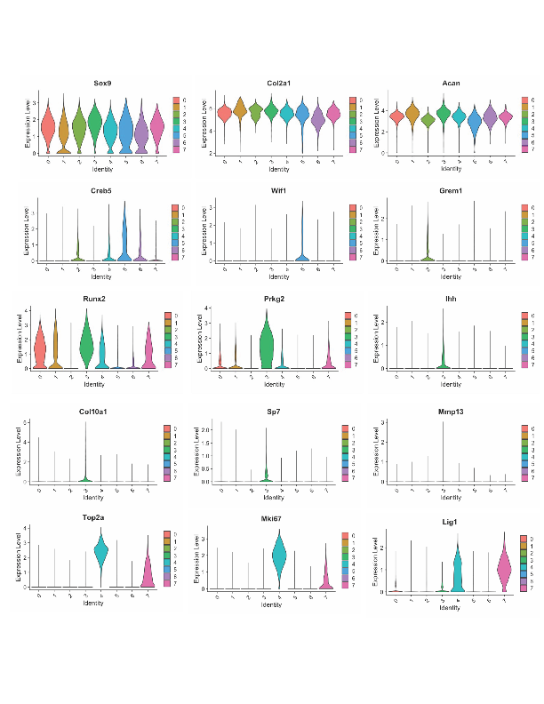

Supplementary Figure 3: Pseudotime ordering of single cells on x-axis in the scale of 0-50 and gene expression on y-axis. The dot size indicates the number of cells in each pseudotime bin and the blue-red color range indicates the expression level from low to high, respectively.

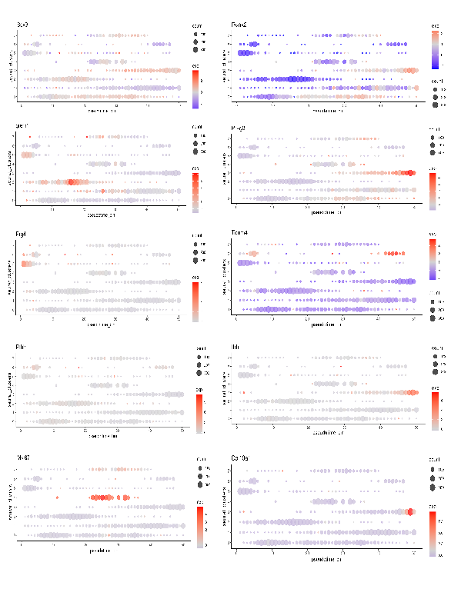
Supplementary Figure 4: GSEA of unique cluster showing downregulation of extracellular matrix structural constituent, ossification, chondrocyte differentiation, skeletal development, and connective tissue development, while upregulation cholesterol homeostasis, sterol biosynthetic process and mTORC1 signaling pathway.
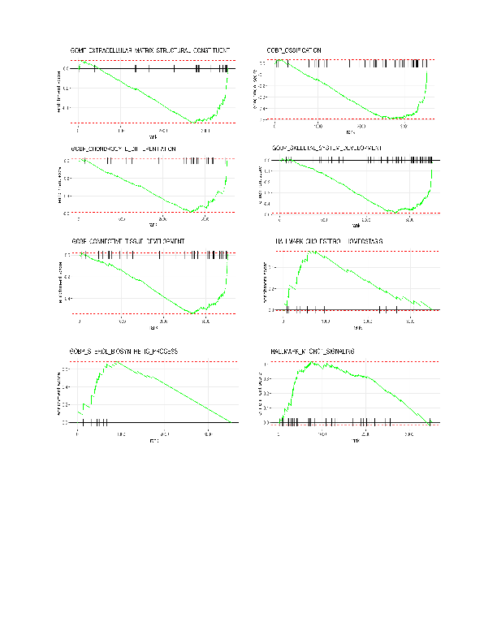

Supplementary Figure 5: GSEA of cluster 2 showing upregulation of ribosomal subunit, oxidative phosphorylation, large ribosomal subunit, mitotic cell cycle, epithelial mesenchymal transition and TNFa signlaing via NFKB.
