Supplementary Materials

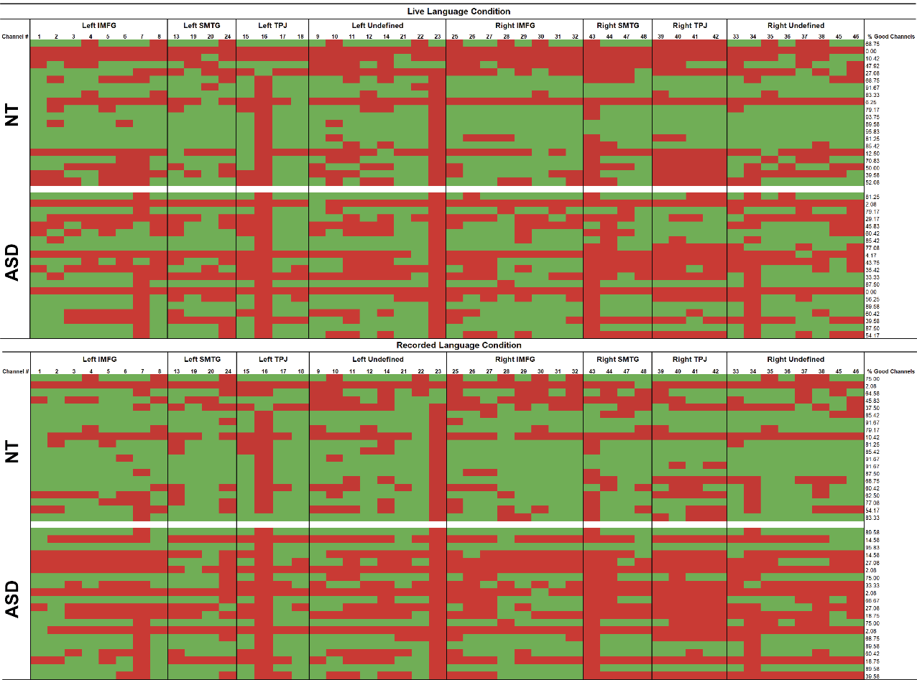
Note. Channels that were pruned (i.e., removed) from analyses based on criteria outlined in the methods section are represented in red. Channels that were included in analyses are represented in green. Each row represents one participant and each column represents one channel.
Figure S1.
Pruned channels for live language condition and recorded language condition by group

Channel analyses
For channel analyses, we conducted within-group one-sample t-tests to identify channels that showed significant activation (i.e., HbO concentration values significantly greater than zero baseline) or deactivation (i.e., HbO concentration values significantly less than zero baseline) during each condition. We also conducted within-group paired sample t-tests to determine whether HbO concentration values significantly differed during the live language condition compared to the recorded language condition in each channel. The Benjamini-Hochberg method was used to correct for multiple comparisons (false discovery rate=.10; Benjamini & Hochberg, 1995).
NT group
Channels showing significant change in HbO during the live language condition. Within the NT group, two channels within the left hemisphere showed evidence of significant deactivation during the live language condition (Figure S3). HbO concentration values were significantly less than zero in channel 4 which covered the left IMFG, and channel 18 which covered the left TPJ. Three channels within the right hemisphere showed evidence of significant activation during the live language condition. HbO concentration values were significantly greater than zero in channel 43 and channel 44 which covered the right SMTG, and channel 41 which covered the right TPJ. One channel within the right hemisphere showed evidence of significant deactivation during the live language condition; HbO concentration values were significantly less than zero in channel 25 which covered the right IMFG. After correction for multiple comparisons, HbO concentration values remained significantly different from zero in channels 4, 18, 25, 41, and 44 (Table S1).
Channels showing significant change in HbO during the recorded language condition. Within the NT group, three channels within the left hemisphere showed evidence of significant deactivation during the recorded language condition (Figure S4). HbO concentration values were significantly less than zero in channel 1 and channel 2 which covered the left IMFG, and channel 18 which covered the left TPJ. Three channels within the right hemisphere showed evidence of significant activation during the recorded language condition. HbO concentration values were significantly greater than zero in channel 43, channel 44, and channel 48 which covered the right SMTG. After correction for multiple comparisons, HbO concentration values remained significantly different from zero in channels 1 and 2 only (Table S1).
Channels showing significant differences in HbO between conditions. Within the NT group, one channel a showed significant difference in HbO between conditions (Figure S5). HbO was significantly greater during the recorded language condition compared to the live language condition in channel 6 which covered the left IMFG. This statistically significant difference did not survive correction for multiple comparisons (Table S1).
ASD group
Channels showing significant change in HbO during the live language condition. Within the ASD group, two channels showed evidence of significant deactivation during the live language condition (Figure S3). HbO concentration values were significantly less than zero in channel 1 which covered the left IMFG, and channel 31 which covered the right IMFG. After correction for multiple comparisons, HbO concentration values remained significantly less than zero in channel 31 only. No channels showed evidence of significant activation during the live language condition (Table S1).
Channels showing significant change in HbO during the recorded language condition. Within the ASD group, one channel showed evidence of significant deactivation during the recorded language condition (Figure S4). HbO concentration values were significantly less than zero in channel 5 which covered the left IMFG. This statistically significant difference did not survive correction for multiple comparisons. No channels showed evidence of significant activation during the recorded language condition (Table S1).
Channels showing significant differences in HbO between conditions. Within the ASD group, three channels showed significant differences in HbO between conditions (Figure S5). HbO was significantly greater during the live language condition compared to the recorded language condition in channel 5 which covered the left IMFG. HbO was significantly greater during the recorded language condition compared to the live language condition in channel 1 which covered the left IMFG, and channel 47 which covered the right SMTG. These statistically significant differences did not survive correction for multiple comparisons (Table S1).

Table S1. Within-group comparisons of HbO concentration values in all channels
ROI | Channel # |  |  | p-value
NT
 |  | Live Language  vs. Baseline |  |  | Recorded Language  vs. Baseline |  | Live Language  vs. Recorded Language
Left  IMFG | 1 | .626 |  |  | .001*** | (–) | .117
Left  IMFG | 2 | .083 |  |  | .005** | (–) | .375
Left  IMFG | 3 | .186 |  |  | .978 |  | .190
Left  IMFG | 4 | .007** | (–) |  | .861 |  | .059
Left  IMFG | 5 | .832 |  |  | .774 |  | .998
Left  IMFG | 6 | .965 |  |  | .986 |  | .008** | RL>LL
Left  IMFG | 7 | .850 |  |  | .371 |  | .678
Left  IMFG | 8 | .107 |  |  | .291 |  | .987
Left  SMTG | 13 | .170 |  |  | .258 |  | .671
Left  SMTG | 19 | .797 |  |  | .143 |  | .098
Left  SMTG | 20 | .781 |  |  | .864 |  | .927
Left  SMTG | 24 | .403 |  |  | .117 |  | .633
Left  TPJ | 15 | .266 |  |  | .090 |  | .959
Left  TPJ | 16 | .539 |  |  | .253 |  | .245
Left  TPJ | 17 | .683 |  |  | .189 |  | .493
Left  TPJ | 18 | .006** | (–) |  | .037* | (–) | .063
Right  IMFG | 25 | .007** | (–) |  | .211 |  | .551
Right  IMFG | 26 | .600 |  |  | .483 |  | .178
Right  IMFG | 27 | .676 |  |  | .802 |  | .386
Right  IMFG | 28 | .376 |  |  | .203 |  | .164
Right  IMFG | 29 | .517 |  |  | .206 |  | .374
Right  IMFG | 30 | .812 |  |  | .279 |  | .466
Right  IMFG | 31 | .796 |  |  | .190 |  | .597
Right  IMFG | 32 | .957 |  |  | .879 |  | .862
Right  SMTG | 43 | .019* | (+) |  | .020* | (+) | .242
Right  SMTG | 44 | .005** | (+) |  | .017* | (+) | .215
Right  SMTG | 47 | .930 |  |  | .303 |  | .385
Right  SMTG | 48 | .788 |  |  | .023* | (+) | .212
Right  TPJ | 39 | .340 |  |  | .390 |  | .070
Right  TPJ | 40 | .131 |  |  | .429 |  | .059
Right  TPJ | 41 | .005** | (+) |  | .099 |  | .365
Right  TPJ | 42 | .168 |  |  | .167 |  | .772
ASD
 |  | Live Language  vs. Baseline |  |  | Recorded Language vs. Baseline |  | Live Language  vs. Recorded Language
Left  IMFG | 1 | .007** | (–) |  | .675 |  | .014* | RL>LL
Left  IMFG | 2 | .234 |  |  | .284 |  | .821
Left  IMFG | 3 | .224 |  |  | .839 |  | .930
Left  IMFG | 4 | .707 |  |  | .073 |  | .597
Left  IMFG | 5 | .722 |  |  | .020* | (–) | .044* | LL>RL
Left  IMFG | 6 | .075 |  |  | .149 |  | .069
Left  IMFG | 7 | .386 |  |  | .995 |  | .995
Left  IMFG | 8 | .531 |  |  | .443 |  | .534
Left  SMTG | 13 | .990 |  |  | .691 |  | .906
Left  SMTG | 19 | .791 |  |  | .520 |  | .869
Left  SMTG | 20 | .417 |  |  | .282 |  | .269
Left  SMTG | 24 | .355 |  |  | .738 |  | .862
Left  TPJ | 15 | .631 |  |  | .184 |  | .301
Left  TPJ | 16 | .304 |  |  | .687 |  | .593
Left  TPJ | 17 | .835 |  |  | .452 |  | .153
Left  TPJ | 18 | .295 |  |  | .905 |  | .201
Right  IMFG | 25 | .217 |  |  | .706 |  | .917
Right  IMFG | 26 | .589 |  |  | .501 |  | .715
Right  IMFG | 27 | .527 |  |  | .475 |  | .577
Right  IMFG | 28 | .257 |  |  | .759 |  | .247
Right  IMFG | 29 | .765 |  |  | .977 |  | .862
Right  IMFG | 30 | .587 |  |  | .063 |  | .237
Right  IMFG | 31 | .003** | (–) |  | .209 |  | .762
Right  IMFG | 32 | .309 |  |  | .744 |  | .721
Right  SMTG | 43 | .110 |  |  | .490 |  | .211
 | 44 | .219 |  |  | .396 |  | .599
 | 47 | .160 |  |  | .134 |  | .039* | RL>LL
 | 48 | .738 |  |  | .523 |  | .067
Right  TPJ | 39 | .060 |  |  | .764 |  | .568
Right  TPJ | 40 | .881 |  |  | .447 |  | .914
Right  TPJ | 41 | .435 |  |  | .625 |  | .524
Right  TPJ | 42 | .898 |  |  | .352 |  | .166
Note. * p<.05, ** p<.01, *** p≤.001, before correction for multiple comparisons. Values in bold survived correction for multiple comparisons. (+) represents a significant increase in HbO relative to baseline (i.e., activation) and (–) represents a significant decrease in HbO relative to baseline (i.e., deactivation). ASD=Autism Spectrum Disorder, NT=Neurotypical, LL=Live Language, RL=Recorded Language, ROI=Region of Interest, IMFG=Inferior and Middle Frontal Gyrus, SMTG=Superior and Middle Temporal Gyrus, TPJ=Temporal Parietal Junction

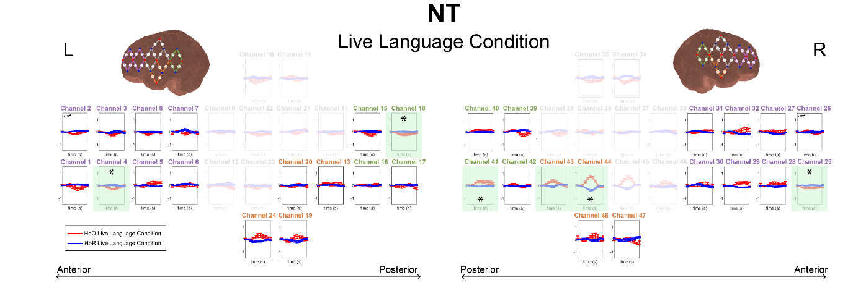
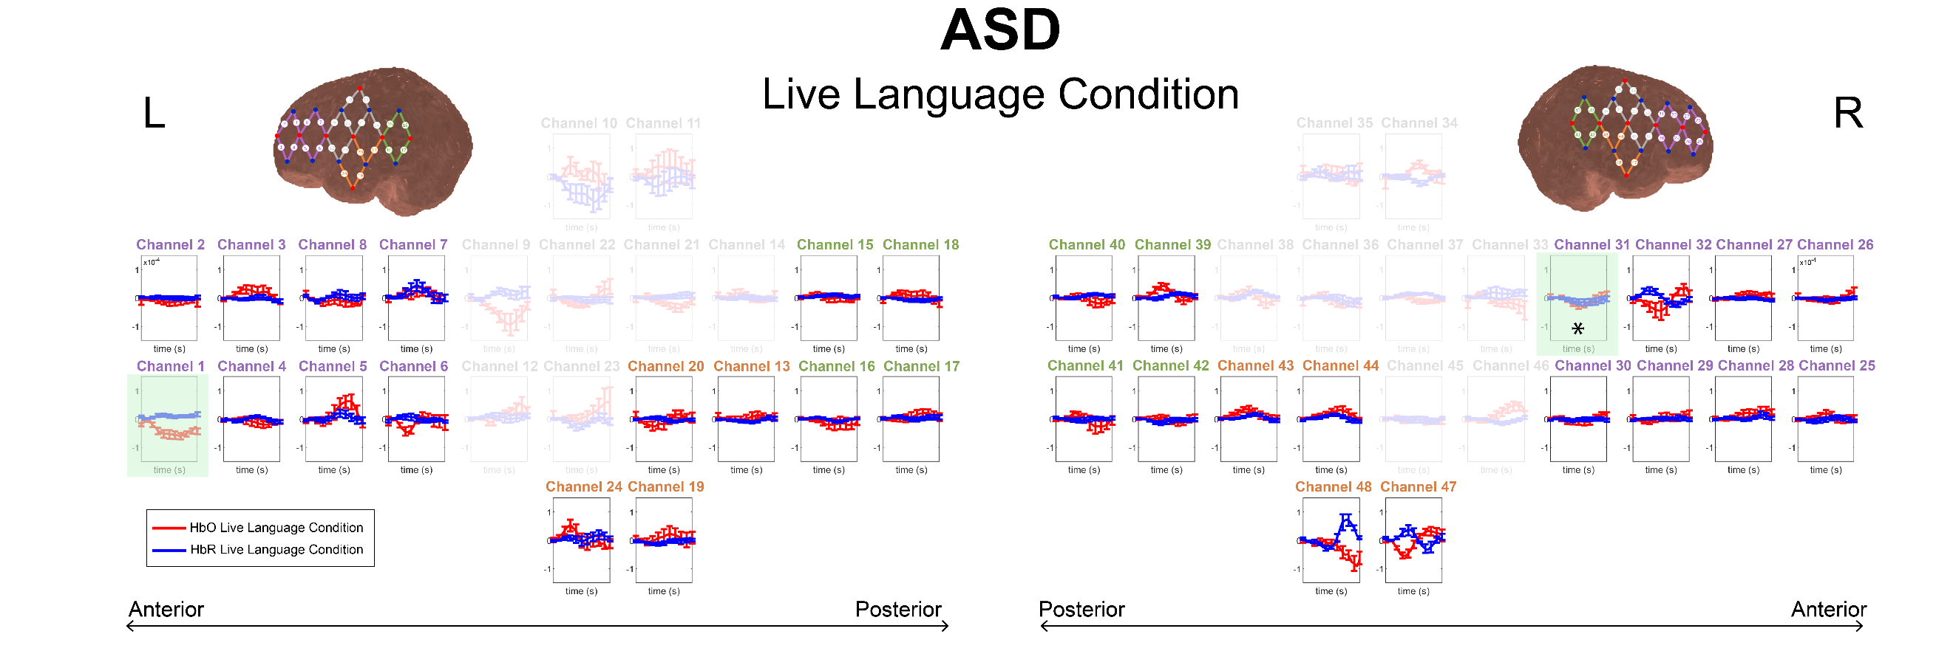
Note. HbO concentration values are shown in red and HbR concentration values are shown in blue. Channels highlighted in green showed average HbO concentration values over the analysis window (0 to 10 seconds) that were significantly different from a baseline concentration value of zero, before correction for multiple comparisons. Channels that survived correction for multiple comparisons are marked with an asterisk. Error bars represent standard error values every 2 seconds. The y-axis shows a range of concentration values from -1.5x10⁻⁴ to 1.5x10⁻⁴ M*mm. Channels that are greyed out did not cover brain regions of interest and were thus excluded from one-sample t-test analyses. Channels covering the IMFG are labeled in purple, channels cover the SMTG are labeled in orange, and channels covering the TPJ are labeled in green. ASD=Autism Spectrum Disorder, NT=Neurotypical
Figure S3.
Average hemodynamic response from -2 to 18 seconds during the live language condition by group (NT vs ASD)

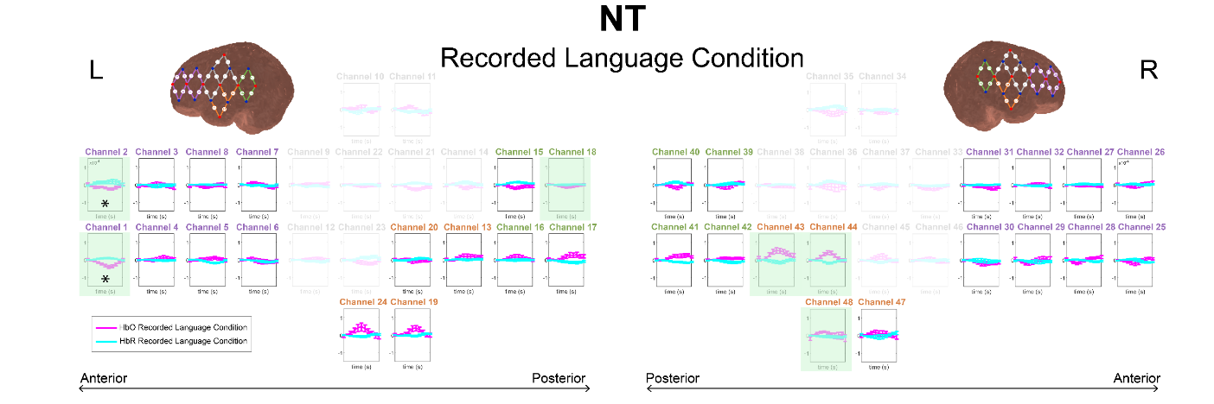
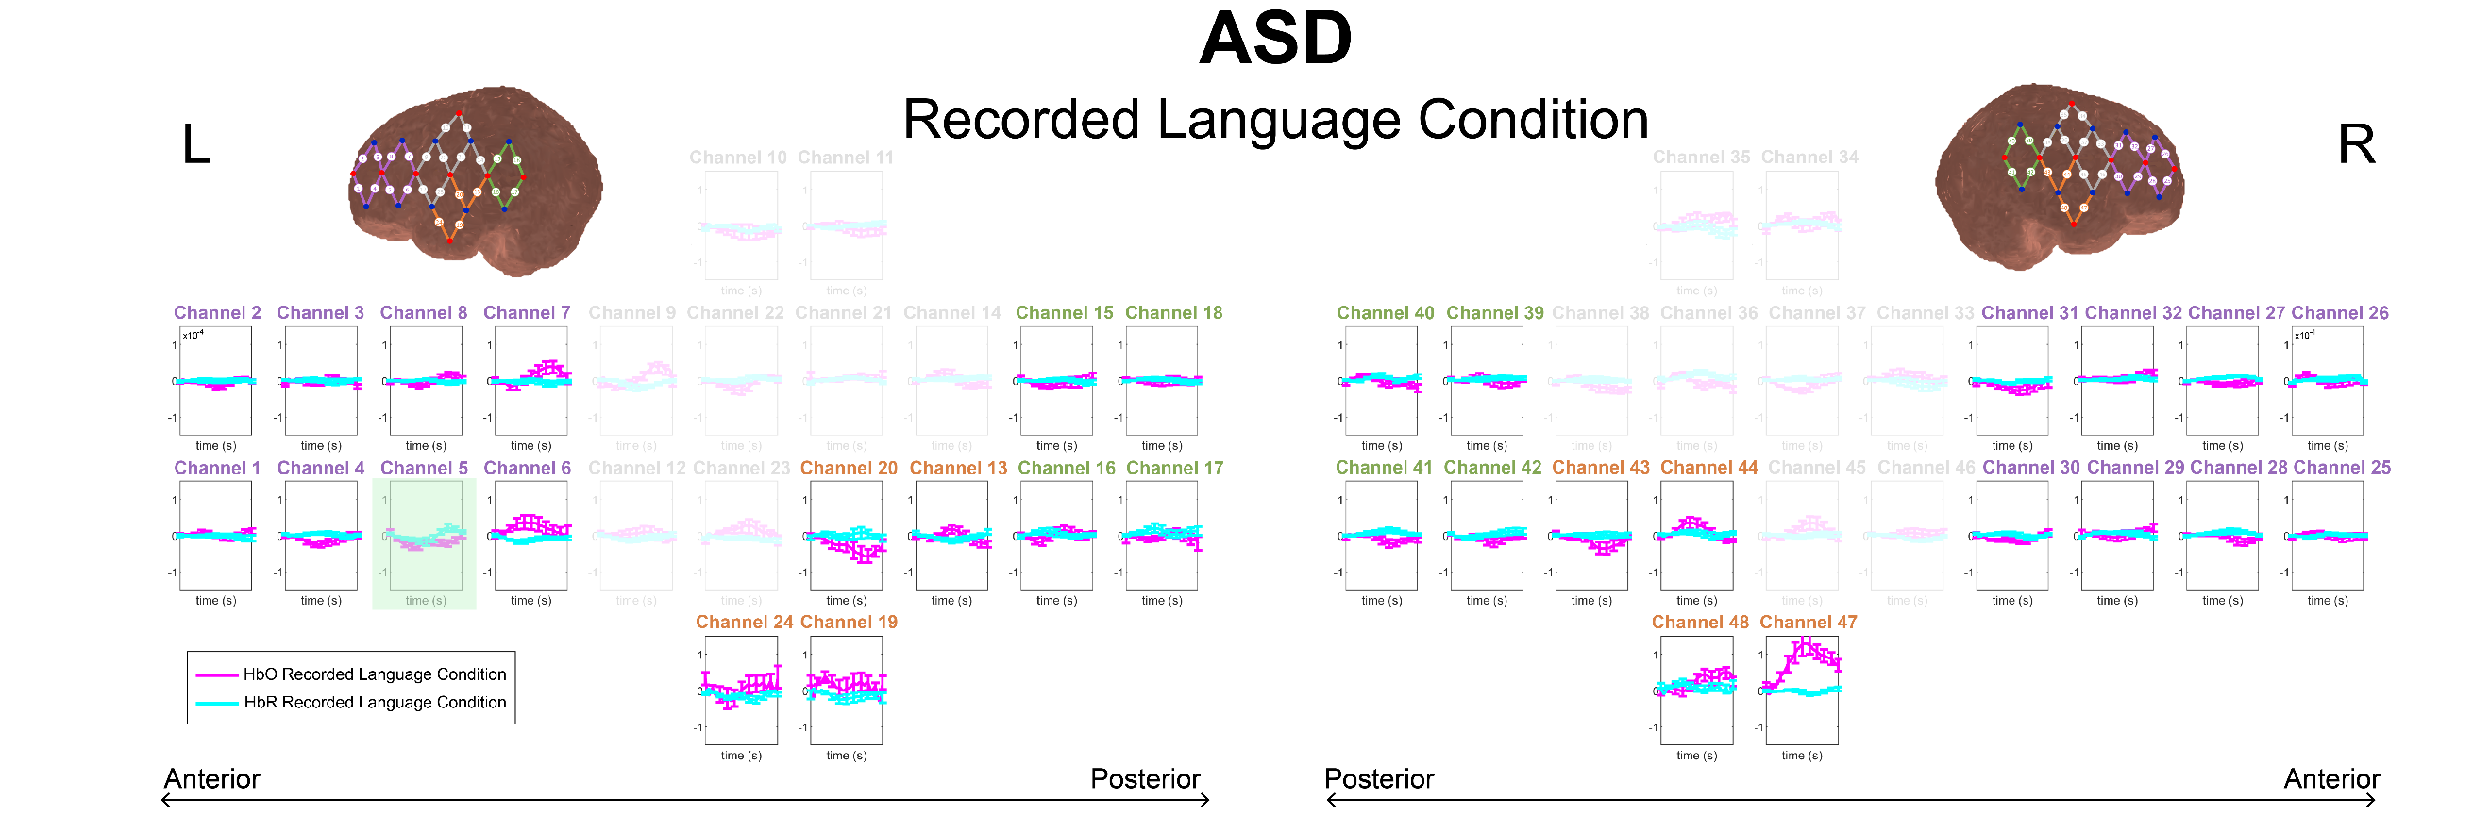
Note. HbO concentration values are shown in pink and HbR concentration values are shown in cyan. Channels highlighted in green showed average HbO concentration values over the analysis window (0 to 10 seconds) that were significantly different from a baseline concentration value of zero, before correction for multiple comparisons. Channels that survived correction for multiple comparisons are marked with an asterisk. Error bars represent standard error values every 2 seconds. The y-axis shows a range of concentration values from -1.5x10⁻⁴ to 1.5x10⁻⁴ M*mm. Channels that are greyed out did not cover brain regions of interest and were thus excluded from one-sample t-test analyses. Channels covering the IMFG are labeled in purple, channels cover the SMTG are labeled in orange, and channels covering the TPJ are labeled in green. ASD=Autism Spectrum Disorder, NT=Neurotypical
Figure S4.
Average hemodynamic response from -2 to 18 seconds during the recorded language condition by group (NT vs ASD)
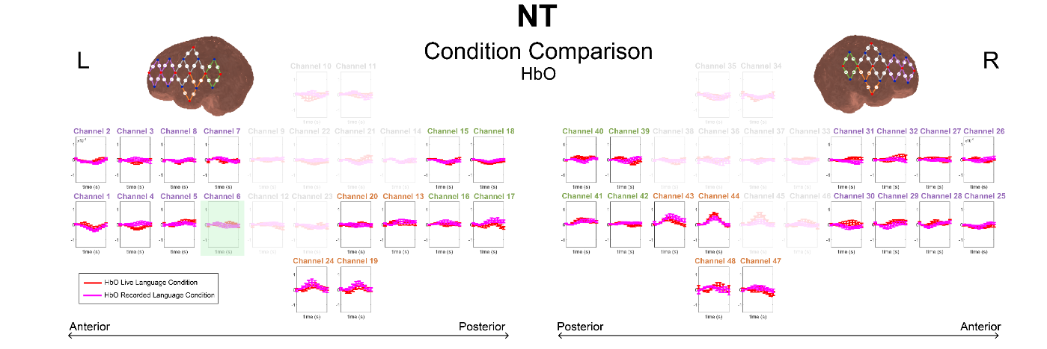
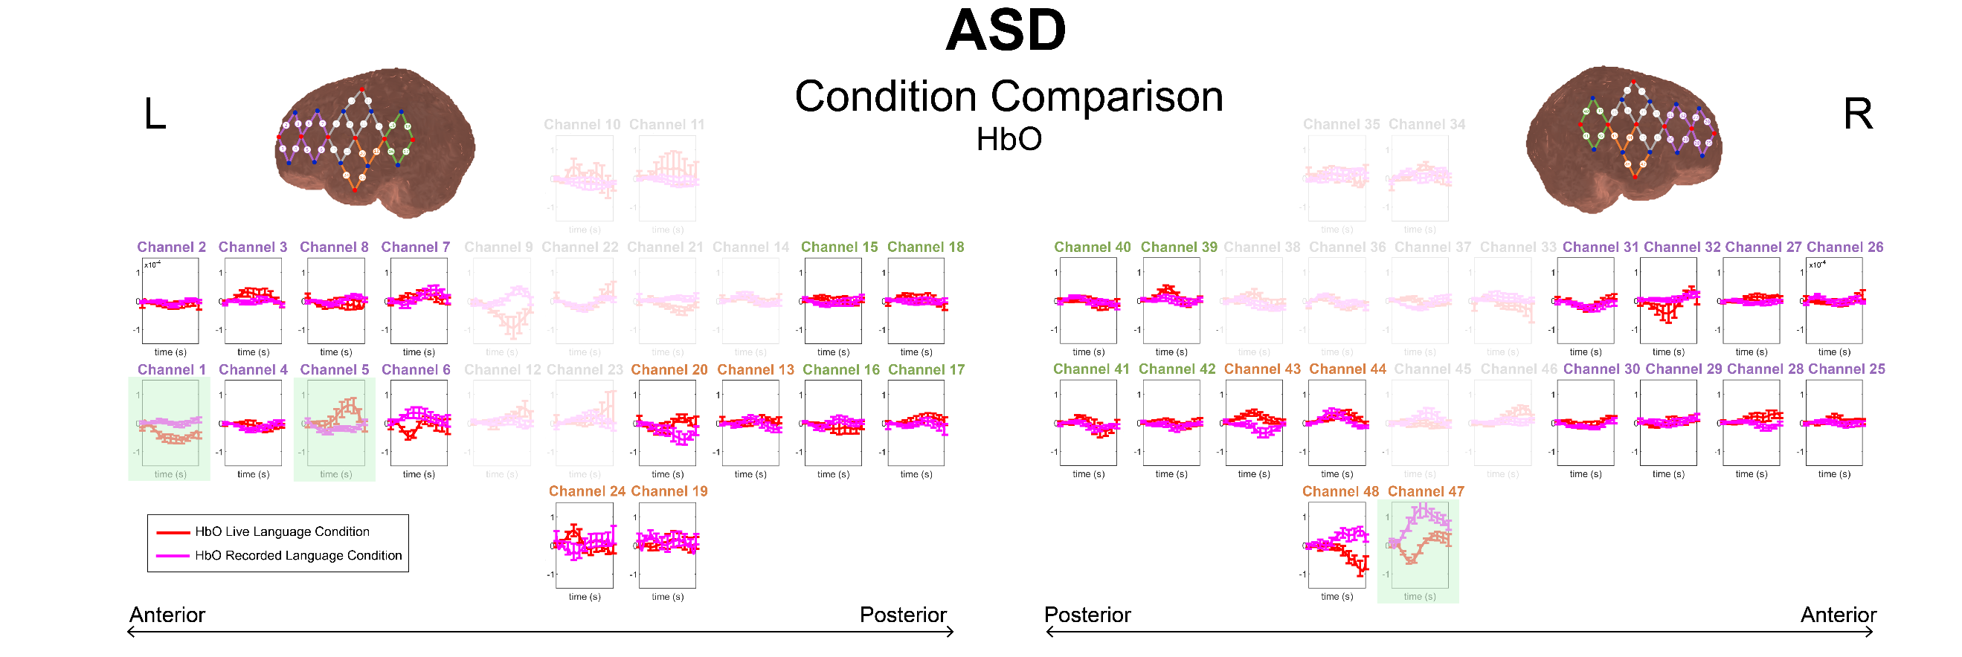
Note. Average change in HbO concentration values from -2 to 18 seconds is depicted in red for the live language condition and pink for the recorded language condition. Channels highlighted in green showed a significant difference in average HbO concentration values over the analysis window (0 to 10 seconds) between the live language condition and the recorded language condition. Error bars represent standard error values every 2 seconds. The y-axis shows a range of HbO concentration values from -1.5x10⁻⁴ to 1.5x10⁻⁴ M*mm. Channels that are greyed out did not cover brain regions of interest and were thus excluded from within group paired samples t-tests. Channels covering the IMFG are labeled in purple, channels covering the SMTG are labeled in orange, and channels covering the TPJ are labeled in green. ASD=Autism Spectrum Disorder, NT=Neurotypical
Figure S5.
Comparison of live language condition and recorded language condition by group (NT vs ASD)

