- Night eating

VARIABLES
  0 (n.19)
  1 (n.2)
  p
 | 103,32±43,17 | 242,00±2,83 | <0,001
  TG (mg/dL)
 | 1,91±1,15 | 4,01±0,38 | <0,01
  TG/HDL ratio
 | 199,00±40,73 | 254,83±10,37 | <0,05
  TCOL (mg/dL)
OT (pg/mL) | 1418,42±461,63 | 1163,810±210,35 | n.s.

- Food addiction

VARIABLES
  0 (n.16)
  1 (n.5)
  p
 | 1,73±1,04 | 4,35±1,21 | <0,001
  Total score EBA-O
 | 2,29±1,66 | 5,60±1,85 | <0,001
  Sweet eating
 | 1,98±2,36 | 5,07±1,19 | <0,01
  Binge eating
 | 1,81±1,72 | 4,27±2,23 | <0,01
  Hyperphagia
 | 0,97±0,09 | 0,84±0,09 | <0,01
  WHR
 | 1452,99±463,09 | 1086,02±164,00 | <0,01
  OT (pg/mL)

- Sweet eating

VARIABLES
  0 (n.15)
  1 (n.6)
  p
 | 1,71±1,01 | 3,97±1,55 | <0,001
  Total score EBA-O
 | 1,82±1,52 | 3,83±2,75 | <0,05
  Hyperphagia
 | 1401,57±441,35 | 1375,67±503,46 | n.s.
  OT (pg/mL)

- Hyperphagia

VARIABLES
  0 (n.15)
  1 (n.6)
  p
 | 1,78±1,08 | 3,80±1,70 | <0,005
  Total score EBA-O
 | 48,52±6,89 | 56,79±12,34 | <0,05
  HSI
 | 1384,28±400,71 | 1418,90±590,64 | n.s.
  OT (pg/mL)

- Binge eating

VARIABLES |  | 1 (n.8) | p
  0 (n.13)
 | 1,60±1,00 | 3,58±2,00 | <0,001
  Total score EBA-O
 | 1441,79±508,92 | 1316,79±340,56 | n.s.
  OT (pg/mL)

- Total score EBA-O

VARIABLES
  0 (n.18)
  1 (n.3)
  p
 | 0,79±1,00 | 2,33±2,00 | <0,05
  Night eating
 | 0,95±0,00 | 0,84±0,00 | <0,05
  WHR
 | 1437,62±464,65 | 1133,52±211,30 | n.s.
  OT (pg/mL)

Supplementary Tables 1A;1B;1C;1D;1E;1F Comparison of studied variables between patients with and without dysfunctional eating behavior identified by EBA-O in the study population (One-Way ANOVA). Values are expressed as mean ± standard deviation. 0= negative test; 1= positive test.
Abbreviations: TG, Triglycerides; TSH, Thyrotropin; TG/HDL ratio, Triglyceride/HDL cholesterol ratio; TCOL, Total Cholesterol; EBA-O, Eating Behaviour Assessment for Obesity; WHR, Waist-Hip ratio; HSI, Hepatic Steatosis Index.

- Food addiction-binge eating
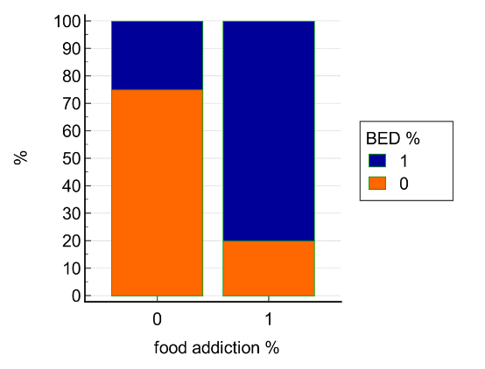
 | Food_addiction
Binge eating | 0 | 1
0 | 12 | 1 | 13 (61,9%)
1 | 4 | 4 | 8 (38,1%)
 | 16  (76,2%) | 5  (23,8%) | 21

Chi-square | 4,654
DF | 1
Significance level | P < 0,05
Contingency coefficient | 0,426

- Food addiction-sweet eating
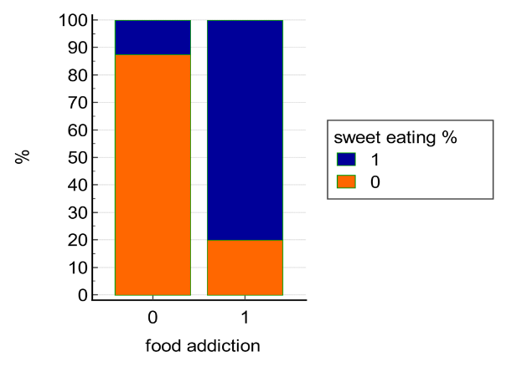
 | Food_addiction
Sweet eating | 0 | 1
0 | 14 | 1 | 15 (71,4%)
1 | 2 | 4 | 6 (28,6%)
 | 16  (76,2%) | 5  (23,8%) | 21

Chi-square | 8,100
DF | 1
Significance level | P < 0,005
Contingency coefficient | 0,528

- Food addiction-total score

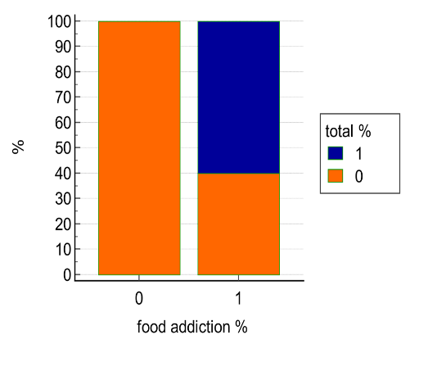
 | Food_addiction
Total score | 0 | 1
0 | 16 | 2 | 18 (85,7%)
1 | 0 | 3 | 3 (14,3%)
 | 16  (76,2%) | 5  (23,8%) | 21

Chi-square | 10,667
DF | 1
Significance level | P < 0,001
Contingency coefficient | 0,580

- Sweet eating- hyperphagia

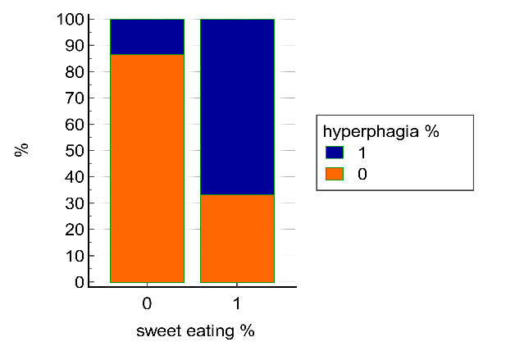
 | Sweet eating
Hyperphagia | 0 | 1
0 | 13 | 2 | 15 (71,4%)
1 | 2 | 4 | 6 (28,6%)
 | 15  (71,4%) | 6  (28,6%) | 21

Chi-square | 5,689
DF | 1
Significance level | P < 0,01
Contingency coefficient | 0,462

- Total score-hyperphagia
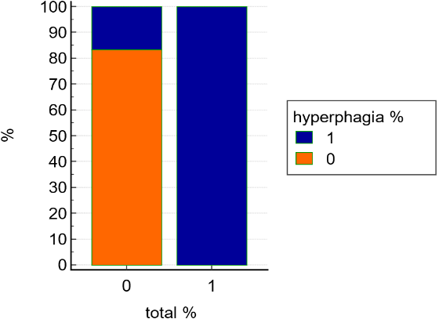

 | Total score
Hyperphagia | 0 | 1
0 | 15 | 0 | 15 (71,4%)
1 | 3 | 3 | 6 (28,6%)
 | 18  (85,7%) | 3  (14,3%) | 21

Chi-square | 8,333
DF | 1
Significance level | P < 0,005
Contingency coefficient | 0,533

Supplementary Figures 1 A-B-C-D-E Chi-square test for correlation analysis between eating behavior disorders found at EBA-O in the study population (n.21). 0= negative test; 1= positive test.

Supplementary Figure 2. Direct linear correlation between OT levels and body mass index (BMI) in the study population (n.21).

Supplementary Figure 3. Direct linear correlation between OT levels and glycated hemoglobin (HbA1c) in the study population (n.21).

Supplementary Figure 4. Direct linear correlation between OT levels and hepatic steatosis index (HSI) in the study population (n.21).

Supplementary Figure 5. Direct linear correlation between OT levels and estradiol in the female study population (follicular phase) (n.16).

