Perception of body size across weight categories and association with body size dissatisfaction among early primary school children
Tove L. Drilen¹, Trine T. Eik-Nes²³, Ellen M. I. Ersfjord⁴, Christian A. Klöckner⁵, and Rønnaug A. Ødegård¹⁶

¹ Department of Clinical and Molecular Medicine, Norwegian University of Science and Technology, Trondheim, Norway
² Department of Neuromedicine and Movement Science, Norwegian University of Science and Technology, Trondheim, Norway
³ Nord-Trøndelag Hospital Trust, Levanger Hospital, Levanger, Norway.
⁴ Department of Health and Nursing Sciences, University of Agder, Kristiansand, Norway
⁵ Department of Psychology, Norwegian University of Science and Technology, Trondheim, Norway
⁶ Centre of Obesity Research (ObeCe), St. Olav’s Hospital, Trondheim, Norway.

Contact information:
Tove L. Drilen, Department of Clinical and Molecular Medicine, Norwegian University of Science and Technology, Regional Centre for Obesity Research and Innovation, Post box 3250, Torgarden, 7006 Trondheim, Norway
E-mail: tove.l.drilen@ntnu.no

Supporting Information

No. | 1 | 2 | 3 | 4 | 5 | 6 | 7 | 8 | 9
 | 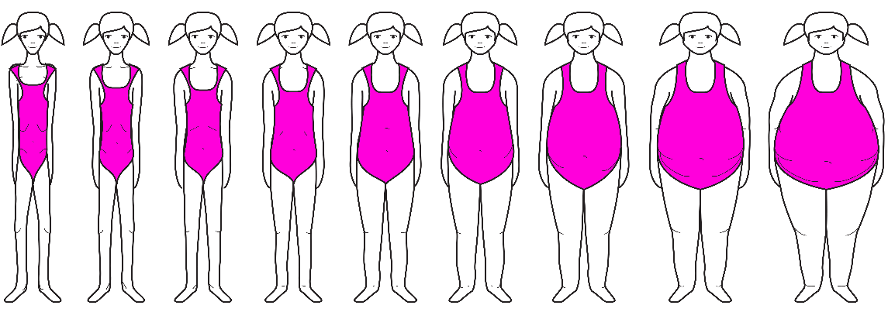
Age (years) | Under  weight | Healthy weight |  |  | Over  weight | Obesity | Severe Obesity
8.0 | <14.00 | 14.00 | 15.40 | 16.80 | 18.20 | 21.44 | >21.44
8.5 | <14.13 | 14.13 | 15.63 | 17.13 | 18.63 | 22.04 | >22.04
9.0 | <14.26 | 14.26 | 15.84 | 17.41 | 18.99 | 22.66 | >22.66
9.5 | <14.40 | 14.40 | 16.06 | 17.72 | 19.38 | 23.31 | >23.31
Supplementary Figure 1. Assigned BMI cut-offs for the female silhouette figures. The body silhouette figures are used with permission from Dr. Tiggemann. The weight categories are estimated based on IOTF cut-offs (1).

No. | 1 | 2 | 3 | 4 | 5 | 6 | 7 | 8 | 9
 | 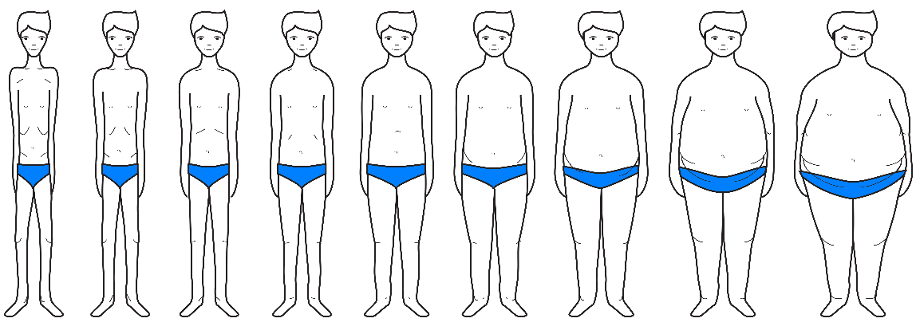 |  |  |  |  |  |  | 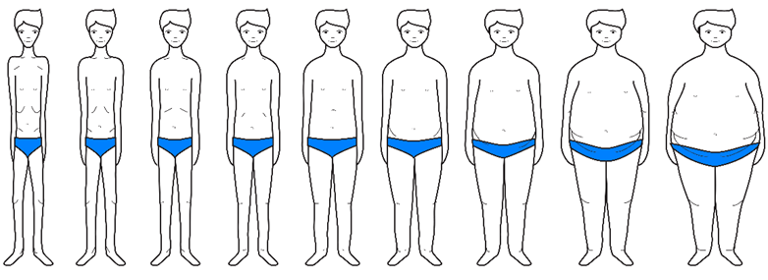
Age (years) | Under-  weight | Healthy weight |  |  | Over-  weight | Obesity | Severe Obesity
8.0 | <14.13 | 14.13 | 15.56 | 16.98 | 18.41 | 21.56 | >24.61
8.5 | <14.24 | 14.24 | 15.74 | 17.23 | 18.73 | 22.11 | >25.45
9.0 | <14.36 | 14.36 | 15.93 | 17.50 | 19.07 | 22.71 | >26.40
9.5 | <14.49 | 14.49 | 16.14 | 17.78 | 19.43 | 23.34 | >27.39
Supplementary Figure 2. Assigned BMI cut-offs for the male silhouette figures. The body silhouette figures are used with permission from Dr. Tiggemann. The weight categories are estimated based on IOTF cut-offs (1).

Table S1: Body size perception across the weight categories

 | PERCEIVED WEIGHT CATEGORIES
ACTUAL WEIGHT CATEGORIES | Underweight  (n=1) | Normal weight  (n=146) | Overweight/Obesity  (n=62)
Underweight  (n=13) | 0 (0%) | 9 (69%) | 4 (31%)
Healthy weight  (n=159) | 1 (0.5%) | 117 (73.5%) | 41 (26%)
Overweight/Obesity  (n=37) | 0 (0%) | 20 (54%) | 17 (46%)
Supplementary Figure 3. Body size perception across the weight categories. Actual weight categories are estimated according to age- and gender-specific IOTF BMI cut-offs for children (1). Perceived weight categories include Underweight (silhouette figure 1), Healthy weight (silhouette figures 2-4), overweight (silhjouette figure 5) and obesity (silhouette figures 6-9).

Reference
1. Cole TJ, Lobstein T. Extended international (IOTF) body mass index cut-offs for thinness, overweight and obesity. Pediatric Obesity. 2012;7(4):284-94.

