SUPPLEMENTARY MATERIAL

Collection, characterisation, and recycling potential of disposable vape pens in the UK

Joseph Mainª, Spyridoula Gerassimidouª, Eleni Iacovidouª
ª Division of Environmental Sciences, College of Health, Medicine and Life Sciences, Brunel University London, Uxbridge, UB8 3PH, UK

*Corresponding author: eleni.iacovidou@brunel.ac.uk

- Setting up the recycling scheme

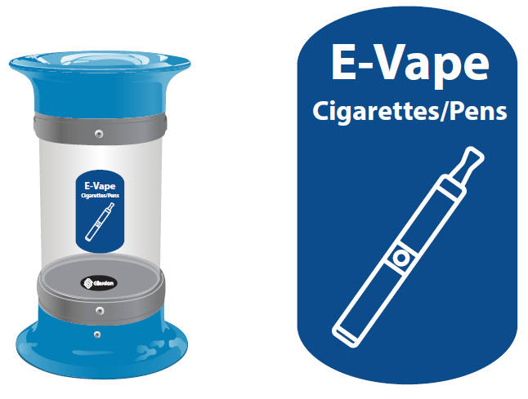
Fig. A1 The 5-litre vape bins and vape bin labels, installed at BUL

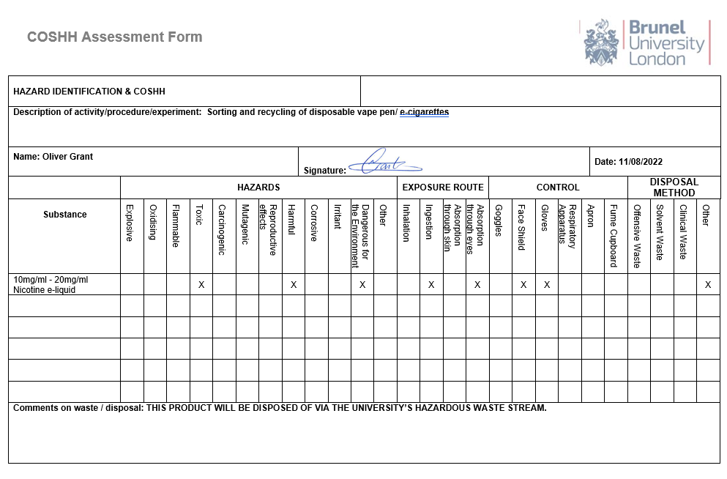
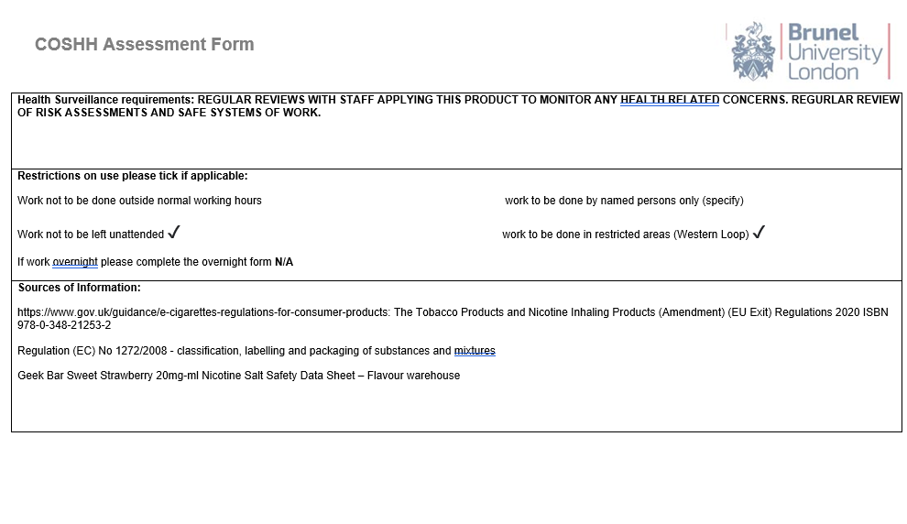
Fig. A2 The completed Control of Substances Hazardous to Health (COSHH) form for 20mg/ml nicotine solution (e-liquid commonly found in disposable vapes)

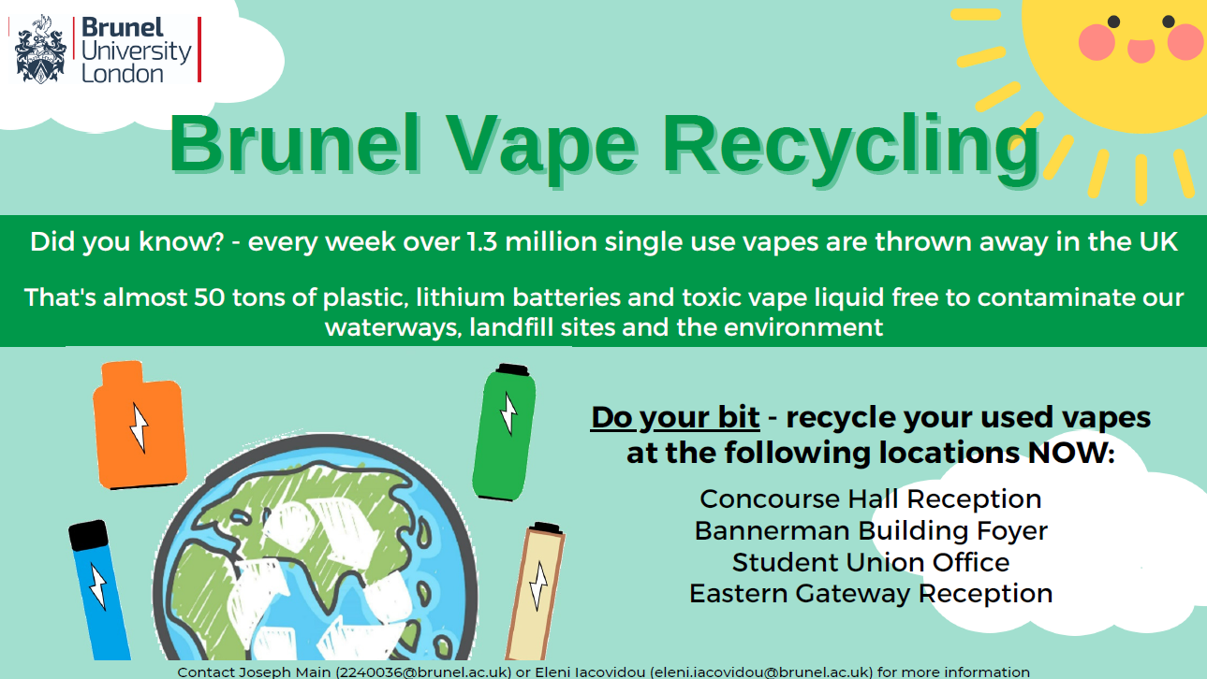
Fig. A3 The electronic poster, advertising the vape recycling scheme, on noticeboard rotation display on screens across the BUL campus

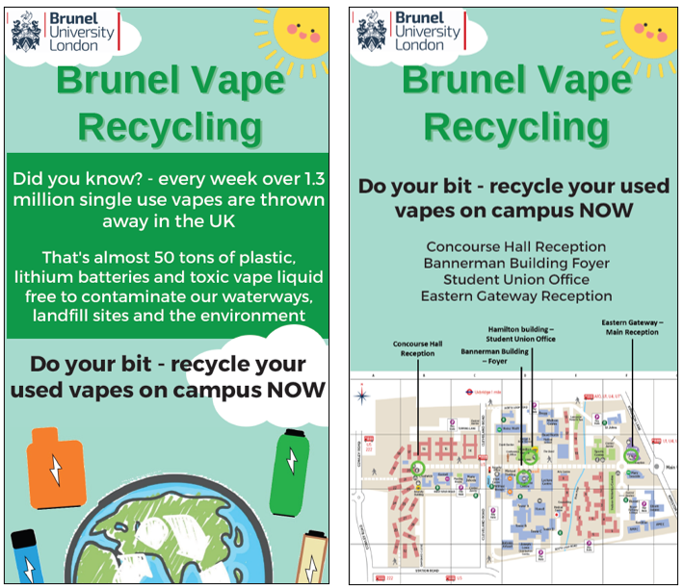
Fig. A4 The social media posts for the vape recycling scheme, advertised on student union and University affiliated social media pages

- Data analysis

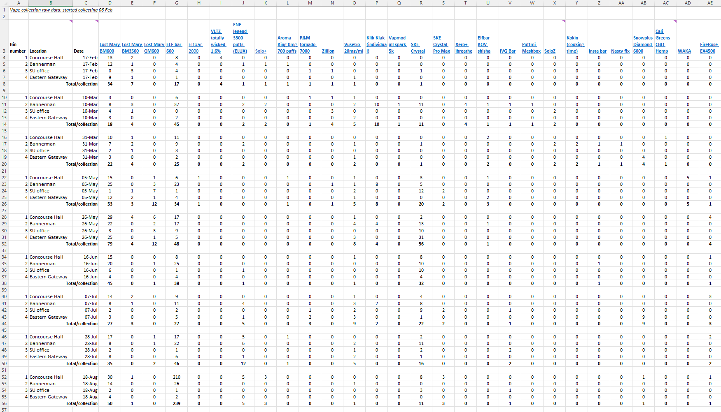
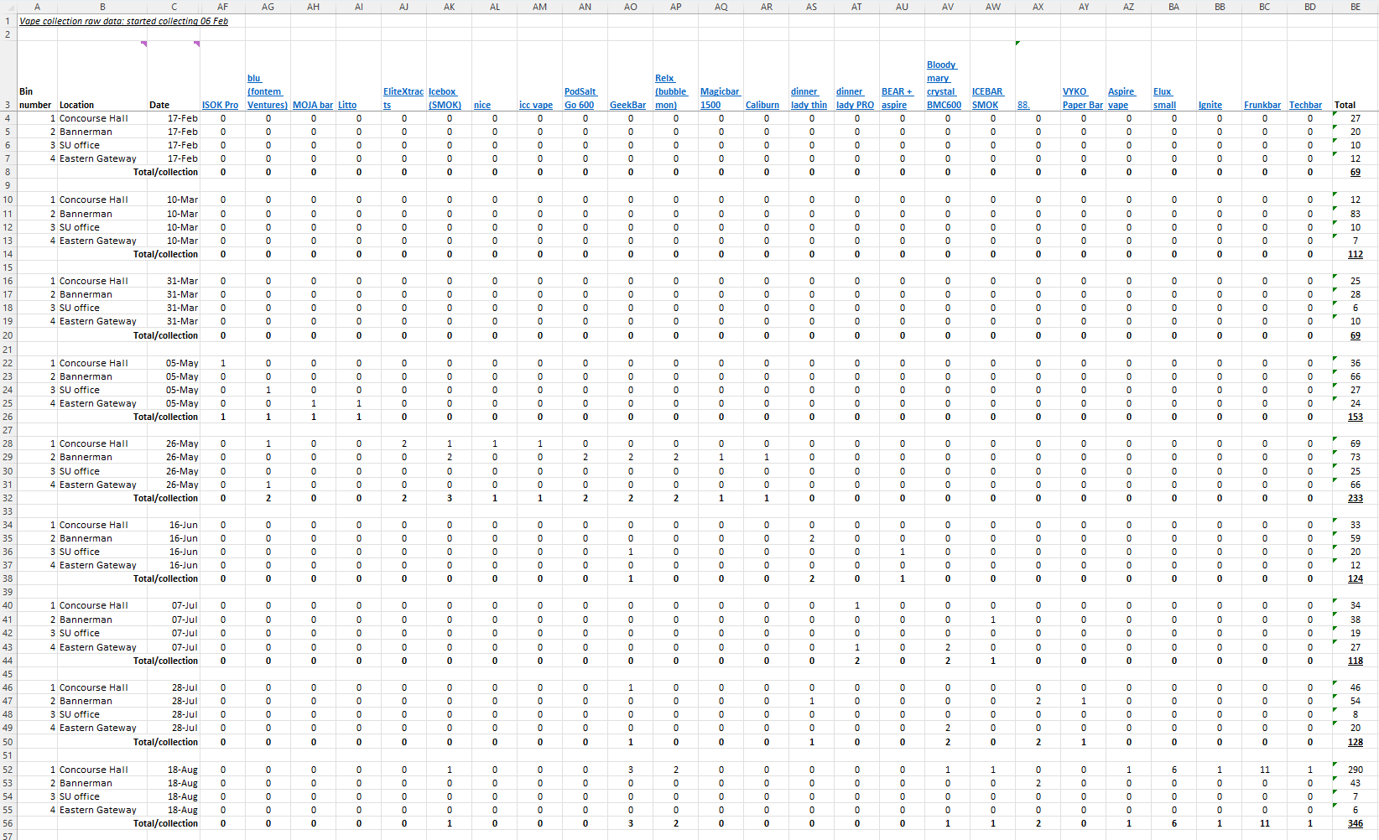
Fig. B1 The full raw data set derived from the categorisation of the vapes collected via the BUL vape recycling scheme

Table B1 Statistical breakdown of disposable vapes collected during the six-month monitoring period
Mean vapes processed per collection | 150.22
Standard deviation | 88.08
Range | 277
Q1 | 112
Q2 | 124
Q3 | 153
Interquartile range | 41

Table B2 The quantity of disposable vapes collected in each bin location, by collection date
Collection date | Concourse Hall | Bannerman | SU Office | Eastern Gateway | Total collected
17-Feb | 27 | 20 | 10 | 12 | 69
10-Mar | 12 | 83 | 10 | 7 | 112
31-Mar | 25 | 28 | 6 | 10 | 69
05-May | 36 | 66 | 27 | 24 | 153
26-May | 69 | 73 | 25 | 66 | 233
16-Jun | 33 | 59 | 20 | 12 | 124
07-Jul | 34 | 38 | 19 | 27 | 118
28-Jul | 46 | 54 | 8 | 20 | 128
18-Aug | 290 | 43 | 7 | 6 | 346
TOTAL | 572 | 464 | 132 | 184 | 1352

Kruskal-Wallis H test
The H test value was determined using the Kruskal-Wallis H test calculation below, where n represents the total samples (36, as there were 9 collections performed on each of the 4 bin locations), R_{x}² represents the sum of ranks for each collection point, and n_{x} represents the sample size (number of collections) for each collection point (9).
$$H= \left[\frac{12}{n(n+1)}\sum{\frac{R_{x}^{2}}{n_{x}}}\right]-3(n+1)$$

Table B3 The results of the Kruskal-Wallis H test, performed on the vape data collated from each vape recycling collection point
n | 36
k (number of data sets) | 4
H (test value) | 18.292
Degrees of Freedom (k-1) | 3
Chi Squared distribution value for p<0.01 | 11.345

Table B4 The highest frequency vape models collected, percentage of total and actual quantities collected, and manufacturer/model specifications
Model | Elfbar600 | LM BM600 | SKE Crystal Bar | VuseGo700 | ELUX legend 3500 | LM QM600 | LM BM3500 | Klik Klak | Other*
Brand | ElfBar | Lost Mary | SKE | Vuse | ELUX Technology | Lost Mary | Lost Mary | Element e-liquids | Various
Manufacturer | Shenzhen iMiracle Technology | Shenzhen iMiracle Technology | Shenzhen SKE Technology | British American Tobacco | Dongguan Topson Electronic Technology | Shenzhen iMiracle Technology | Shenzhen iMiracle Technology | Unknown | Various
Number collected | 519 | 363 | 170 | 37 | 28 | 27 | 26 | 24 | 158
% of total collected | 38.39% | 26.85% | 12.57% | 2.74% | 2.07% | 2.00% | 1.92% | 1.78% | 11.69%
Battery capacity | 350mAh | 350mAh | 500mAh | 370mAh | 1500mAh | 550mAh | 1250mAh | 500mAh | N/A
Battery type | Lithium-ion | Lithium-ion | Unknown | Lithium-ion | Unknown | Lithium-ion | Lithium-ion | Unknown | N/A
Nicotine tank volume | 2ml | 2ml | 2ml | 2ml | 10.5ml | 2ml | 10.5ml | Unknown | N/A
UK regulatory status | Legal | Legal | Legal | Legal | Illegal for sale | Legal | Illegal for sale | Legal | N/A
 |  |  |  |  |  |  |  |  | *Other < 20 vapes collected

