Table 1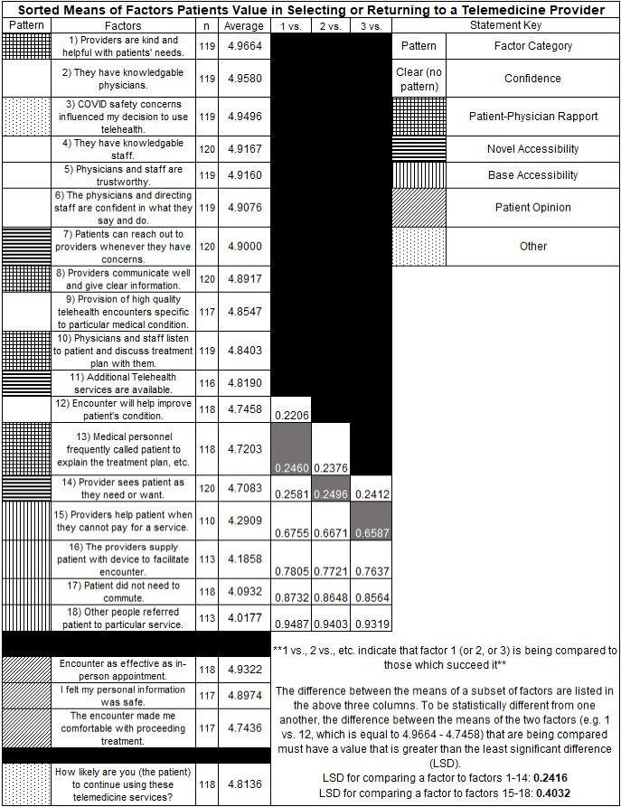
Table 1: This study rated factors valued by patients who completed telemedicine visits versus those who did not complete telemedicine visits

