Supplementary Information Files

S 1: Operating instructions and optimal camera and LED infrared flash units’ position in relation to ASBs stations

Trail Camera set-up for the monitoring of Mosquitoes landing on Attractive Sugar Bait

Materials:

- Bushnell Core DS 30MP No Glow Trail Camera
- Lensbaby 46mm macro filter kit with +1, +2, and +4 dioptric strength filters
- Joby GorillaPod 3K Pro Kit Tripod or equivalent
- Modular camera mounting side brackets to hold the two re-wired LED infrared flashes
- 32GB San Disk Extreme Pro SDHC card
- Rechargeable Batteries (6 per camera).

Method:

- Insert memory card (32GB MAXIMUM) into the card slot on the side of the camera, as well as batteries into the battery cartridge prior to turning the camera on.
- Switch the camera into setup mode to begin programming the camera to the desired settings, remembering to press OK to confirm each setting after it has been input:
  - Mode: CAMERA
  - Image Size: 30MP
  - Flash Range: LOW
  - Sensor Level (Controls the PIR sensor): AUTO
  - Camera Mode: 24HRS
  - Field Scan: ON
    - Block A Start Time: 1st Desired Start Time
    - Block A Finish Time: 1st Desired End Time
    - Block B Start Time: 2nd Desired Start Time
    - Block B Finish Time: 2nd Desired End Time
  - Interval: Dependant on desired length between photos
- Once the required setting parameters have been input, the camera can now be switched to the ON position, to begin the capture procedure.
- Mount the camera to the desired tripod or mount and attach the external LED infrared flash modules to the arms of the brackets at the distances and angles outlined (Fig. 1).
- Fix the +2-macro filter to the camera so that it covers both camera lenses using the 3D printed 2-piece adaptor and zip tie(s).
- Camera is now ready to be placed at the optimal distance of 55cm from the target bait station.

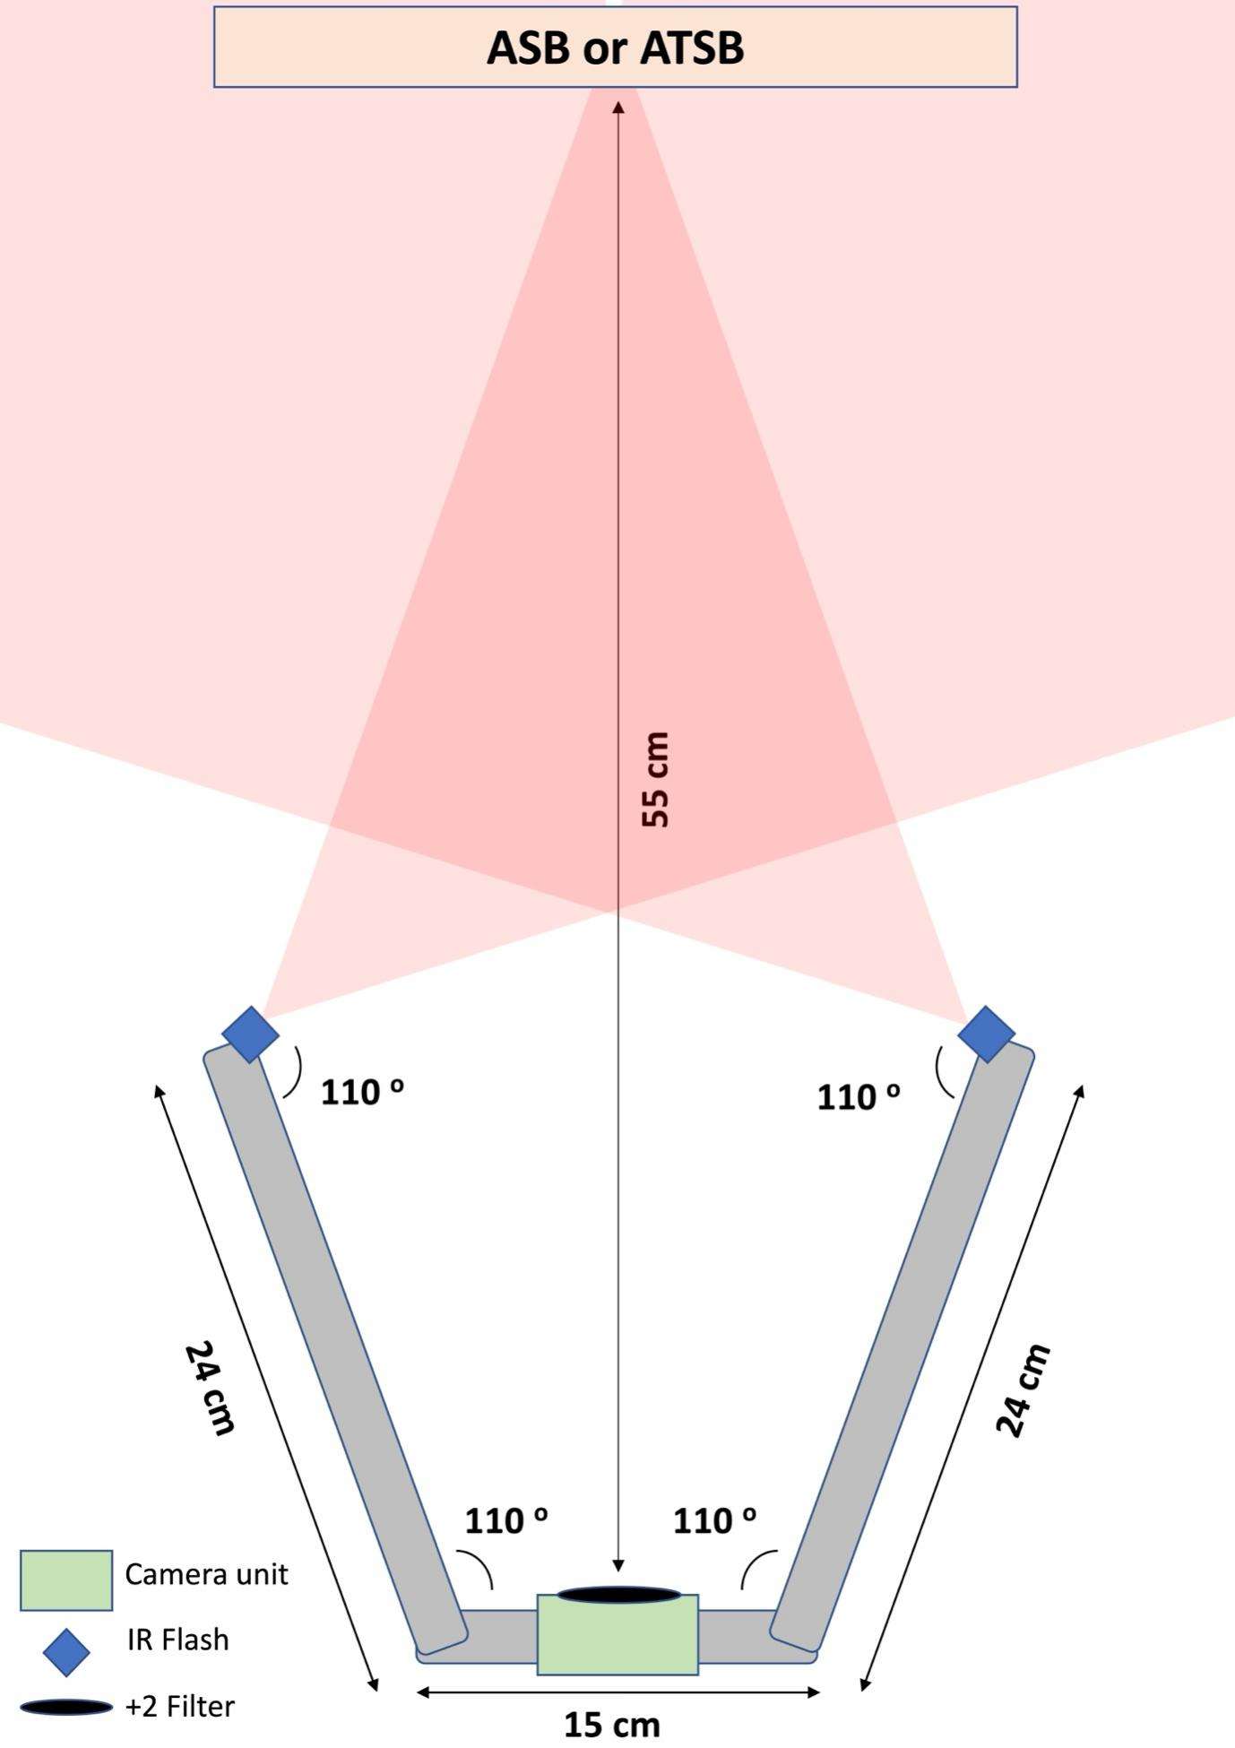
Fig. 1. Recommended distances from the camera's objective (including close-up filter) to an ASB or ATSB surface and position and angle of the re-wired infrared flash.

S 2: Draft foldable camera station design using aluminium hinged plates as frame and side wiring to prevent access to the camera

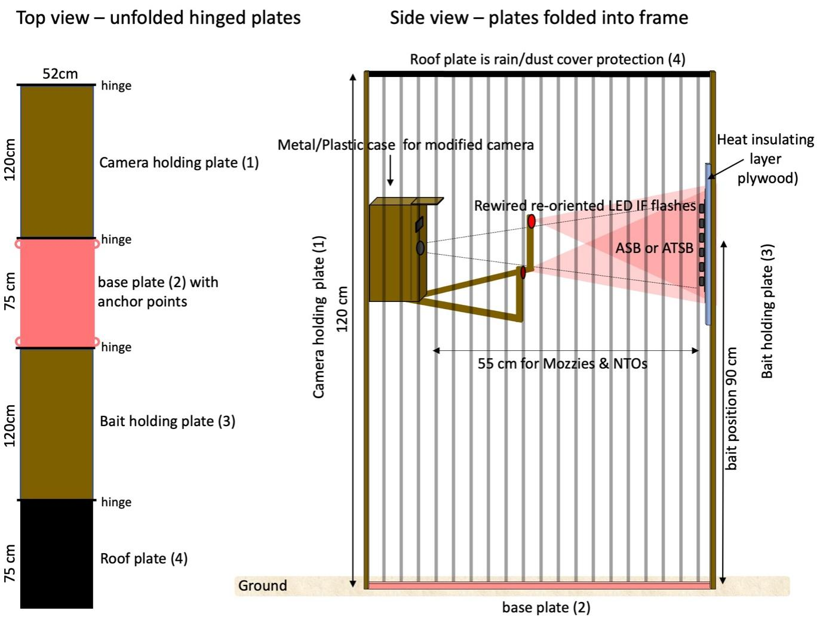

S 3: Outlier analyses of visit duration on baits (here >12 min) using logarithmic (top) and linear scales (bottom - distribution bounded to 1-100 min) - Boxplots indicate median and 1st and 3rd quartile, whilst whiskers extend to the 3rd quartlile + 1.5*interquartile range. Datapoints beyond that limit were considered outliers (here >12 min) and indicative of mosquitoes resting or sleeping on the baits after their feeding bout.
