Supplementary material
Methods
Cell viability assay
Cell viability was determined by CCK-8 (Enhanced Cell Counting Kit-8, Beyotime, C0043). After trypsinization of HL-1 cells in the logarithmic growth phase, 5 × 103 cells/well were uniformly inoculated into 96-well plates. 10 μL CCK-8 working solution was added to each well, followed by incubation at 37°C for 2 hours. The absorbance was then detected at 450 nm using a fluorescence microplate reader. The cells without any treatment were used as the control group, and the cell survival rate was expressed as the percentage of the control group.
Enzyme-linked immunosorbent assay (ELISA)
Blood samples were collected before surgery (T0), 2 hours after aortic cross-unclamping (T1), and 24 hours after aortic cross-unclamping (T2). After centrifugation at 2,500 rpm for 15 minutes, plasma samples were collected and stored at -80°C within 1 day for further analysis. Plasma levels of sVEGFR3, VEGF-C and VEGF-D were determined by ELISA according to the manufacturer's instructions (R&D Systems, Minneapolis, MN).

Results
In vitro, stimulated ischemia/reperfusion injury was induced by hypoxia/reoxygenation. Cell viability was assessed by CCK-8 to investigate the oxygen-glucose deprivation and reperfusion time of the stimulated I/R injury model in HL-1 cells. As shown in Fig. S1A, when HL-1 was subjected to 12 hours of oxygen-glucose deprivation and 4 hours of reperfusion, cell viability decreased to approximately 25%, indicating successful establishment of the model. We also used CCK-8 to investigate the optimal concentration of sVEGFR3 to treat HL-1 cells. The results showed that when HL-1 cells were treated with 50ng/ml sVEGFR3, the cell survival rate was highest under sI/R injury stress.

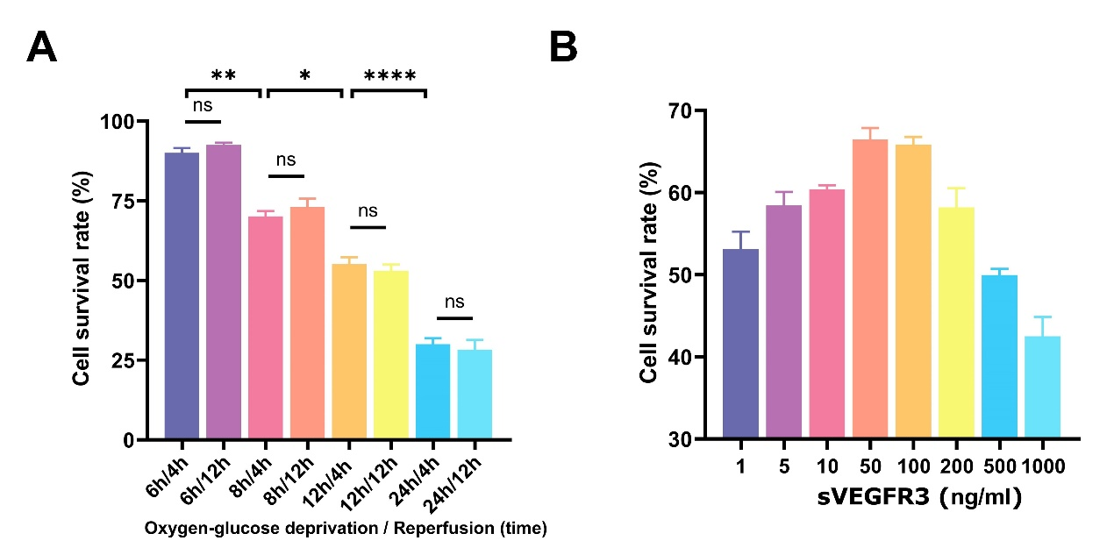

Figure S1. sVEGFR3 may play a role in myocardial I/R injury in patients.
(A) Cell viability was assayed by CCK-8 to explore the oxygen-glucose deprivation and reperfusion time of the stimulated I/R injury model in HL-1 cells. (B) CCK-8 was used to explore the optimal concentration of sVEGFR3 to treati HL-1 cells.

Table S1. List of genes that were significantly up-regulated/down-regulated based on RNA-seq analysis (I/R+sVEGFR3 group versus I/R group, Fold change＞1.2, P＜0.05)
Gene ID | Fold change | P-value
Up-regulated
Slc27a6 | 12.44117032 | 0.006873633
Cd7 | 11.75686298 | 0.00436605
Prf1 | 10.63329251 | 0.010581719
Gm14296 | 10.6098047 | 0.011656819
E030030I06Rik | 10.3398748 | 0.014217977
Upk1b | 9.229642568 | 0.008145858
Slamf6 | 8.42925271 | 0.004539941
Areg | 8.325778288 | 0.028808044
Sult6b2 | 7.630957086 | 0.028178503
Spx | 6.987107719 | 0.023097262
Lrrn4 | 6.949336779 | 0.03861098
Rab39b | 6.531964098 | 0.048139578
Mmp27 | 5.429559371 | 0.02906706
Muc2 | 4.981619229 | 0.006946386
Tex11 | 4.925588224 | 0.010201798
Atp2b3 | 4.280081677 | 0.008066976
Adgrv1 | 4.075104644 | 0.049111902
Smpd5 | 4.056787239 | 0.044646309
Gm8587 | 3.676982339 | 0.040672895
Upk3b | 3.39752044 | 0.031185928
Gm14391 | 2.616027706 | 0.02268753
Etv4 | 2.574969167 | 0.025049077
Slc29a4 | 2.465870697 | 0.017231234
Wdr54 | 2.438892412 | 0.034607495
Cks2 | 2.318019231 | 0.044770316
Il22ra1 | 2.225780837 | 0.022785946
Galnt6 | 2.209341386 | 0.018466918
Ly9 | 2.199180757 | 0.047143088
Lag3 | 2.14808411 | 0.029400139
Tenm4 | 2.063231608 | 0.023127693
Pax5 | 2.044723982 | 0.032756128
Nr5a2 | 2.024487074 | 0.02975978
LOC118568312 | 1.976021067 | 0.017028922
Cd79a | 1.951332216 | 0.039714022
Mgam | 1.938237973 | 0.035707348
Itgax | 1.85877519 | 0.037037492
Spon2 | 1.846009518 | 0.000260775
Stx1a | 1.826214201 | 0.037553355
Gpr132 | 1.825083203 | 0.015477997
Mcub | 1.775326788 | 0.013874699
Helt | 1.707578728 | 0.043123738
Ildr2 | 1.678172942 | 0.03647003
Kif20a | 1.645021569 | 0.037993302
Ackr4 | 1.634986324 | 0.008819523
Ccdc114 | 1.634414678 | 0.036749124
Sv2a | 1.590945764 | 0.004071619
Rtn1 | 1.588606692 | 0.014726098
Chn2 | 1.525182237 | 0.047701565
Sertad4 | 1.51230931 | 0.013771785
Cercam | 1.504759139 | 0.032924038
Aldh3b1 | 1.496067818 | 0.034644518
Mgat3 | 1.488526034 | 0.002231318
Tpbgl | 1.474844413 | 0.041174797
Mis18a | 1.458696935 | 0.048063382
Tctn2 | 1.450344733 | 0.011089073
Adamtsl2 | 1.429250135 | 1.26E-05
Plekhh1 | 1.383173709 | 0.015388021
Gon7 | 1.383046168 | 0.035079643
Tcf21 | 1.380057377 | 0.038038015
Adam19 | 1.375918582 | 0.023448489
Amn1 | 1.365801824 | 0.032390992
Gja5 | 1.363458159 | 0.043418232
Dvl2 | 1.362073703 | 0.035003504
Zfat | 1.359573279 | 0.041163892
Nes | 1.334487048 | 0.003484893
Nynrin | 1.331034122 | 0.040042336
Sdf2l1 | 1.326550657 | 0.013452358
Clip3 | 1.322065991 | 0.038866476
Kit | 1.311279818 | 0.021924563
Ints2 | 1.295122063 | 0.029503926
Fscn1 | 1.293815831 | 0.005637811
Dbh | 1.28380421 | 0.028452587
Bmper | 1.280355118 | 0.045087593
Ret | 1.272501394 | 0.022469427
Colec11 | 1.270483556 | 0.008642404
Tulp3 | 1.267182325 | 0.035890491
Col1a1 | 1.261619581 | 0.016322433
Mrc2 | 1.255257617 | 0.017208074
Col6a3 | 1.25193362 | 0.013609016
Frem2 | 1.250630017 | 0.032024929
Dpy19l1 | 1.250554901 | 0.030714865
Nubp1 | 1.24723107 | 0.046847135
Tmc6 | 1.244084121 | 0.008616325
Prickle3 | 1.240448447 | 0.00631445
Ier2 | 1.239221488 | 0.018528887
Sardh | 1.238915404 | 0.015710105
Ccdc58 | 1.237798765 | 0.003262455
Rp2 | 1.233454142 | 0.008914339
Abca9 | 1.232168183 | 0.011865795
Gbp6 | 1.225230375 | 0.024577634
Ddah2 | 1.219117262 | 0.046568022
Fgf16 | 1.218837387 | 0.046510905
Vangl1 | 1.215871166 | 0.049661119
Yipf1 | 1.213428116 | 0.012632429
Svep1 | 1.211332616 | 0.012786501
Prcp | 1.209407653 | 0.031293703
Rasgrp2 | 1.208562528 | 0.041090666
Acta1 | 1.207486769 | 0.003736688
Manf | 1.206612651 | 0.031979599
Lars2 | 1.206536189 | 0.041645394
Tuba8 | 1.204872026 | 0.009346705
H4c8 | 1.202617407 | 0.029010288
Mndal | 1.20083846 | 0.018238547
Down-regulated
Gm10591 | 0.038892098 | 0.016872146
Nrxn3 | 0.079583339 | 0.007577853
Gm11578 | 0.109686212 | 0.025787205
Pnp2 | 0.129935204 | 0.00560347
Slc18a1 | 0.142063356 | 0.000944227
Gpr1 | 0.226964595 | 0.041636041
Phldb3 | 0.23697456 | 0.022340135
Rnase1 | 0.338983543 | 0.016749155
LOC108167594 | 0.356437142 | 0.025127803
Cdk5r1 | 0.366897669 | 0.017436926
Mroh6 | 0.372301092 | 0.04448625
Gpr21 | 0.377301918 | 0.038218001
Cfap74 | 0.394312428 | 0.01066448
Rorb | 0.409083321 | 0.012997611
Epha1 | 0.435408628 | 0.044000821
Acap1 | 0.465975662 | 0.004536124
Rpl27a-ps4 | 0.488721944 | 0.035989533
Gm10767 | 0.503435943 | 0.03719308
Med18 | 0.518880975 | 0.045693786
Fgfr2 | 0.52595641 | 0.035851734
Ovgp1 | 0.529261317 | 0.026796631
Tekt4 | 0.530550986 | 0.024913674
Fam89a | 0.571170717 | 0.033695029
Aph1c | 0.575426867 | 0.013125984
Zfp72 | 0.579506887 | 0.003735216
Gm45855 | 0.589377662 | 0.01146365
Larp6 | 0.600800177 | 0.043729517
Phf21b | 0.615696815 | 0.042677422
Gm11992 | 0.63199966 | 0.049404043
Parvg | 0.635591523 | 0.034178328
Lurap1 | 0.638364348 | 0.035686297
H1f4 | 0.639677396 | 0.04020127
Hpn | 0.690289073 | 0.042415125
Hddc2 | 0.709335853 | 0.029422225
Hmgcs2 | 0.709799055 | 0.008756877
Ehd3 | 0.713552551 | 0.004015839
Cdca4 | 0.713954929 | 0.015123569
Haus4 | 0.71711976 | 0.038645995
Zbtb8a | 0.720942742 | 0.044025701
Morf4l1b | 0.724204998 | 0.011624571
Carmil1 | 0.726603996 | 0.047066744
Eif4ebp3 | 0.730753466 | 0.015253063
Acsm5 | 0.735574767 | 0.048748497
Acot1 | 0.743764326 | 0.006755326
Tmem140 | 0.747897014 | 0.000657599
Zfp369 | 0.754960166 | 0.025712573
Chrna2 | 0.755928959 | 0.043297213
Cdh4 | 0.763294058 | 0.042605951
Fam13c | 0.764266864 | 0.027508837
Gpld1 | 0.773394941 | 0.013814424
Stmn1 | 0.779429515 | 0.031715808
Zfp866 | 0.782781725 | 0.025535471
Dcp1a | 0.784092266 | 0.007415451
Asb6 | 0.784385732 | 0.026279035
Ptges3-ps | 0.784551174 | 0.006529576
Dtd2 | 0.789175165 | 0.027445832
Zfp52 | 0.790019807 | 0.017378141
2410002F23Rik | 0.792560807 | 0.002301609
Spire1 | 0.797398899 | 0.025317062
Pygo2 | 0.799300518 | 0.022979158
Bend5 | 0.800131263 | 0.01760881
Cpeb1 | 0.800875024 | 0.024470791
Glcci1 | 0.801929829 | 0.042730333
Lzts3 | 0.805135077 | 0.047092671
Snx24 | 0.80885732 | 0.009424249
Llph | 0.809172594 | 0.027196669
Wdr74 | 0.810591043 | 0.010086894
Evc2 | 0.810883524 | 0.035071826
Usp53 | 0.814327819 | 0.01895678
Mgmt | 0.815339819 | 0.047164549
Taf1a | 0.816733465 | 0.006797257
Ctdp1 | 0.817213458 | 0.006704842
Cldn12 | 0.818956014 | 0.003173238
Zswim7 | 0.819671479 | 0.01455908
Klhl33 | 0.821505341 | 0.017579449
Pfkfb1 | 0.821619474 | 0.040303004
Rnpc3 | 0.826500948 | 0.019491831
Slc40a1 | 0.828254129 | 0.030016798
Gtf2e2 | 0.829312433 | 0.039372
Plcl2 | 0.830418273 | 0.006034232
Tspan4 | 0.831938235 | 0.020025565
Ddx51 | 0.833169952 | 0.015624805

Table S2. Correlation of among plasma levels of sVEGFR3, VEGFC and VEGFD at different time points during cross-clamping cardiopulmonary bypass surgery.
Variables | Spearman correlation | P value
T0
VEGFR3-VEGFC | 0.101 | 0.335
VEGFR3-VEGFD | 0.023 | 0.826
T1
VEGFR3-VEGFC | 0.069 | 0.510
VEGFR3-VEGFD | 0.049 | 0.640
T2
VEGFR3-VEGFC | 0.028 | 0.792
VEGFR3-VEGFD | 0.042 | 0.688
T0 refers to the pre-operative time. T1 refers to 2 hours after aortic cross-unclamping. T2 refers to 24 hours after aortic cross-unclamping.

