Supporting Information
To ensure accurate measurement and control of the light intensity used during the procedure, we employed a power meter to quantify the intensity of the light being delivered to the cornea. During the crosslinking process, a collimator was utilized to provide focused illumination, directing the light into a narrow beam. In this case, the collimator was positioned above the cornea, allowing the light to be precisely directed onto the treatment area.

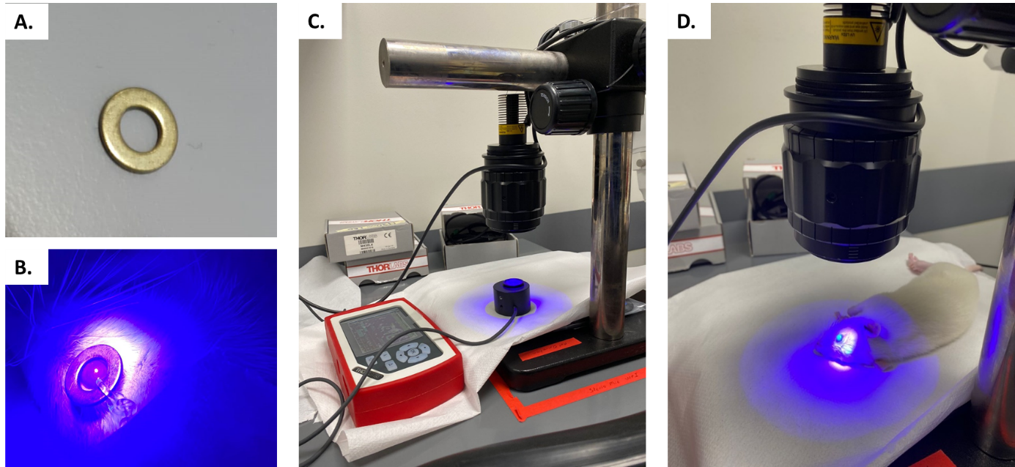
Supp. Figure 1. Overview of corneal crosslinking setup. (A) Metal ring 7 mm prepared to protect the limbus, the sclera, and conjunctiva, (B) Position of the ring on the eye during light illumination, (C) Irradiation dose in the lightning setup was measured with a power meter to ensure the correct amount of light given, (D) Application of light illumination on cornea to accelerate crosslinking procedure.

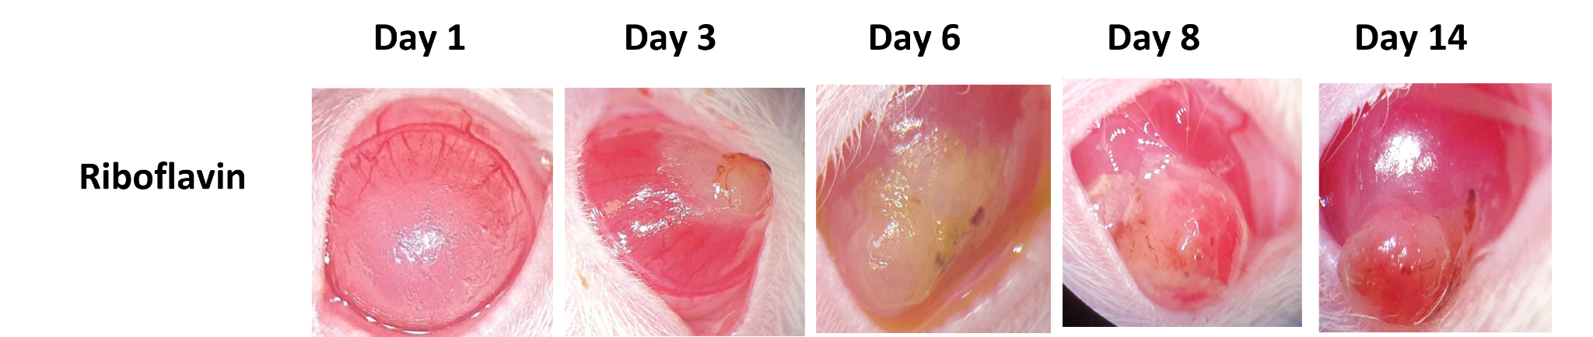
Supp. Figure 2: Macroscopic image of the riboflavin group treated with 1.8 J/cm2 UV-A (n=6). Severe complication with corneal perforation observed due to UV-A irradiation in rat corneas. Eyes were treated with antibiotics until the rats were euthanized.

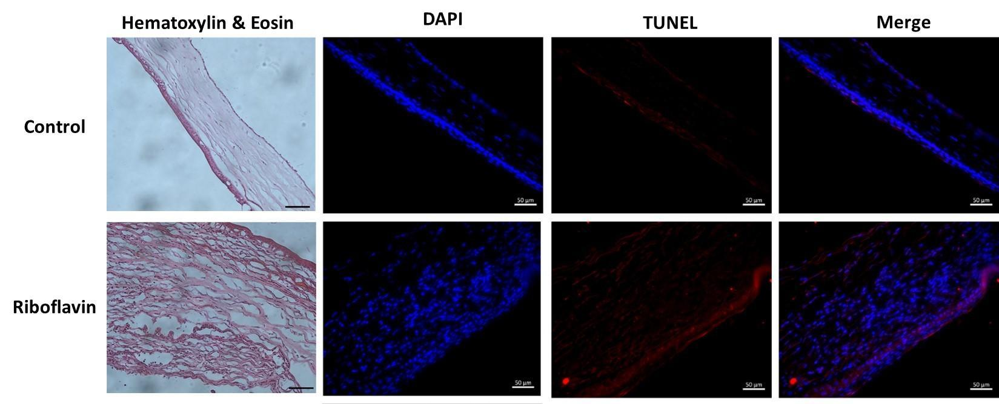Supp. Figure 3: Histological and cell death examination of control and the riboflavin group treated with 1.8 J/cm2 UV-A. Corneal fibrosis was observed as a response to injury in the riboflavin group. Irregular collagen fiber and neovascularization were also found with hematoxylin and eosin staining. Increase in the cell death following 1.8 J/cm2 UV-A. Scale bars represent 50 µm.

