Data sources

This paper takes 31 provinces in China (Hong Kong, Macao and Taiwan data are not available) as research samples, starting from the earliest statistical year available, and chooses 2018-2023 as the research period.
The data that support the findings of this study are openly available in China National Bureau of Statistics at https://www.stats.gov.cn/sj/ndsj/ , China's weather Report at http://tianqihoubao.com/ and China Charging Alliance at http://en.caam.org.cn:9527/.

China National Bureau of Statistics at https://www.stats.gov.cn/sj/ndsj/
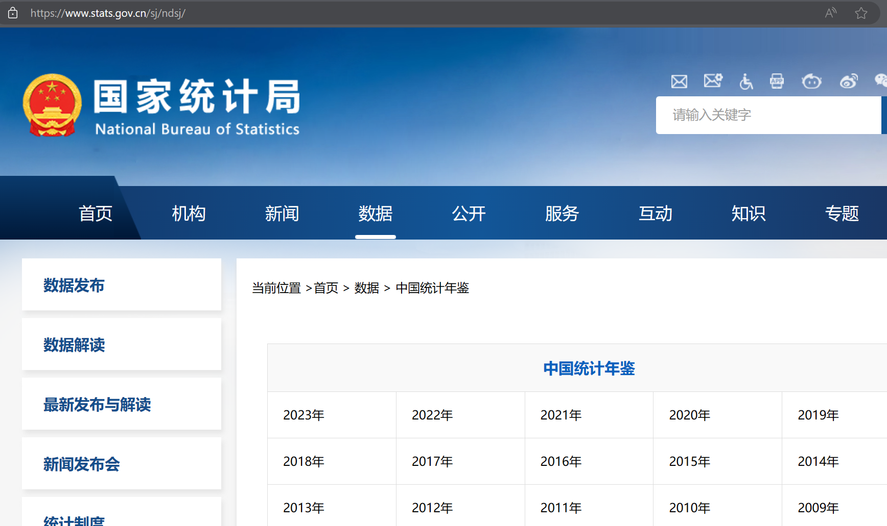

China's weather Report at http://tianqihoubao.com/
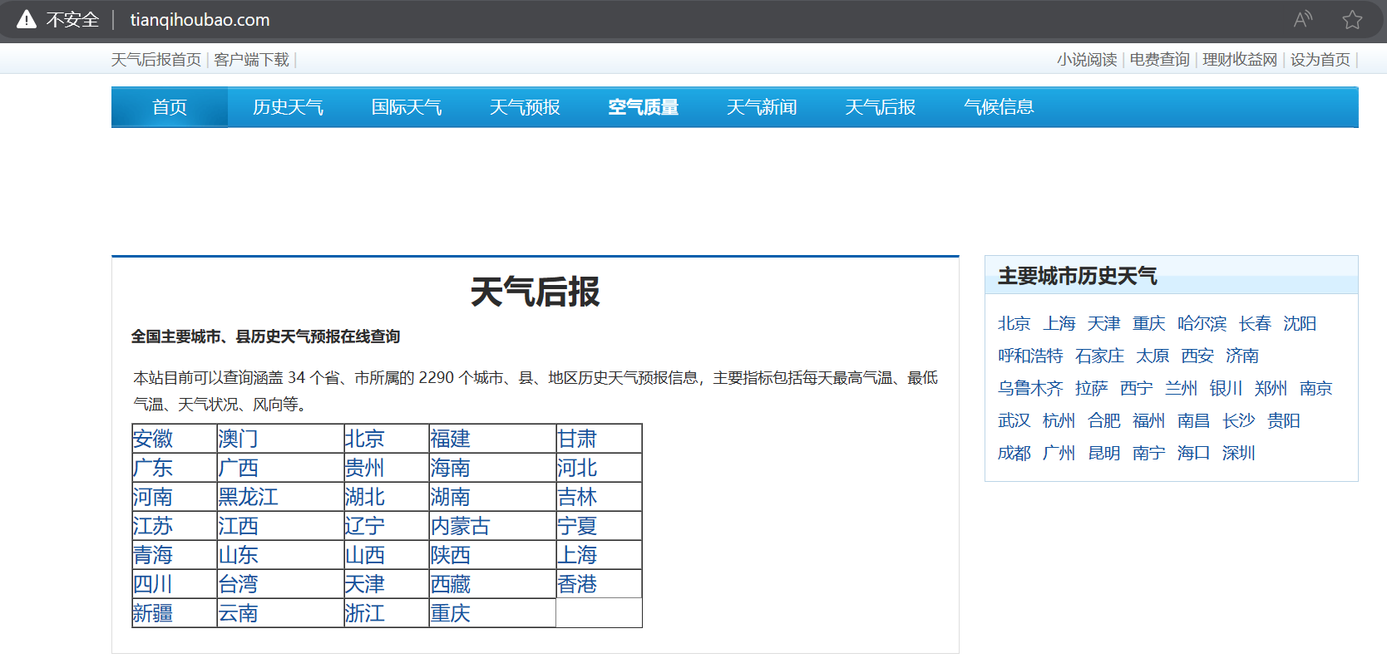

China Charging Alliance at http://en.caam.org.cn:9527/
