Figure1
SIRT1
Figure2

Figure3
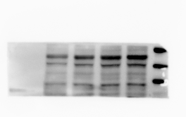
Caspase-1

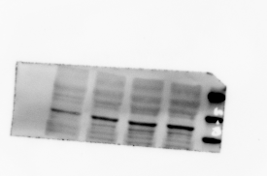
GSDMD

Figure4
SIRT1
NLRP3
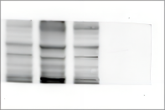
Caspase-1
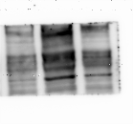
GSDMD

