Synthesis, theoretical investigation, ADMET studies, antimicrobial Activity, and docking analysis of some novel imidazolidinone derivatives
Ahmed Khodair^{1,}*, Dalia Imam^{2,3}, Nabila Kheder^{4,}*, Asmaa Fahim⁵, and Ahmed El-Barbary²
¹ Department of Chemistry, Faculty of Science, Kafrelsheikh University, Kafrelsheikh 33516, Egypt.
² Department of Chemistry, Faculty of Science, Tanta University, Tanta 31527, Egypt.

³ Department of Basic Science, High Institute of Engineering & Technology, ElMahala ElKobra, Egypt.
⁴ Department of Chemistry, Faculty of Science, Cairo University, Giza 12613, Egypt.
⁵ Green Chemistry Department, National Research Centre, Dokki, 12622, Giza, Egypt.
E-Mail: khodair2020@yahoo.com; aik@sci.kfs.edu.eg; nabila_abdelshafy@cu.edu.eg

Spectral Data of Synthesized Compounds
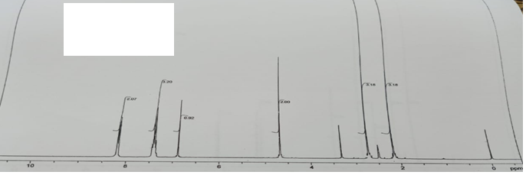
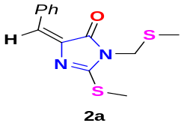

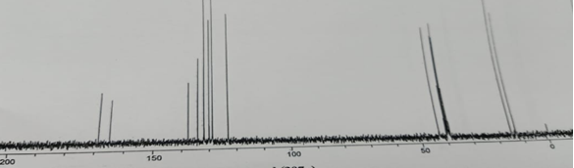
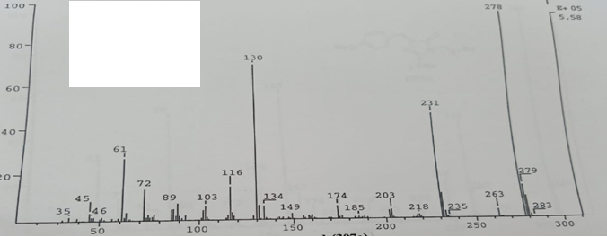

Fig. S1. NMR (¹H, ¹³C) and Mass spectra of imidazole derivative 2a.
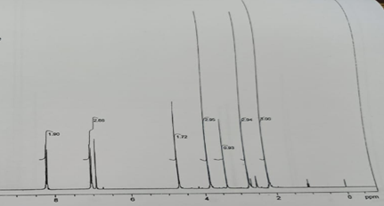
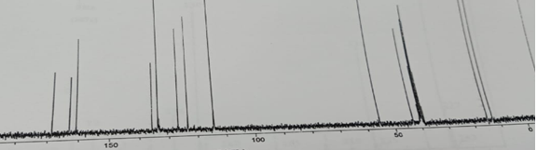
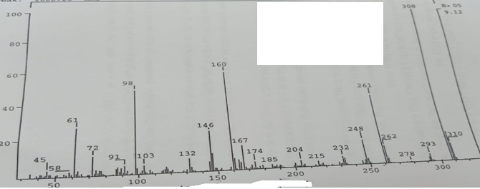
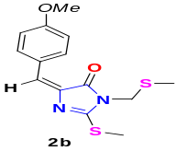
Fig. S2. NMR (¹H, ¹³C) and Mass spectra of imidazole derivative 2b.
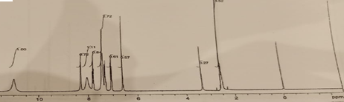
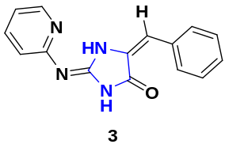
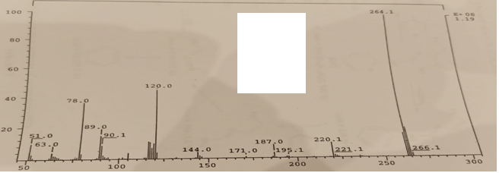

Fig. S3. ¹H NMR and Mass spectra of imidazole derivative 3.
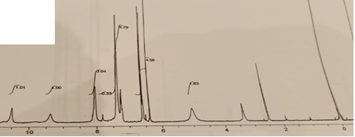
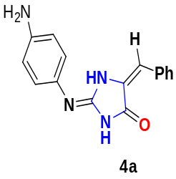
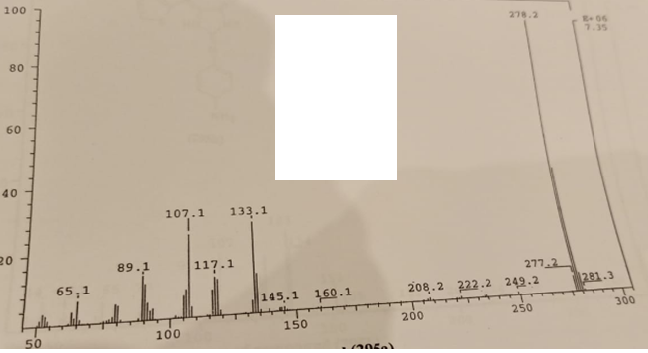

Fig. S4. ¹H NMR and Mass spectra of imidazole derivative 4a.
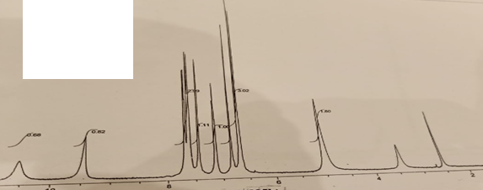
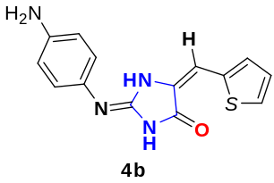
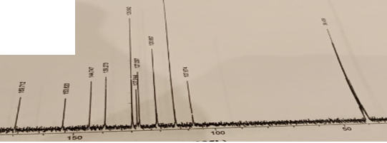

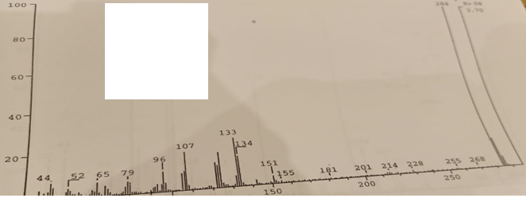

Fig. S5. NMR (¹H, ¹³C) and Mass spectra of imidazole derivative 4b.

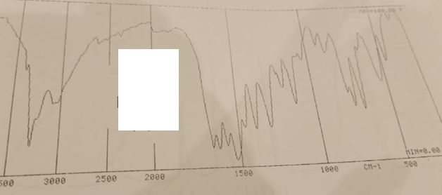
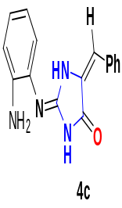
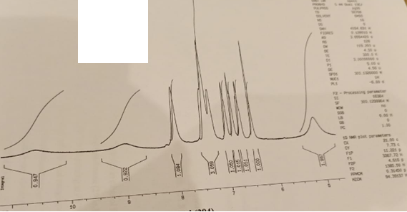
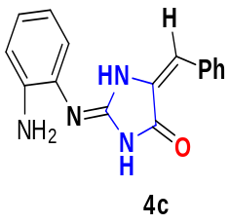
Fig. S6. IR and ¹H NMR of imidazole derivative 4c.
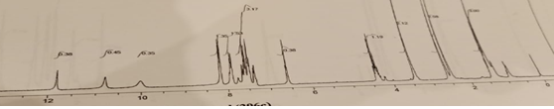
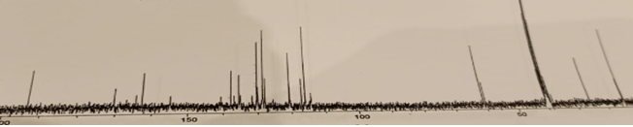
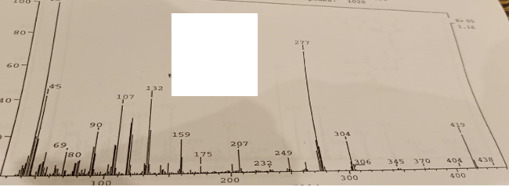
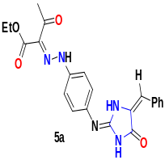
Fig. S7. NMR (¹H, ¹³C) and Mass spectra of azo derivative 5a.
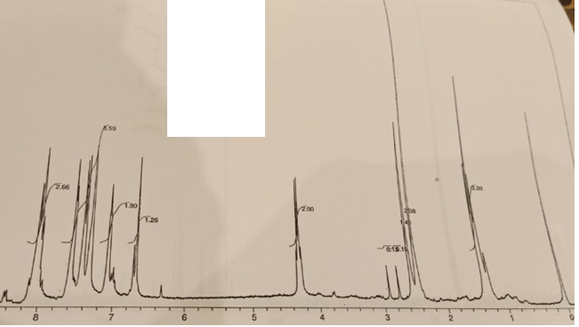
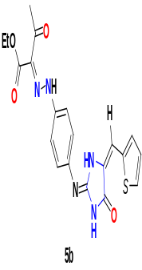
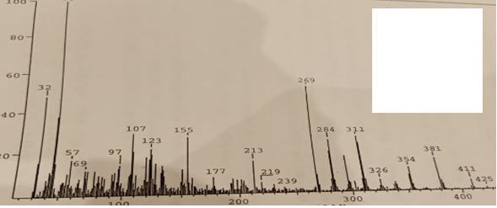

Fig. S8. ¹H NMR and Mass spectra of azo derivative 5b.
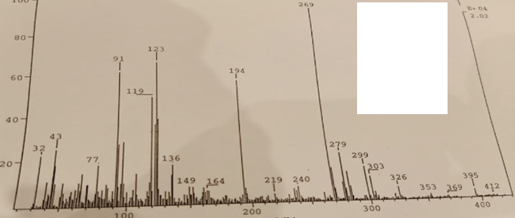

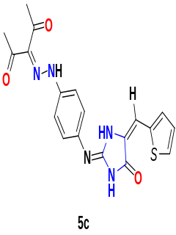

Fig. S9. Mass spectrum of azo derivative 5c.
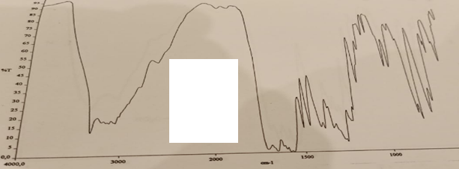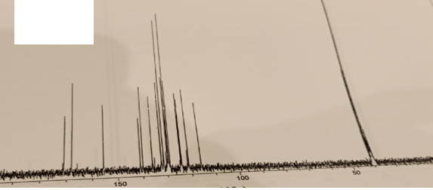

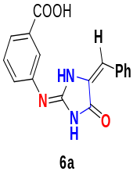
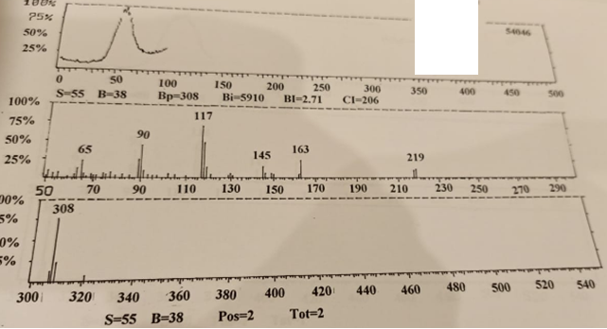
Fig. S10. IR, ¹³C NMR, and Mass spectra of azo derivative 6a.
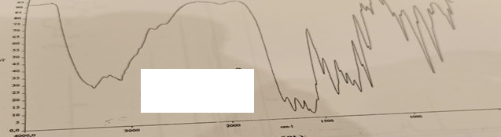
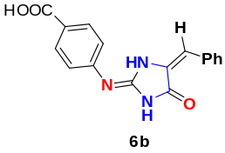
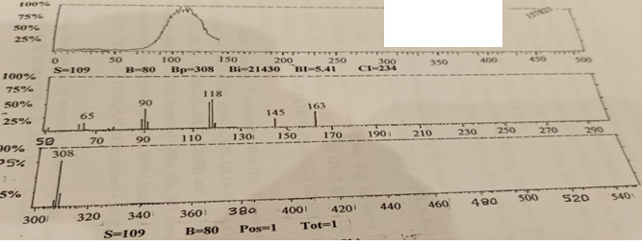
Fig. S11. IR, and Mass spectrum of azo derivative 6b.
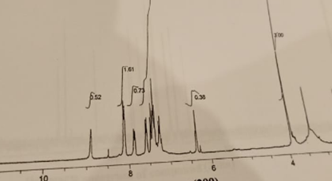
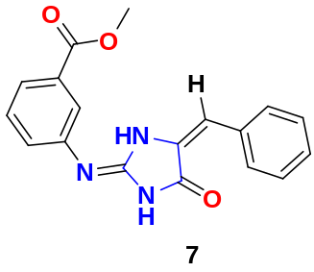
Fig. S12. ¹H NMR spectrum of ester derivative 7.
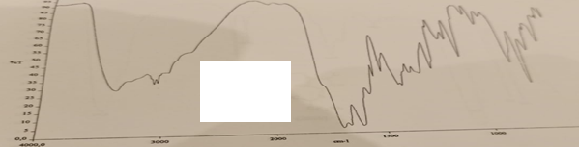
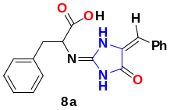
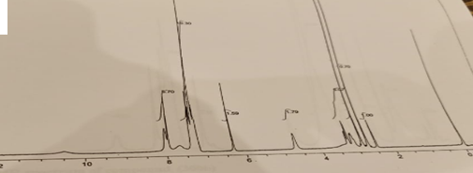
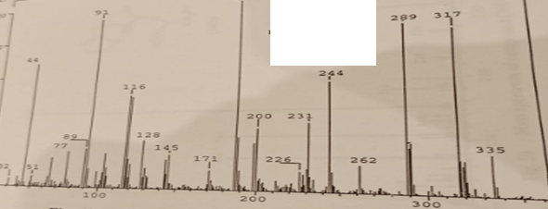
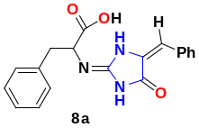
Fig. S13. IR, ¹H NMR and Mass spectra of imidazole derivative 8a.
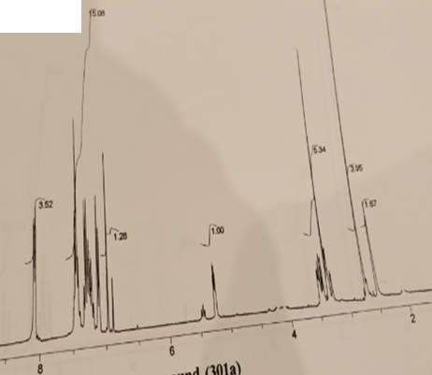
Fig. S14. ¹H NMR spectra of imidazo[1,2-a]imidazole derivative 9a.
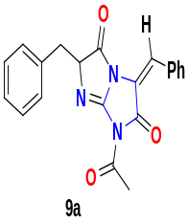
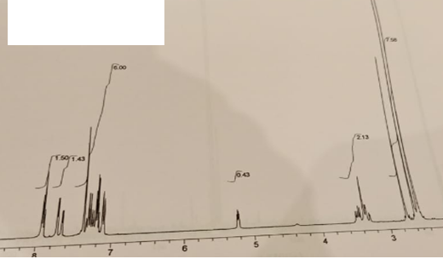
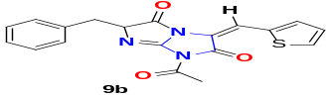
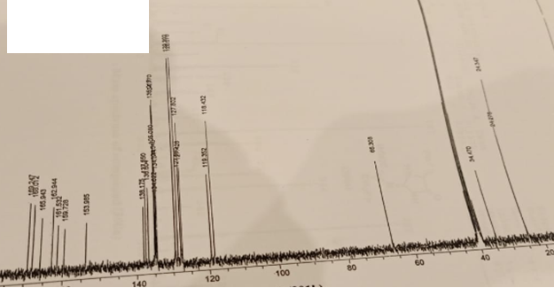
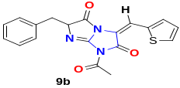

Fig. S15. ¹H and ¹³C NMR spectra of imidazo[1,2-a]imidazole derivative 9b.
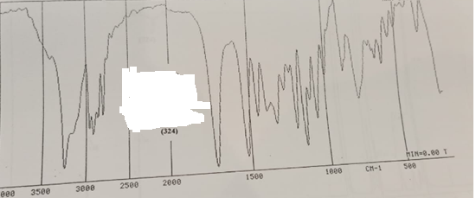
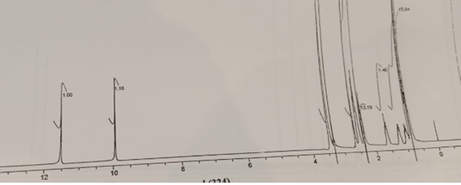
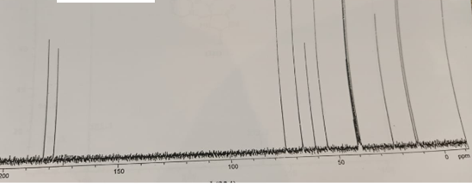
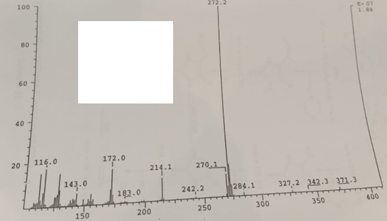
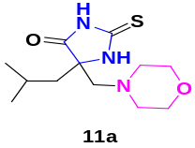
Fig. S16. IR, NMR (¹H, ¹³C) and Mass spectra of imidazole-morpholine hybrid 11a.
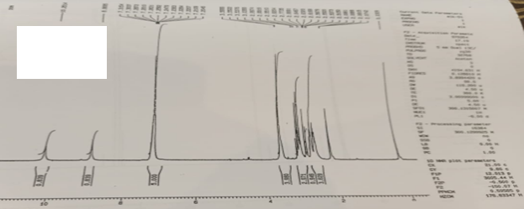

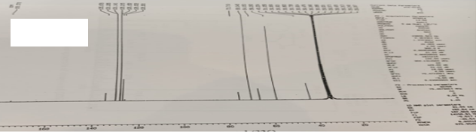

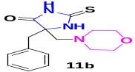

Fig. S17. NMR (¹H, ¹³C) spectra of imidazole-morpholine hybrid 11b.
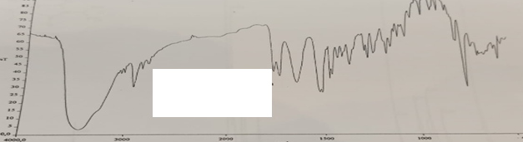

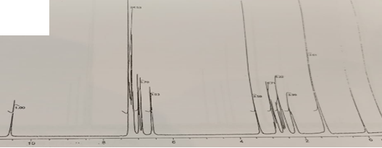

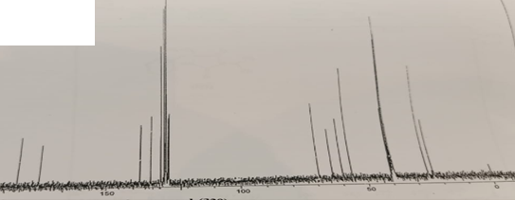

c
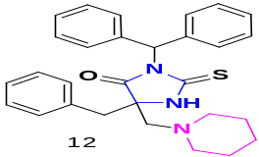
Fig. S18. IR, NMR (¹H, ¹³C) and Mass spectra of imidazole-piperidine hybrid 12.

