Supplementary Information

HTR1D regulates the PI3K/Akt signaling pathway to impact hepatocellular carcinoma development and resistance to sorafenib
Yingai Zhang^{1,2,3}, Yuting Zhang¹, Shuai Zhou⁴, Mujeeb Ur Rehman⁵, Fankai Lin^{2,3}, Jianquan Zhang^{4,#}, Hailong Zhou^{1,#}
1 School of Life and Health Sciences, Hainan University, Haikou, Hainan, 570228, China
2 Central Laboratory, Affiliated Haikou Hospital of Xiangya Medical College, Central South University, Haikou, Hainan,570208, China
3 Haikou City Key Laboratory of Clinical Medicine, Haikou, Hainan, 570208, China
4 Hepatobiliary surgery, Affiliated Haikou Hospital of Xiangya Medical College, Central South University, Haikou Hainan, 570208, China
5 Algal Bioactives and Bio products Group, State Key Laboratory of Marine Resource Utilization in South China Sea, Hainan University, Haikou, 570228, China

Corresponding authors: E-mail addresses: jianquanzhang@126.com(Jianquan Zhang), zhouhl@hainanu.edu.cn (Hailong Zhou)

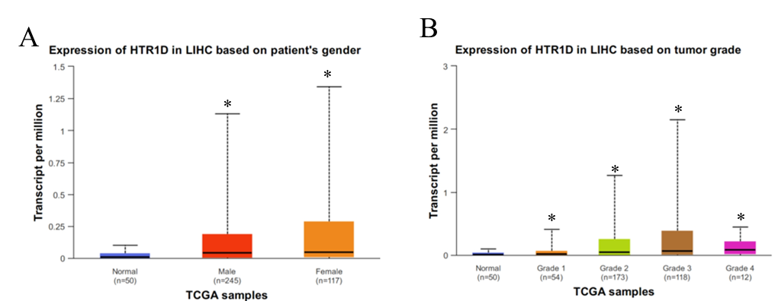
Figure S1 Association of HTR1D gene expression with A. patient’s gender and B. tumor grade. * indicates P<0.05

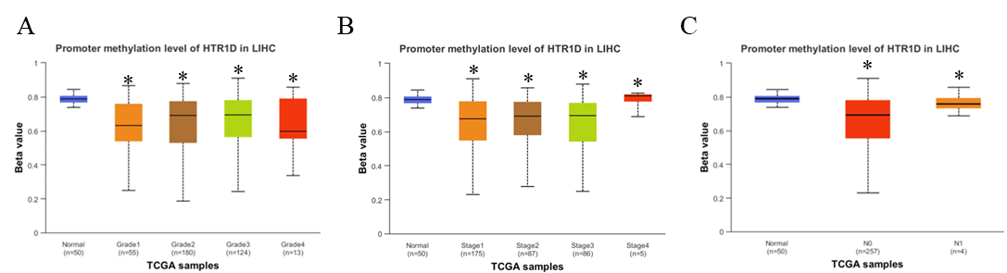
Figure S2 Promoter methylation level of HTR1D in LIHC. * indicates P<0.05

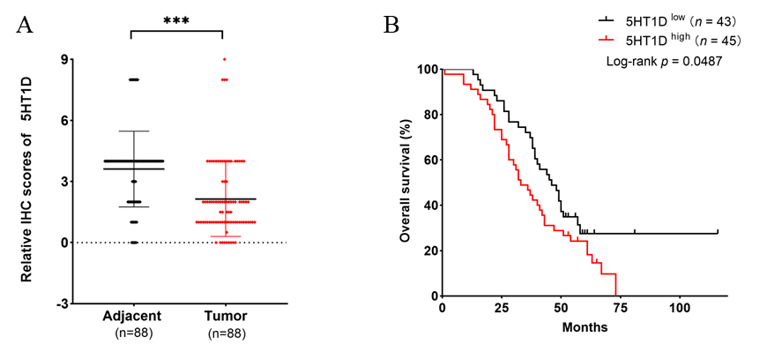
Figure S3 A. Differential analysis of antibody expression in hepatocellular carcinoma and paracarcinoma tissues. B. Survival analysis. *** indicates P<0.001.

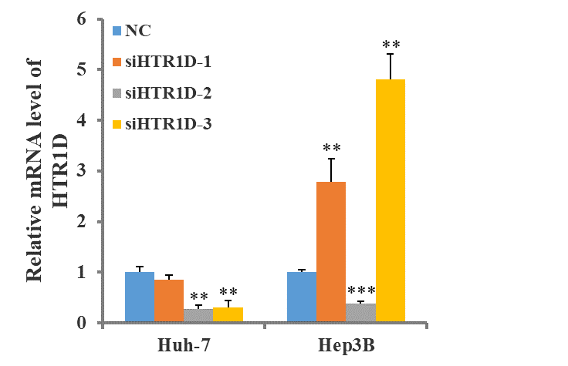
Figure S4 Validity of each HTR1D siRNA detected by qPCR. ** indicates P<0.01, *** indicates P<0.001.

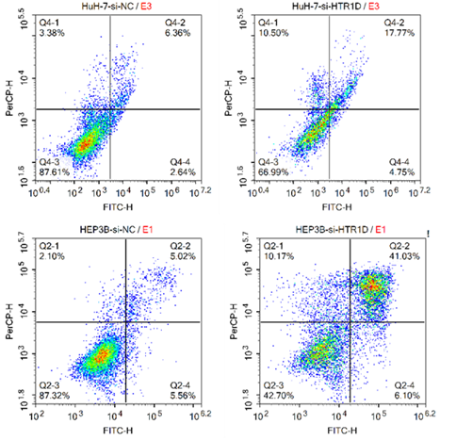
Figure S5 Flow cytometry to detect apoptosis in HuH-7 and HEP3B cells.

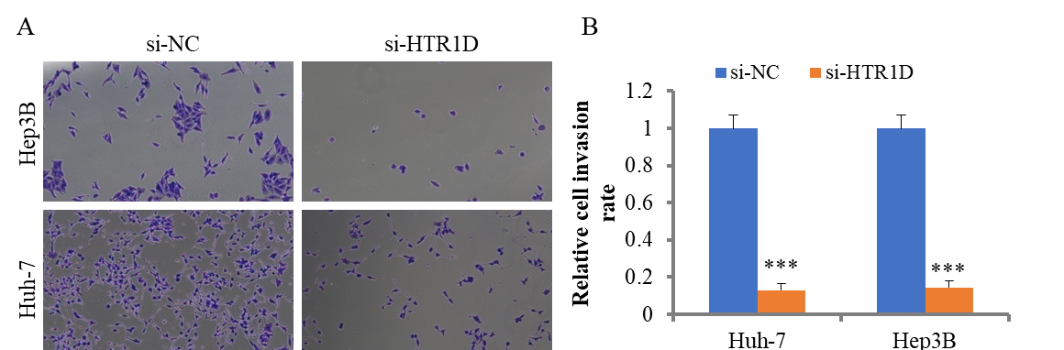
Figure S6 Transwell assay was used to determine invasion abilities of HuH-7 and HEP3B cells. *** indicates P<0.001.

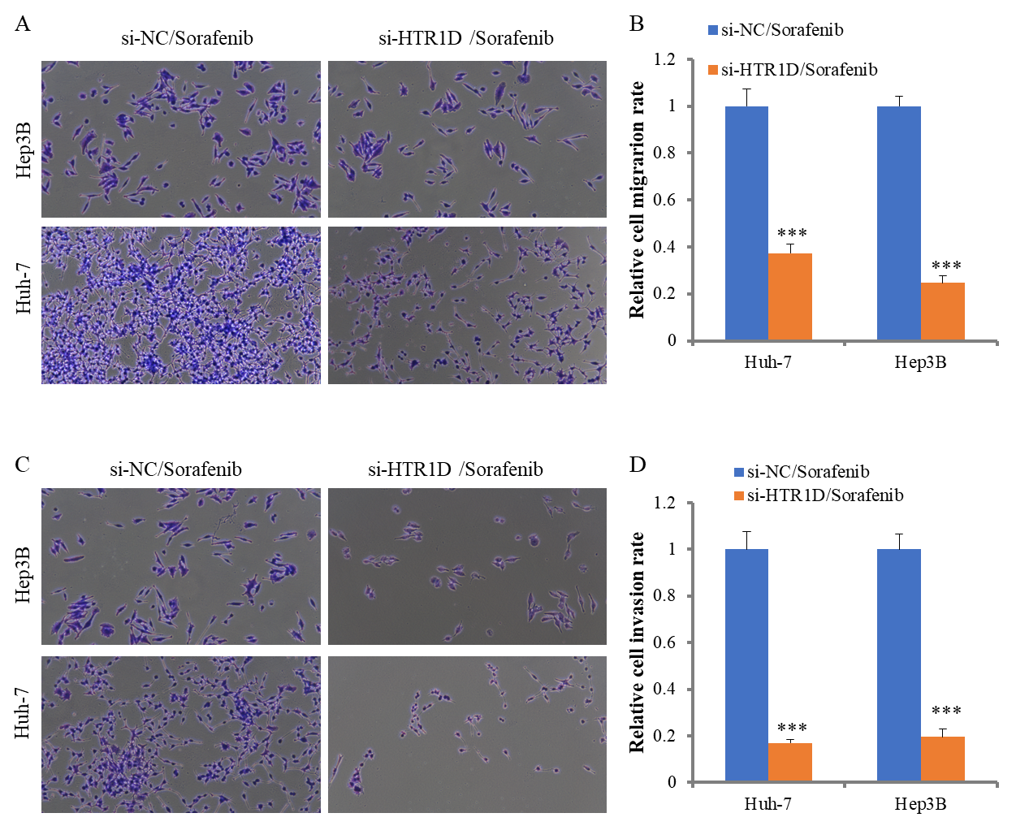
Figure S7 Transwell assay was used to determine A-B. migration and C-D. invasion abilities of HuH-7 and HEP3B cells. *** indicates P<0.001.

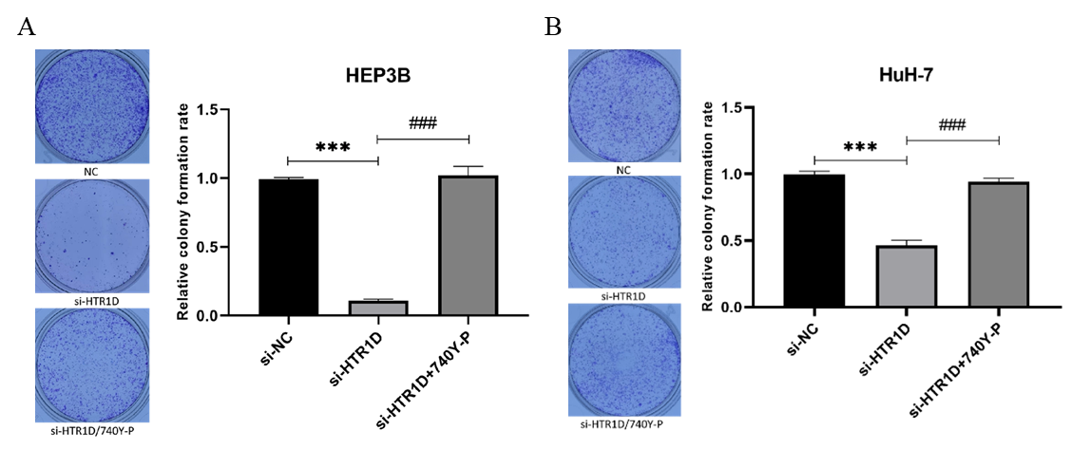
Figure S8 Representative images and rate of colony formation assay for HuH-7 and HEP3B. *** indicates P<0.001.

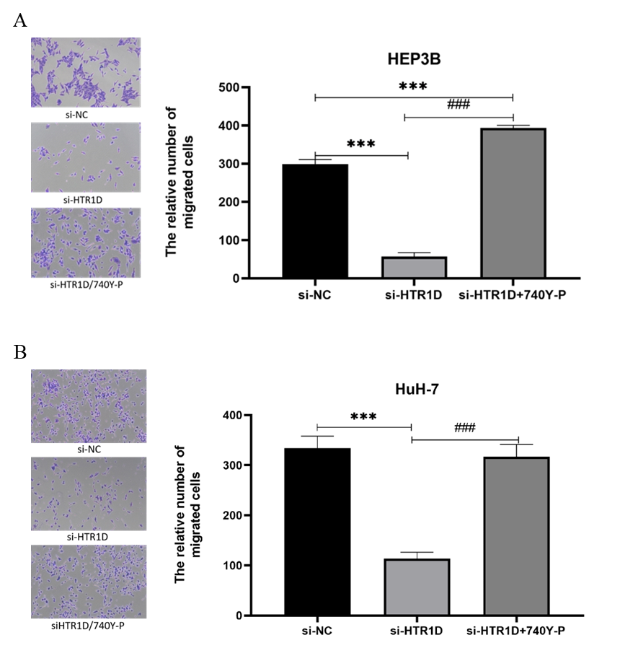
Figure S9 Transwell assay was used to determine migration abilities of HuH-7 and HEP3B cells. *** indicates P<0.001.
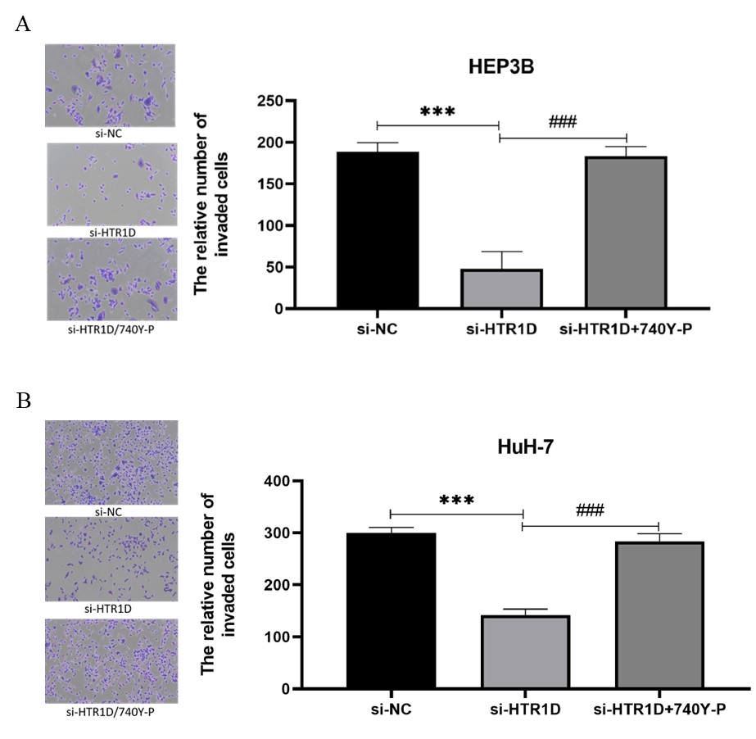
Figure S10 Transwell assay was used to determine invasion abilities of HuH-7 and HEP3B cells. *** indicates P<0.001.

