Supplementary Information 2

HTR1D regulates the PI3K/Akt signaling pathway to impact hepatocellular carcinoma development and resistance to sorafenib
Yingai Zhang^{1,2,3}, Yuting Zhang¹, Shuai Zhou⁴, Mujeeb Ur Rehman⁵, Fankai Lin^{2,3}, Jianquan Zhang^{4,#}, Hailong Zhou^{1,#}
1 School of Life and Health Sciences, Hainan University, Haikou, Hainan, 570228, China
2 Central Laboratory, Affiliated Haikou Hospital of Xiangya Medical College, Central South University, Haikou, Hainan,570208, China
3 Haikou City Key Laboratory of Clinical Medicine, Haikou, Hainan, 570208, China
4 Hepatobiliary surgery, Affiliated Haikou Hospital of Xiangya Medical College, Central South University, Haikou Hainan, 570208, China
5 Algal Bioactives and Bio products Group, State Key Laboratory of Marine Resource Utilization in South China Sea, Hainan University, Haikou, 570228, China

Corresponding authors: E-mail addresses: jianquanzhang@126.com(Jianquan Zhang), zhouhl@hainanu.edu.cn (Hailong Zhou)

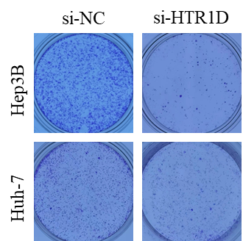

Figure 1 Raw data for colony formation assay in Figure 2D

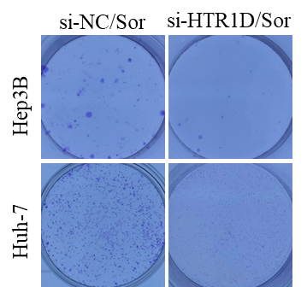
Figure 2 Raw data for colony formation assay in Figure 3C

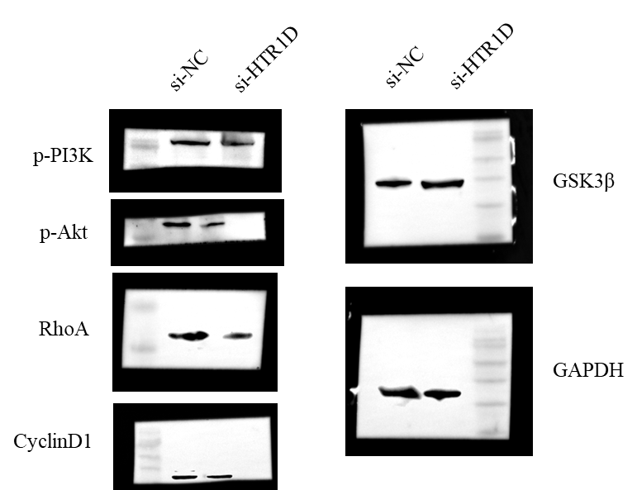
Figure 3 Raw data for westen blot in Figure 3E

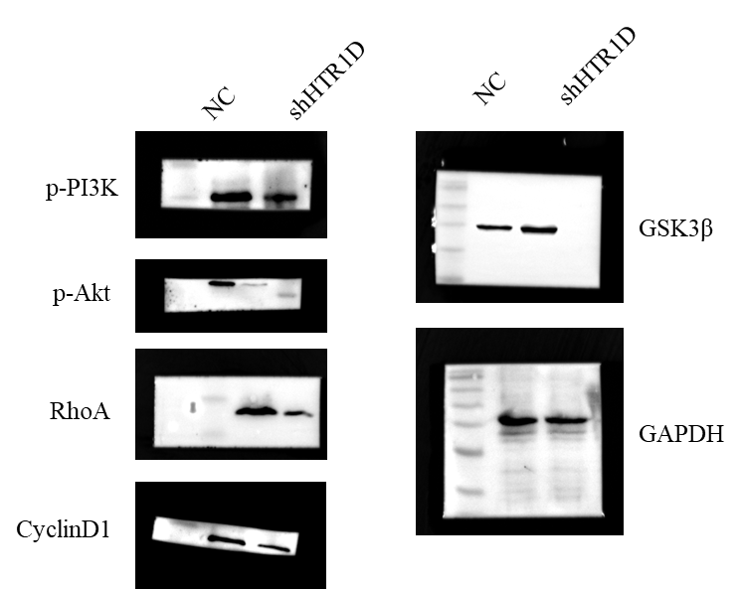
Figure 4 Raw data for westen blot in Figure 4I

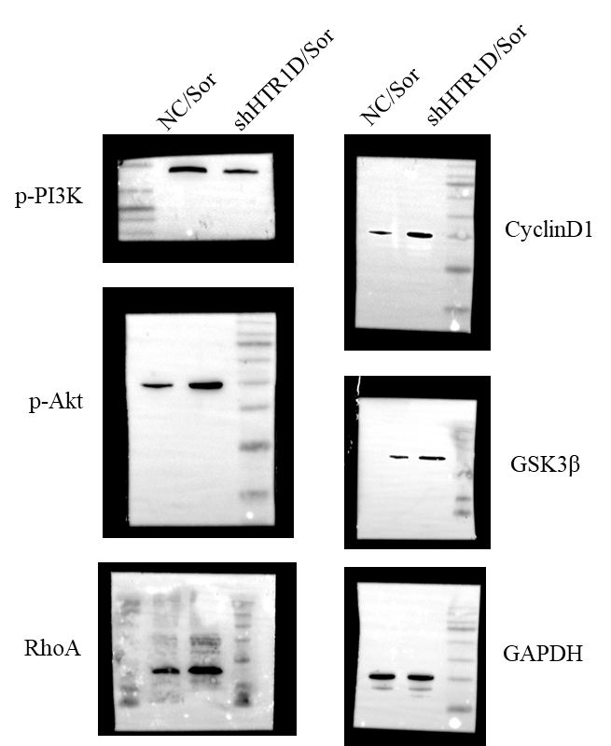

Figure S5 Raw data for westen blot in Figure 4K

