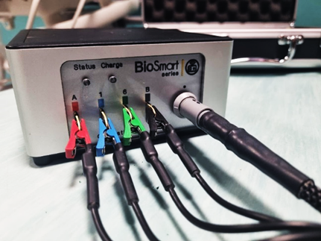

Figure 2. Biosmart ® EX.516(XX) calibration test.

