Supplementary Information
Interconvertible and rejuvenated Lewis acidic electrolyte additive for lean electrolyte lithium sulfur batteries

Hannah Cho^{1,4}, Jinkwan Jung^{2,4}, Ilju Kim¹, Jinuk Kim¹, Sejin Kim¹, Jonghyun Hyun¹, Chang Hoon Lee², Hobeom Kwack², Wonsik Oh², Jinwoo Lee¹ and Hee-Tak Kim^{1,3*}
¹Department of Chemical and Biomolecular Engineering, KAIST, 291 Daehak-ro, Yuseong-gu, Daejeon 34141, Republic of Korea
²LG Energy solution, LG Science park E6 Block, 30 Magokjungang 10-ro, Gangseo-gu Seoul 07796, Republic of Korea
³LG Energy Solution-KAIST Frontier Research Lab, KAIST, 291, Daehak-ro, Yuseong-gu, Daejeon 34141, Republic of Korea
⁴These authors contributed equally: Hannah Cho, Jinkwan Jung

* Corresponding author: Hee-Tak Kim (E-mail: heetak.kim@kaist.ac.kr )

Supplementary Figures

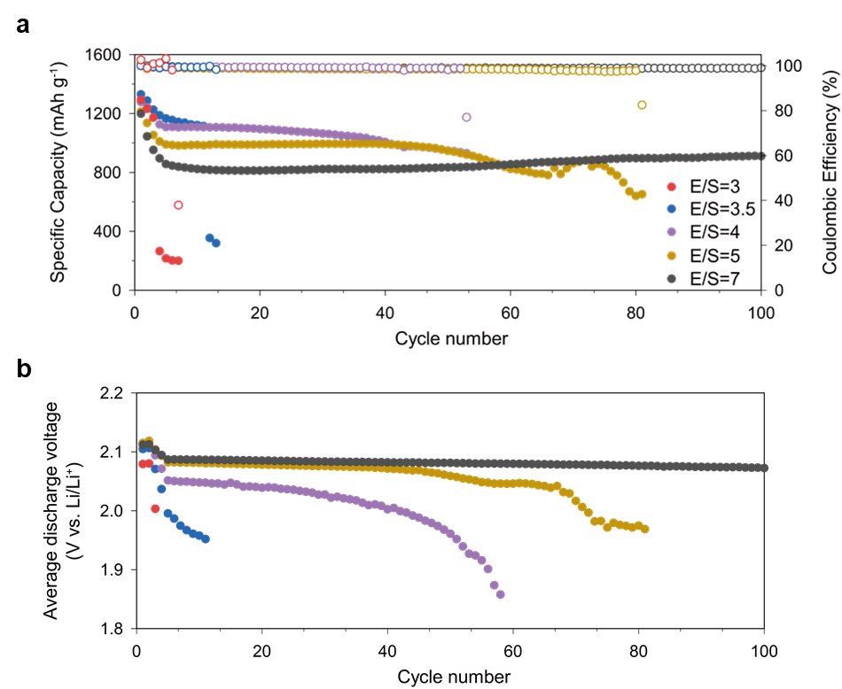
Supplementary Fig. 1 | Cycle performance of the Li-S coin cells with the FSI-DME electrolyte under different E/S ratios. a, Cycling stability and b, average discharge voltages of the Li-S coin cells with different E/S ratios at a current density of 0.2 C.
With decreasing E/S ratio, the initial discharge capacity increased; however, the cycling stability drastically deteriorated, consistent with the previous findings¹.
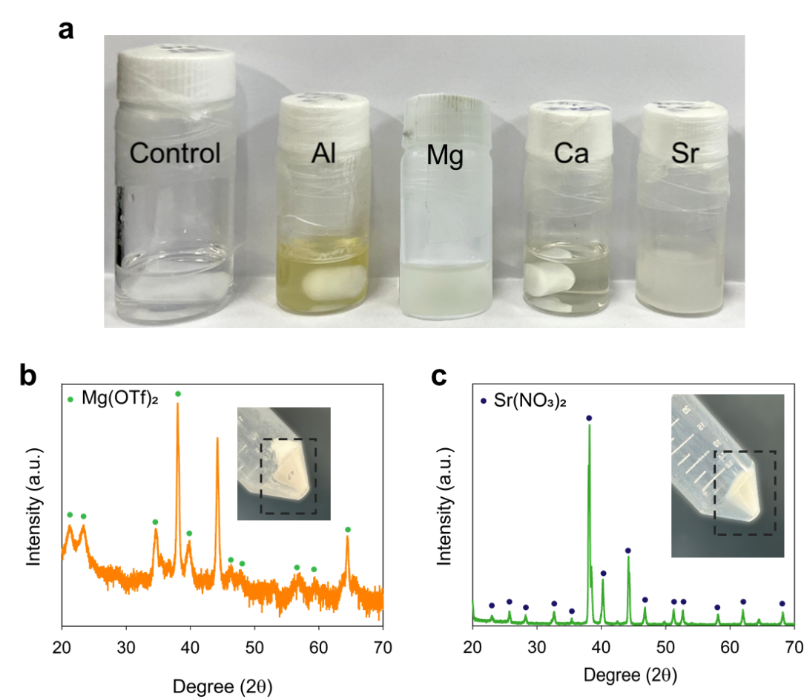
Supplementary Fig. 2 | Compatibility of a, Optical images of the control and additive (0.05 M)-containing electrolytes. b, c, X-ray diffraction (XRD) patterns of the precipitates in the Mg (b) and Sr (c) electrolytes, respectively.
After being left for several days, precipitates appeared in the Mg and Sr electrolytes, while gelation occurred in the Al electrolyte. The precipitate in the Mg electrolyte, Mg(OTf)₂, indicates the low solubility of Mg(OTf)₂ in the control electrolyte. The formation of Sr(NO₃)₂ in the Sr electrolyte is attributed to a strong Lewis acid-base reaction with NO₃²⁻. Given that LiNO₃ is an indispensable component for mitigating the shuttle effect, Sr²⁺ cations are inadequate additives for LSB electrolytes. Similar phenomena occured when Mg, Sr, and Al salts were added to the commonly-used LiTFSI-DOL-DME electrolyte.
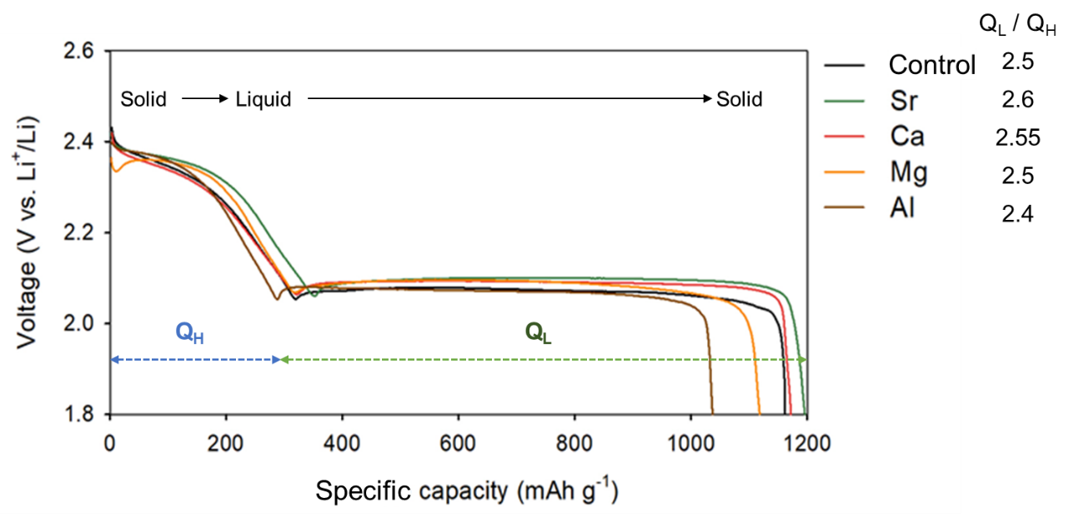
Supplementary Fig. 3 | Voltage profiles of pouch cells with the multivalent cation additives.
As the Lewis acidity decreases (from Al to Sr), the discharge capacity increases, and the capacity ratio of the second to first voltage plateau region (Q_{L}/Q_{H}) higher. The increase in the Q_{L}/Q_{H} ratio suggests delayed electrode passivation by in the second voltage plateau region. While suppressing polysulfide dissolution is vital for stable operation at low E/S ratios, it can reduce electrode utilization², leading to a shortened second plateau observed in Mg²⁺ and Al³⁺ additive-containing electrolytes. The presence of two voltage plateaus in all electrolytes indicate that 0.05 M Lewis acidic additives do not drastically alter the redox reaction pathway.
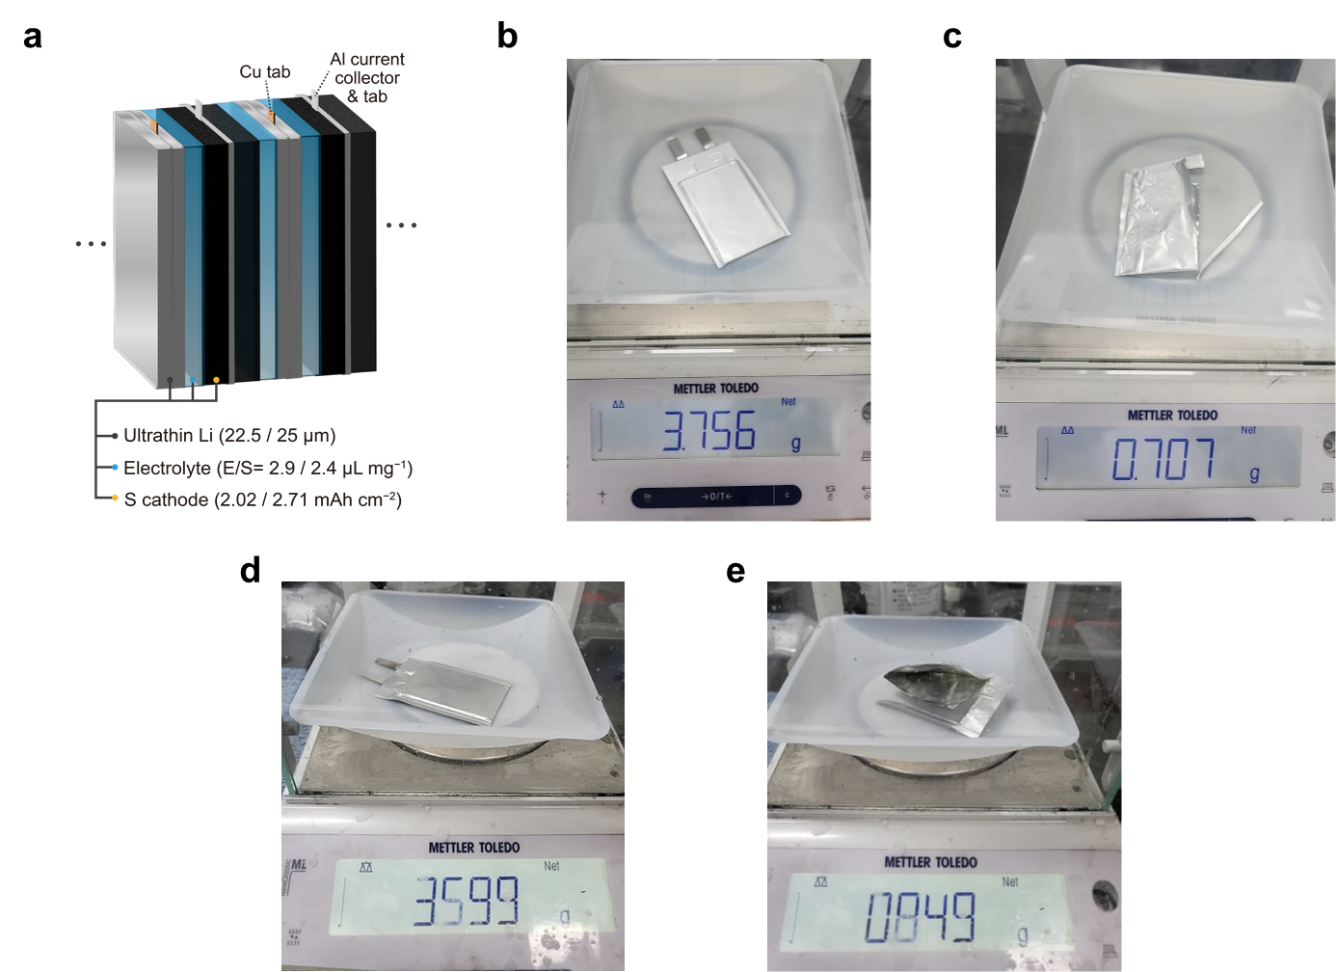
Supplementary Fig. 4 | Pouch-type stack cells. a, Schematic of the pouch-type stack cell. The weight of b, the high energy cell and of c, its pouch. The weight of d, the high-power cell and of e, its pouch. The gravimetric energy density was calculated based on the total cell mass excluding the package mass.

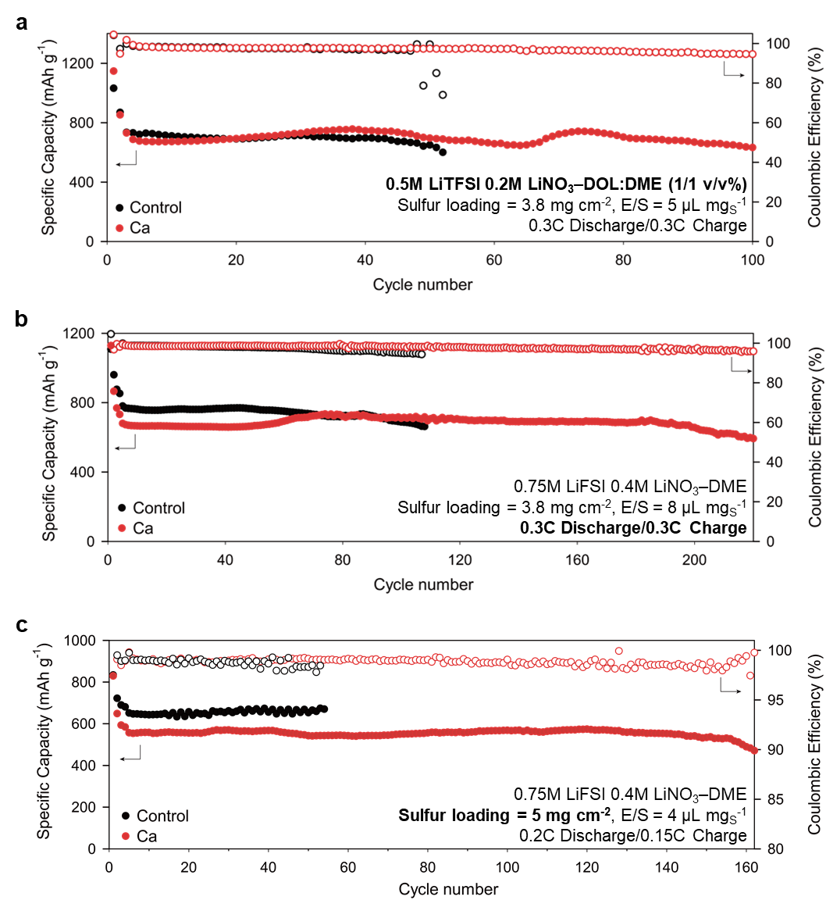
Supplementary Fig. 5 | Consistent positive effect of 0.05 M Ca(OTf)₂ additive on cycling stability across the three cell designs. Sulfur loadings, electrolyte compositions, E/S ratios and charge/discharge C-rates are indicated in the figures.

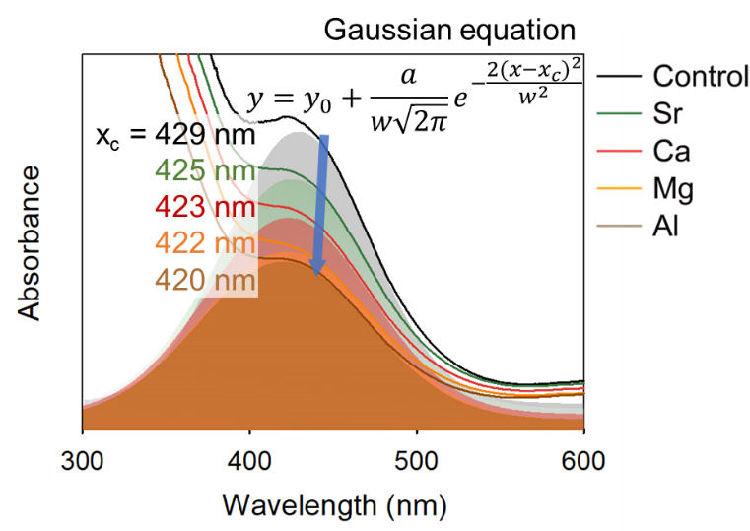
Supplementary Fig. 6 | UV-vis spectra of the electrolytes taken from the coin cells (E/S = 4 μL mg⁻¹) after being discharged to 2.1 V.
The PS concentration in the electrolyte reaches its maximum during discharge at the voltage dip (approximately 2.1 V) after the first voltage plateau³. Thus, we collected the electrolytes from the cells after discharging to 2.1 V and conducted UV-vis spectroscopic analysis. Gaussian fitted S₄²⁻ peaks show a blue shift with increasing the Lewis acidity of cation, indicating an increase in the cation-S₄²⁻ interaction.
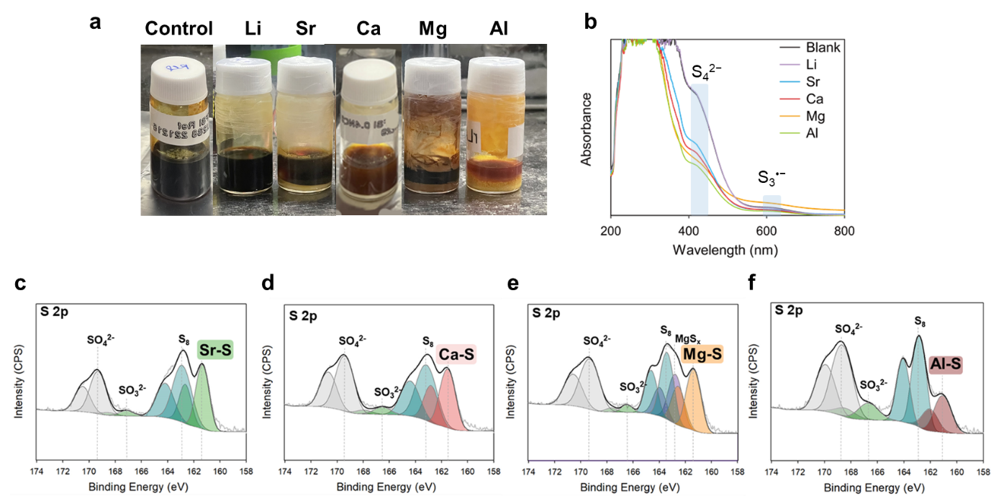
Supplementary Fig. 7 | Analysis of the precipitates formed in the polysulfide solutions with the cation additives. a, Image of 0.2 M Li₂S₈ in DME (control) and 0.1 M Al(OTf)₃, Mg(OTf)₂, Ca(OTf)₂, Sr(TFSI)₂, and 0.2 M LiOTf-containing control solution. b, UV-vis spectra of the supernatants. c–f, S 2p XPS characterization of the precipitates.
To evaluate the effect of OTf anion on polysulfide solubility, we added 0.2 M LiOTf to a 0.2 M Li₂S₈ DME solution. No precipitate formed upon the addition of LiOTf to the control solution. The absorbance from S₄²⁻ decreased with increasing Lewis acidity of the additives. However, adding LiOTf did not alter the UV-vis spectra, again indicating that OTf ⁻ anions do not affect PS concentration in the electrolyte.
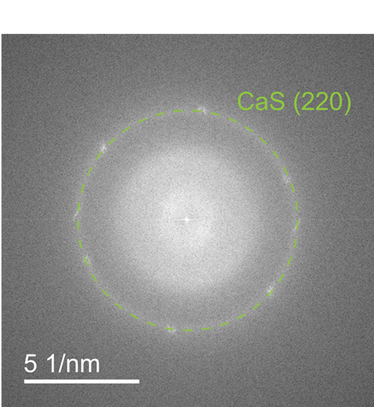
Supplementary Fig. 8 | Selected area diffraction (SAED) pattern for the sulfur cathode discharged to 2.1 V

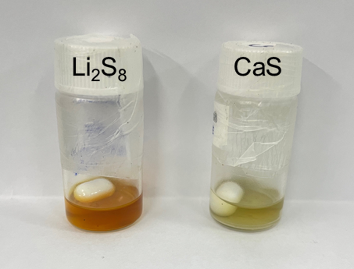
Supplementary Fig. 9 | Optical images of the 2 mM Li₂S₈ solution in DME before (left) and after (right) the addition of 0.05 M of CaS.

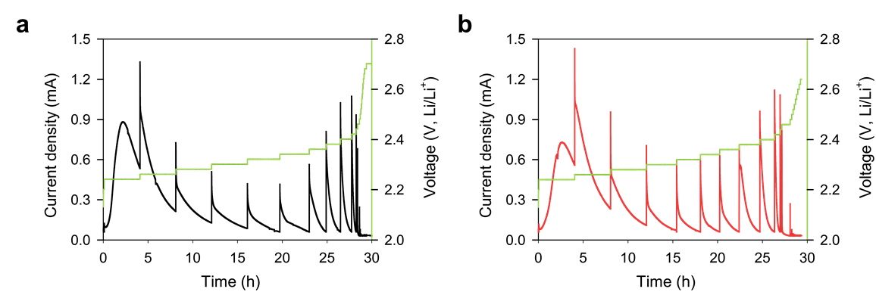
Supplementary Fig. 10 | PITT measurements of Li-S coin cells during charge. Current profiles with the a, control and b, Ca electrolytes.
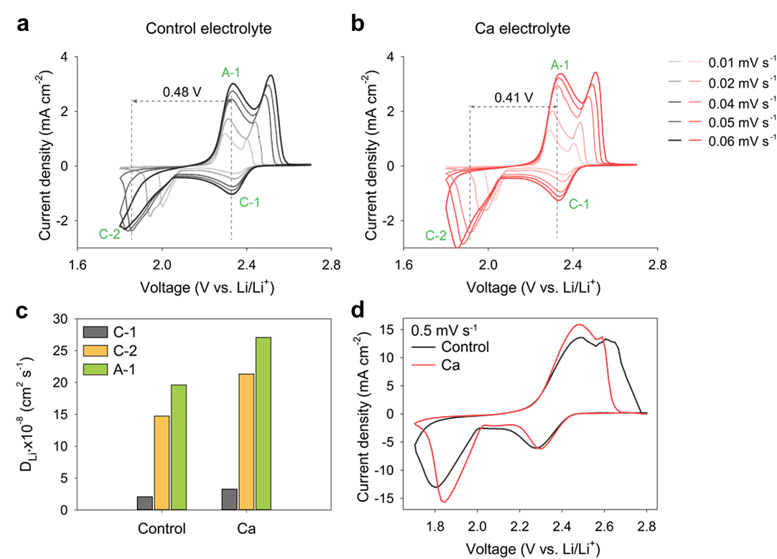
Supplementary Fig. 11 | Cyclic voltammetry (CV) test of Li-S coin cells. a,b, CV curves for the control (a) and Ca electrolytes (b) under lean electrolyte condition (E/S ratio of 4 μL mg⁻¹). c, Li⁺ diffusion coefficient (D_{Li+}) obtained from Randles-Sevick equation. d, CV curves under E/S ratio of 7 μL mg⁻¹.
The D_{Li+} in the Ca electrolyte surpassed that in the control electrolyte by 45%. Both control and Ca electrolytes exhibited CV curves showing a gradual increase in peak separation between C-1 (cathodic peak from the reduction of PSs to Li₂S) and A-1 (anodic peak from the oxidation of Li₂S to PSs) due to the sluggish redox kinetics. However, the Ca electrolyte displayed a significantly smaller peak separation.
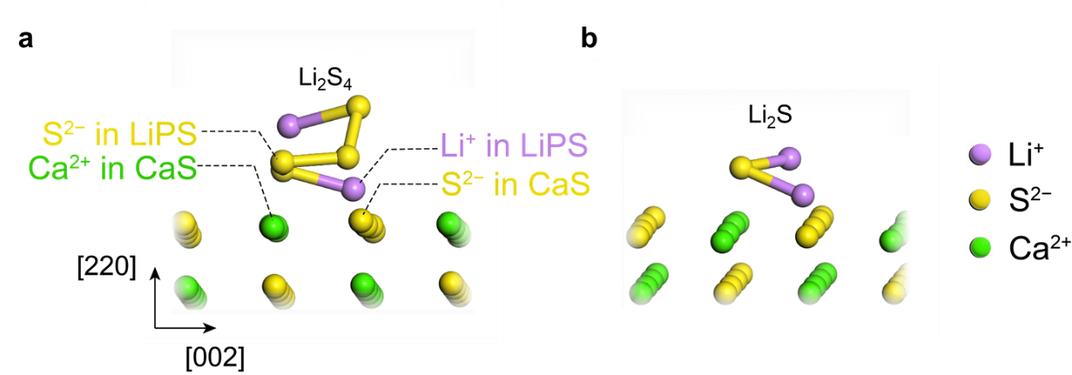
Supplementary Fig. 12 | Optimized configurations of a, Li₂S₄ and b, Li₂S on Cas (2 2 0).
For both Li₂S₄ and Li₂S, the Li and S are positioned in close proximity to the S and Ca of CaS, respectively.
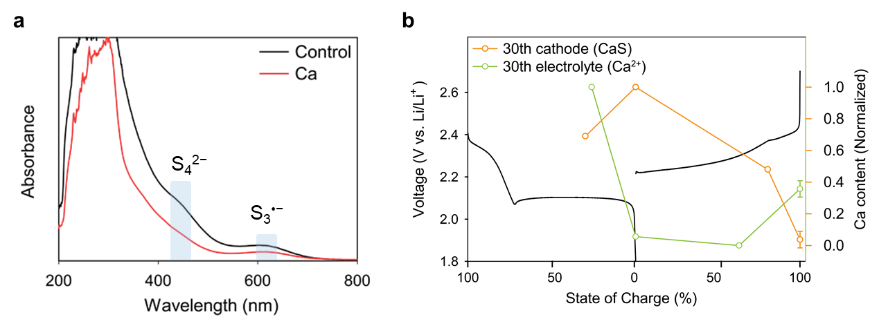
Supplementary Fig. 13 | a, UV-vis spectroscopy of the control and Ca electrolytes taken from the coin cells discharged to 2.1 V after 30 cycle operation. b, ICP-MS analysis of the cathode and electrolyte extracted after 30 cycles.
Even after 30 cycles, the Ca electrolyte maintained a lower polysulfide concentration compared to the control, indicating sustained polysulfide-capturing efficacy. Additionally, by the 30th cycle, Ca²⁺ content in the electrolyte decreased during discharge, and Ca content in the cathode decreased during charging, suggesting the regeneration of Ca²⁺ and CaS after extended cycles.
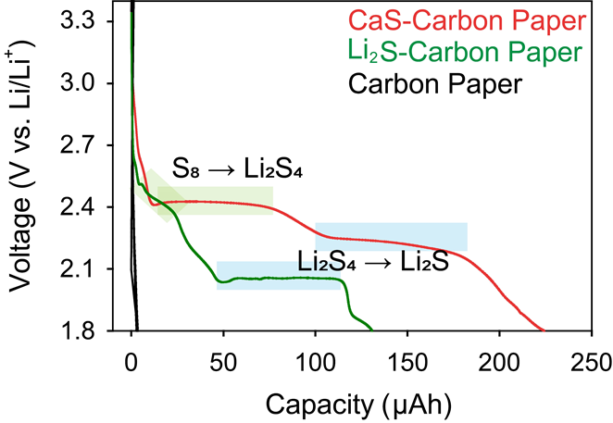
Supplementary Fig. 14 | Galvanostatic discharge profiles of the Li-Carbon paper cells incorporating CaS or Li₂S in the carbon paper electrode.
The cells were initially charged up to 4.0 V to oxidize CaS or Li₂S to S₈. For both the CaS and Li₂S electrodes, the formation of S₈ after charging was confirmed by the appearance of two voltage plateaus in subsequent discharge. The larger capacity of the CaS electrode suggests that CaS can be more readily oxidized than Li₂S.

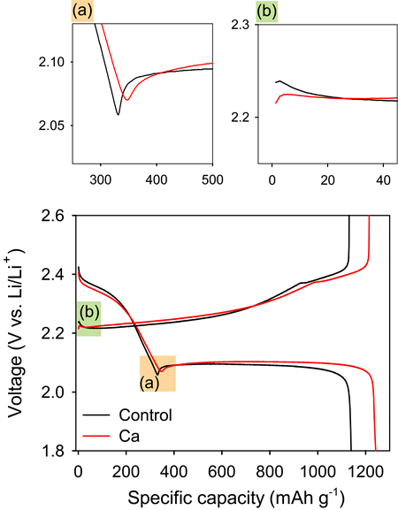
Supplementary Fig. 15 | Voltage profiles of the Li-S coin cells with the control and Ca electrolytes (E/S ratio = 4 μL mg⁻¹) at 0.05 C. a, Decreased Li₂S nucleation overpotential and b, decreased delithiation overpotential for the Ca electrolyte.
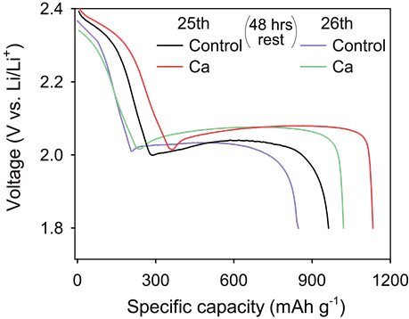
Supplementary Fig. 16 | Discharge voltage profiles of the coin cells with the control and Ca electrolytes (E/S = 5 μL mg⁻¹) before and after a charging and a subsequent rest for 48 h.
After 25 cycles of operation, cells with the control and Ca electrolytes were rested for 48 hours before discharg. The control and Ca electrolyte cells exhibited 80% and 90% capacity retention, indicating reduced self-discharge for the Ca electrolyte.
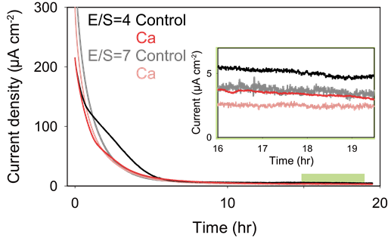
Supplementary Fig. 17 | Shuttle currents measurement at 2.35 V using chronoamperometry for the control and Ca electrolyte at two E/S ratios (4 and 7).
PS shuttle was more pronounced at lower E/S ratios due to higher PS concentration in the electrolytes. The addition of Ca mitigated the PS shuttle by reducing polysulfide concentrations in the electrolytes.
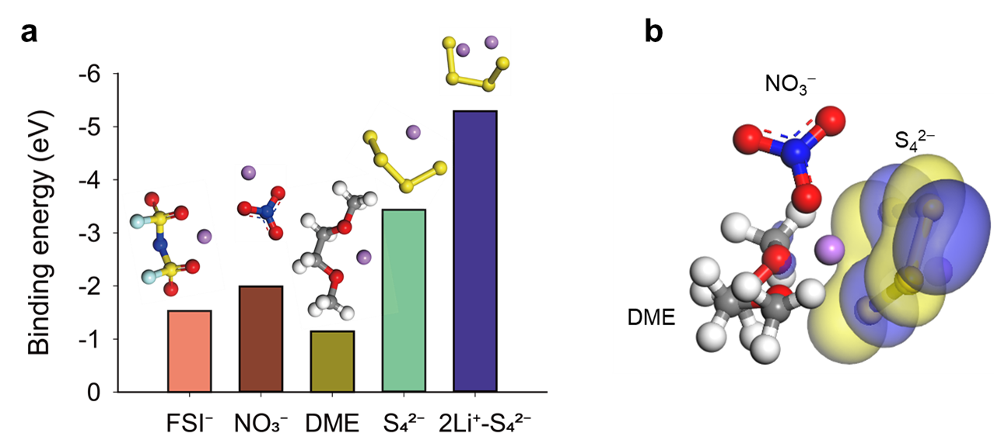
Supplementary Fig. 18 | Inclusion of PS in the Li⁺ solvate in the control electrolyte. a, The Li⁺ binding energy of FSI–, NO₃–, S₄^{2–}, and LiS₄– estimated using the DFT calculation. b, Solvation structure of Li⁺ in control electrolyte.
The Li⁺ binding energy for PS (S₄²⁻) is highest among the electrolyte components. For the Li⁺ solvate including S₄²⁻, the LUMO is distributed around S₄²⁻.
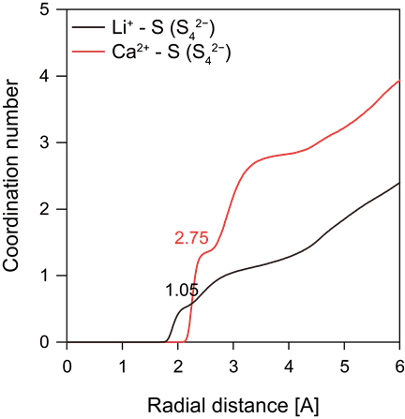
Supplementary Fig. 19 | Coordination numbers of Li⁺−S and Ca²⁺−S in the Ca electrolyte.
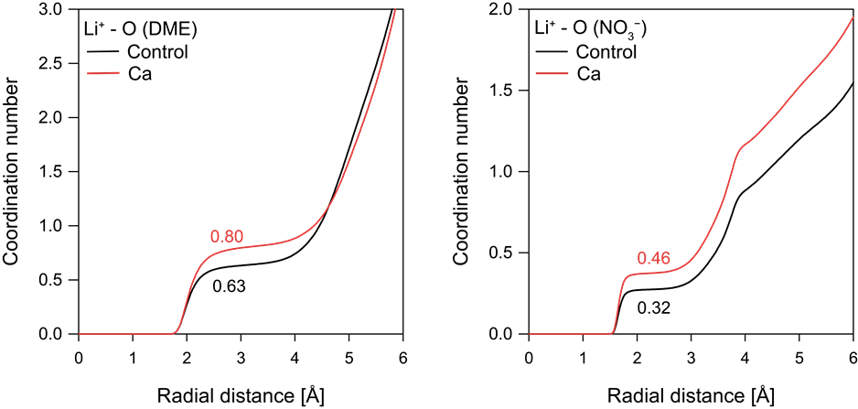
Supplementary Fig. 20 | Li⁺ solvate structure in the PS-containing electrolytes. a, b, Cumulative distribution functions of Li⁺ solvation with DME and NO₃⁻ in the control and Ca electrolyte. These show the changes of Li⁺ solvation shell with lowering low PS solubility from a PS-rich solvate structure to an anion-rich solvate structure.
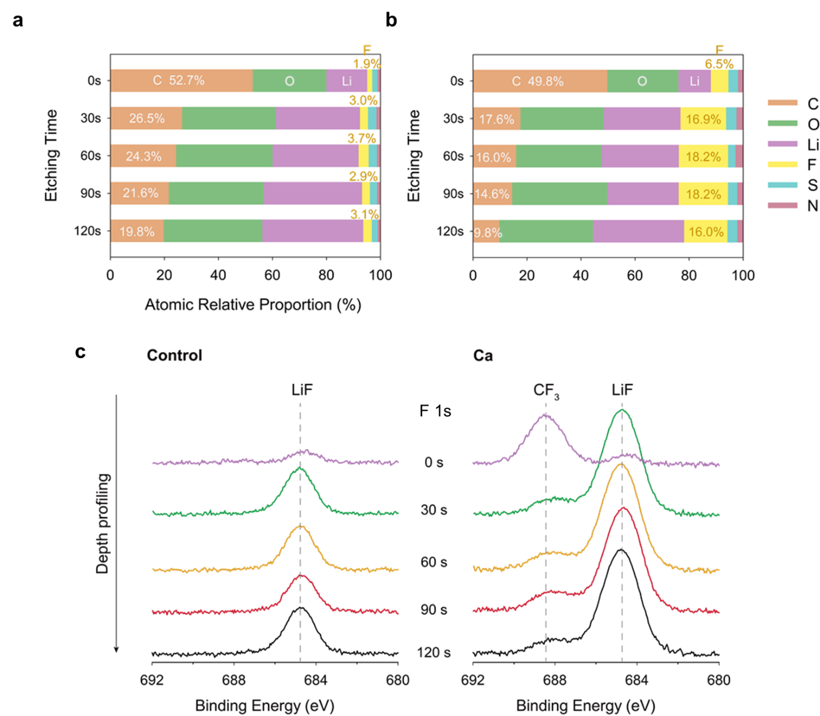
Supplementary Fig. 21 | Chemical structure of the SEI formed on Li metal anode. a, b, Atomic ratio of the SEI determined from XPS analysis at different etching time (0, 30, 60, 90, and 120 s of cycled Li metal electrodes in the a, control electrolyte and b, Ca electrolyte. c, F 1s spectra. Li metal electrode cycled with Ca electrolyte exhibits small CF₃ peak due to the reduction of triflate (OTf ⁻) anions.
The F atomic content of the SEI formed with the Ca electrolyte was over five times higher compared to that of the control electrolyte at 30 s of sputtering, and similar differences were observed at other etching times. Simultaneously, the atomic carbon proportion produced by the decomposition of solvent decreased for the Ca electrolyte. These organic components often cause SEI swelling and high interfacial resistance, reducing the LMA reversibility.
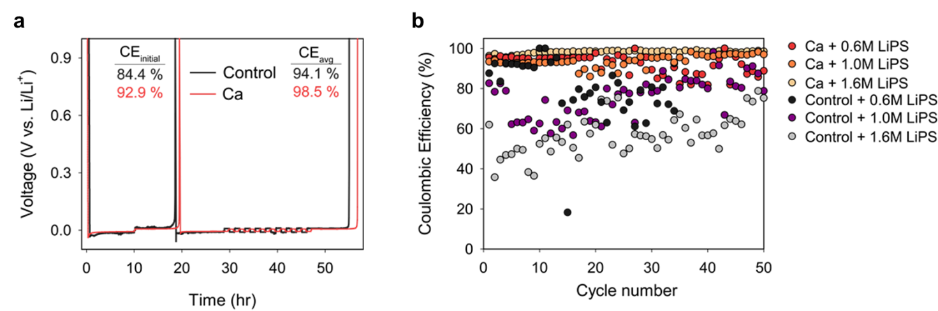
Supplementary Fig. 22 | Coulombic efficiency measurement for the Li-Ni half cells a, the results of the Coulombic efficiency measurement with Aurbach protocol for the Li-Ni half cells with the control and Ca electrolytes including 1.6 M Li₂S₄. The Ca catholyte exhibits higher coulombic efficiency. b, The plot of Coulombic efficiency as a function of cycle number for the Li-Ni half cells with the 0.6, 1.0, or 1.6 M Li₂S₄-containing electrolytes under the galvanostatic cycling at 0.5 mA cm⁻² / 1.0 mAh cm⁻².
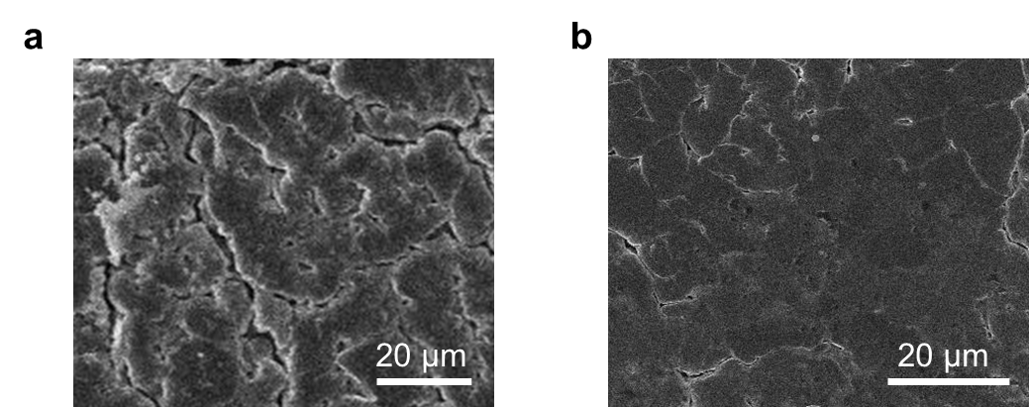
Supplementary Fig. 23 | SEM images of Li electrodes after 10 cycles operations. Li electrodes with a, control electrolyte and b, Ca electrolyte.
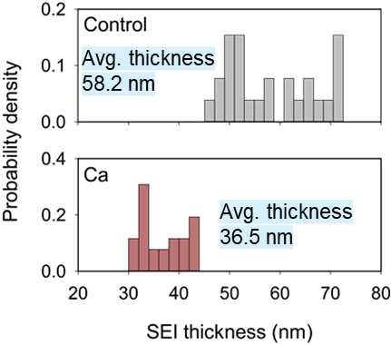
Supplementary Fig. 24 | Distribution of SEI thicknesses based on cryo-TEM. In the presence of PSs, control electrolyte exhibits 40% thicker SEI than Ca electrolyte and wider thickness distribution. The data are represented by measuring the thickness of different locations (n = 26) for each sample.
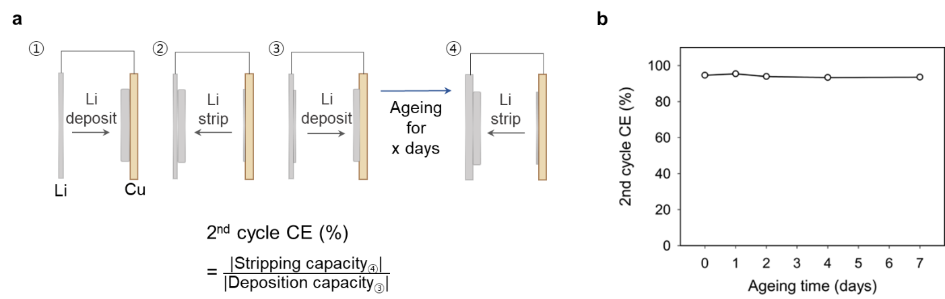
Supplementary Fig. 25 | Second cycle CE of Li-Cu cells with the PS-free control electrolyte. a, Second cycle CE measuring protocol and b, Second cycle CE with the storage time.
The cells were stored at OCV after the charge (2nd charge) and then discharged (2nd discharge). The percent ratio between discharge and charge capacity was measured by varying the storage time. The CE values approached to a limiting value of 90%, which is contrasted by the gradual decrease in CE with storage time in the presence of PS.
Supplementary Table 1 | Pouch-type bi-cell information (E/S = 3.5 μL mg⁻¹)

Cu foil thickness | 8 μm
Al foil thickness | 13 μm
Separator thickness | 19 μm
Lithium metal thickness | 40 μm
Electrolyte/sulfur ratio (E/S, μL mg⁻¹) | 3.5
Active material : carbon : binder | 56.25 : 18.75 : 25.00
Areal capacity | 2.46 mAh cm⁻² (1.5-Ca electrolyte)
Total cell capacity | 73.73 mAh (1.5-Ca electrolyte)

Supplementary Table 2 | Cycling performance of the pouch cells with Ca(OTf)₂ additive in comparison with previously reported pouch cells.

Key approach | E/S ratio (μL mg⁻¹) | Li thickness (μm) | C-rate | Current density (mA cm⁻²) | E_{g}  (Wh kg⁻¹) | Cycles | Reference
This work | 2.9 | 22.5 | 1.0 | 2.0 | 346 | 350
This work | 2.4 | 25 | 0.3 | 0.9756 | 486 | 240
BTT | 2.6 | 100 | 0.1 | N/A | 441 | 17 | [4]
EPSE | 3 | 50 | 0.025 | 0.255438 | 300 | 23 | [5]
MoS₂-LiI | 3.5 | 75 | 0.05 | 0.594625 | 346 | 24 | [6]
HATN polymer | 3g/Ah | 200 | 0.1 | 0.93006 | 303 | 30 | [7]
HFE-DME | 3.5 | 75 | 0.05 | 0.37 | 338 | 30 | [8]
DMDSe+EPSE | 3.5 | 75 | 0.05 | 0.375 | 359 | 37 | [9]
DPDTe | 5 | 50 | 0.05 | 0.41875 | 336.1 | 50 | [10]
3d-omsh/ZnS,Co–N–C/S | 2.5 | 100 | 0.05 | 0.52 | 317 | 80 | [11]
LiPON | 5.67 | N/A | 0.07 | 0.79 | 300 | 120 | [12]
Li_{x}MoS₂ | 2.4 | 100 | 0.16 | 2 | 441 | 200 | [13]
DIPS | 2.7 | 50 | 0.025 | 0.255438 | 394 | 103 (50%) | [14]

References:

- Zerrin, T. et al. An overlooked parameter in Li-S batteries: The impact of electrolyte-to-sulfur ratio on capacity fading. Nano Energy 104, 107913 (2022).
- Pang, Q. et al. Tuning the electrolyte network structure to invoke quasi-solid state sulfur conversion and suppress lithium dendrite formation in Li-S batteries. Nat. Energy 3, 783-791 (2018).
- McBrayer, J. D., Beechem, T. E., Perdue, B. R., Apblett, C. A. & Garzon, F. H. Polysulfide Speciation in the Bulk Electrolyte of a Lithium Sulfur Battery. J. Electrochem. Soc. 165, A876 (2018).
- Guo, W. et al. Artificial dual solid-electrolyte interfaces based on in situ organothiol transformation in lithium sulfur battery. Nat. Commun.12, 3031 (2021).
- Zhang, X.-Q. et al. Electrolyte Structure of Lithium Polysulfides with Anti-Reductive Solvent Shells for Practical Lithium–Sulfur Batteries. Angew. Chem. Int. Ed. 60, 15503-15509 (2021).
- X.-Y. et al. Regulating Lithium Salt to Inhibit Surface Gelation on an Electrocatalyst for High-Energy-Density Lithium–Sulfur Batteries. J. Am. Chem. Soc. 144, 14638-14646 (2022).
- Wang, X. et al. Dense-Stacking Porous Conjugated Polymer as Reactive-Type Host for High-Performance Lithium Sulfur Batteries. Angew. Chem. Int. Ed. 60, 11359-11369 (2021).
- Li, Z. et al. Correlating Polysulfide Solvation Structure with Electrode Kinetics towards Long-Cycling Lithium–Sulfur Batteries. Angew. Chem. Int. Ed. 62, e202309968 (2023).
- Liu, Y. et al. An Organodiselenide Comediator to Facilitate Sulfur Redox Kinetics in Lithium-Sulfur Batteries with Encapsulating Lithium Polysulfide Electrolyte. Angew. Chem. Int. Ed. Engl. 62, e202303363 (2023).
- Zhang, W. et al. Dual-Functional Organotelluride Additive for Highly Efficient Sulfur Redox Kinetics and Lithium Regulation in Lithium-Sulfur Batteries. Energy Environ. Mater. (2022).
- Zhao, C. et al. A high-energy and long-cycling lithium-sulfur pouch cell via a macroporous catalytic cathode with double-end binding sites. Nat. Nanotechnol. 16, 166-173 (2021).
- Wang, W. et al. Lithium phosphorus oxynitride as an efficient protective layer on lithium metal anodes for advanced lithium-sulfur batteries. Energy Storage Mater. 18, 414-422 (2019).
- Li, Z. N. et al. Lithiated metallic molybdenum disulfide nanosheets for high-performance lithium-sulfur batteries. Nat. Energy 8, 84-93 (2023).
- Hou, L.-P. et al. An encapsulating lithium-polysulfide electrolyte for practical lithium–sulfur batteries. Chem 8, 1083-1098 (2022). 32

