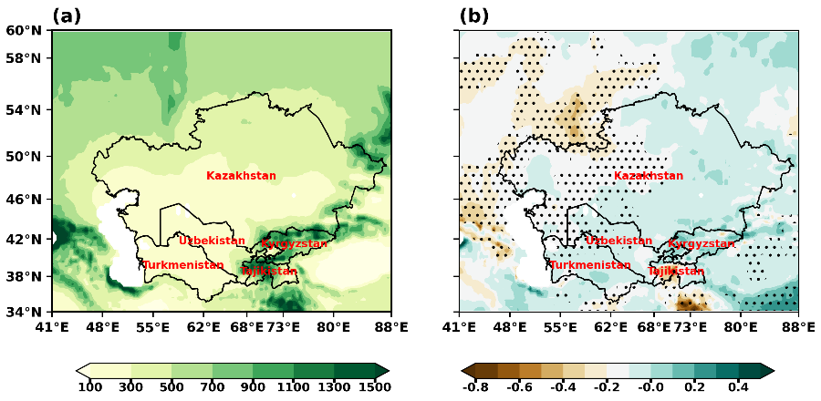
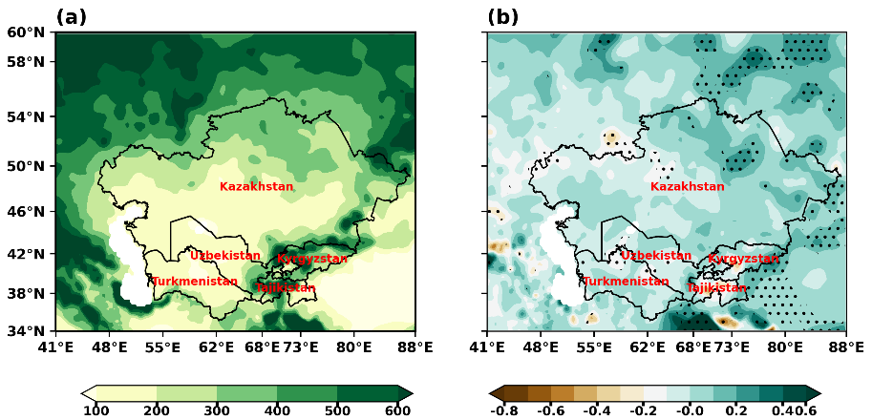
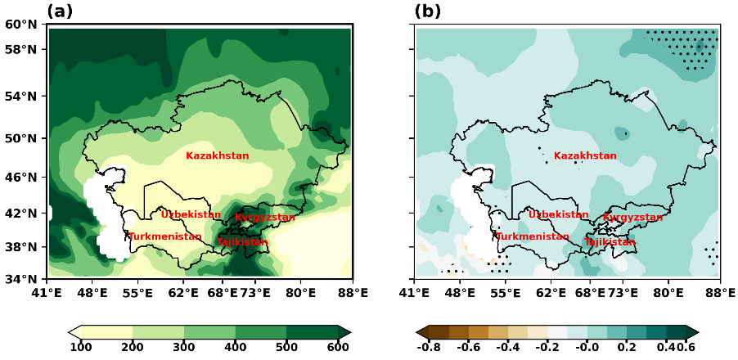
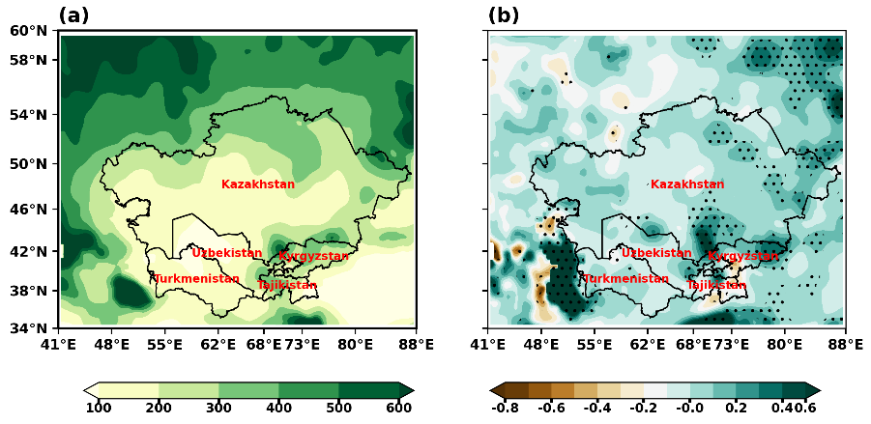

Figure 1:

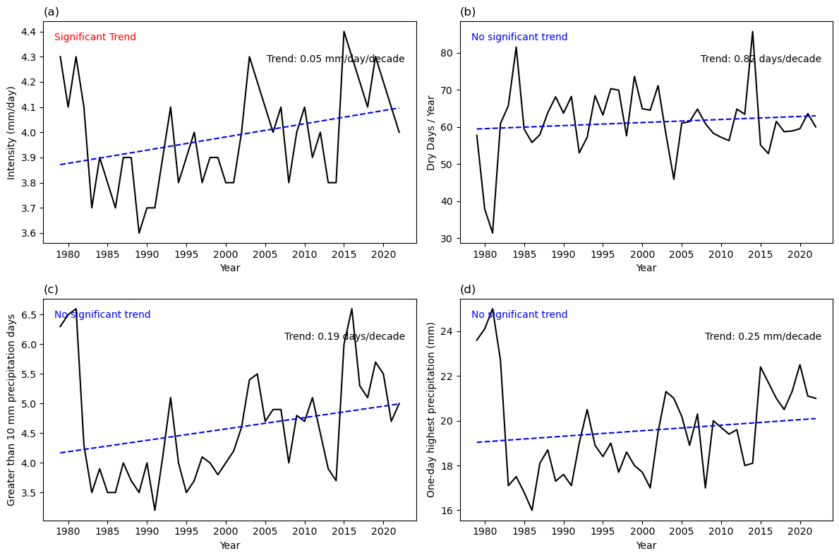
Figure 2: Devansh@9769768644

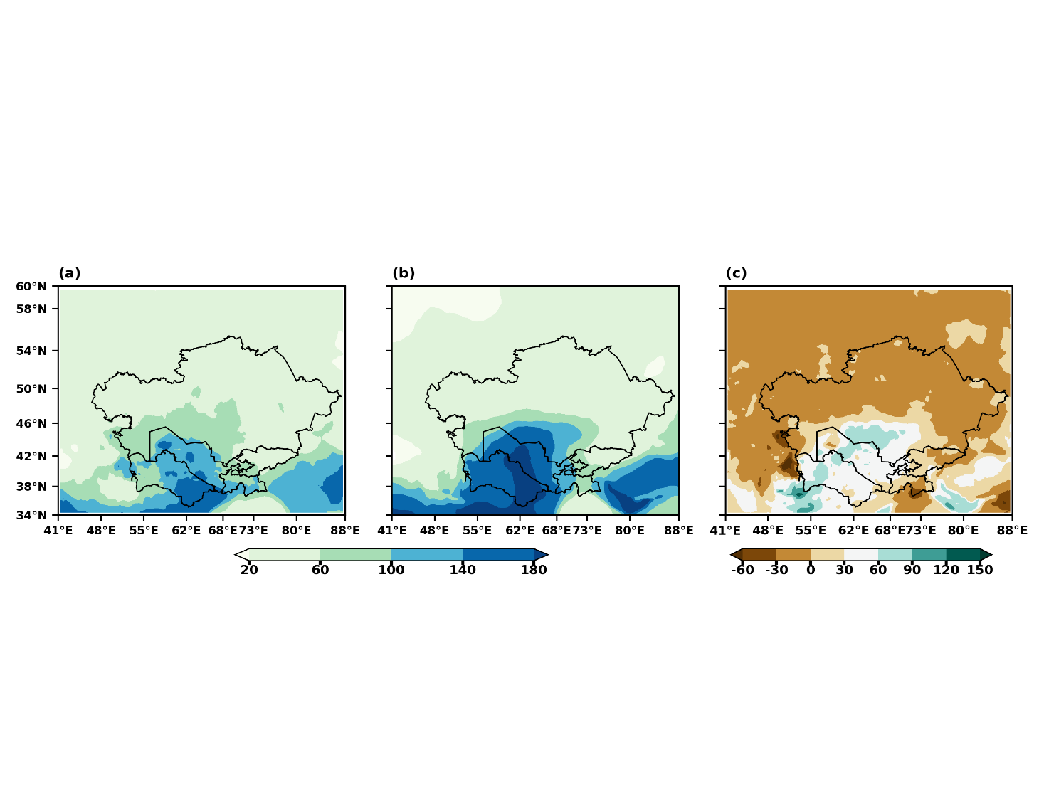
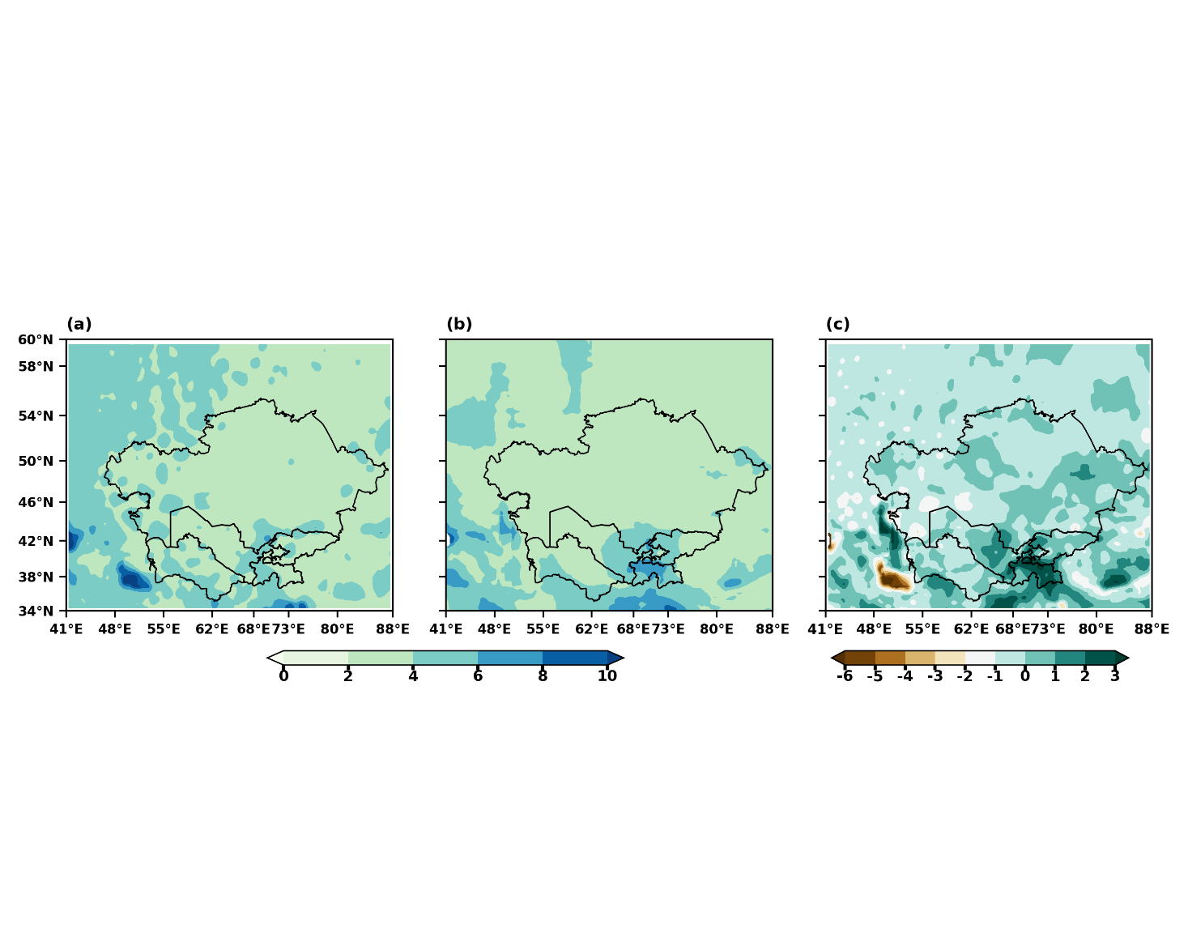
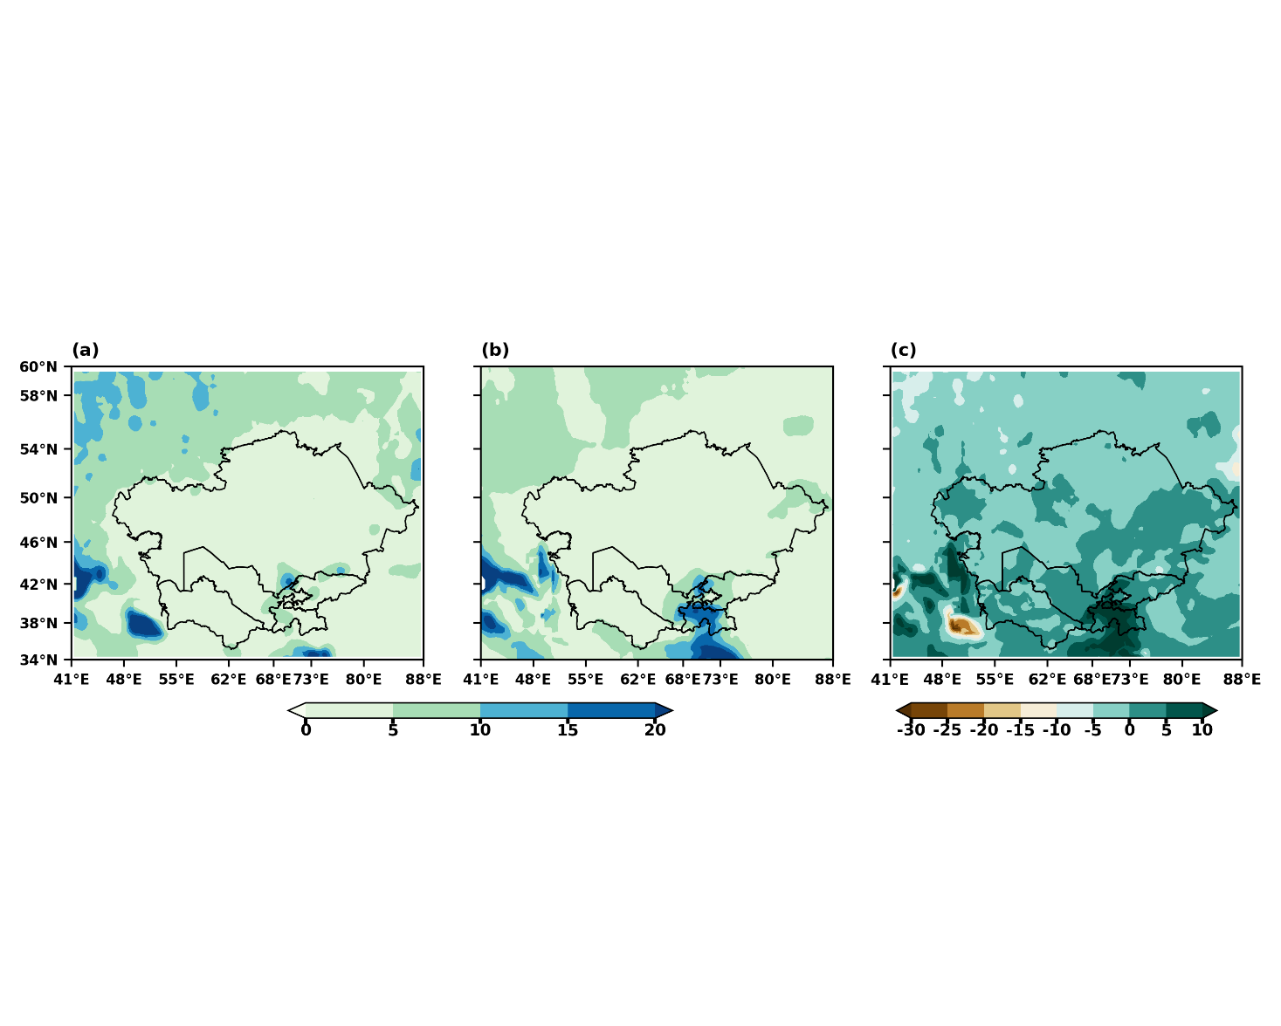
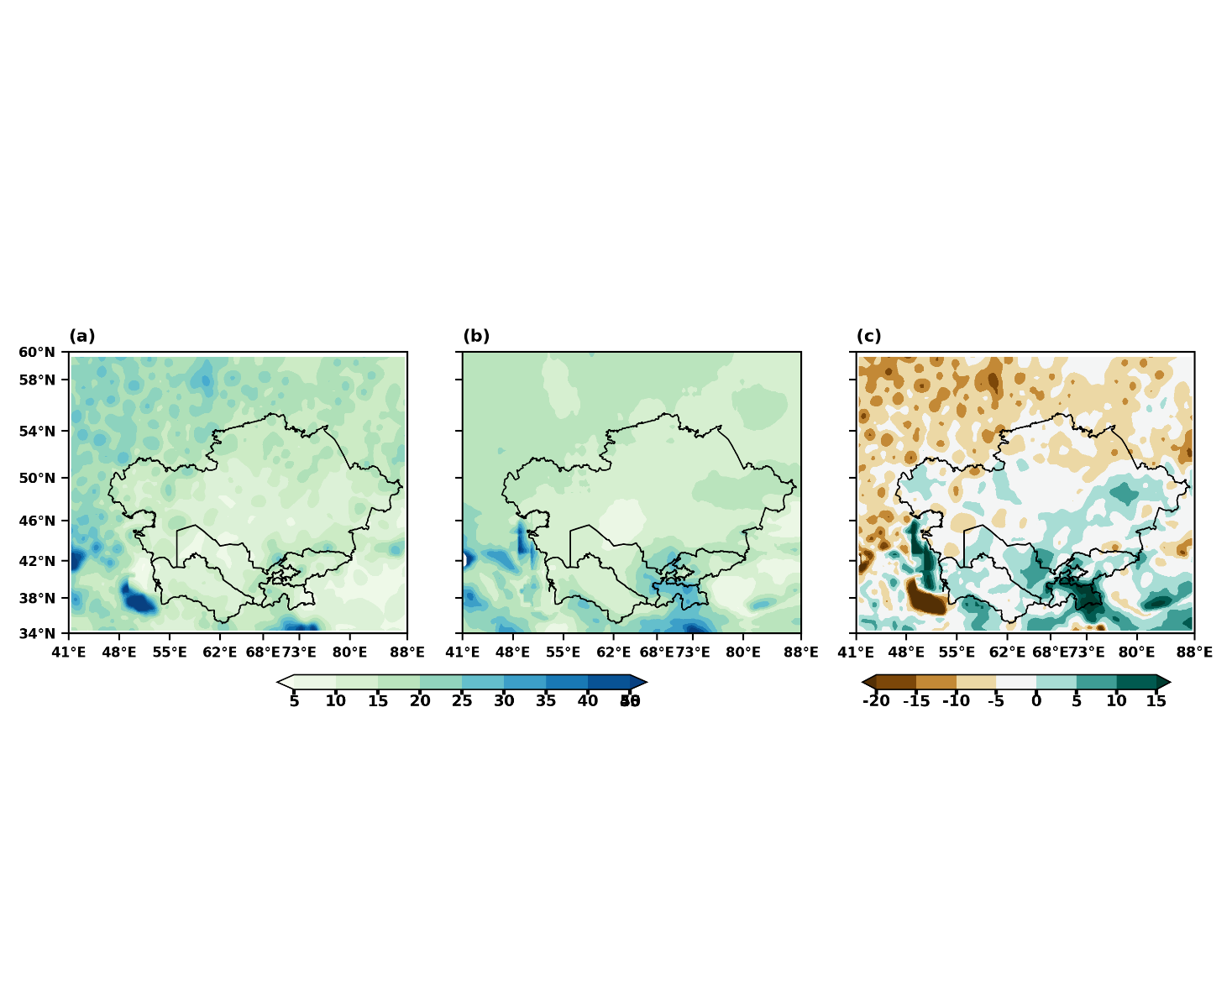
CPC CMIP6 MME Bias
(a) (b) (c)
(d) (e) (f)
(j) (k) (l)
(g) (h) (i)
RX1DAY PD10MM CDD SDII

Figure 3: The spatial distribution of extreme precipitation indices across Central Asia is depicted in three columns: CPC (1st column), CMIP6 MME (2nd column), and BIAS (3rd column) for the period 1985–2014.

