Table S1. Bacterial strains and plasmids used in this study
Strain or plasmid | Description | Source or reference
Strains  V. alginolyticus  ATCC 33787  E. coli  DH5α  BL21  Plasmids  pSCT32  pSCT32-hol  pSCT32-lys  pSCT32-hol-lys | type strain  supE44lacU169(lacZM15)hsdR17 recA lendA1gyrA96 thi-1 relA1  thi thr leu tonA lacY supE recA[RP4-2-Tc::Mu] λpirR6K Km^{r}  a broad host range regulatable expression vector  holin (orf 26) in pSCT32  lysozyme (orf 27) in pSCT32  holin +lysozyme (orf26-orf 27) in pSCT32 | Lab collection  Lab collection  Simon et al. 1983  Zhang et al. 2017  This study  This study  This study

Table S2. Oligonucleotides used in this study
Name | Sequence (5’to 3’) | Description
holin-fwd  holin-rev  lysozyme-fwd  lysozyme-rev | CACACAGGAAACAGACCATATGAAAGATTGGTTCGACAAATTAAC  GCTCCTGAACCCCCGGGGTCAGTTTCACTCAGTGC  CACACAGGAAACAGACCATATGAAACTGACTAAGCGGATC  GCTCCTGAACCCCCGGGATCCATTTCCATGCAGCG | holin gene cloning forward primer  holin gene cloning reverse primer  ilpA gene cloning forward primer  ilpA gene cloning reverse primer

Table S3 Functional classification of the 41 coding sequences in phage VaPW genome
Function part | Gene | Qeury_length | Accession number | Putative Function and best match | Top_%-Simil | E value
Structure | 17 | 288 | YP_010109752.1 | GPO family capsid scaffolding protein  [Vibrio phage ValB1MD-2] | 98.61% | 0.0
 | 18 | 340 | YP_010109751.1 | major capsid protein, P2 family  [Vibrio phage ValB1MD-2] | 100.00% | 0.0
 | 20 | 154 | YP_010109749.1 | head completion/stabilization protein  [Vibrio phage ValB1MD-2] | 99.35% | 2e-111
 | 21 | 162 | YP_010109748.1 | tail protein  [Vibrio phage ValB1MD-2] | 99.38% | 1e-103
 | 22 | 219 | YP_010109747.1 | virion morphogenesis protein  [Vibrio phage ValB1MD-2] | 99.09% | 3e-132
 | 31 | 657 | YP_010109738.1 | tail tape measure protein  [Vibrio phage ValB1MD-2] | 98.48% | 0.0
 | 33 | 401 | YP_010109736.1 | baseplate J/gp47 family protein  [Vibrio phage ValB1MD-2] | 99.25% | 0.0
 | 34 | 198 | YP_010109735.1 | tail protein  [Vibrio phage ValB1MD-2] | 98.99% | 2e-145
 | 35 | 592 | YP_010109734.1 | tail protein  [Vibrio phage ValB1MD-2] | 98.65% | 0.0
DNA packaging | 15 | 343 | YP_010109754.1 | portal protein  [Vibrio phage ValB1MD-2] | 99.42% | 0.0
 | 19 | 238 | YP_010109750.1 | terminase  [Vibrio phage ValB1MD-2] | 100.00% | 8e-179
DNA replication and ragulation | 1 | 340 | YP_010109772.1 | tyrosine-type recombinase/integrase  [Vibrio phage ValB1MD-2] | 84.41% | 0.0
 | 2 | 373 | DAE90189.1 | Cytosine specific methyltransferase  [Siphoviridae sp.] | 53.82% | 2e-125
 | 6 | 228 | DAE94280.1 | HNH endonuclease  [Myoviridae sp.] | 45.10% | 2e-21
 | 7 | 207 | YP_009948758.1 | helix-turn-helix domain-containing protein [Vibrio phage PV94] | 33.00% | 3e-29
 | 13 | 626 | DAL50143.1 | Replication associated protein  [Myoviridae sp.] | 37.25% | 3e-72
 | 16 | 631 | YP_010109753.1 | terminase family protein  [Vibrio phage ValB1MD-2] | 99.21% | 0.0
 | 25 | 68 | YP_010109744.1 | C4-type zinc finger protein  [Vibrio phage ValB1MD-2] | 94.12% | 6e-42
 | 26 | 69 | YP_009812535.1 | holin family HP1  [Vibrio phage1.202.O._10N.222.45.E8] | 58.82% | 2e-44
 | 27 | 196 | YP_010109742.1 | lysozyme  [Vibrio phage ValB1MD-2] | 98.47% | 2e-142
 | 38 | 157 | YP_010109731.1 | DNA-binding protein  [Vibrio phage ValB1MD-2] | 99.36% | 3e-113
Other | 3 | 646 | DAQ04938.1 | Protein of unknown function DUF262  [Myoviridae sp.] | 32.74% | 2e-32
 | 9 | 179 | YP_009812514.1 | regulatory CII family protein  [Vibrio phage 1.202.O._10N.222.45.E8] | 59.22% | 6e-74
 | 23 | 376 | YP_010109746.1 | DUF2586 family protein  [Vibrio phage ValB1MD-2] | 99.20% | 0.0
 | 24 | 137 | YP_010109745.1 | DUF2597 family protein  [Vibrio phage ValB1MD-2] | 100.00% | 2e-99
 | 32 | 113 | YP_010109737.1 | DUF2590 family protein  [Vibrio phage ValB1MD-2] | 100.00% | 3e-79

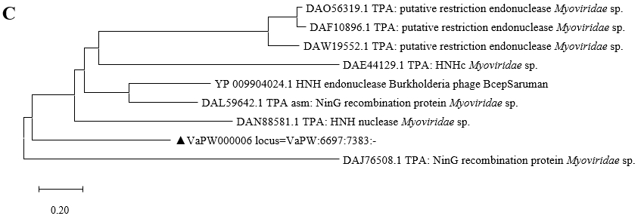
Figure S1 Phylogenetic analysis based on the amino acid sequence of endonuclease (Orf 6 )

Figure S2 Holin domain of Orf26

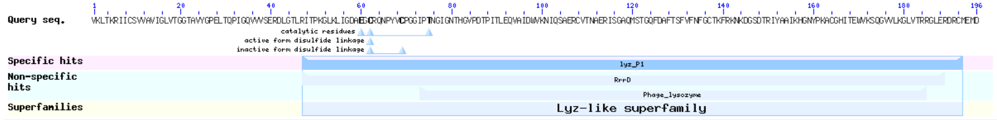
Figure S3 Lysozyme domain of Orf27

