List of Supplemental information for ‘Disruption of β-Catenin Destruction Complex by Ephexin1-Axin1 Interaction Promotes Colorectal Cancer Proliferation’
Supplementary Figure Legends and Figures…………………………………………p2-20
Supplementary Tables…………………………………………………………………p21-23
Supplementary Methods………………………………………………………………p24-25
Full unedited blots for Figures……………………...………………………………...p26-31
SUPPLEMENTARY FIGIRE LEGENDS AND FIGIRES
Supplementary Fig. 1
Supplementary Fig. 1. Correlation analysis between Ephexin1 expression and Wnt target genes using bioinformatics analysis in TCGA cohort. a, b Correlation analysis between Ephexin1 and Wnt/β-catenin target genes (a) or non-Wnt/β-catenin target genes (b) in the TCGA-COAD and COADREAD cohorts, respectively. Statistical processing and visualization were performed using the R program. A narrower contour indicates a higher density of data points. The red line illustrates the correlation, while the shaded area represents the regression analysis. The Pearson correlation coefficient method was employed for the correlation analysis.
Supplementary Fig. 2
Supplementary Fig. 2. Comparison of the expression levels of Lgr5 and Ephexin1 in colorectal tissue using fluorescence Staining. a Representative images of fluorescence staining for Lgr5 and Ephexin1 in normal colon tissue. Scale bar = 50 μm. b, c Fluorescence staining was used to analyze the expression of Lgr5 (green) and Ephexin1 (red) in both normal colon tissue (b) and colon cancer tissue (c). DAPI (blue) stains the nuclei and serves as a counterstain. Arrows indicate Lgr5-positive cells and cells co-expressing Ephexin1. Scale bar = 50 μm.
Supplementary Fig. 3
Supplementary Fig. 3. Wnt3a-CM treatment increases the expression of Ephexin1. a HCT116 cells were treated with Wnt3a-CM for the indicated time periods. Cell lysates were then subjected to Western blot analysis with the indicated antibodies. b HCT116 and HEK293T cells were treated with Wnt3a-CM for the indicated periods of time, after which select transcripts were evaluated using RT-qPCR. The values denote relative expression normalized to β-actin mRNA ± SEM. ns, not significant; *p < 0.05; **p < 0.01; ***p < 0.001 compared with control. p values are for a two-tailed Student’s t-test.

Supplementary Fig. 4
Supplementary Fig. 4. Positive correlation between Wnt/β-catenin targeted drug sensitivity and Ephexin1 expression. The R program was utilized for statistical processing and visualization. A narrower contour indicates a higher data distribution. The red straight line illustrates the correlation, while the gray area represents the regression analysis. The Pearson correlation coefficient method was utilized for the correlation analysis.

Supplementary Fig. 5
Supplementary Fig. 5. Functional enrichment analysis and transcript analysis of indicated genes in Ephexin1-depleted HCT116 cells. a The functional enrichment analysis illustrated the biological pathways and processes associated with correlated genes. This analysis was conducted using ClueGO software (https://apps.cytoscape.org/apps/cluego), and visualization was facilitated by Cytoscape 3.10.1. b RT-qPCR analysis was carried out on the indicated genes in Ephexin1-depleted HCT116 cells. Values represent the relative expression normalized to β-actin mRNA ± SEM. *P < 0.05; **P < 0.01; ***P < 0.001 compared with control. P values are for a two-tailed Student’s t-test.

Supplementary Fig. 6
Supplementary Fig. 6. Ephexin1 regulates the transcriptional role of b-catenin. a HEK293T cells were transfected with three differently labeled Ephexin1 constructs. Cell lysates were analyzed by Western blot using the indicated antibodies. b The levels of β-catenin, Lgr5, and Ephexin1 proteins in HEK293T cells transfected with either a control vector or increasing amounts of Flag-tagged Ephexin1 were assessed. Cell lysates were subjected to Western blot analysis with the indicated antibodies. c TOP-Flash luciferase activity was measured in HEK293T cells after the transfection of Flag-tagged β-catenin and/or treatment with Wnt3a-CM. d TOP-Flash luciferase activity was analyzed after treatment with Wnt3a-CM in control or Ephexin1-depleted HEK293T cells. e The luciferase activity assay was conducted after transfection with Flag-tagged Ephexin1 and/or treatment with Wnt3a-CM in HEK293T cells. *P < 0.05; **P < 0.01; ***P < 0.001 compared with control. P values are for a two-tailed Student’s t-test.

Supplementary Fig. 7
Supplementary Fig. 7. Ephexin1 interacts with the β-catenin destruction complex. a Schematic representation of the bait plasmid (pGBKL-Ephexin1-GAL4-DNA binding domain) and the prey plasmid (GAL4 transcription activation domain-fused HeLa cDNA library). b Transformed yeast cells were selected on the minimal media lacking leucine and tryptophan (SD-LW) to select for the bait and prey plasmids, respectively. Specific interactions between the two proteins were monitored by (i) the appearance of a visible blue color in the filter assay; (ii) the growth of colonies on the selective medium lacking leucine, tryptophan, and uracil (SD-LWU); and (iii) the growth of colonies on the selective medium lacking leucine, tryptophan, and adenine (SD-LWA). c A list of proteins identified in the screening that interacted with Ephexin1. d HEK-293T cells were transfected with Flag-β-catenin, Flag-Axin1, Flag-TCF4, EGFP-CK1, HA-GSK3β, HA-Dvl1, and Myc-APC. Co-immunoprecipitation was performed using the indicated antibodies. The levels of indicated proteins in the extracts and Co-IP products were analyzed by western blot analysis. e Extracts from HCT116 cells were subjected to immunoprecipitation using the indicated antibodies. The immunocomplexes and inputs were analyzed by western blot using the indicated antibodies.

Supplementary Fig. 8
Supplementary Fig. 8. Ephexin1 binds directly to the RGS domain of Axin1. An in vitro GST-pulldown assay was conducted to analyze the binding of recombinant Hisx6-tagged Axin1 (1-221aa or 780-862aa) with GST or GST-Ephexin1 full-length. Glutathione beads were used for the GST pulldown assay and were subjected to western blot analysis with His and GST antibodies.

Supplementary Fig. 9
Supplementary Fig. 9. Interaction with the DH domain of Ephexin1 is required for its interaction with Axin1. a Schematic representation of a series of deletion mutants of Ephexin1 is provided. A summary of the binding intensity between each of the Ephexin1 deletion mutants and Axin1 is displayed on the right. b Protein extracts from HEK293T cells, co-transfected with V5-tagged Ephexin1 mutants and Flag-tagged Axin1, were immunoprecipitated with an anti-Flag antibody and subjected to western blot analysis using the indicated antibodies.

Supplementary Fig. 10
Supplementary Fig. 10. Prediction of the RR-DH domain of Ephexin1 and complex using AlphaFold Multimer. a Sequence coverage values are presented for the RR-DH domain of Ephexin1 and the RGS domain of Axin1 protein predictions. b Prediction IDDT (Isolated Distance Difference Test) scores for models are ranked in the Ephexin1 (RR-DH domain) and Axin1 (RGS domain) protein complex prediction. c Predictive Alignment Error (PAE) for each ranked model by AlphaFold Multimer. The best model is Ranked 1, and the closer it is to blue, the higher the predicted domain formation and interaction between the two proteins.

Supplementary Fig. 11
Supplementary Fig. 11. Overexpression of Ephexin1 reduces the interaction between β-catenin and destruction complex proteins. Co-immunoprecipitation analysis was conducted on HEK293T cells transfected with Flag-tagged Ephexin1. Cell lysates were immunoprecipitated with an anti-β-catenin antibody and subjected to western blot analysis with the indicated antibodies.

Supplementary Fig. 12
Supplementary Fig. 12. Prediction of Ephexin1 (RR-DH domain), Axin1 (RGS domain), and APC (Axin1 binding site1,2,3) protein complex using AlphaFold-Multimer. a Sequence coverage values for predictions related to RGS domain of Axin1 (1-211aa) and the three Axin1 binding sites on APC: site 1 (1567-1595aa), site 2 (1716-1734aa), and site 3 (2032-2050aa). b Prediction IDDT (Isolated Distance Difference Test) scores for models ranked in the Ephexin1 (RR-DH domain) and Axin1 (RGS domain) protein complex prediction. c Predicted alignment errors (PAE) for models of Axin1 and APC by AlphaFold Multimer. d Sequence coverage values for predictions related to RR-DH domain of Ephexin1, RGS domain of Axin1, and three A xin1 binding sites of APC (sites 1, 2, 3). e Prediction IDDT scores for models ranked in the Ephexin1 / Axin1 / APC protein complex prediction. f Predicted alignment errors (PAE) for models of Ephexin1 (RR-DH domain), Axin1 (RGS domain), and APC (Axin1 binding site1,2,3) by AlphaFold-Multimer.

Supplementary Fig. 13
Supplementary Fig. 13. Effects of Wnt/β-catenin signaling inhibition by IWR1-endo treatment in CRC cell lines. a The indicated CRC cell lines (SW480, HT-29, DLD-1, LoVo, LS174T, and HCT116) were either treated with IWR1-endo (80 μM) or left untreated for 12 hours, followed by staining with Annexin V (green) for immunohistochemical analysis. Data are presented as mean ± SEM. ns, not significant; ***p < 0.001, two-tailed Student’s t-test. b, c Control and Ephexin1-deficient HCT116 cells were either treated with IWR1-endo (80 μM) or left untreated for 12 hours, and then labeled with β-catenin (b) and cyclin D1 (c) for immunohistochemical analysis. Data are presented as mean ± SEM. ns, not significant; **p < 0.01; ***p < 0.001, two-tailed Student’s t-test.

Supplementary Fig. 14
Supplementary Fig. 14. Testing Ephexin1 Transgenic (TG) Mice. a PCR analysis was performed on wild-type (WT) and Ephexin1 TG mice using the primer pairs shown in the adjacent panels. Arrows indicate the locations of PCR primers. The sequences of the primer set for detecting the Ephexin1 expression vector (CMV promoter (forward) and mEphexin1 CDS-1 (reverse); mEphexin1 CDS-2 (forward) and mEphexin1 CDS-2 (reverse)) are provided in the ‘Methods’ section. b Western blot and RT-PCR analyses of wild-type (WT) and Ephexin1 TG mice were conducted.

Supplementary Fig. 15
Supplementary Fig. 15. Model of Ephexin1-mediated Wnt / β-catenin signaling regulation. Schematic representation of the model illustrating the primary mechanism of the tumorigenic effect of Ephexin1-mediated Wnt / β-catenin signaling in CRC.

SUPPLEMENTARY TABLES
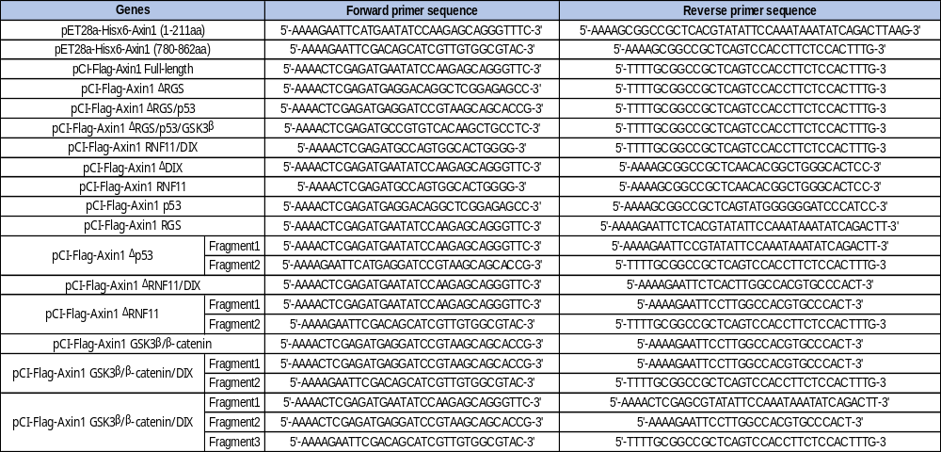
Supplementary Table S1. List of primer sequences for cloning.
Supplementary Table S2. List of primer sequences for RT-qPCR.
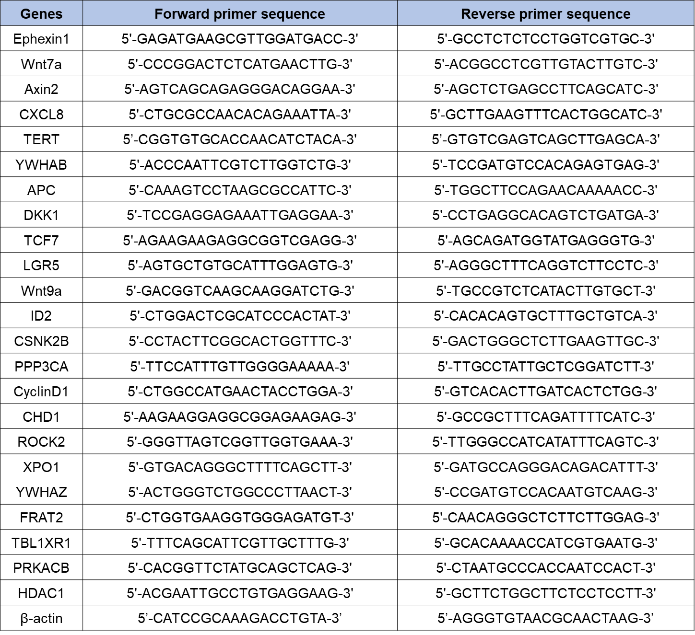

Supplementary Table S3. Antibody information in this study
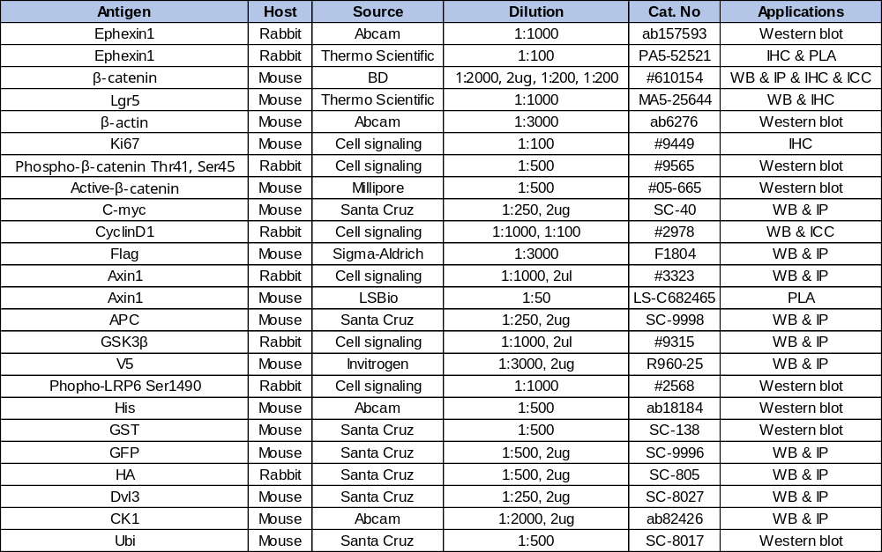

SUPPLEMENTARY METHODS
Yeast two hybrid analysis
For the yeast two-hybrid screening, the Ephexin1 bait (full length, NM_019850) was cloned into the EcoRI/BamHI sites of the pGBKT7 vector. The human HeLa cDNA AD library was cloned as SalI/NotI fragments in the pGADT7 vector. Yeast two-hybrid screening of Ephexin1 was performed in the yeast PBN204 strain, containing three reporters (URA3, lacZ, and ADE2) under the control of different GAL promoters. Yeast transformants of the Ephexin1 bait and human HeLa cDNA AD library were spread on selection medium [SD-leucine, tryptophan, uracil (SD-LWU)] that supports the growth of yeasts with bait and prey plasmids yielding proteins that interact with each other. After selecting yeast colonies on uracil-deficient media, we monitored the activity of beta-galactosidase. We also investigated whether the URA+ and lacZ+ colonies could grow on adenosine-deficient media. To confirm the interaction, the prey parts of DNAs from 60 candidates, which satisfied three reporter genes' expression, were amplified by PCR or E. coli transformation, and then the amplified candidate preys were reintroduced into the yeast PBN204 strain with the Ephexin1 bait plasmid or with a negative control plasmid.

Generation of Ephexin1 transgenic mice
Transgenic (TG) mice overexpressing mEphexin1 were generated through pronuclear microinjection. The forward primer (5'-ATGGAGACCAAAAACTCTGAAGACT-3') and reverse primer (5'-TCATTGACGATTCCGGC-3') of the mouse Ephexin1 gene were used to amplify mEphexin1 cDNA by RT-PCR. The PCR product was cloned into the pGEM-T Vector (Promega) and subsequently digested using XhoI/NotI restriction enzymes. This was followed by cloning into the pCI-neo expression vector (Promega). The recombinant mouse Ephexin1 gene, once isolated and purified, was microinjected into fertilized eggs of C57BL/6 mice according to a standard protocol (Macrogen, Seoul, South Korea). The integration of the transgene was confirmed through genotyping, PCR, and western blotting.

Genotyping of Ephexin1 transgenic mice
Genomic DNA was extracted from the liver tissues of C57BL/6 WT and Ephexin1 TG mice using the AccuPrep® Genomic DNA Extraction Kit (Bioneer). The purity of each DNA sample was determined by measuring the absorbance ratio at OD260/OD280 using a NanoDrop2000 instrument (Thermo Fisher Scientific, Inc.). Genomic DNA with a ratio of 1.8–2.0 was used for PCR. The primers used for PCR were as follows: CMV promoter forward: 5'-CACCAAAATCAACGGGACTT-3'; mEphexin1 CDS-1 reverse: 5'-TCACAGCACGATTGAAGAGG-3'; mEphexin1 CDS-2 forward: 5'-AGATGACCGAGAGGCCACC-3'; mEphexin1 CDS-2 reverse: 5'-AGCCGCTCACCAAAGATCCA-3'. mGAPDH forward: 5’-TGGCTCTTAAAAAGTGCAGG-3’, reverse: 5’-TCCACCACCCTGTTGCTGTA-3’. The PCR products were evaluated by electrophoresis on a 1.5% (w/v) agarose gel containing RedSafe Nucleic Acid Staining Solution (iNtRON, Korea).

Full blots related Fig.1, Fig.2 and Fig.3

Full blots related Fig.4

Full blots related Fig.5
Full blots related Fig.5 and Fig.6

Full blots related Fig. S3, Fig. S6 and Fig. S7

Full blots related Fig. S7, Fig. S8, Fig. S9, Fig. S11 and Fig. S14

