Supplemental Information for
Occurrence and risk of organophosphate flame retardants in multiple urban water of Beijing, China
Weihua Cui ª, Shaoyong Lu ^{b,*}
ª School of Water Resources and Environment, China University of Geosciences, Beijing 100083, China;
^{b} State Key Laboratory of Environmental Criteria and Risk Assessment, National Engineering Laboratory for Lake Pollution Control and Ecological Restoration, Chinese Research Academy of Environmental Sciences, Beijing, 100012, China.

Table of contents

Table S1 The geographical coordinates of Wenyu River, groundwater and STPs. 2
Table S2 Detail information of STPs. 3
Table S2 Physical and chemical properties of common organophosphorus flame retardants. 4
Table S3 Occurrence profile and fate of the target OPFRs in STPs and hospital samples of Beijing, ng/L. 7
Fig S1. RQ evaluation for OPFRs in the multiphase urban water bodies of Beijing, China 8

Table S1 The geographical coordinates of Wenyu River, groundwater and STPs.
Location | Samples | Latitude |  | Longitude
Wenyu River | W1 | 40°07′53″ | 116°19′59″
Wenyu River | W2 | 40°09′02″ | 116°24′17″
Wenyu River | W3 | 40°05′43″ | 116°29′06″
Wenyu River | W4 | 40°01′56″ | 116°33′55″
Wenyu River | W5 | 39°59′10″ | 116°38′11″
Wenyu River | W6 | 39°56′49″ | 116°38′12″
Wenyu River | W7 | 39°55′37″ | 116°39′13″
STPs | H | 40°02′37″ | 116°30′57″
STPs | M | 40°36′65″ | 116°83′62″
STPs | C | 39°87′68″ | 116°52′02″
Groundwater | G | 40°19′73″ | 116°59′96″

Table S2 Detail information of STPs.
 | Location | Service population | Type of sewage | Daily average  treating  quantity | Maximum treating  quantity | Hydraulic Retention Time (HRT) | ferric chloride  (PIX) | Sewage treatment process | Remarks
Sewage treatment plants (STPs) | Haidian District | 300000~400000 people | domestic sewage | 30000~40000 m³/d | 80000 m³/d | 10~12 h | 100 mg/L | anaerobic/anoxic/oxic (A²/O) activated  sludge +MBR process
Sewage treatment plants (STPs) | Chaoyang District | 300000~400000 people | domestic sewage | 30000~40000 m³/d | 100000  m³/d | 6~8 h | 100 mg/L | cyclic activated  sludge technology (CAST).
Sewage treatment plants (STPs) | Miyun District | 300000~400000 people | domestic sewage/industrial wastewater (7:3) | 30000~40000 m³/d | 80000  m³/d | 8~12 h | 100 mg/L | anoxic/oxic (A²O) activated sludge +MBR process

Table S2 Physical and chemical properties of common organophosphorus flame retardants.
Abbr. | Name | CAS Number | Molecular formula | S | Vp | H | logK_{ow} | logK_{oc} | t_{1/2} | BCF | Application
TPP | tripropyl phosphate | 513-08-6 | C₉H₂₁O₄P | 827 | 4.33×10⁻³ | 8.2×10⁻⁶ | 2.67 | 2.83 | / | 63.1 | plasticizer
TCP | tricresyl phosphate | 1330-78-5 | C₂₁H₂₁O₄P | 0.36 | 6.0×10⁻⁷ | 9.2×10⁻⁷ | 5.11 | 4.35 | / | 8.56×10³ | Plasticizer, polyvinylchloride, hydraulic fluids, cellulose, cutting oils, transmission fluids
TCEP | tris(2-chloroethyl) phosphate | 115-96-8 | C₆H₁₂Cl₃O₄P | 7000 | 6.13×10⁻² | 3.3×10⁻⁶ | 1.44 | 2.48 | 17.5 | 1.37 | Flame retardant, plasticizer, lacquer, paint, glue, industrial processes
TCPP | tris-(2-chloroisopropyl) phosphate | 13674-84-5 | C₉H₁₈Cl₃O₄P | 1600 | 2.02×10⁻⁵ | 6.0×10⁻⁸ | 2.59 | 2.71 | 8.6 | 42.4 | Flame retardant, plasticizer, flexible and rigid polyurethane foam (PUF), rubber and textile coatings
TDCPP | tris(dichloropropyl) phosphate | 13674-87-8 | C₉H₁₅Cl₆O₄P | 1.5 | 7.36×10⁻⁸ | 2.6×10⁻⁹ | 3.65 | 2.35 | 21.3 | 13.5 | Flame retardant, plasticizer, lacquer, paint, glue
TDBP | tris(2,3-dibromopropyl) phosphate | 126-72-7 | C₉H₁₅Br6O₄P | / | / | / | 4.29 | / | / | / | Plasticizer, flame retardant
Note: S: solubility in water at 25 ℃, mg/L; Vp: saturated vapor pressure at 25 ℃, mmHg; H: henry's law constant at 25 ℃, atm/m³/mol; log K_{ow}: n-octanol/water partition coefficient; log K_{oc}: soil adsorption coefficient; t_{1/2}: photodegradation in the atmosphere, 5*10⁻⁵ OH/mol, h; BCF: bioaccumulation factor. The data are compiled from previous studies (World Health Organization, 1991, 1997; Lassen & Lokke, 1999; Leisewitz et al., 2000; Fisk et al., 2003; Marklund et al., 2003; Björklund et al., 2004; Rodriguez et al., 2006; Van der Veen and De Boer, 2012; Wei et al., 2015; Kim et al., 2017)
References:
Björklund, J., Isetun, S., & Nilsson, U. 2004. Selective determination of organophosphate flame retardants and plasticizers in indoor air by gas chromatography, positive‐ion chemical ionization and collision‐induced dissociation mass spectrometry. Rapid communications in mass spectrometry, 18(24), 3079-3083.
Fisk, P.R., Girling, A.E., Wildey, R.J., 2003. Prioritisation of Flame Retardants for Environmental Risk Assessment. Environment Agency, United Kingdom.
Kim, U. J., Oh, J. K., & Kannan, K. (2017). Occurrence, removal, and environmental emission of organophosphate flame retardants/plasticizers in a wastewater treatment plant in New York State. Environmental science & technology, 51(14), 7872-7880.
Lassen, C., Lokke, S., 1999. Brominated Flame Retardants: Substance Flow Analysis and Assessment of Alternatives. Danish Environmental Protection Agency (EPA).
Leisewitz, A., Kruse, H., Schramm, E., 2000. Substituting Environmentally Relevant Flame Retardants: Assessment Fundamentals. Environmental Research Plan of the German Federal Ministry for the Environment, Nature Conservation and Nuclear Safety (research, report).
Marklund, A., Andersson, B., Haglund, P., 2003. Screening of organophosphorus compounds and their distribution in various indoor environments. Chemosphere 53, 1137-1146.
Rodriguez, I., Calvo, F., Quintana, J. B., Rubi, E., Rodil, R., & Cela, R. 2006. Suitability of solid-phase microextraction for the determination of organophosphate flame retardants and plasticizers in water samples. Journal of Chromatography A, 1108(2), 158-165.
Van der Veen, I., & de Boer, J. (2012). Phosphorus flame retardants: properties, production, environmental occurrence, toxicity and analysis. Chemosphere, 88(10), 1119-1153.
Wei, G. L., Li, D. Q., Zhuo, M. N., Liao, Y. S., Xie, Z. Y., Guo, T. L., ... & Liang, Z. Q. 2015. Organophosphorus flame retardants and plasticizers: sources, occurrence, toxicity and human exposure. Environmental Pollution, 196, 29-46.
World Health Organization, 1991. Environmental Health Criteria 111, Triphenyl Phosphate. World Health Organization, Geneva, Switzerland.
World Health Organization, 1997. Environmental Health Criteria 192: Flame Retardants: a General Introduction. World Health Organization, Geneva, Switzerland.

Table S3 Occurrence profile and fate of the target OPFRs in STPs and hospital samples of Beijing, ng/L.
 | Compounds | TPP | TCPP | TCP | TDCPP | TCEP | TDBP
STPs (Chaoyang District) | Influent | 0.78 | 79.89 | 0.03 | 24.81 | 26.63 | ND
STPs (Chaoyang District) | Effluent | 0.67 | 208.53 | 0.29 | 47.74 | 81.89 | ND
STPs (Chaoyang District) | Total removal (%) | 14.56 | -161.01 | -856.67 | -92.44 | -207.49 | -
STPs (Haidian Dstrict) | Influent | 0.62 | 40.94 | ND | ND | 15.53 | ND
STPs (Haidian Dstrict) | Secondary effluents | 0.52 | 209.26 | ND | 34.92 | 58.92 | ND
STPs (Haidian Dstrict) | Removal (%) | 16.61 | -411.09 | - | - | -279.38 | -
STPs (Haidian Dstrict) | Effluent | 0.77 | 203.99 | 0.01 | 42.20 | 60.50 | ND
STPs (Haidian Dstrict) | Removal (%) | -48.16 | 2.52 | - | -20.85 | -2.68 | -
STPs (Haidian Dstrict) | Total removal (%) | -23.55 | -398.23 | - | - | -289.54 | -
STPs (Miyun Dstrict) | Influent | 0.95 | 216.01 | 0.14 | ND | 39.12 | ND
STPs (Miyun Dstrict) | Secondary effluents | 1.60 | 275.44 | 0.04 | 35.33 | 132.12 | ND
STPs (Miyun Dstrict) | Removal (%) | -68.81 | -27.51 | 74.26 | - | -237.72 | -
STPs (Miyun Dstrict) | Effluent | 0.96 | 293.40 | 0.06 | 71.30 | 169.37 | ND
STPs (Miyun Dstrict) | Removal (%) | 40.32 | -6.52 | -74.29 | -101.83 | -28.20 | -
STPs (Miyun Dstrict) | Total removal (%) | -0.74 | -35.83 | 55.15 | - | -332.94 | -
Note: ND: not detected.
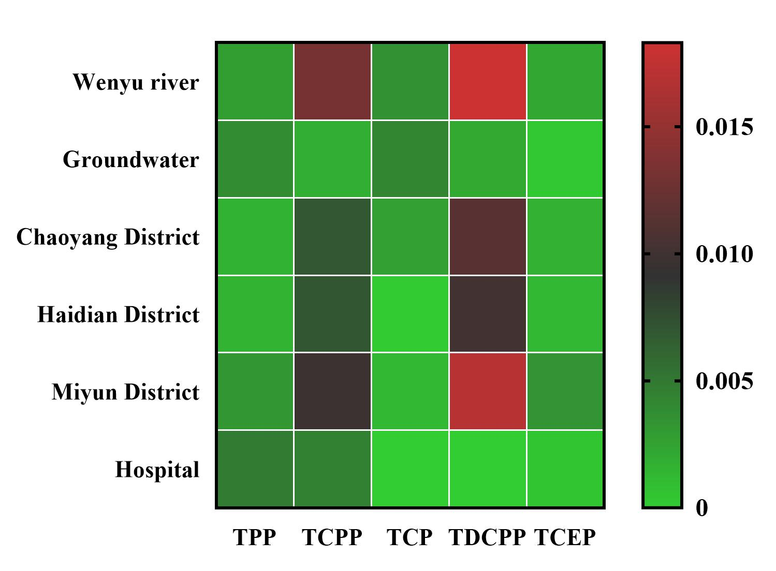

Fig S1. RQ evaluation for OPFRs in the multiphase urban water bodies of Beijing, China

*Corresponding author. Tel.: +86-10-84935064 E-mail address: sylu@craes.org.cn(S. Lu)

